**Loading club-sticker database onto localhost version of the website**

1. 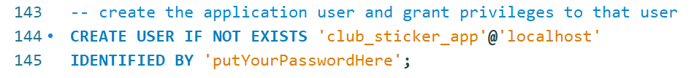Within the private folder, open access\club_sticker_localhost_nopassword.sql and edit the password for the club_sticker_app account.
2. Run the query.
3. Go over to access\clubsticker-dbAccess-noPW.csv.  
   Rename the file to clubsticker-dbAccess.csv. (I have changed includes\deployment.php to account to refer to this file as the constant for DB_ACCESS_CREDENTIALS_FILE)  
   Replace “YourPasswordHere” with the password that you just changed on the .sql script in there.

At this point, the database is loaded and an account has been made for the application to run queries on it.

**Inserting a Sticker onto the Product Page**

1. Find an image you like and resize it to 500 x 500 using software like paint. Save it as a .jpeg.
2. 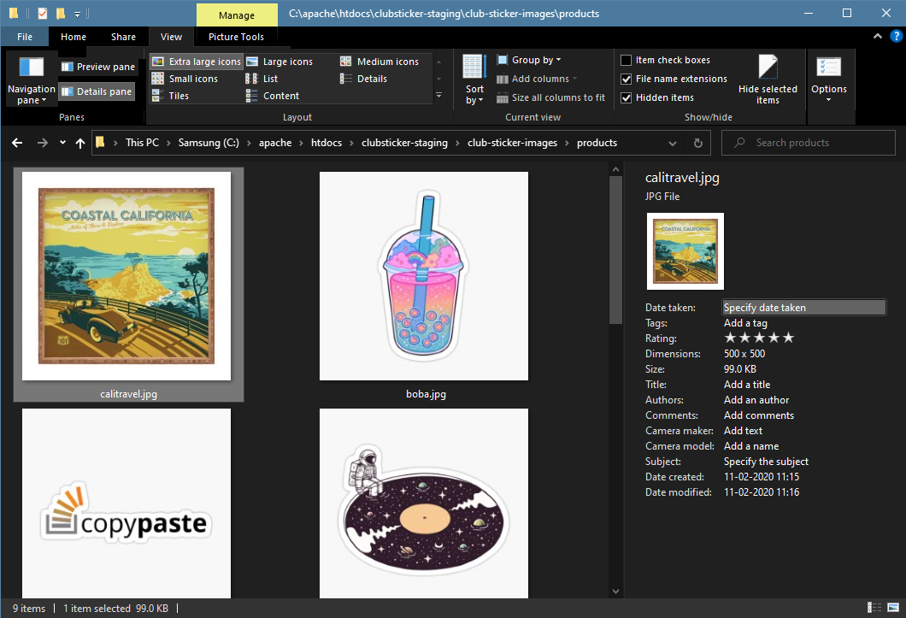Drag the image into the public/ folder for the application; place the image into the  
   club-sticker-images/products/  
   Make a note of the filename since you’ll be using that as the productCode in the SQL query.
   1. In this example, I’ve added calitravel.jpg. When I insert it into the database, productCode will be calitravel.
3. 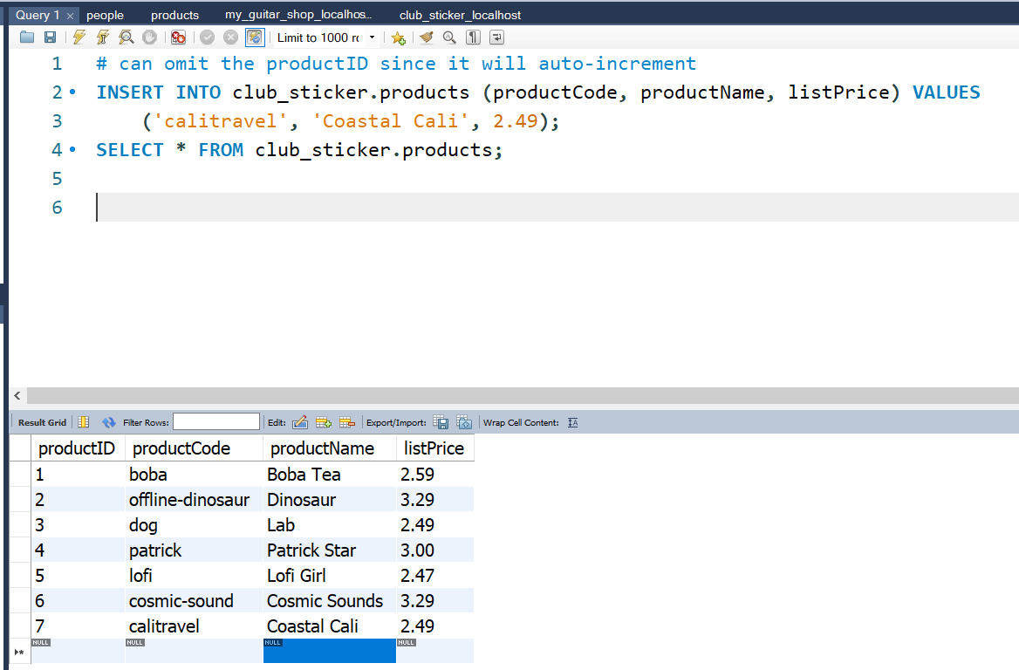To register this sticker in the database, go to MySQL Workbench or phpMyAdmin and update the products table using a query like:  
   club_sticker.products (productCode, productName, listPrice)
4. 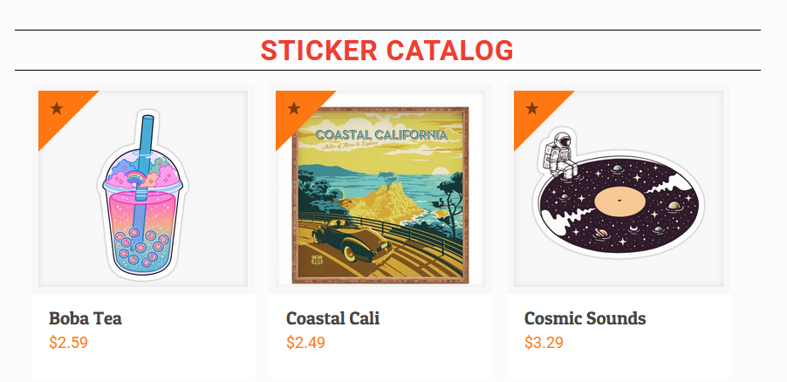Refresh the homepage. The sticker should be on the front page.