**Steps to Deploy the Club Sticker Application (Rev. Upload Assignment)**

**In the root of the repository:**

1. Go to the sqlscripts/ folder and locate club_sticker_localhost_v3.sql
   1. Alter Line 39 to a password of your choice. Save it.
   2. 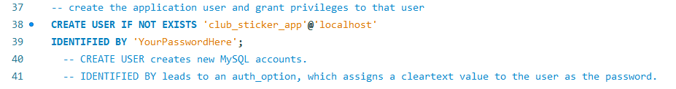Run the club_sticker_localhost_v3.sql script to initiate the database.
2. Go to the access/ folder and locate clubsticker-dbAccess-noPW.csv.
   1. 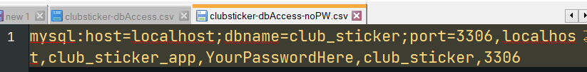Alter “YourPasswordHere” to the password you chose in 1a.
   2. Rename the file to dbAccess.csv.

Now go over the public folder of the application.

1. Go to index.php and change the following constants:
   1. NON_WEB_BASE_DIR to where you place your CIS 4270 private code files
   2. 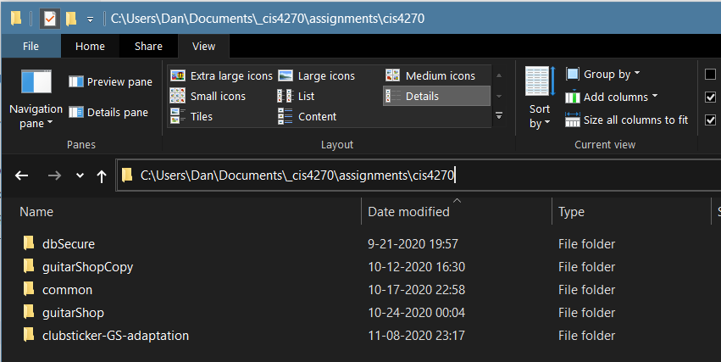APP_NON_WEB_BASE_DIR to where you placed the clubsticker application. Mines is named clubsticker-GS-adaptation (see below for what it looks like in the filesystem).

This version of the website uses the **gd library** in order to convert and manipulate images during uploads. To enable usage of it…

1. Locate your **php.ini**
2. 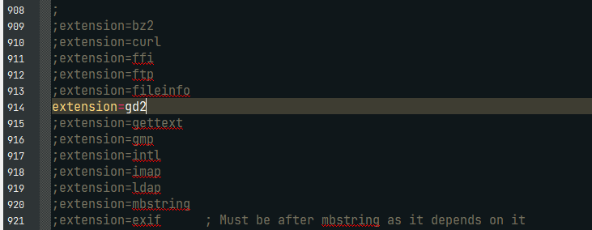Edit this line, uncommenting extension=gd2.
3. Restart the web server.
4. 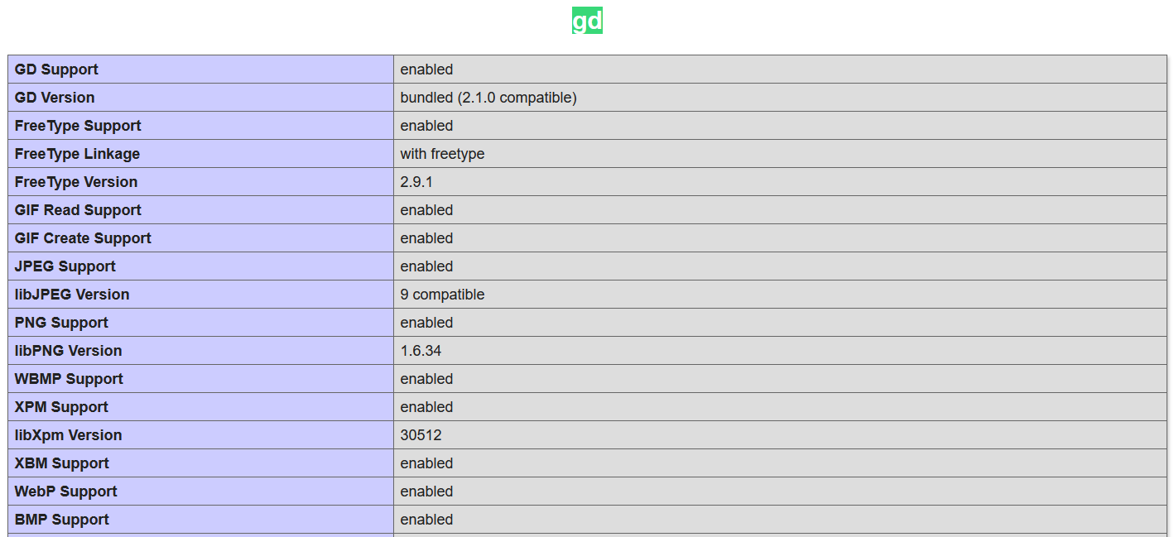You should see the changes in your phpinfo output.