**Walchand College Of Engineering, Sangli.**

(An Autonomous Institute)

Department of Computer Science and Engineering

**TY B.Tech. (CSE) – II [ 2021-22 ]**

**Software Engineering Tools Lab**

**Assignment 1**

**Report on**

Data preprocessing, classification and visualization using weka software

Submitted by

**Dattatray P. Reve**

2019BTECS00007

TYCSE, Batch- T1

2021-2022

# Table of Contents

1. Abstract
2. Introduction
3. Objectives
4. Work
5. Conclusion
6. References

**Abstract**

Orange is a C++ core object and routines library that incorporates a huge variety of standard and non-standard machine learning and data mining algorithms. It is an open-source data visualization, data mining, and machine learning tool. Orange is a scriptable environment for quick prototyping of the latest algorithms and testing patterns. It is a group of python-based modules that exist in the core library. It implements some functionalities for which execution time is not essential, and that is done in Python.

## Introduction

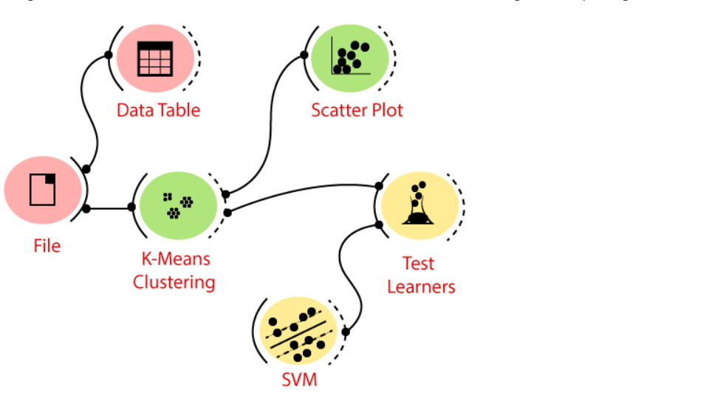

Above model shows how orange software visualize.

**Objectives**

1. Understanding why orange software use
2. Understanding the how the to visualize data using orange software

**Working :**

step 1 : Install orange software on your system

step 2: After installing open the orange software and you will see this type of interface

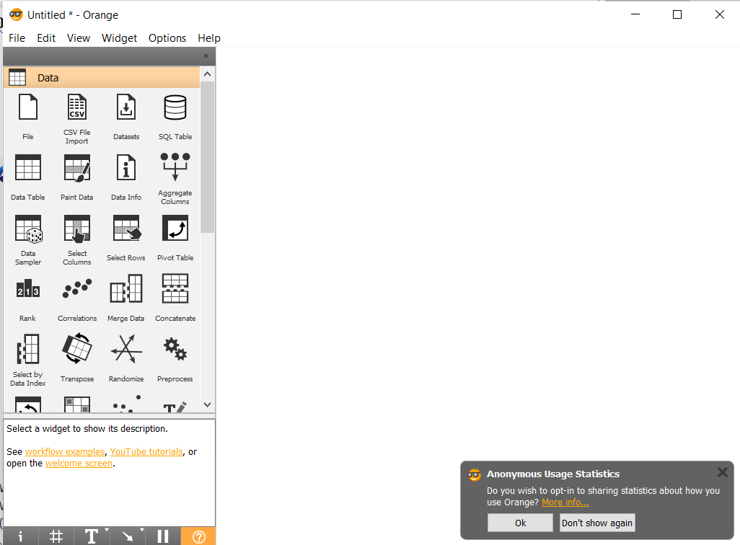

Step 2: to open file click on file

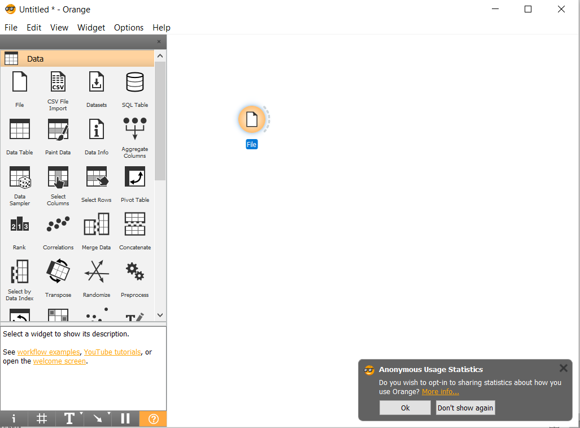

Step 3 : Double click on newly visible file and select target file that you want visualize

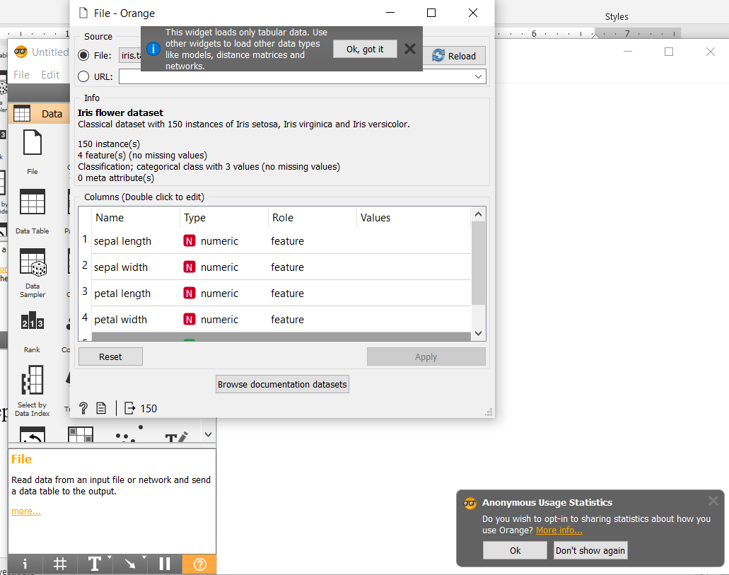

Step 4 : After that right side half curve around the file and move anywhere and choose data visualization method and you will see data according that format

**Data Distribution**

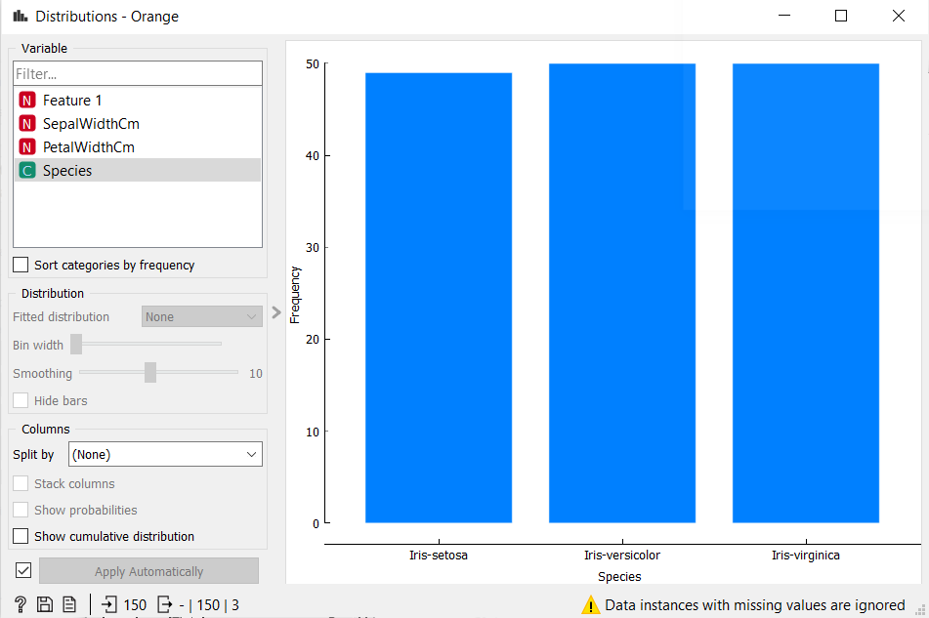



**Show linear projection**

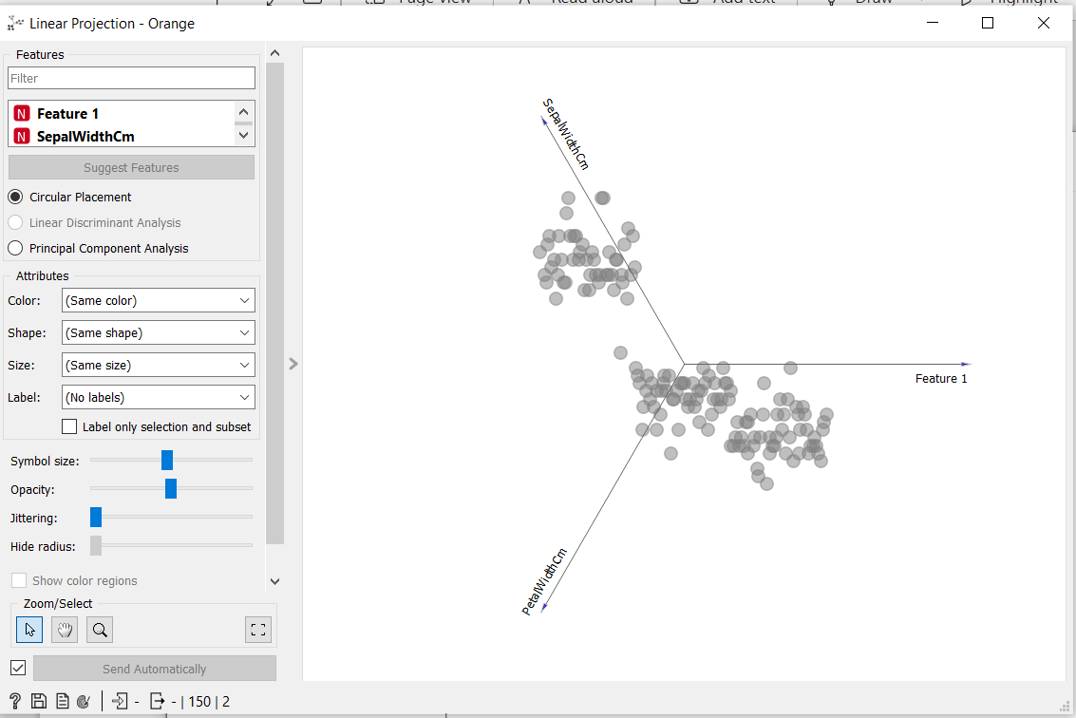

Below are the some the other method for used by me visualization

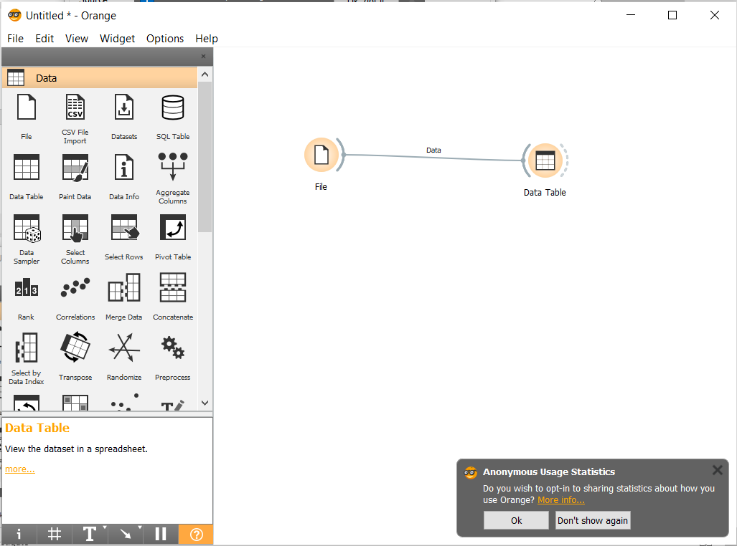

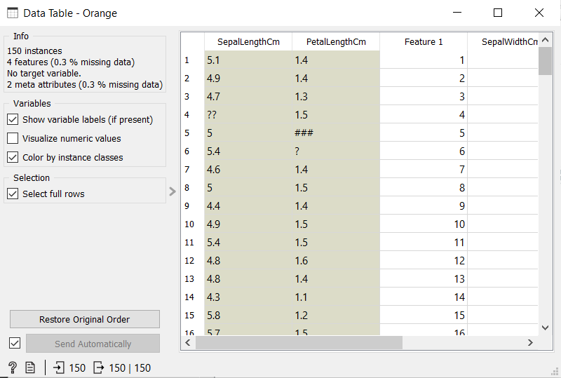

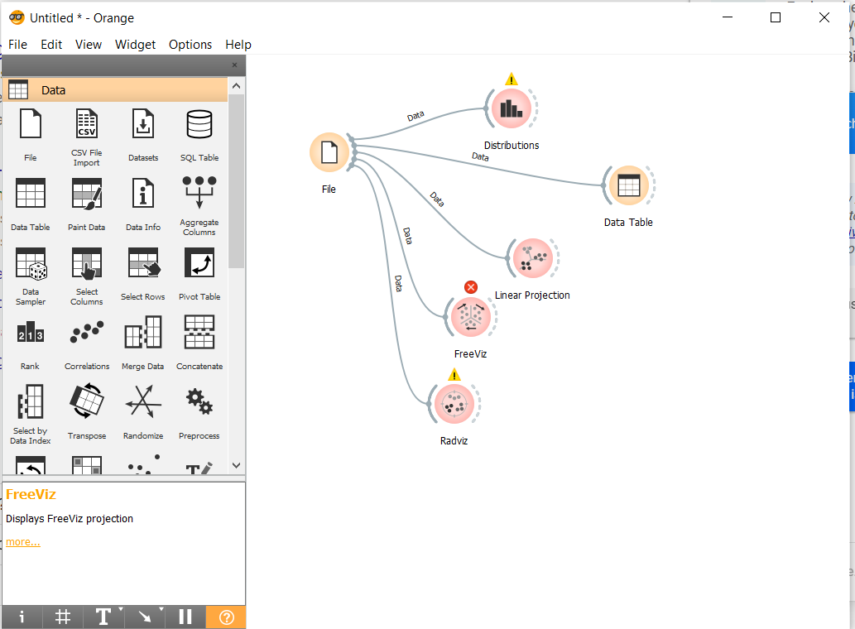

# Conclusion

We learn data visualization in orange software .

**References**

**https://orangedatamining.com/**