**Walchand College Of Engineering, Sangli.**

(An Autonomous Institute)

Department of Computer Science and Engineering

**TY B.Tech. (CSE) – II [ 2021-22 ]**

**Software Engineering Tools Lab**

**Assignment 1**

**Report on**

Data preprocessing, classification and visualization using weka software

Submitted by

**Dattatray P. Reve**

2019BTECS00007

TYCSE, Batch- T1

2021-2022

# Table of Contents

1. Abstract
2. Introduction
3. Objectives
4. Work
5. Conclusion
6. References

## Abstract

WEKA is an open source software provides tools for data preprocessing, implementation of several Machine Learning algorithms, and visualization tools so that you can develop machine learning techniques and apply them to real-world data mining problems.

## Introduction

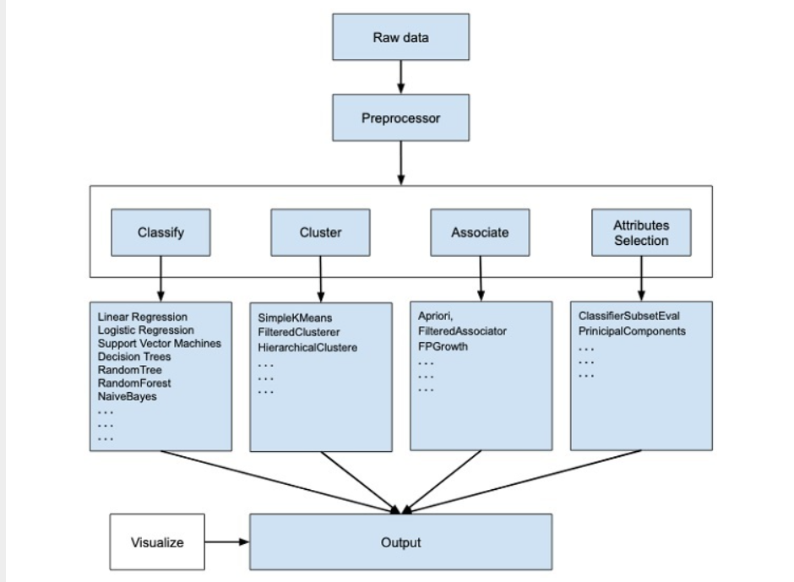

Above model shows how weka software analyse and their flow of data using some machine learning algorithm

## Objectives

1. Understanding why weka software is used
2. Understanding the how the to analyze data using weka software

**Work :**

1. Install weka software on your system
2. After installing open the weka software and you will see this type of interface



3. Click on Explore button then you will see this interface

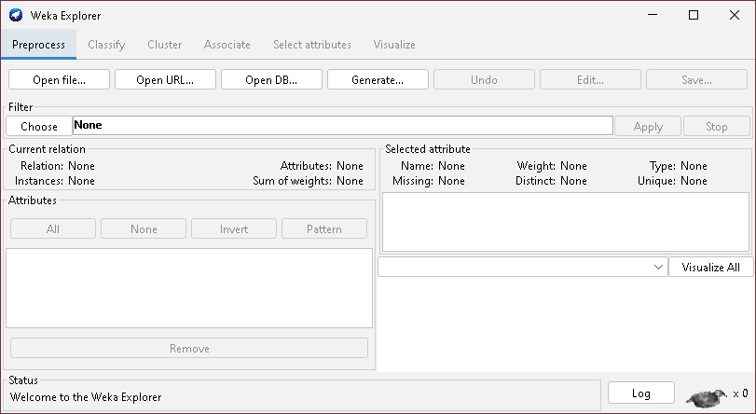

4.Click on open file button under the Preprocess tab And select your data set from your local drive with proper extension

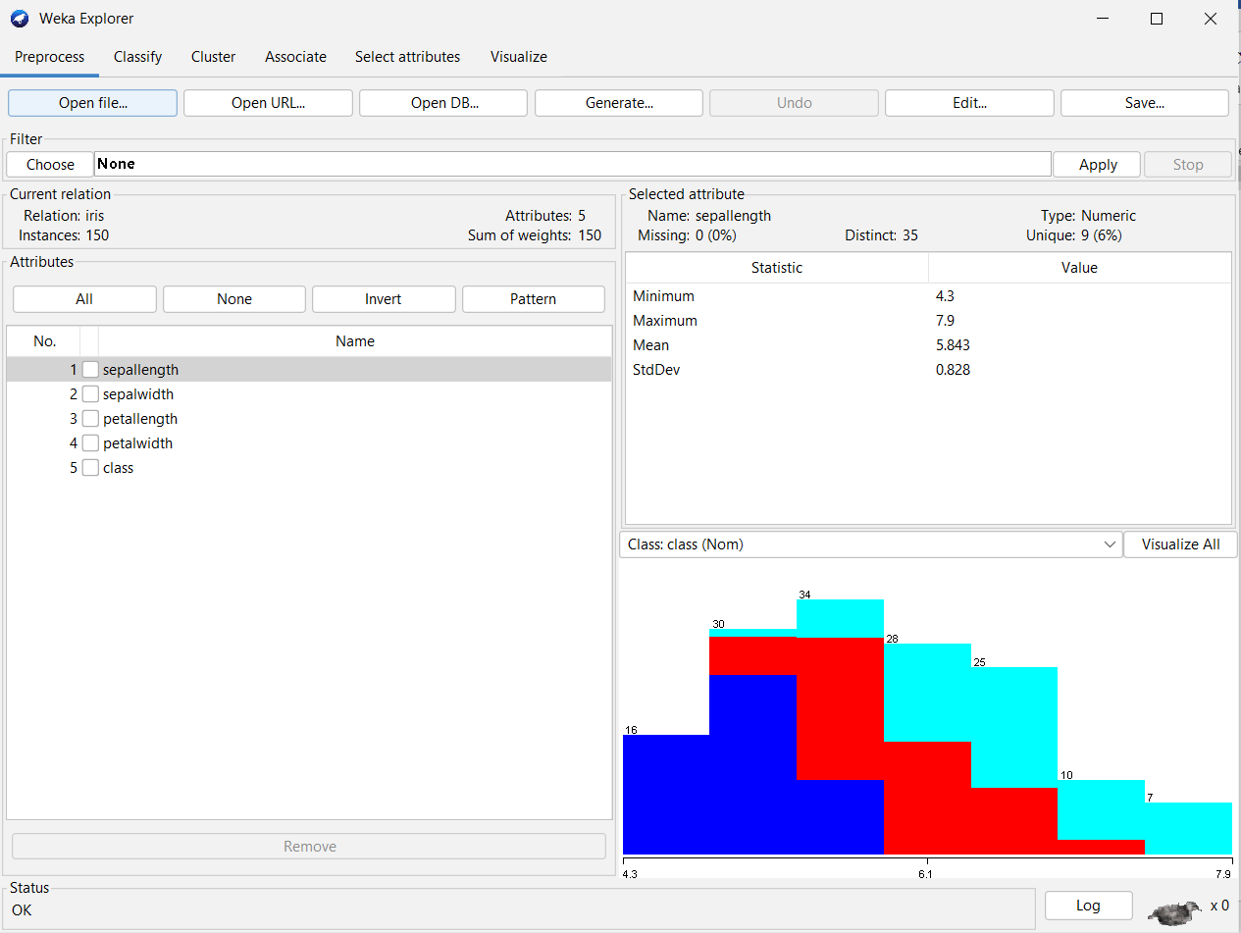

**Data classification**

6 :Click on classify tab. Click on choose button and choose under the classifier file many ML algorithms choose whichever you want choose more than two and each time click on start button.

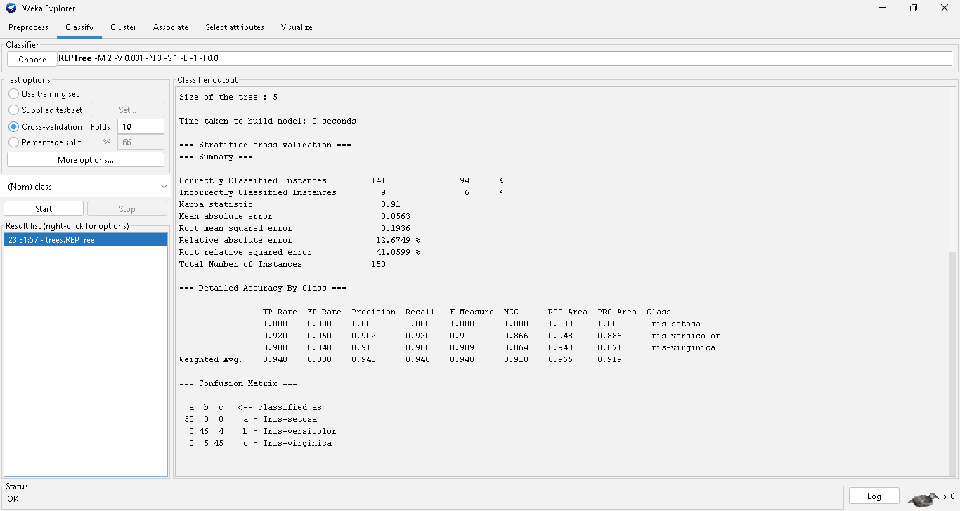

In result list ML algo and right side their result in this way you can classify the data their confusion matrix

**Data visualization**

7 : Click on ML algo name and right click. Choose any visualize option

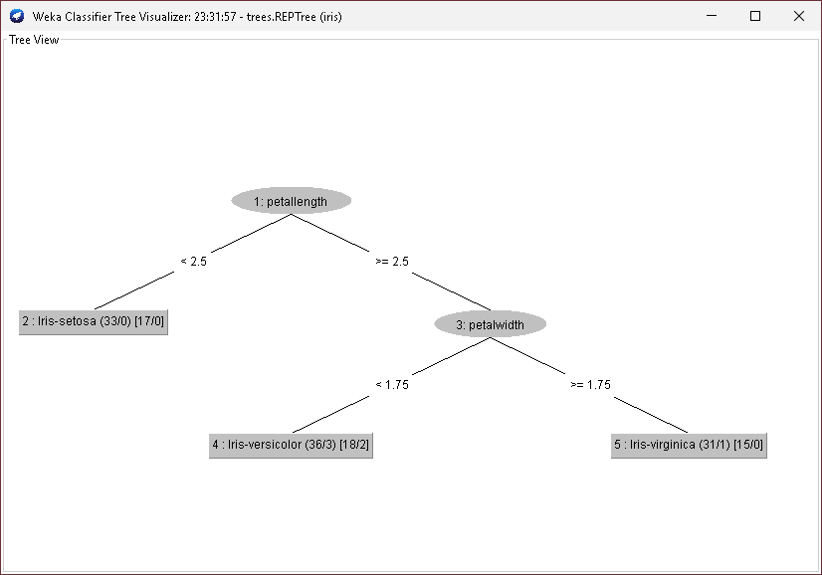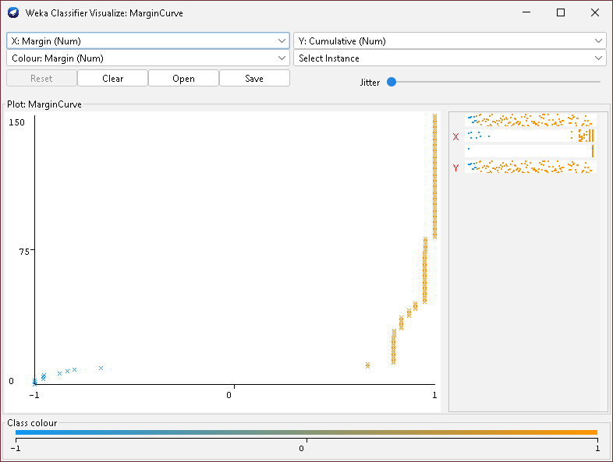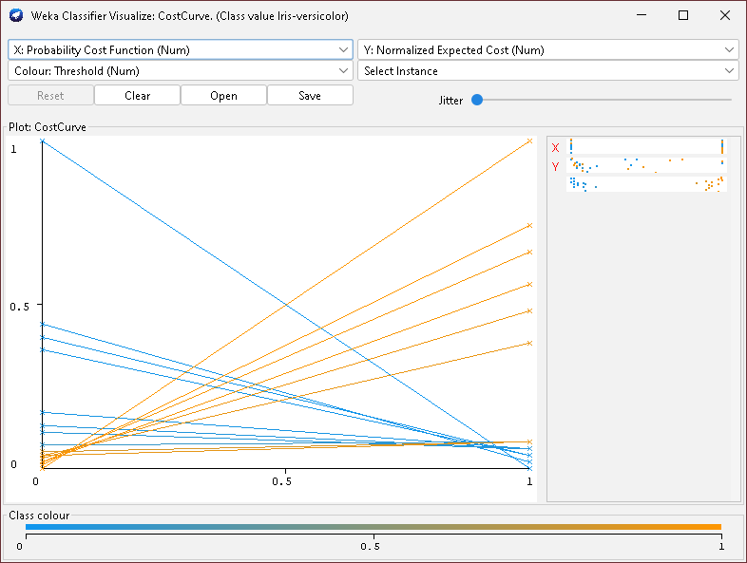

# Conclusion

We learn what is how to preprocess, classify and visualize data in weka software with their provided ML algos .

# References

* + [What is Weka? (tutorialspoint.com)](https://www.tutorialspoint.com/weka/what_is_weka.htm)