**TY B.Tech. (CSE) – II [ 2021-22 ]**

**Software Engineering Tools Lab**

**PRN/ Roll No: 2019BTECS00004 & 2019BTECS00007**

**Name: Yash Nale & Dattatray Reve**

**Batch: T1**

**Assignment No. 2**

**Module 2- Software Development Frameworks**

1. **For Eclipse IDE provide the answers for below questions:**
2. **Original author – IBM(International Business Machines Corporation)**
3. **Developers – Eclipse Foundation**
4. **Initial release – 1.0 / 7 November 2001**
5. **Stable release – 4.22.0 / 8 December 2021**
6. **Preview release – 4.21 (2021-09 release)**
7. **Repository (with cloud support) –**

[**https://download.eclipse.org/releases/latest/**](https://download.eclipse.org/releases/latest/)

1. **Written in (Languages) – Java, C**
2. **Operating System support – macOS, Windows and Linux**
3. **Platform, portability – Java Platform, Standard Edition & Portable**
4. **Available in (Total languages) – Available in 44 languages**
5. **List of languages supported – C, C++, C#, JavaScript, Perl, PHP, Python, R, Ruby, etc**
6. **Type – Integrated Development Environment**
7. **Website –** [**https://www.eclipse.org/ide/**](https://www.eclipse.org/ide/)
8. **Features – Provides code insight, provides workspace, provides editors and views, etc**
9. **Size (in MB, GB etc.) – 182 MB**
10. **Privacy and Security – Any personally identifiable information collected by virtue of contributions will be publicly available on the Internet in unencrypted form and without access restriction.**
11. **Type of software (Open source/License) – Open Source**
12. **Latest version – 4.22.0**
13. **Cloud support (Yes/No) – Yes**
14. **Applicability – Eclipse is especially designed to handle large development projects**
15. **Drawbacks (if any) – Eclipse has a tendency to run slower than other IDEs. There are many reasons for this, such as insufficient memory allocation**
16. **Implement linear regression problem using Google Colab (Perform pre-processing, training and testing)**

**Dataset** – [**https://www.kaggle.com/spittman1248/cdc-data-nutrition-physical-activity-obesity**](https://www.kaggle.com/spittman1248/cdc-data-nutrition-physical-activity-obesity)

**Pre-processing**

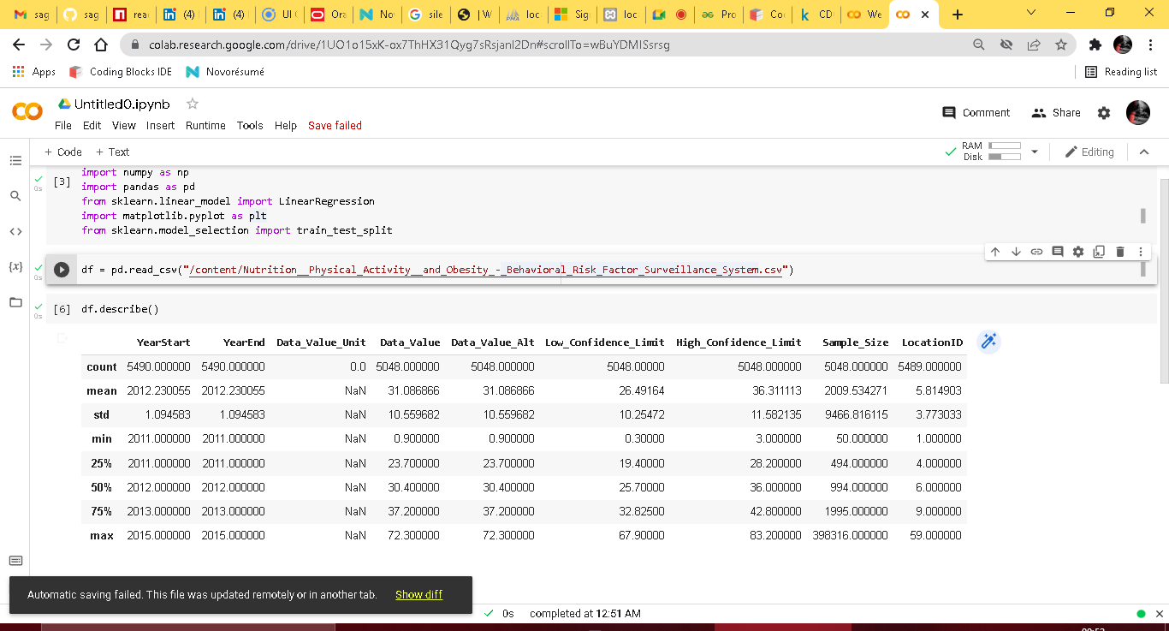

**Training**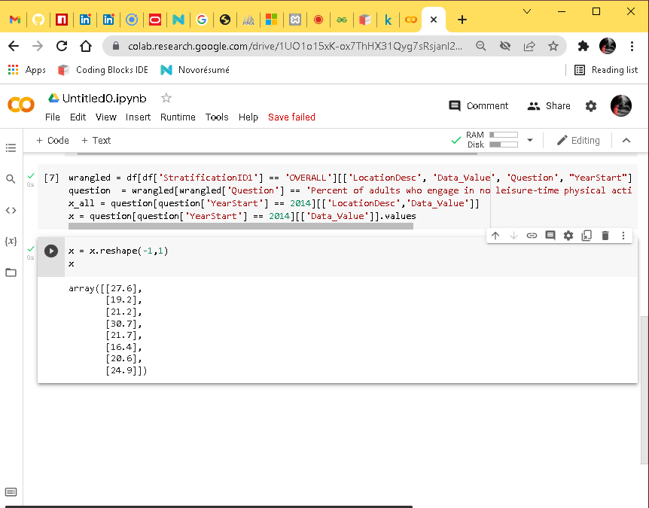

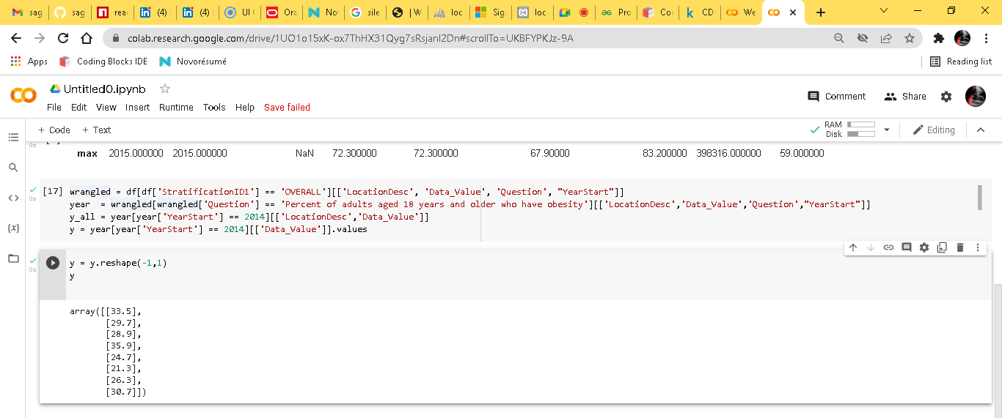

**Testing**

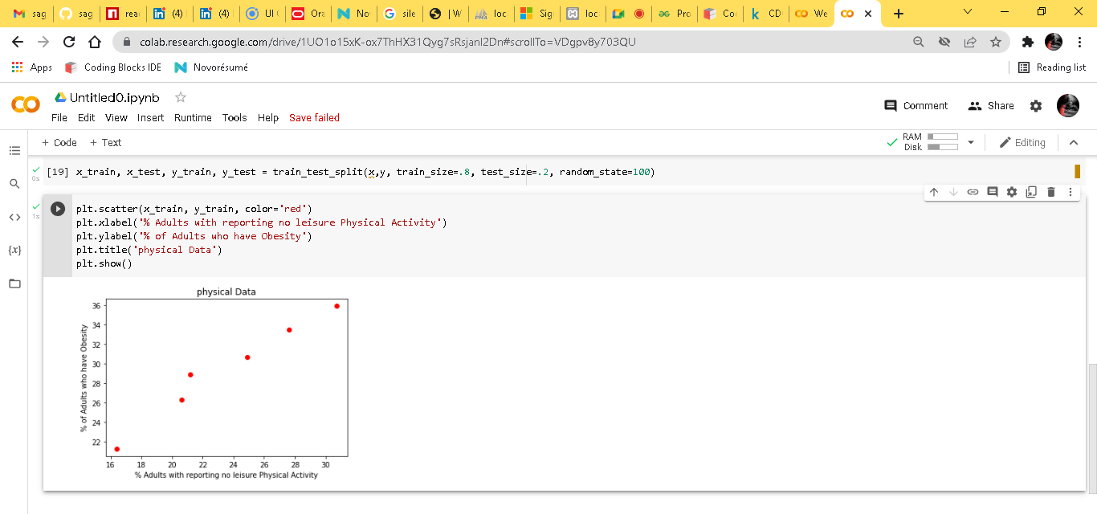

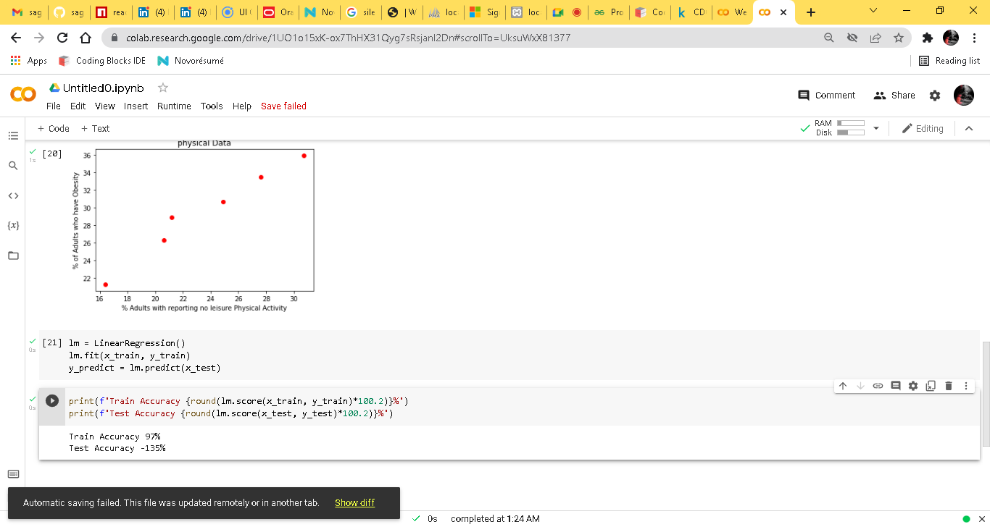

**Linear Regression**

