**TY B.Tech. (CSE) – II [ 2021-22 ]**

**Software Engineering Tools Lab**

**PRN/ Roll No: 2019BTECS00007**

**Full name: Dattatray Parmeshwar Reve**

**Batch: T1**

**Assignment No. 1**

**Module 1- Introduction to OSS**

1. **Weka is a GUI workbench that empowers data wranglers to assemble machine learning pipelines, train models, and run predictions without having to write code.**

**Using Weka tool perform below tasks such as data preprocessing, data classification (use any appropriate ML algorithm) and data visualization efficiently on given dataset.**

**Use the Iris dataset given-**

[**https://drive.google.com/file/d/1A3Fxsfzm6BSfhFZGDrjI47RTe45bSgYP/view**](https://drive.google.com/file/d/1A3Fxsfzm6BSfhFZGDrjI47RTe45bSgYP/view)

**Note-provide screen shots for every task**

**Create a report which will illustrate the details of tasks performed (for e.g to perform preprocessing of data provide details of navigation and selection of appropriate parameters)**

Ans:

Weka

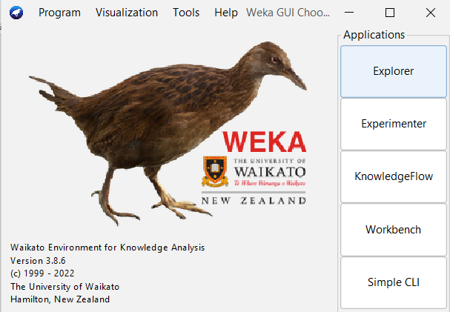

preprocess

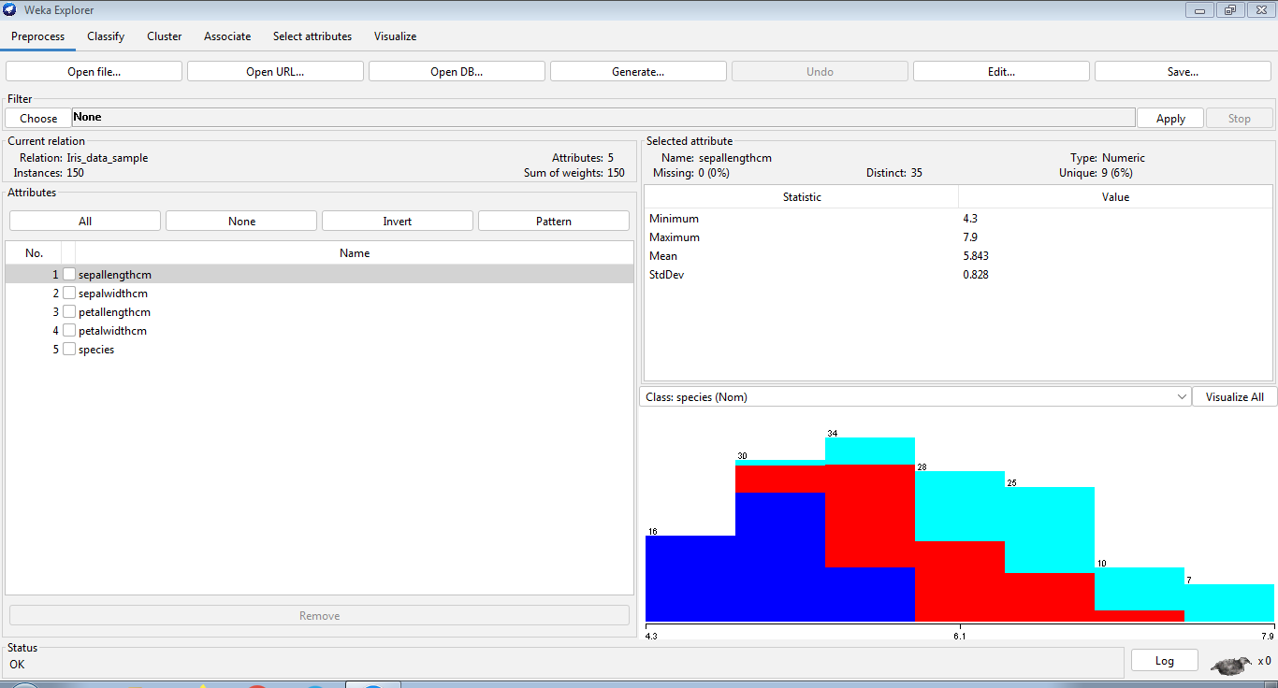

Visualize ALL

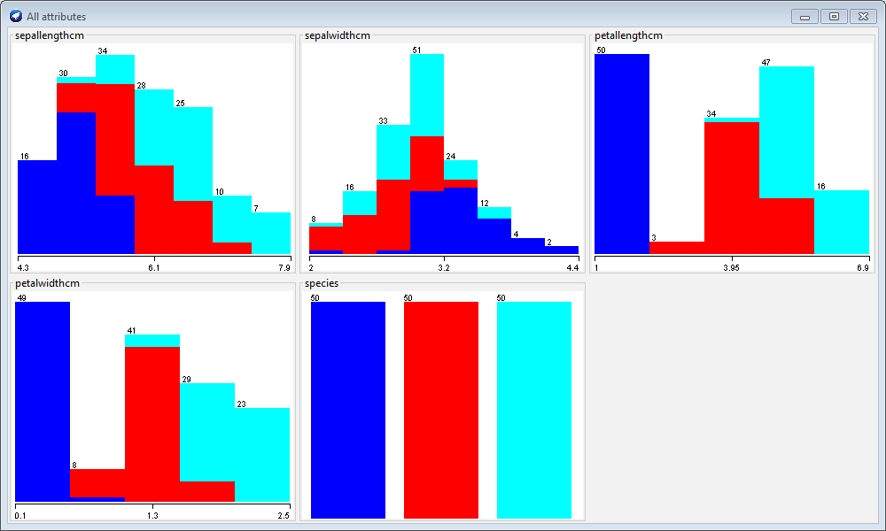

Classify

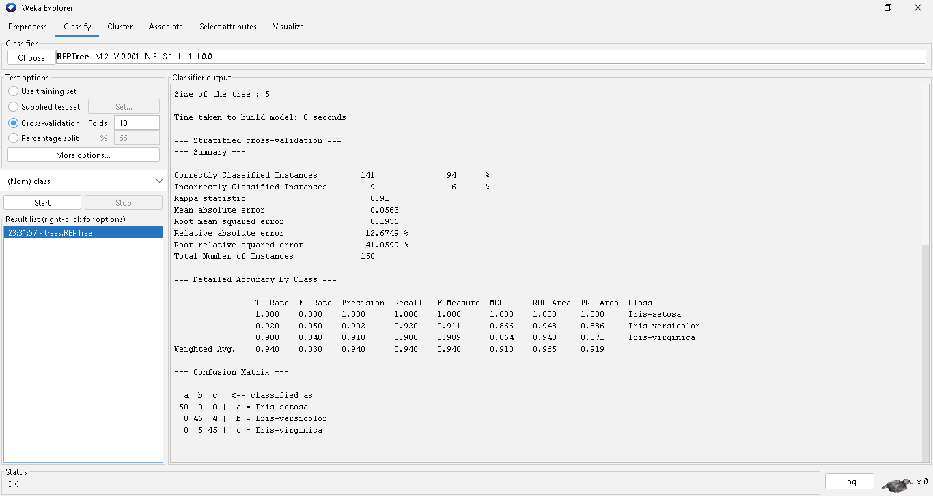

ML Algorithm

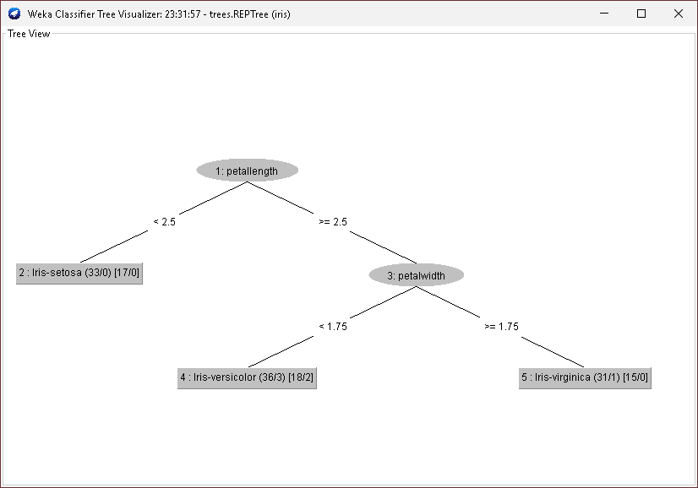

Visualize

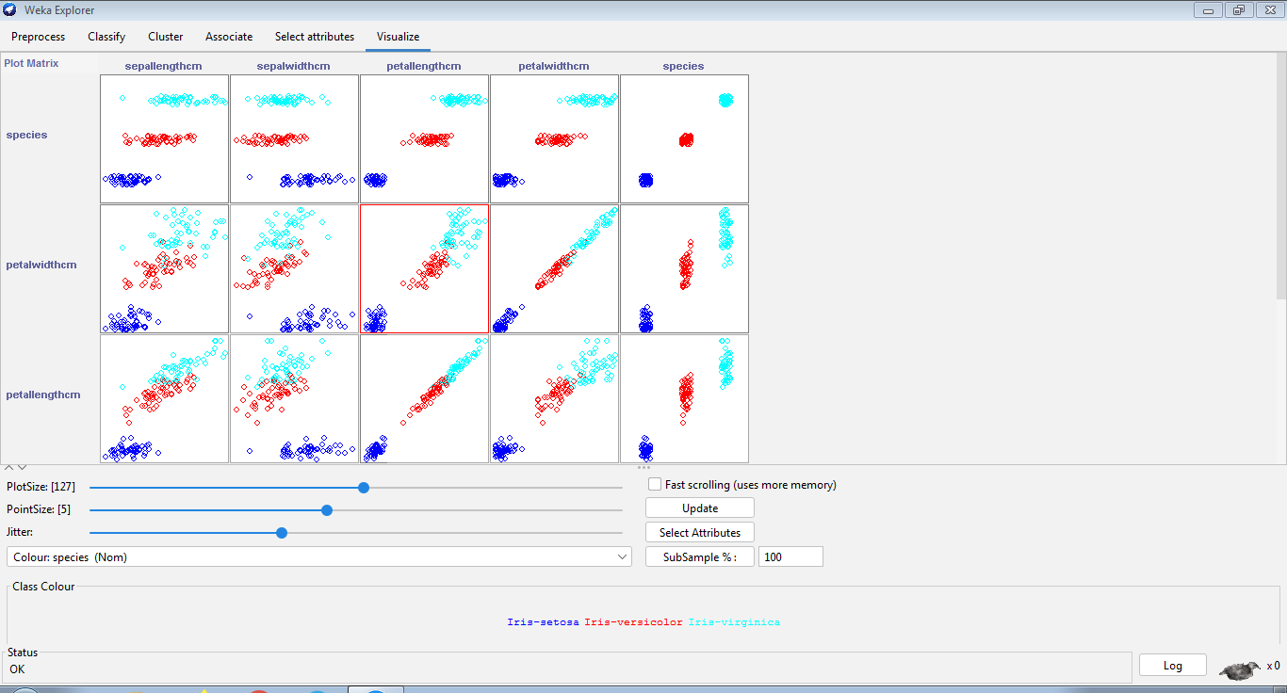

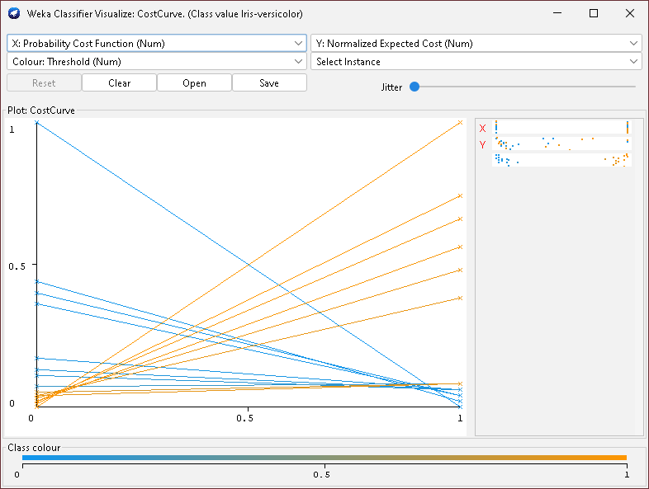

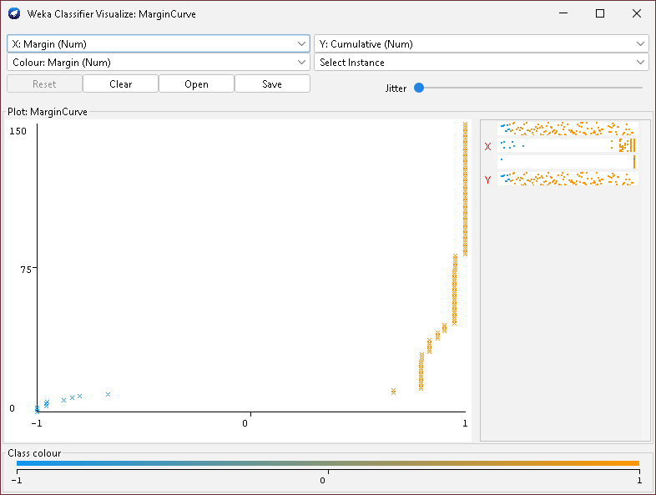

**2) Orange is an easy to use data visualization tool with a large toolkit. In spite of being a GUI-based beginner-friendly tool, you mustn’t mistake it for a light-weight one. It can do statistical distributions and box plots as well as decision trees, hierarchical clustering and linear projections.**

**a. Install orange**

**b. Show data distribution**

**c. Show linear projection**

**d. Show FreeViz**

**Use dataset** [**https://drive.google.com/file/d/1m6sKI1Dap0XK6Bw1edUd5PohwpPwXnd9/view**](https://drive.google.com/file/d/1m6sKI1Dap0XK6Bw1edUd5PohwpPwXnd9/view)

Ans:

**Orange**

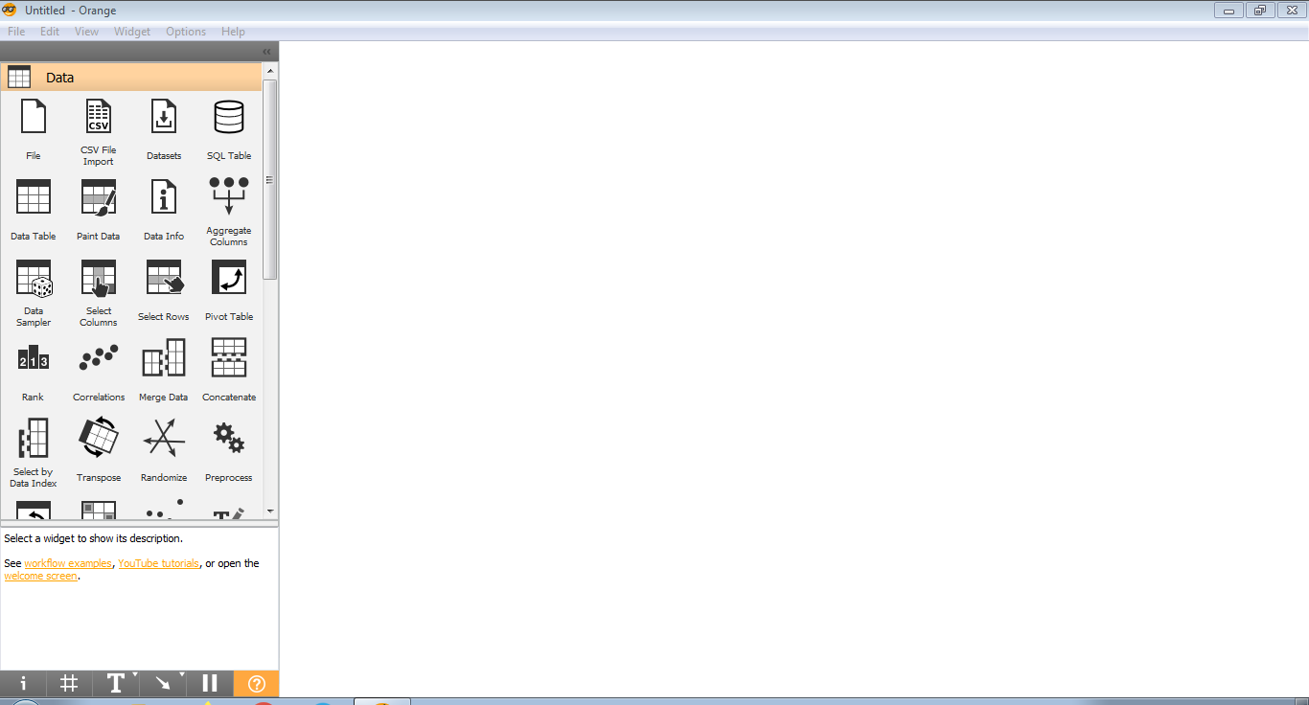

**Distributions**

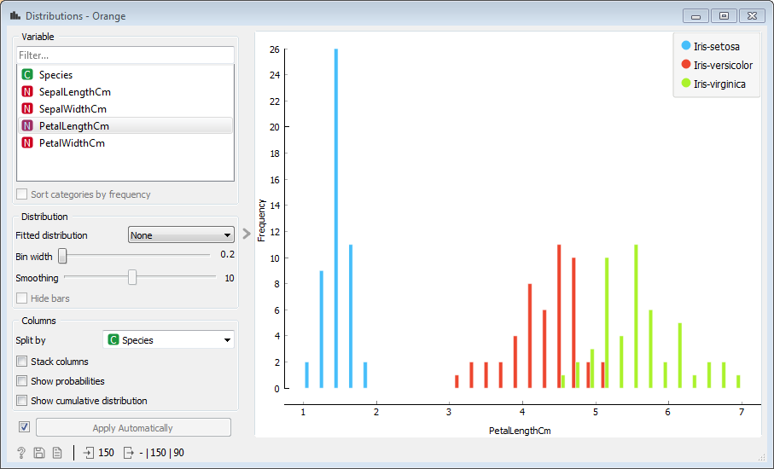

**Linear Projection**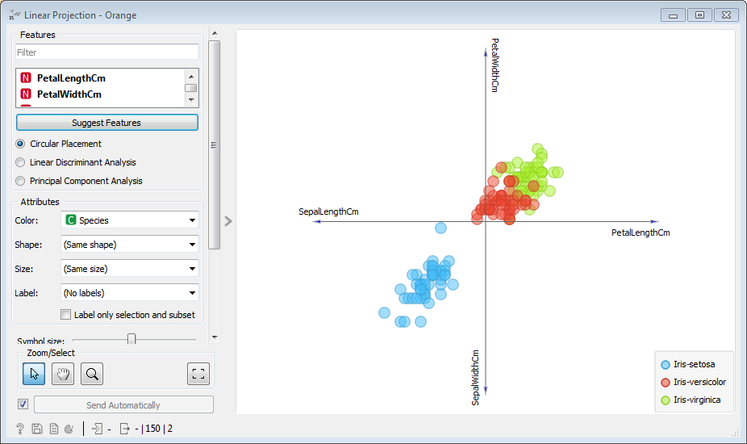

**Fr­eeviz ­– Multivariate Projection**

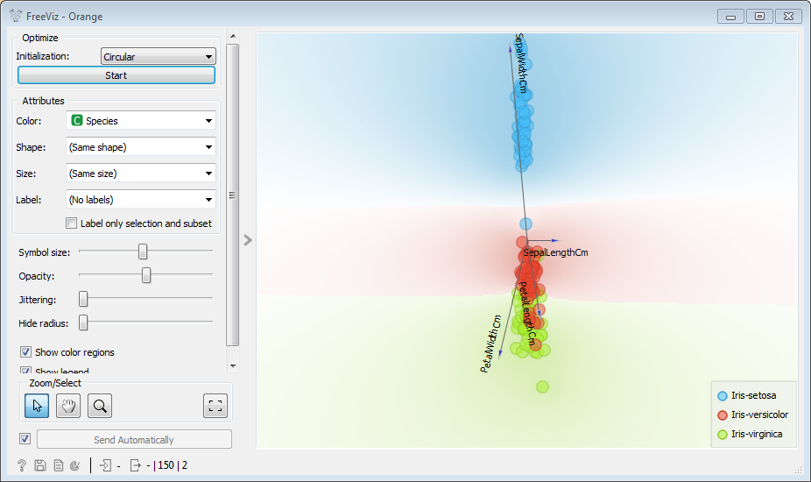

**3) Differentiate in between free software, Open source software and proprietary software with respect to its properties.**

**Ans:**

**Free Software**

“Free software” means software that respects users’ freedom and community. Roughly, it means that the users have the freedom to run, copy, distribute, study, change and improve the software.

The term “free software” is sometimes misunderstood—it has nothing to do with price. It is about freedom.

While open source is a development philosophy that is more business oriented, free software is a social and moral philosophy.

**Open Source Software**

Open source software is a computer software whose source code is available openly in internet and programmers can modify it to add new features and capabilities without any cost. Here the software is developed and tested through open collaboration. This software is managed by an open source community of developers. It provides community support as well as commercial support if available for maintenance. We can get it for free of cost. This software also sometimes comes with license and sometimes does not**.** Free software is a social movement while open source is a development methodology. That’s why the term open source is more palatable to the corporate world because it places less emphasis on freedom

**Proprietary Software**

Proprietary software is a computer software where the source codes are not publicly not available only the company which has created can modify it. Here the software is developed and tested by the individual or organization by which it is owned not by public. This software is managed by a closed team of individuals or groups that developed it. We have to pay to get this software and it commercial support if available for maintenance. The company gives a valid and authenticated license to the users to use this software.

**4) Using Anaconda Python create Histogram, Scatter plot and Bar plot for the dataset given below.**

**Dataset-**

[**https://drive.google.com/file/d/1i11BZFe8Xj9kNq7eeE9KOa_Iz1KhEdXJ/view**](https://drive.google.com/file/d/1i11BZFe8Xj9kNq7eeE9KOa_Iz1KhEdXJ/view)

**a. Scatter plot- Scatter plot of Price Vs Age**

**b. Histogram- for Kilometer and CC**

**c. Bar plot- Bar plot for different fuel types**

Ans:

**Scatter Plot – Price v/s Age**

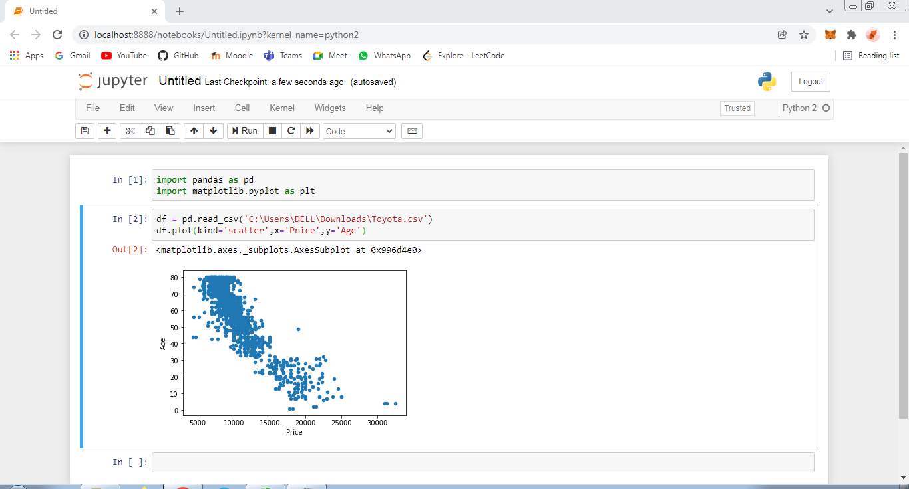

**Histogram – Kilometer**

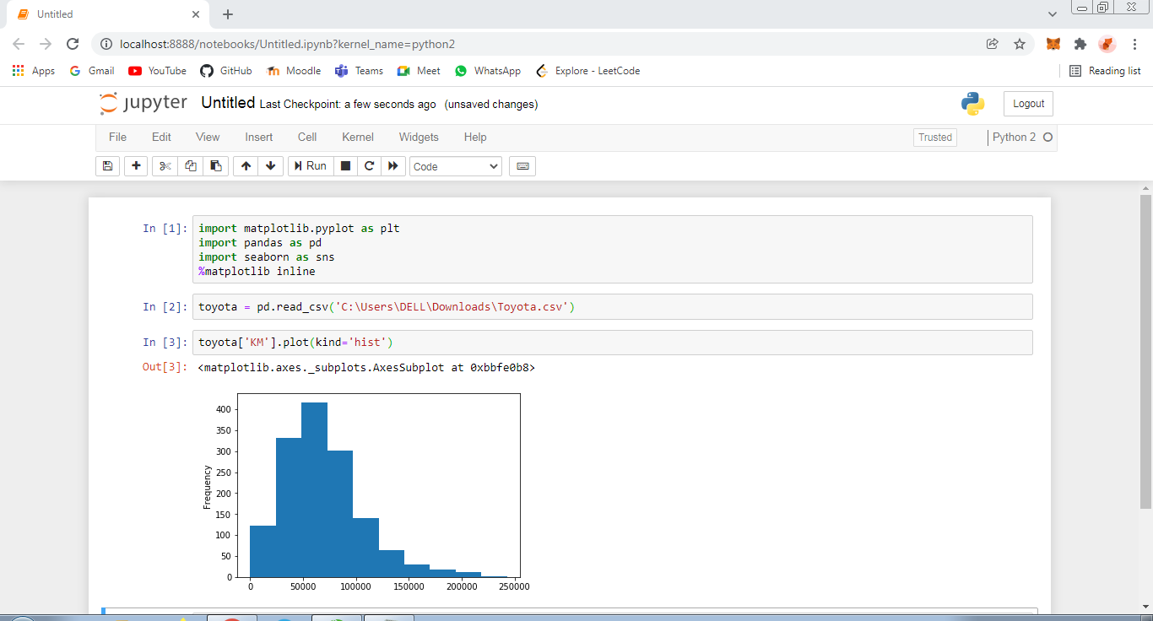

**Histogram – CC**

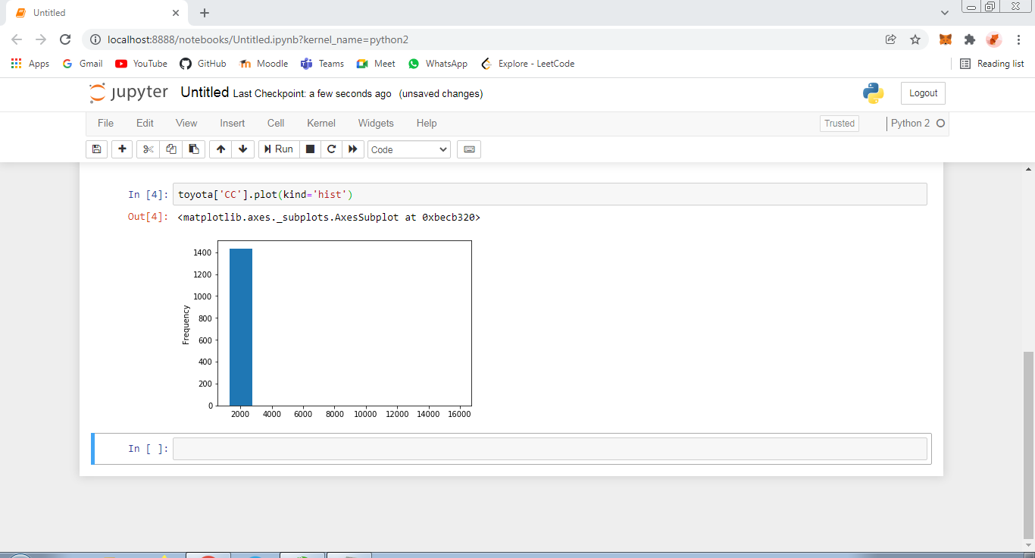

**Bar Plot – Fuel Types**

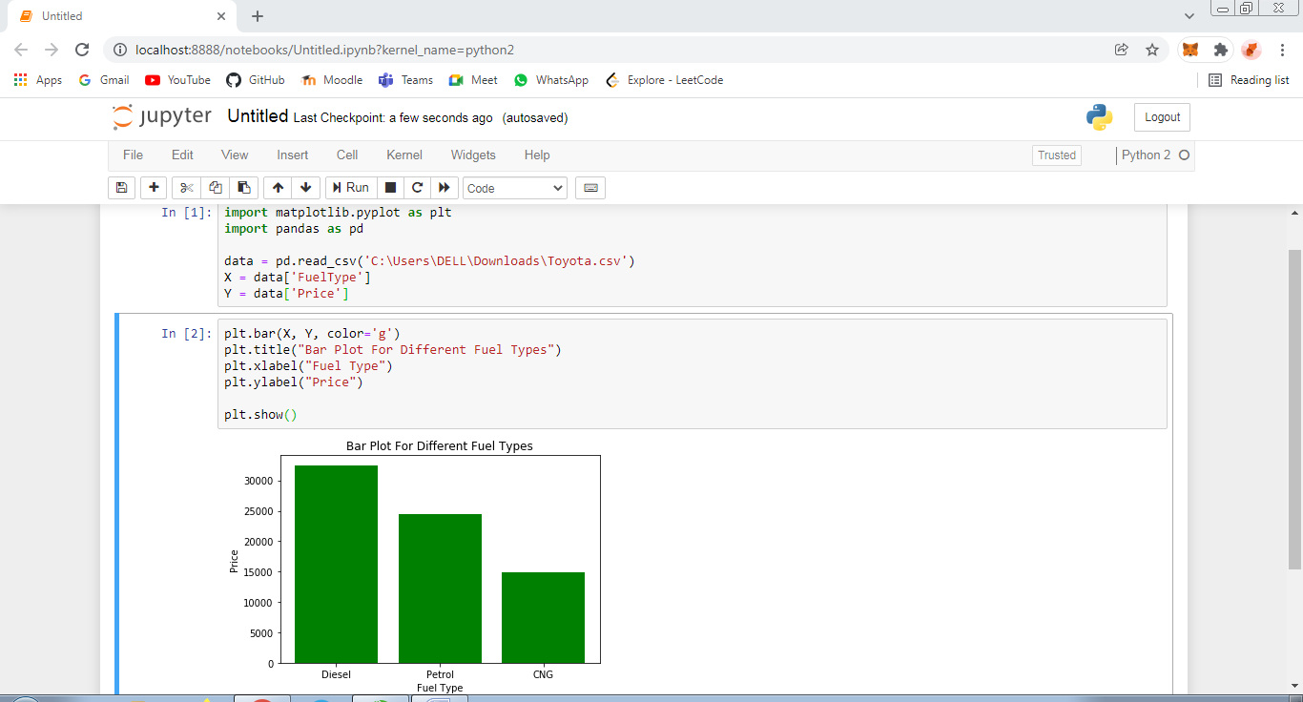

**5) Enlist some examples along with its purpose and properties (at least 10) of FOSS and proprietary software with respect to database.**

**FOSS Software’s**

1. Mozilla Firefox – Mozilla Firefox is a customizable internet browser and free open source software. It offers thousands of plug-ins that are accessible with a single click of your mouse.
2. VLC Media Player – VLC Media Player is one of the most popular open source software examples that you can use for free. This multimedia player is used for video, media and audio files and it plays discs, webcams, streams and devices.
3. Linux – Linux operating system is most commonly used on desktops. What makes this operating system different from the others is that it costs nothing and it is incredibly customizable.
4. Blender – Blender is a 3D graphics and animation tool that supports motion tracking, simulation, animation, video editing, rendering, modelling and much more
5. GNU Compiler Collection – GNU Compiler Collection is a collection of compilation tools for software development in the C, C++ and other programming languages**.**

**Proprietary Software’s**

1. Microsoft Windows – Windows, is a group of several proprietary graphical operating system families, all of which are developed and marketed by Microsoft.
2. Adobe Flash Player – Adobe Flash Player is computer software for content created on the Adobe Flash platform. Flash Player is capable of viewing multimedia contents, executing rich Internet applications, and streaming audio and video.
3. iTunes – iTunes is a media player, media library, Internet radio broadcaster, mobile device management utility, and the client app for the iTunes Store, developed by Apple Inc.
4. Google Earth - Google Earth is a computer program, that renders a 3D representation of Earth based primarily on satellite imagery.
5. Skype – Skype is a proprietary telecommunications application that specializes in providing VoIP-based video-telephony, videoconferencing and voice calls.

**\*\*\*\*\*\*\*\*\*\*\*\*\*\*\*\*\*\*\*\*\*\*\*\*\*END\*\*\*\*\*\*\*\*\*\*\*\*\*\*\*\*\*\*\*\*\*\*\*\*\*\*\***