1. **Define a simple services like Converting Rs into Dollar and Call it from different platform like JAVA and .NET**

Note: write same program in java also attach with this practical

Step 1: Open visual studio

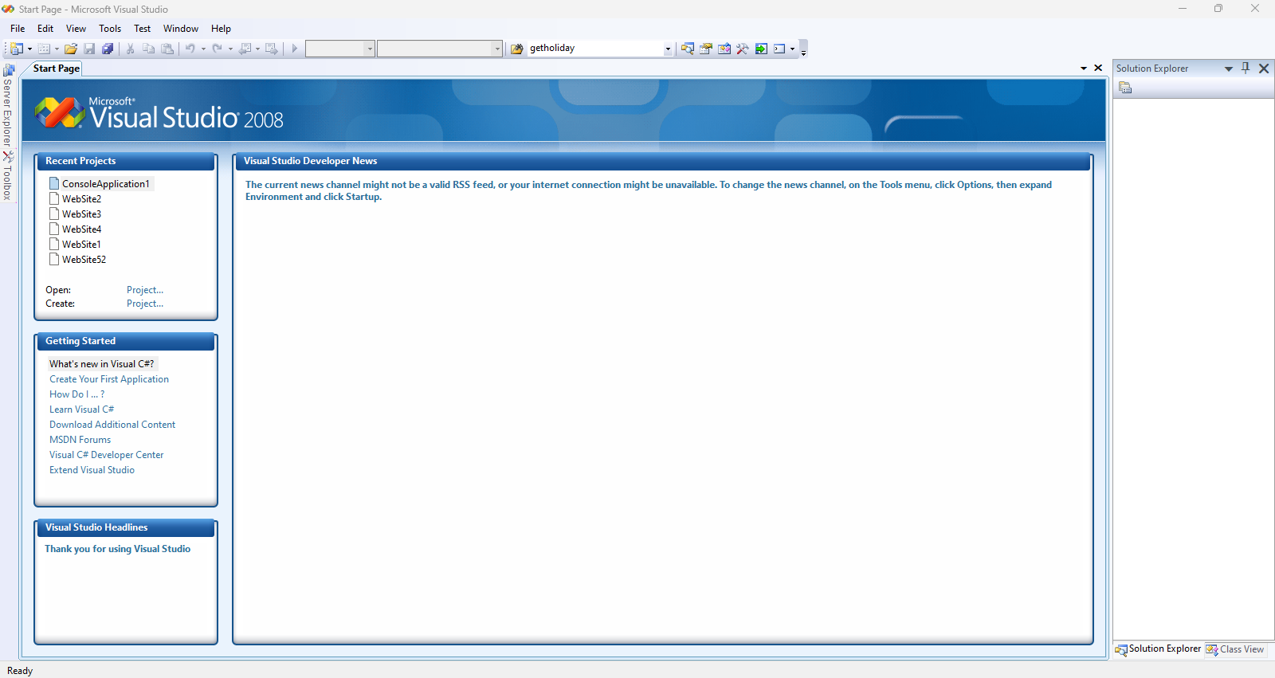

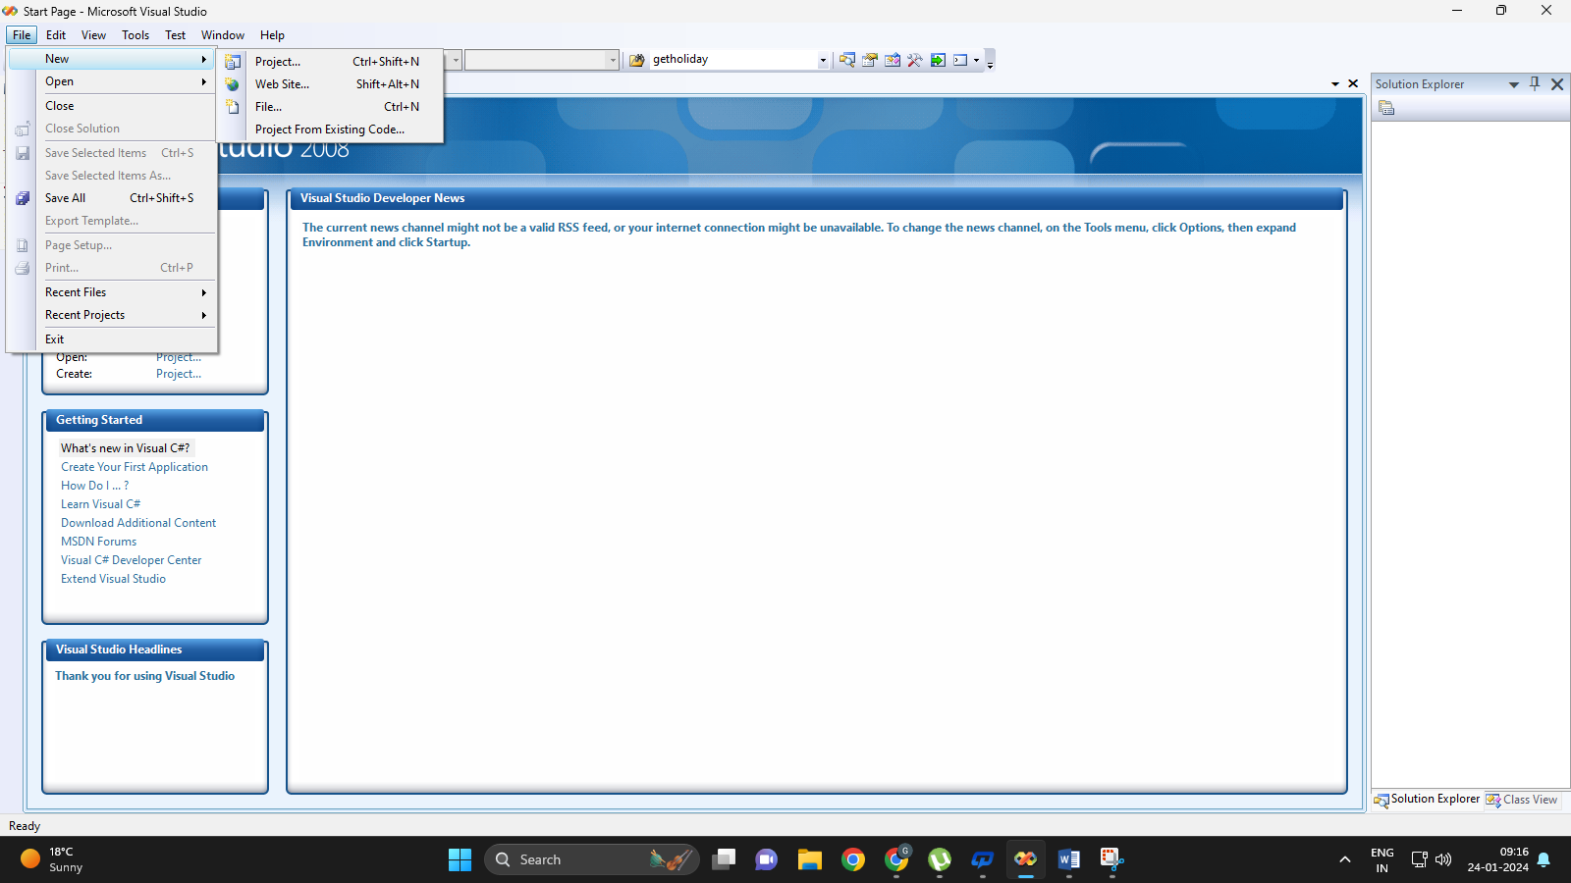

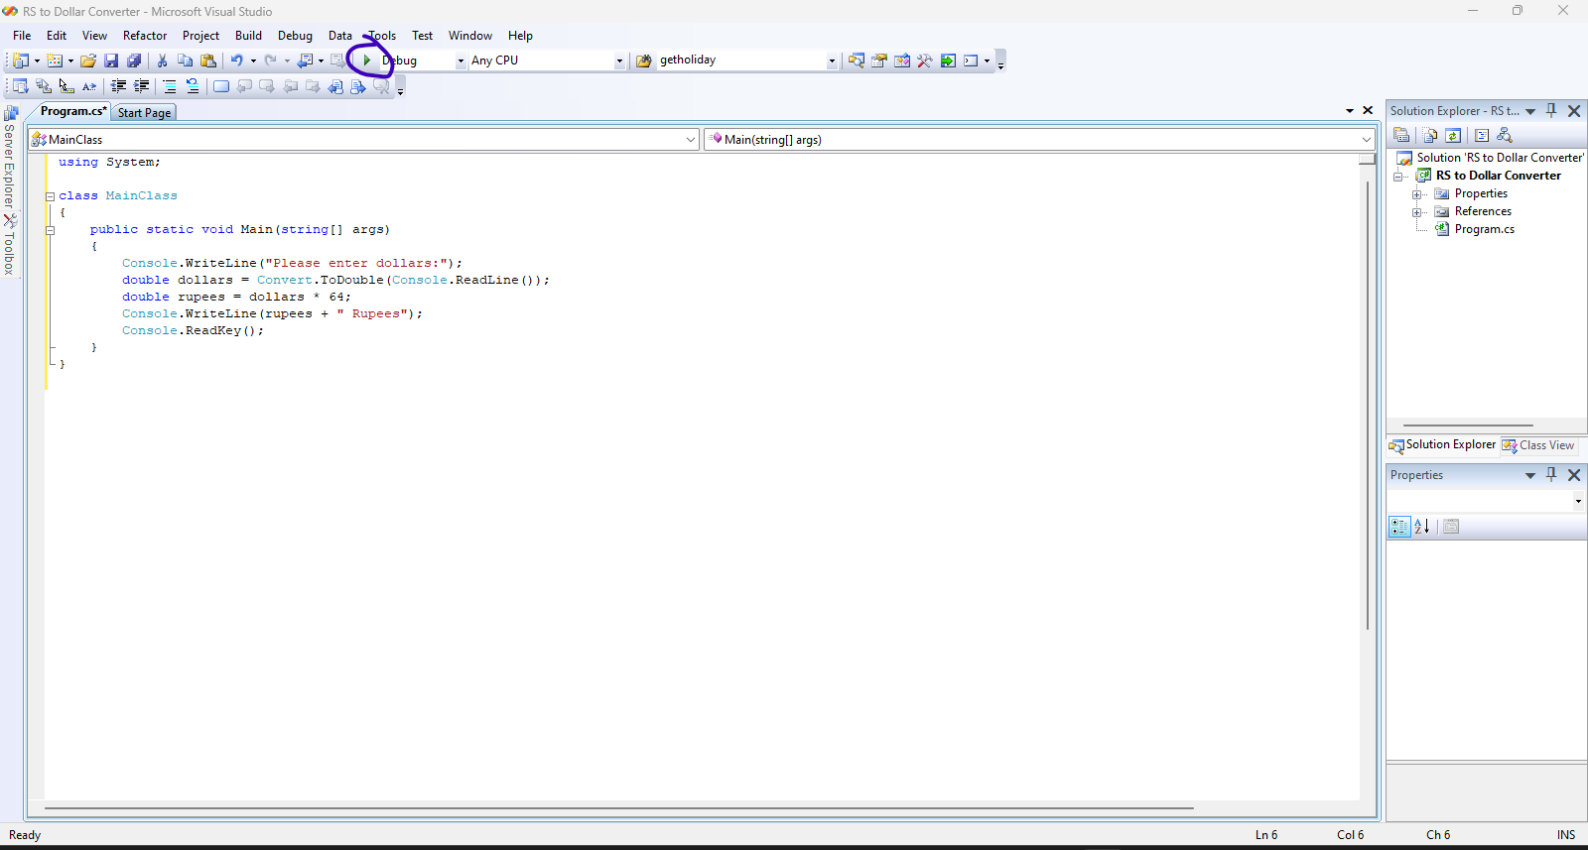

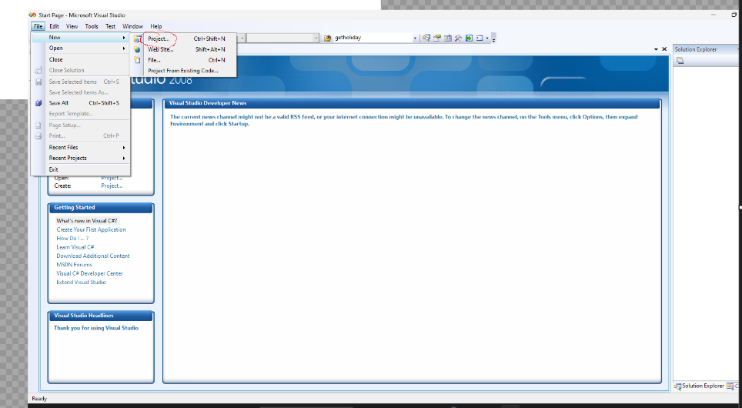

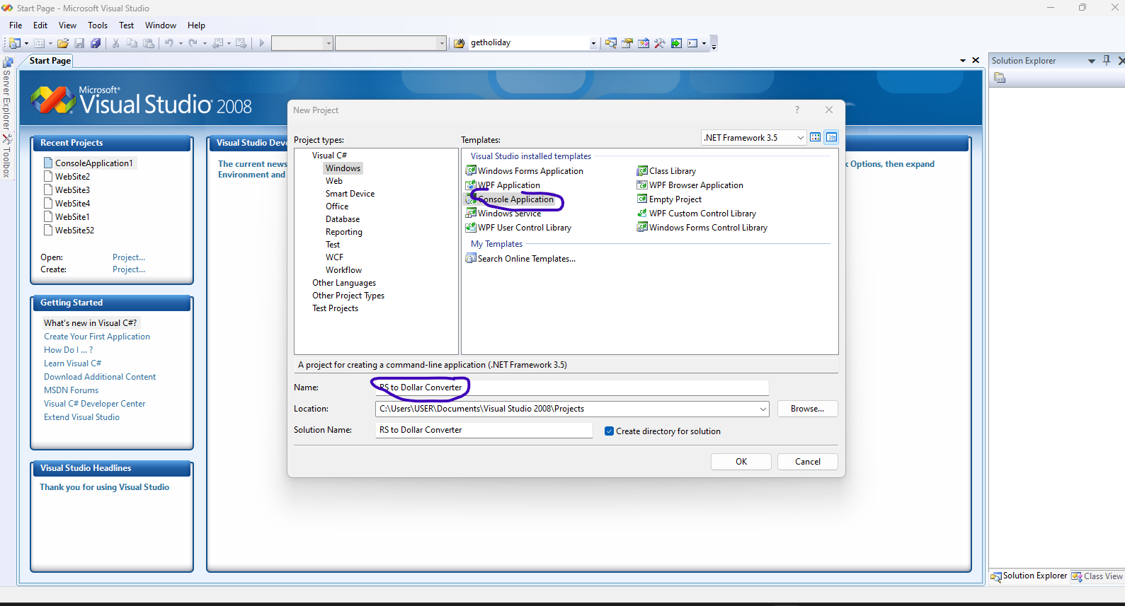

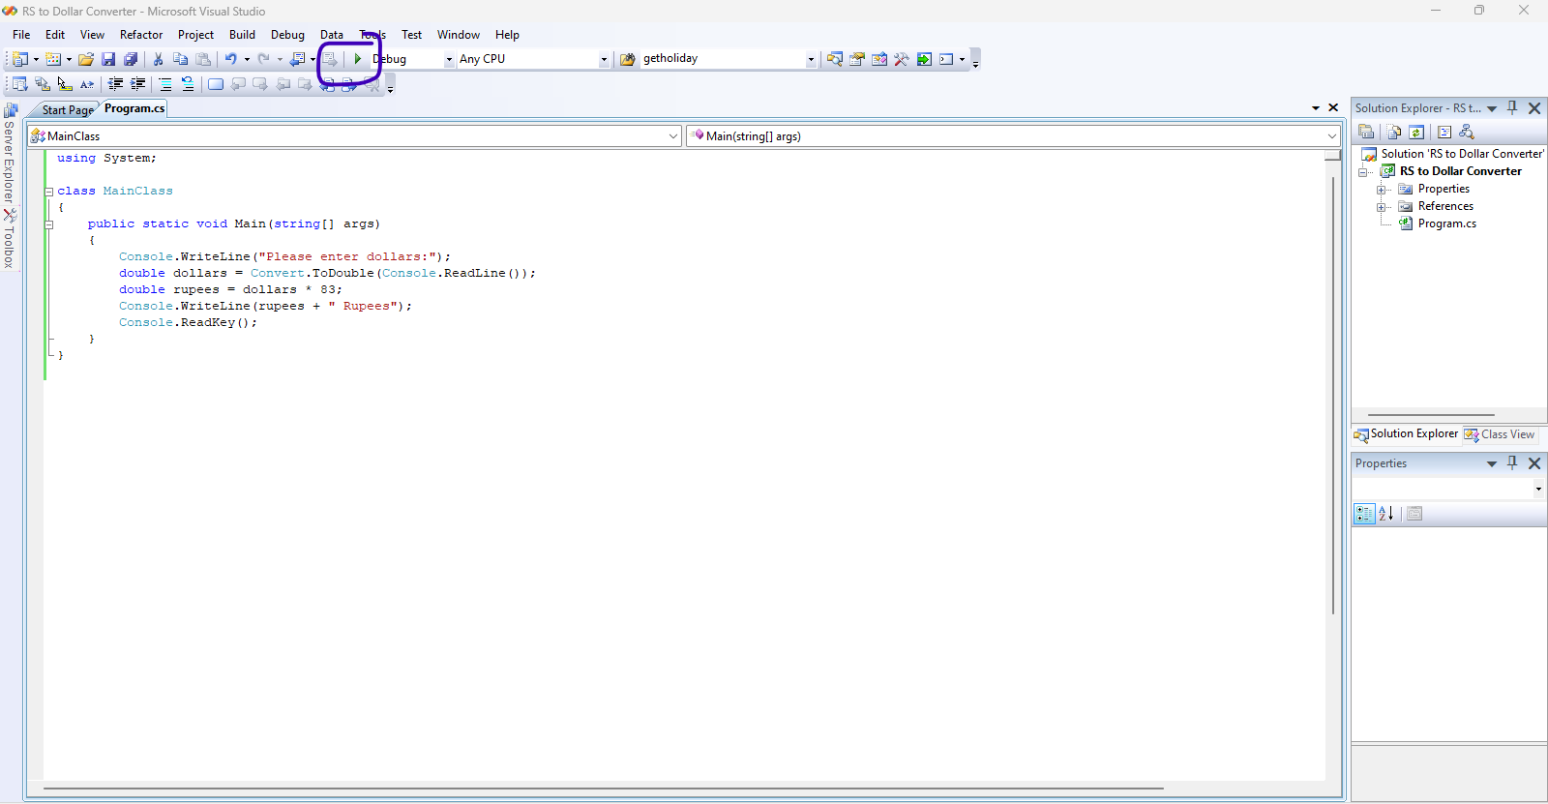

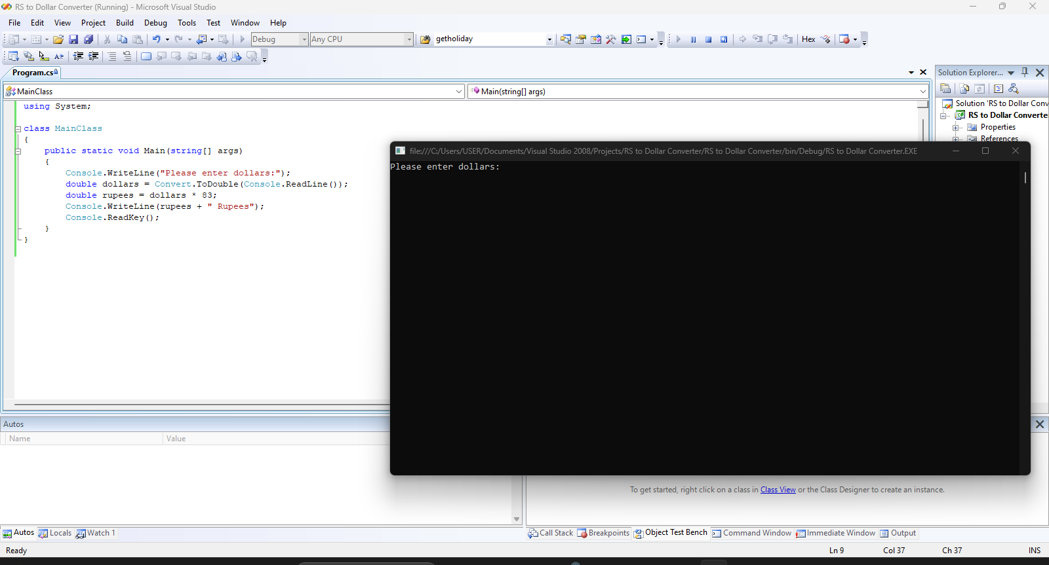

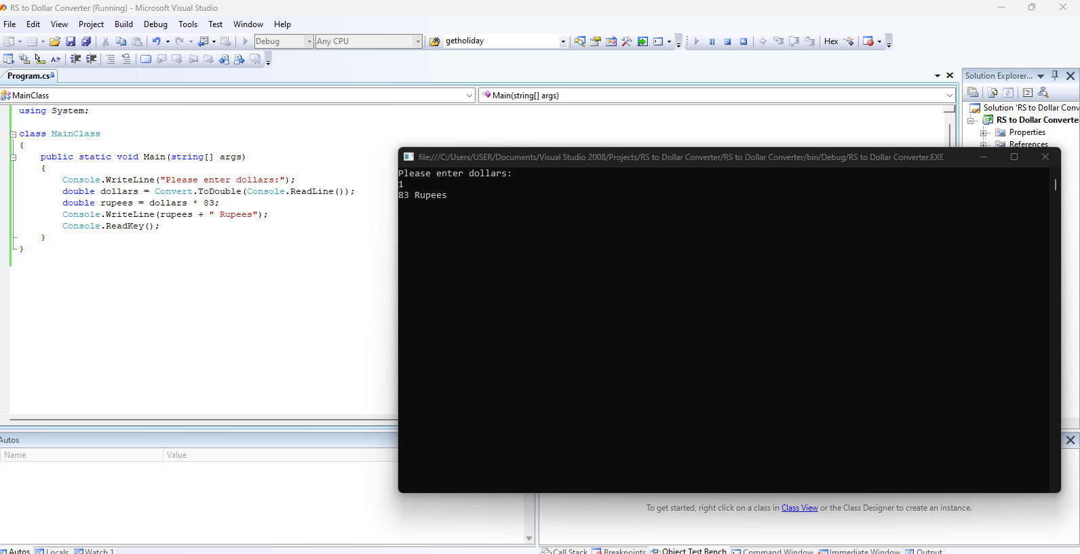

**Code:**

using System;

class MainClass

{

    public static void Main(string[] args)

    {

        Console.WriteLine("Please enter dollars:");

        double dollars = Convert.ToDouble(Console.ReadLine());

        double rupees = dollars * 83;

        Console.WriteLine(rupees + " Rupees");

        Console.ReadKey();

    }

}

2. Create a Simple SOAP service

**Step 1:** Download SOAP UI 5.2.0 Version and install on system

<https://www.soapui.org/downloads/soapui/soapui-os-older-versions/>

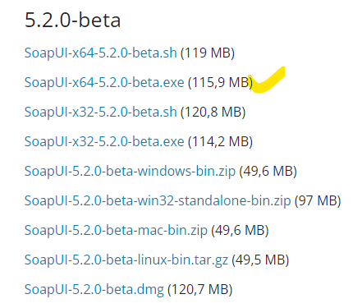

Step 1: Click on Create Soap Project

Step 2: paste the SOAP url of calculator

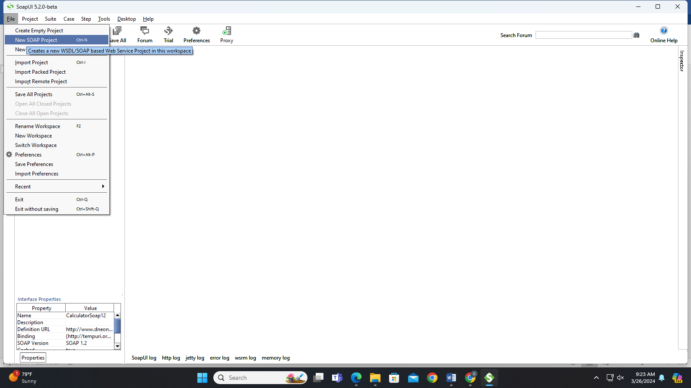

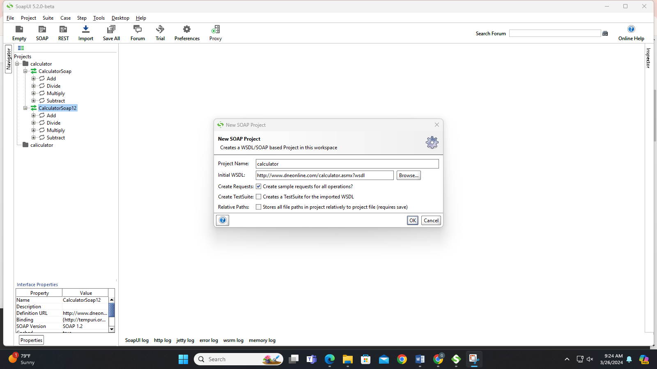

After importing the free SOAP WSDL url we got web services of calculator

Double clock on the service request to cross check the services are responding or not

Double click on ADD Request You will get below window

**Add:**

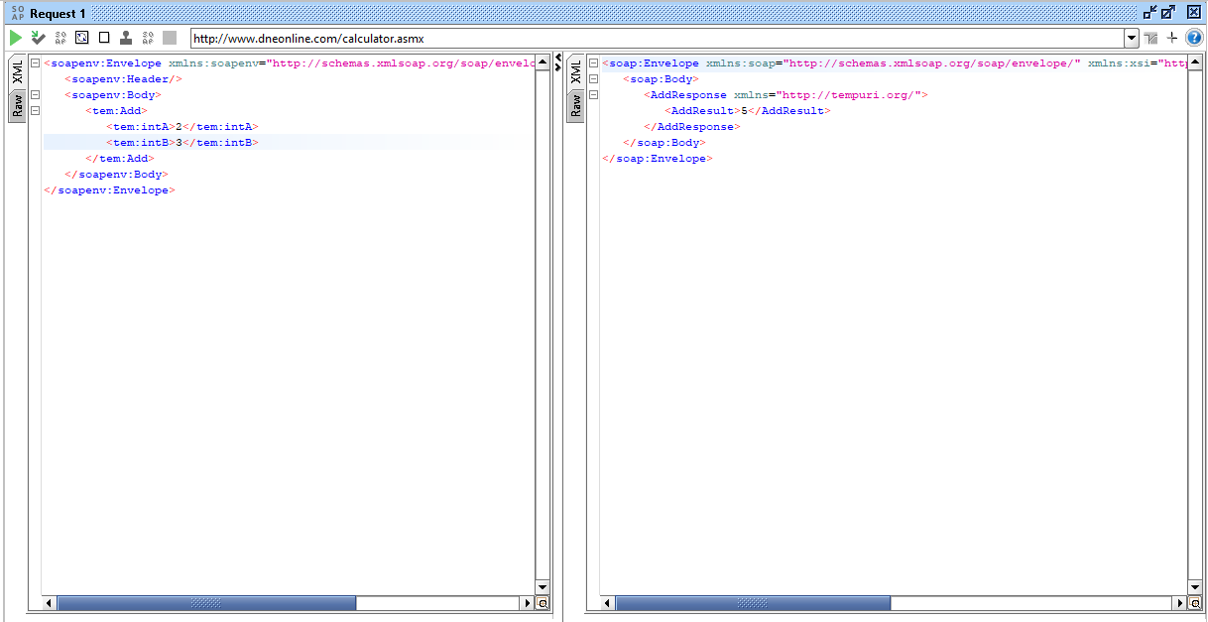

**Divide**

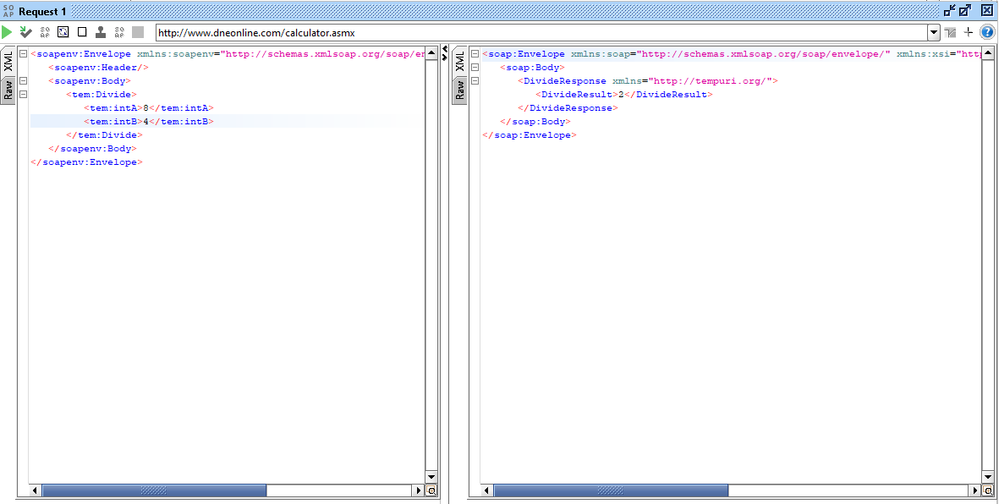

**Multiply:**

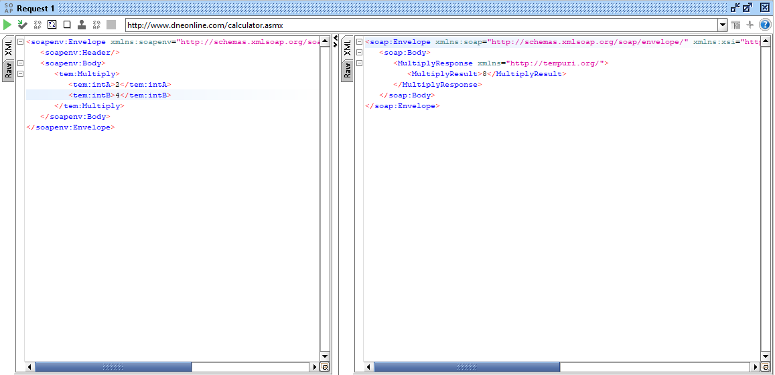

**Subtract:**

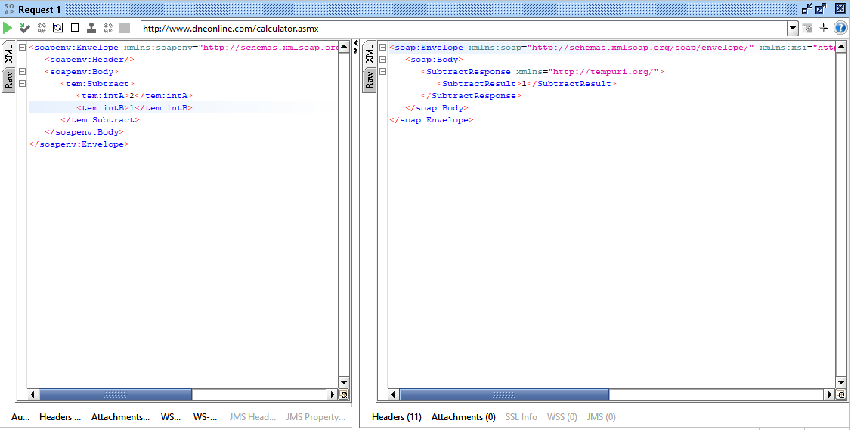

**Number Conversion:**

URL [https://www.dataaccess.com/webservicesserver/numberconversion.wso?WSDL](https://www.dataaccess.com/webservicesserver/numberconversion.wso?WSDL=)

This is another simple WSDL file which provides 2 services. A numeric which you input will be converted into its number name and dollar amount in words

**Number to dollars:**

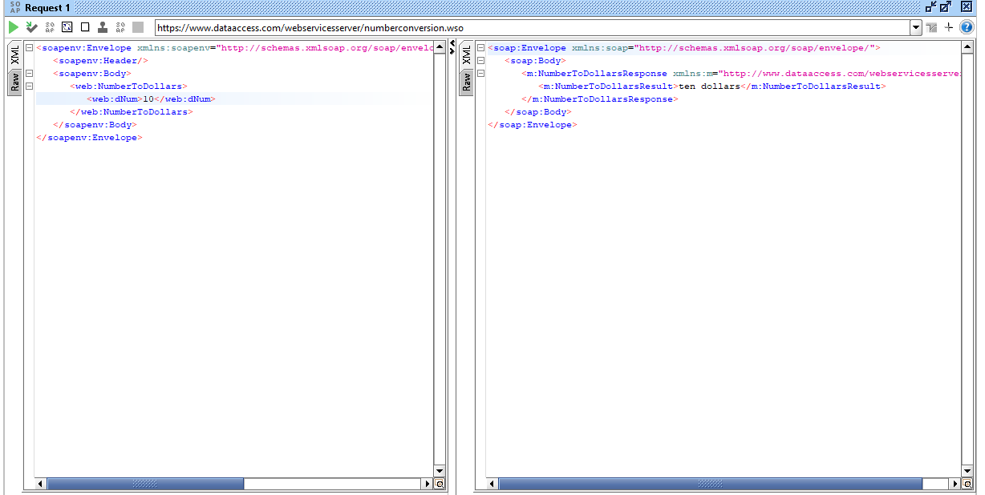

**Numbers to word:**

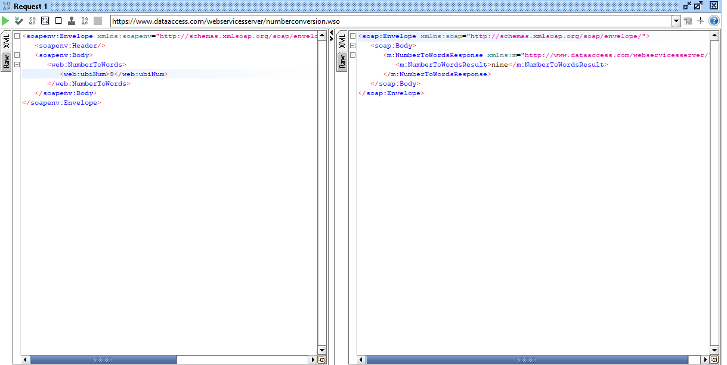

**3. Create a Simple REST Service**

[**https://www.omdbapi.com/**](https://www.omdbapi.com/)

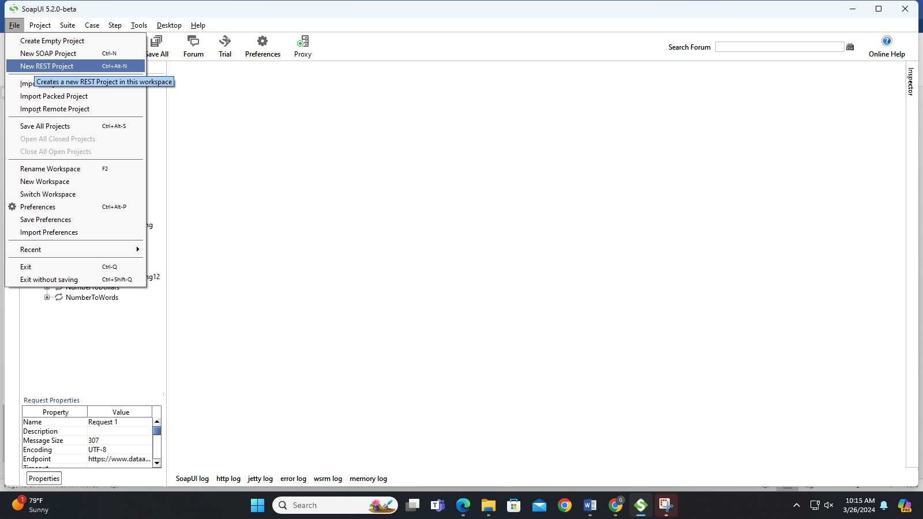

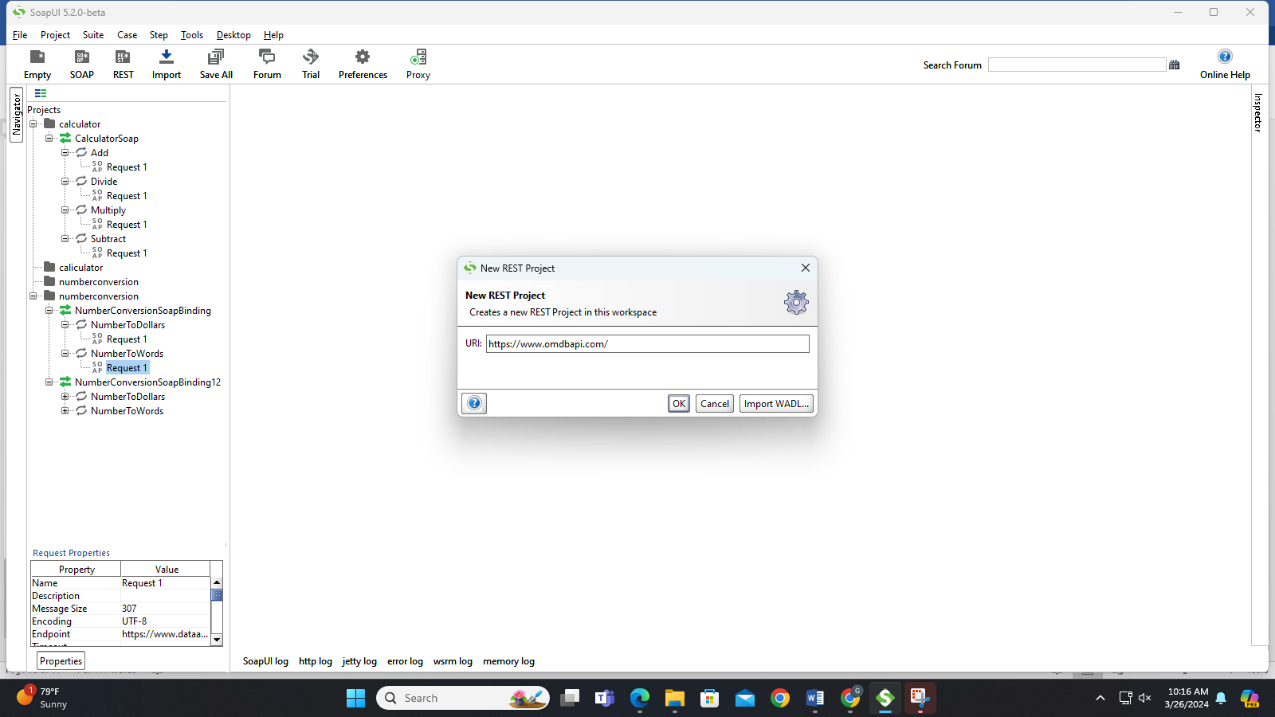

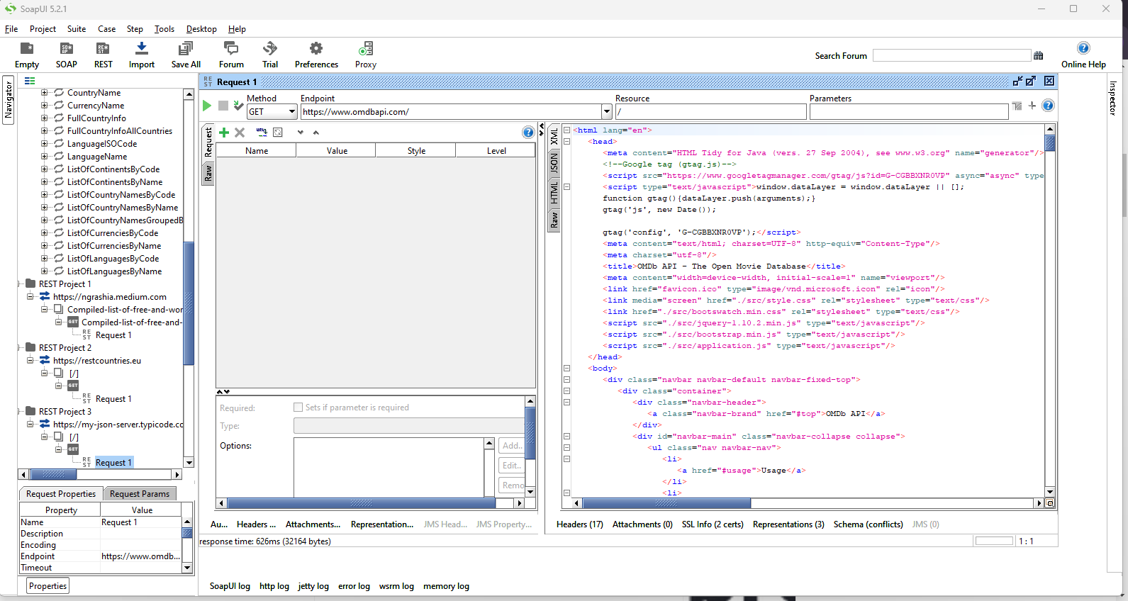

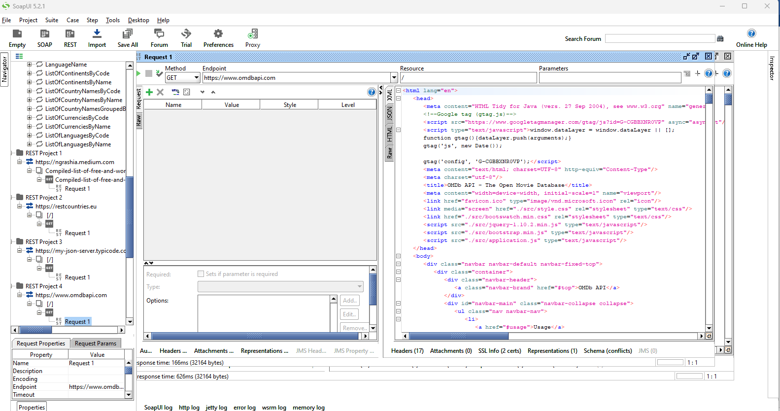

**5. Practical Installation and Configuration of virtualization using KVM.**

**1. LC_ALL=C lscpu | grep Virtualization**

**2. egrep -c '(vmx|svm)' /proc/cpuinfo**

**3. sudo apt update**

**4. sudo apt install qemu qemu-kvm virt-manager bridge-utils**

**5. sudo reboot**

**6. sudo adduser raitlibvirtd**

**7. sudo apt-get install qemu-kvm libvirt-daemon-system libvirt-clients**

**bridge-utils**

**8. sudo systemctl enable libvirtd.service**

**9. systemctl start libvirtd.service**

**10.sudo systemctl status libvirtd**

**11.sudo apt install virt-manager**

**12. sudo virt-manager**

**Note: Attach the screen shots In the documents**