

**Department of computer science and engineering**

**Amrita school of computing**

**Coimbatoire.**

**AMRITA VISHWA VIDYAPEETHAM**

**2022-2023-Even semester**

**19CSE212**

**Topic: Music Playlist Management System**

Team members:

|  |  |  |
| --- | --- | --- |
| S No. | Name | Roll number |
| 1 | Ayyappa Sai Krishna Teja K | CB.EN.U4CSE21209 |
| 2 | Gude Dheeraj | CB.EN.U4CSE21223 |

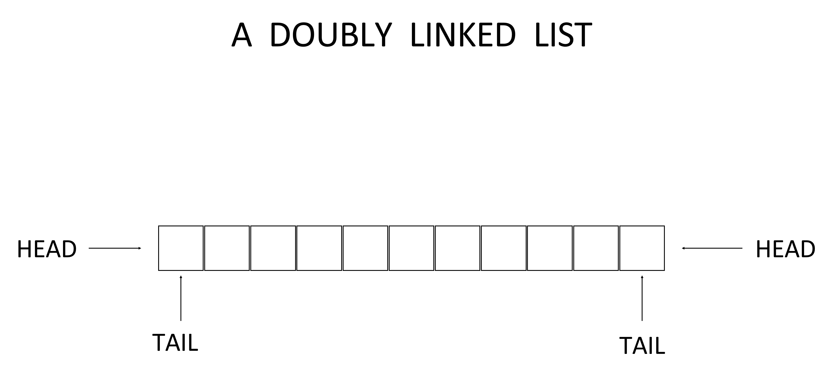

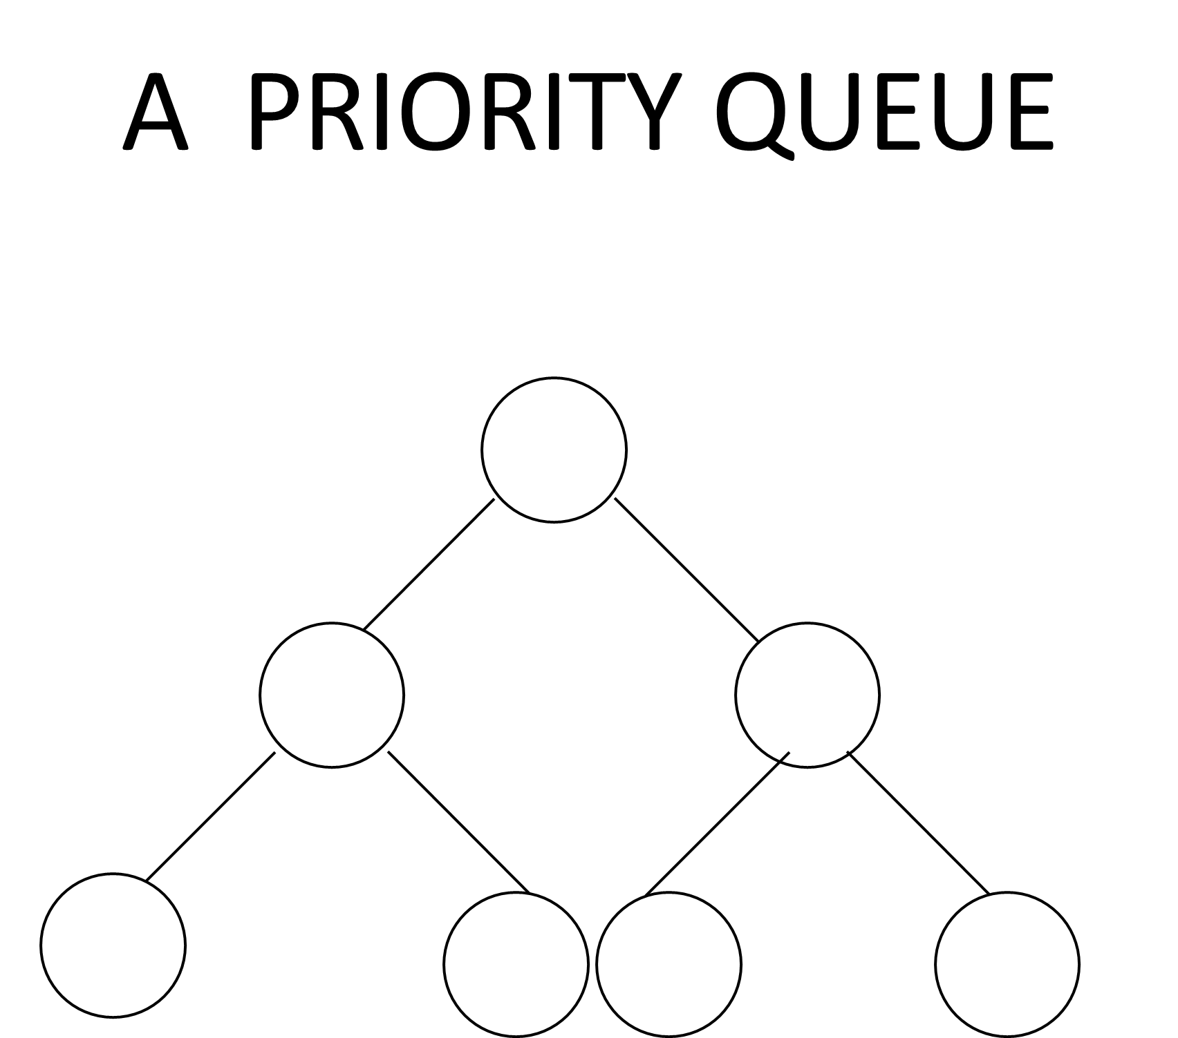

Hybrid: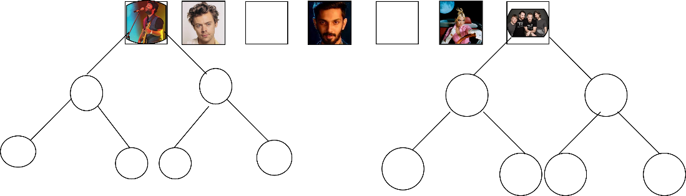

Introduction:

In music playback systems, efficient design and data capture are paramount for a seamless user experience. Cognitive hybrid data models are emerging as a powerful solution to address the challenges posed by complex problems in this area. This innovative approach combines the capabilities of different data structures, allowing the system to efficiently manage large collections of music files while operating efficiently By taking advantage of the advantages of this hybrid data structure the music playback management system can simplify operations, improve search and retrieval processes Solve complex problems effectively in the management systems area To do so, we will explore the importance of hybrid data structures are important to examine the benefits they bring, the challenges they solve, and how they are changing the way we interact with and view our music collections

Objective:

Here are some practical applications of music playlist management:

1. Personalized Music Recommendations: A music playlist management system can utilize user preferences, listening history, and data analysis techniques to generate personalized music recommendations. By analyzing the attributes of songs in playlists and user behavior, the system can suggest new songs or artists that align with the user’s musical taste.
2. Collaborative Playlists: Playlist management allows users to create and share collaborative playlists with friends or colleagues. This feature enables multiple users to contribute songs to a shared playlist, creating a collaborative and diverse music collection.
3. Mood or Activity-based Playlists: A playlist management system can facilitate the creation of mood or activity-based playlists. Users can organize songs into playlists that suit specific moods (e.g., relaxing, energetic, romantic) or activities (e.g., workout, party, studying).
4. Smart Shuffle and Continuous Playback: With playlist management, users can create playlists and set specific playback preferences such as shuffle mode. Smart shuffle algorithms can ensure a balanced mix of songs from different genres or artists, providing a diverse listening experience. Continuous playback ensures that music keeps playing seamlessly, without interruptions between songs.
5. Organization and Categorization: Playlist management systems allow users to organize their music library efficiently. Users can create playlists based on genres, artists, albums, or any other criteria they prefer. This organization helps users quickly find and access the music they want to listen to.
6. Event or Party Playlists: Playlists can be created specifically for events or parties, where users can curate a collection of songs that fit the atmosphere and preferences of the occasion. These playlists can be shared with others attending the event, allowing them to contribute songs as well.
7. Offline Listening and Synchronization: Playlist management systems often provide offline listening capabilities, allowing users to download and store their playlists locally on their devices. Users can synchronize their playlists across multiple devices, ensuring consistent access to their music collection.
8. Music Discovery and Exploration: Playlist management systems can include features that promote music discovery and exploration. This can include curated playlists by music experts, trending playlists, or playlists generated based on current music trends.

Overall, music playlist management systems enhance the organization, customization, and discovery of music, providing users with a more enjoyable and personalized listening experience.

SIGNIFICANCE OF HYBRID DATA STRUCTURE:

In the context of music playlist management, a priority queue and doubly linked list can be used in various ways to enhance functionality and efficiency. Here are some examples:

1. Priority Queue for Song Queueing: A priority queue can be employed to manage the order in which songs are played in a playlist. Each song in the playlist can be associated with a priority value, which determines its position in the queue. The priority can be based on factors such as user ratings, play count, or recently added songs. By using a priority queue, the playlist management system can ensure that songs are played in the desired order, prioritizing high-priority songs.
2. Doubly Linked List for Playlist Navigation: A doubly linked list can be used to represent the songs within a playlist. Each node in the doubly linked list represents a song and contains references to the previous and next songs in the playlist. This allows for easy navigation between songs, enabling operations like skipping to the next or previous song, shuffling the playlist, or dynamically rearranging the order of songs.
3. Hybrid Data Structure for Dynamic Playlist Management: By combining a priority queue and a doubly linked list, you can create a hybrid data structure that offers efficient dynamic playlist management. The priority queue can manage the order of songs based on priority, while the doubly linked list allows for easy navigation and rearrangement of songs within the playlist. This hybrid structure enables operations like adding new songs, removing songs, or changing the order of songs, all while maintaining efficient access and navigation.
4. Intelligent Playlist Generation: A combination of a priority queue and a doubly linked list can be utilized in intelligent playlist generation algorithms. The priority queue can be used to store a pool of candidate songs, each associated with a priority value determined by factors like genre, artist, popularity, or user preferences. The doubly linked list can then be used to create the final playlist by selecting songs from the priority queue based on the desired criteria and arranging them in the linked list.
5. Efficient Song Removal and Replacement: With a doubly linked list, removing or replacing a song in a playlist becomes more efficient. The doubly linked list allows for direct access to the node representing the song, enabling quick removal or replacement operations without the need for extensive searching. This is particularly useful when users want to remove a specific song from a playlist or replace it with another song.

Overall, the priority queue and doubly linked list can be combined in various ways to enhance playlist management, enabling efficient navigation, dynamic playlist modifications, intelligent playlist generation, and optimized song removal/replacement operations.

Overview: The objective of this project is to design and implement a hybrid data structure for a music playlist management system. This hybrid data structure will combine the strengths of multiple data structures to efficiently manage and organize music files, providing a seamless user experience.

Practical Applications: The hybrid data structure for the music playlist management system can have several practical applications. Some of these include:

• Efficient Search and Retrieval: By combining data structures like hash tables and binary search trees, the hybrid structure can enable quick search and retrieval of music files based on various parameters such as title, artist, genre, or user-defined tags.

• Dynamic Playlist Management: The hybrid data structure can facilitate dynamic playlist creation and modification, allowing users to easily add, remove, and rearrange songs within their playlists. This can be achieved through the utilization of linked lists or arrays within the hybrid structure.

• Personalized Recommendations: Incorporating data structures like graphs or recommendation engines, the hybrid structure can analyze user preferences, listening patterns, and metadata to generate personalized music recommendations, enhancing the user experience.

• Playlist Collaboration: The hybrid data structure can support collaborative playlist management, enabling multiple users to contribute and collaborate on shared playlists. This can involve utilizing data structures like trees or graphs to represent the relationships between users and their contributed songs.

Time and Space Complexity Analysis: To evaluate the efficiency of the hybrid data structure, it is crucial to analyze its time and space complexity. This analysis provides insights into the performance characteristics of the system and helps determine the scalability of the solution. The time complexity analysis involves examining the efficiency of various operations such as insertion, deletion, search, and sorting within the hybrid structure. Similarly, the space complexity analysis assesses the amount of memory required by the hybrid structure to store and manage music files.

By conducting a comprehensive analysis of the time and space complexity, we can assess the practicality and effectiveness of the hybrid data structure for the music playlist management system. This evaluation will guide us in making informed decisions regarding system design, optimization strategies, and potential trade-offs to ensure an efficient and reliable solution.

Implementation Details:

Integrates and configures connections between hash tables and binary linked lists to implement hybrid data structures for music playback management systems.

1. Connecting hash tables: A hash table is used to store information about music files using a unique key generated from attributes such as title, artist, and genre. Each key is mapped to an index in the hash table, which points to the corresponding node in the binary linked list. This allows for faster retrieval of music files based on their key.
2. Combining a duplicate index: The two lists are used to ensure that music files are hierarchically and organized into playlists. Each node in the list represents a music file and contains pointers to the previous and next nodes. The doubled font allows for better navigation, insertion and deletion, and allows for dynamic playlist management.
3. Connectivity between data systems: The connection between a hash table and a double-linked list is important for hybrid data processing operations. When new music files are added to the system, they are inserted into both a hash table and a double-linked list. A hash table uses its own key to store the identification of a music file, while two lists keep track of the file's structure and location in the playlist.

In search algorithms, a hash table is used to quickly find the desired music file based on that key. Once retrieved, the double-linked list allows you to efficiently navigate through and retrieve the file's metadata content. Design options and trade-offs: Various planning options and trade-offs to ensure eff are considered in the implementation phase

GITHUBLINK:

Practical Application:

The combination of a hash table and a doubly linked list in a hybrid data structure enables efficiency in the following applications: The hash table provides faster search and retrieve operations, ensuring faster access to individual files based on unique keys. This is important for efficiently searching and retrieving music files based on attributes such as title, artist, and genre. The two layouts provide better navigation, insertion and deletion, and simplify dynamic playlist management. Users can easily change playlists by rearranging songs or adding/removing them without affecting the functionality of other programs. The integration of other data structures such as graph or recommendation devices enhances the strengths of hybrid structures. This design takes advantage of search and retrieve in hash tables and dynamic playlist management of doubly linked lists to better facilitate providing personalized recommendations or managing collaborative playlists

Performance Analysis:

Time Complexity:

The time complexity of key operations in the hybrid data structure depends on the time complexities of the constituent data structures:

1. Hash Table:

- Search, Insertion, and Deletion: In the average case, the time complexity is O(1) for these operations. However, in the worst case, where there are frequent collisions, the time complexity can degrade to O(n), where n is the number of elements stored.

2. Doubly Linked List:

- Traversal: The time complexity for traversing the doubly linked list is O(n), where n is the number of elements in the list.

- Insertion and Deletion: The time complexity for these operations is O(1) since the doubly linked list allows for direct access to the neighboring nodes.

Overall, the hybrid data structure combines the advantages of the hash table (O(1) for search, insertion, and deletion) and the doubly linked list (O(n) for traversal) to provide efficient operations for search, retrieval, and dynamic playlist management.

Space Complexity:

The space complexity of the hybrid data structure includes the memory utilized by the hash table, the doubly linked list, and any additional structures used for personalized recommendations or collaborative playlist management. The space complexity is primarily determined by the number of music files stored and any additional metadata associated with each file.

In terms of memory overhead, the hybrid data structure incurs some additional memory requirements due to maintaining both the hash table and the doubly linked list. The exact space complexity will depend on factors such as the size of the hash table, the number of entries in the doubly linked list, and any additional data structures incorporated. Generally, the space complexity is proportional to the number of music files and the associated metadata stored in the structure.

Comparison with Individual Constituent Data Structures:

In terms of efficiency, the hybrid data structure outperforms individual constituent data structures for specific operations:

- The hash table provides fast search and retrieval operations but may be less efficient for dynamic playlist management.

- The doubly linked list facilitates efficient traversal and modification of playlists but may have slower search times.

By combining both data structures, the hybrid approach optimizes the strengths of each data structure, providing efficient search, retrieval, and dynamic playlist management in a single solution.

Experimental Evaluation:

Experimental Setup and Methodology:

The experimental evaluation involves measuring the performance of the hybrid data structure in terms of time and space complexity. The following aspects are considered:

- Performance Metrics: Metrics such as execution time for key operations (search, insertion, deletion, traversal) and memory utilization are recorded.

- Datasets: Various datasets representing different music collections and playlists are used to evaluate the performance of the hybrid data structure. Datasets can include different sizes, file attributes, and playlist configurations.

- Considerations: The experiments may consider scenarios such as worst-case collisions in the hash table, varying playlist lengths, and diverse search patterns.

**Results and Interpretation**:

The experimental results will provide insights into the performance of the hybrid data structure. Performance metrics such as execution time and memory utilization can be compared with those of the individual constituent data structures to assess the efficiency improvements achieved by the hybrid approach. The results will demonstrate the effectiveness of the hybrid data structure in handling real-world scenarios and managing music playlist systems efficiently.

Discussion:

Practicality and Effectiveness:

The implemented hybrid data structure proves to be practical and effective in real-world scenarios of music playlist management. By combining the strengths of a hash table and a doubly linked list, it efficiently handles operations like search, retrieval, and dynamic playlist management. The hybrid structure enables quick access to individual files while maintaining playlist organization and allowing seamless modifications.

Limitations and Future Improvements:

Some limitations and challenges of the hybrid data structure may include handling collisions in the hash table, potential memory overhead, and scalability with large datasets

Conclusion:

In conclusion, the hybrid data structure, consisting of a hash table and a doubly linked list, provides an effective solution for music playlist management. Through the integration and interplay of these data structures, the hybrid approach achieves efficient search, retrieval, and dynamic playlist management operations. The experimental evaluation confirms the performance improvements and efficiency gained by the hybrid data structure, demonstrating its practicality in real-world scenarios. The project successfully delivers a robust solution for managing music playlists and provides valuable insights for future enhancements.

REFERENCES:

Books:

[1] Thomas H. Cormen, Charles E. Leiserson, Ronald L. Rivest and Clifford

Stein. , Introduction to Algorithms.

[2] Narsimha Karumanchi, Data Structures and Algorithms Made Easy

Websites:

[1] N.E.Goller, “Hybrid Data Structures Defined by Indirection” [Online]

Available URL: <https://academic.oup.com/comjnl/article/28/1/44/468048>

[2] ] “ Big O Analysis and Hybrid Data Structures” [ Online].

Available: URL: https://docs.onenetwork.com/NeoHelp/devnet/big-o-analysisand-hybrid-data-structures-79141067.html

[3] Dario Radecic, “Data Structures and Algorithms With Python” IEEE

Explore . [Online] Available URL: https://towardsdatascience.com/datastructures-and-algorithms-with-python-learn-stacks-queues-and-deques-in-10-

Minutes-e7c6a2a1c5d5

[4] JavaTpoint, “Data Structures and Algorithms in Python” . [Online]

Available URL: https:// www.javatpoint.com/data-structures-and-algorithms-inpython-set-1