|  | | **Hope Foundation’s**  **Finolex Academy of Management and Technology, Ratnagiri** | | | | | | | | | |
| --- | --- | --- | --- | --- | --- | --- | --- | --- | --- | --- | --- |
| **Information Technology Department** | | | | | | | | | |
| Subject name: Cloud Compputing | | | | | | | | Subject Code: ITL803 | | | |
| Class | | BE IT | | Semester – VIII (CBGS) | | | | Academic year: 2022-23 | | | |
| Name of Student | |  | | | | | **QUIZ Score :** | | | | |
| Roll No | |  | | | Assignment/Experiment No. | | | | | 03 | |
| **Title:** Installation and Configuration of Ulteo to demonstrate on demand Application delivery over web browser to explore SaaS Environment. | | | | | | | | | | | |
|  | | | | | | | | | | | |
| **1. Course objectives applicable**  **COB1**. To make students familiar with key concepts of virtualization.  **COB4**. To make students familiar with various service models such as IaaS, SaaS, PaaS, Security as a Service (SECaaS) and Database as a Service. | | | | | | | | | | | |
| **2. Course outcomes applicable:**  **CO1**.Students will be able to understand the concept of virtualization.  **CO4 –**Students will be able to use Ulteo tool for learning various cloud computing services. | | | | | | | | | | | |
| **3. Learning Objectives:**   1. To study the different services using Ulteo cloud platform. 2. To learn installation of Ulteo 3. To study Ulteo dashboard 4. Explore the Ulteo tool and services provided by it. 5. Logon to the remote VMs 6. Monitor and configure remote resources | | | | | | | | | | | |
| **4. Practical applications of the assignment/experiment: Hypervisors are main components of Cloud Implementation** | | | | | | | | | | | |
| **5. Prerequisites**:   1. Knowledge of Openstack 2. Internet Access 3. Knowledge of CIDR, IP Addressing | | | | | | | | | | | |
| **6. Hardware Requirements**:   1. Internet Access with Browser 2. Access to Ulteo IT Services   **7. Software Requirements:**  Browser like Chrome, Internet Explorer Edge | | | | | | | | | | | |
|  | | | | | | | | | | | |
| **8. Quiz Questions (if any): (Online Exam will be taken separately batchwise, attach the certificate/ Marks obtained)**   1. What is Ulteo? 2. List Sevices provided by Ulteo? 3. Which verson of Openstack is under development now? | | | | | | | | | | | |
|  | | | | | | | | | | | |
| **9. Experiment/Assignment Evaluation:** | | | | | | | | | | | |
| **Sr. No.** | **Parameters** | | | | | | | | **Marks obtained** | | **Out of** |
| **1** | Technical Understanding (Assessment may be done based on Q & A **or** any other relevant method.) Teacher should mention the other method used - | | | | | | | |  | | 6 |
| **2** | Neatness/presentation | | | | | | | |  | | 2 |
| **3** | Punctuality | | | | | | | |  | | 2 |
| **Date of performance (DOP)** | | |  | | | **Total marks obtained** | | |  | | **10** |
| **Date of checking (DOC)** | | |  | | | **Signature of teacher** | | | | | |

**10. Theory:**

Ulteo is an open source Virtual Desktop infrastructure project that can deliver various operating systems deskops - including Windows and Linux desktops or applications - to end usersThe Open Virtual Desktop allows corporates to deploy virtualized GNU/Linux and/or Windows desktops. Parts of Ulteo products are based on Debian and Ubuntu. Ulteo Open Virtual Desktop is an open source alternative to Citrix and VMWare solutions.

The steps for installation and configuration of Ulteo are given as follows

Step 1: Install Ulteo through DVD or Open Ulteo OVF file in Vmware player by selecting import VM button

1. If you haven't an Ulteo OVD DVD-ROM yet, please download the corresponding ISO file from this place at [www.ulteo.com](http://www.ulteo.com/) and burn it to a fresh DVD.
2. Insert the Ulteo OVD DVD-ROM into your computer and restart it. If you selected the DVD- ROM as first boot device you'll see the boot loader Screen.
3. Select Install Ulteo Option
4. The first step is used to select the system language. Choose your language from the list and click on Forward.
5. In the second step, the system asks you to define your location. Either select a point on the map or choose one from the Selected city form and click on Forward.
6. The third step is used to define the keyboard layout. Select yours and click on Forward.
7. Then, you have to select the partitioning method. We suggest the automatic method: Erase and use the entire disk.
8. These questions are about the installed operating system itself, user login and password used to access the OS, along with the hostname of the machine.
9. Type a password and confirm it. Useful address is displayed to you for a near future use of OVD.
10. Then read carefully the installation summary, then click on Install and wait til installation completes
11. Finally, click on Restart now to finish installation process. Step 2: In Management machine Open following URLs https://Ulteo-Server-ipaddress/ovd for Client access https://Ulteo-Server-ipaddress/admin for Admin access

Step 3: Login on Admin portal specify Username and Password as Admin

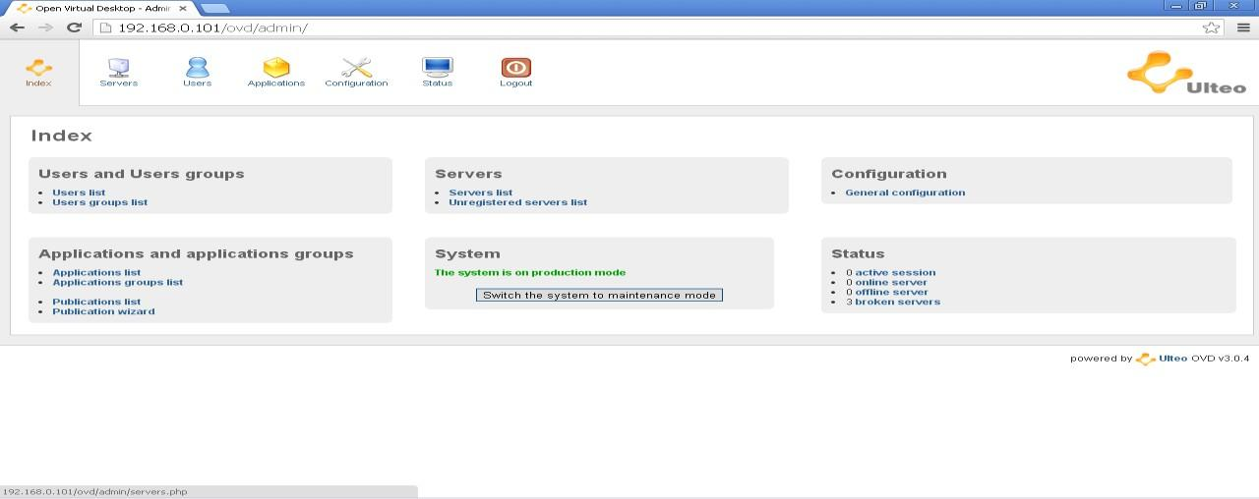

Under server tab Register server, Click on manage to add ip address of Ulteo Server

* 1. Go to user tab to add multiple users
  2. Go to User tab then select user group then create a new user group and add users in to them
  3. Go to Application Tab to Create Application Group



Map User group with Application group And use the services at client side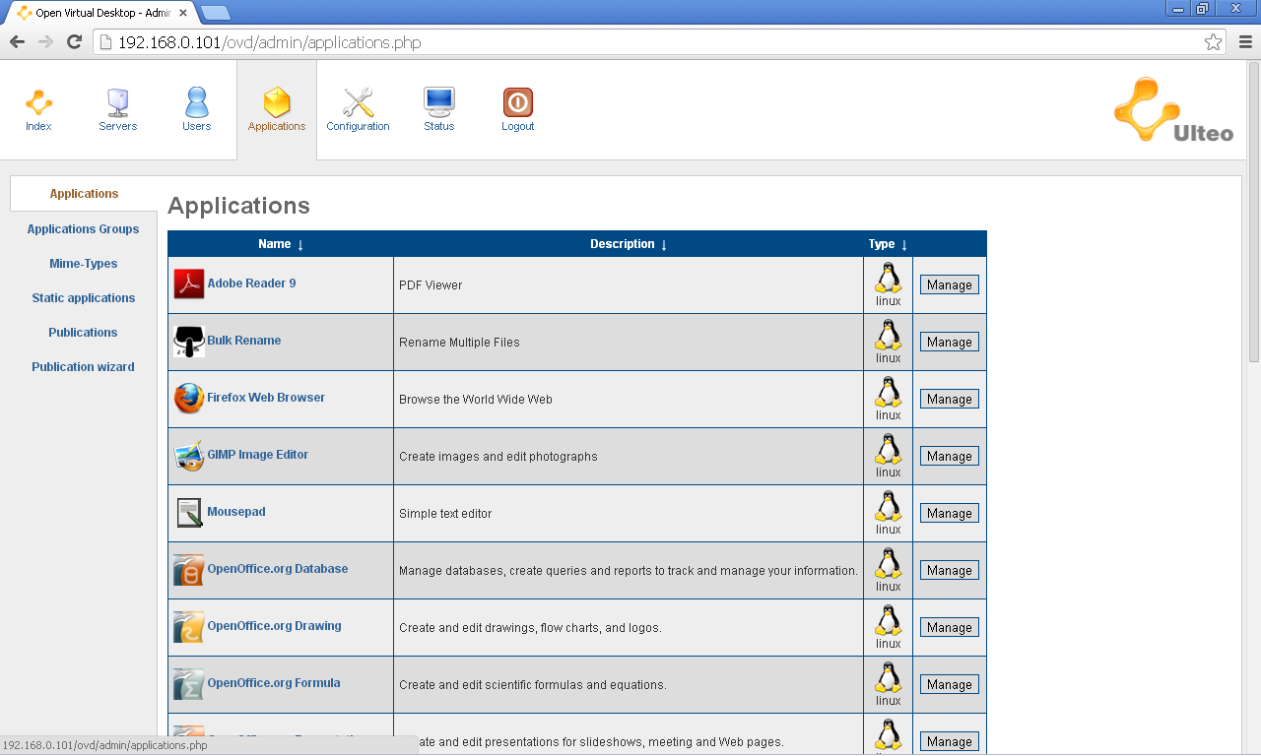

The Administrator panel is limited to Administrator who can manage Applications, users and groups. Once admin logged in to this portal, he can create users, user groups, Application groups maps users to User group and Application group, manages applications or installs softwares based on users requirement Shown in figure 5.11.



.

Ulteo Administrator panel

The Application menu of admin panel shows available applications which can be mapped to users or user groups Shown in



.

Ulteo Application Menu

Step 4: At client side open [https://Ulteo-Server-ipaddress/ovd](https://ulteo-server-ipaddress/ovd) for Client access,Specify Username and Password and Access the softwares added in Application group

Once user selects Access Ulteo option it shows login page of Ulteo session manager shown below. The user can get login name and password by filling Registration form through main page of cloud portal Shown below.

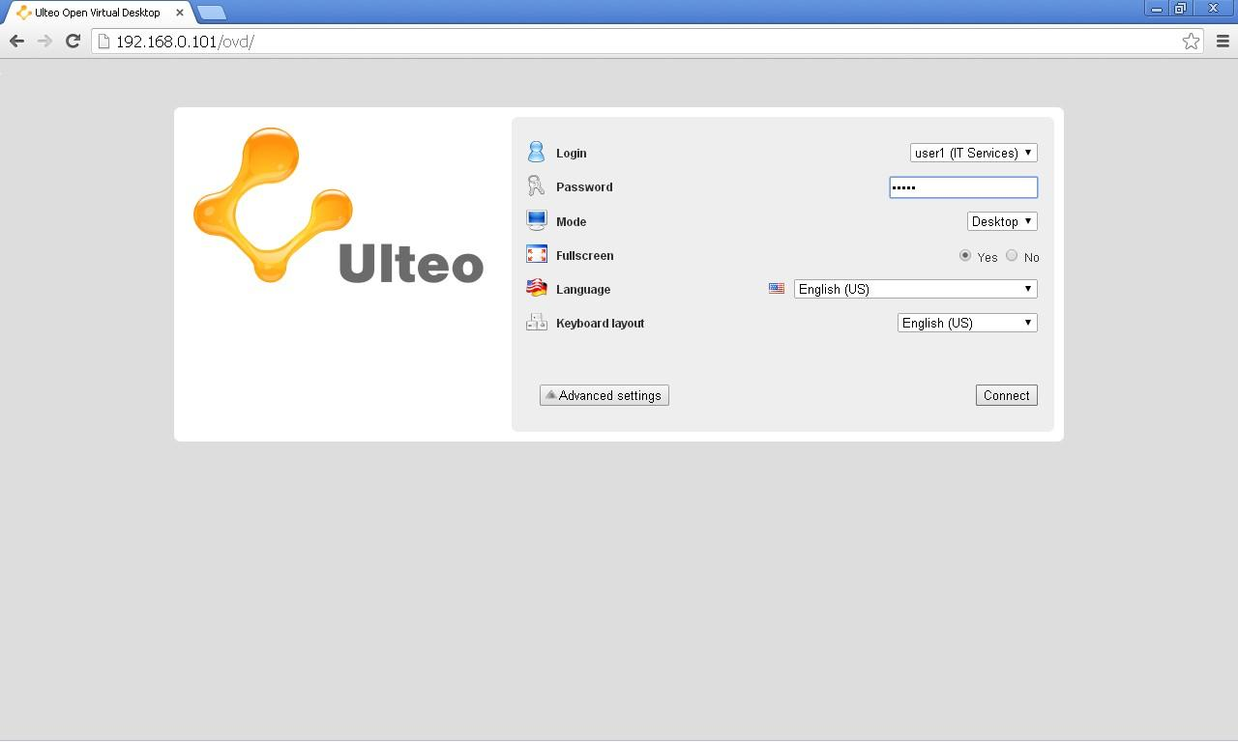

.

Ulteo user Login Portal

Once user is validated he can access the services using portal mode or Desktop mode. Both the modes give access to software applications which are installed on Linux Application Server and Windows Application Server. In portal mode the user get applications in vertical pane Shown in figure 5.9.



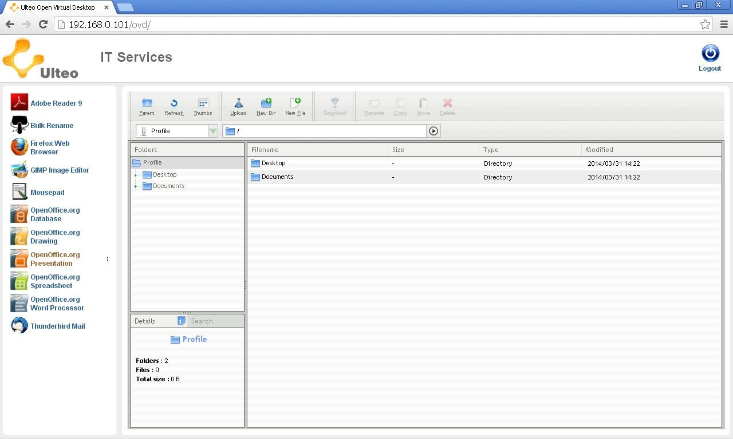

Ulteo Portal mode

While in Desktop mode use gets full flagged Linux desktop running on browser with selected Applications Shown in

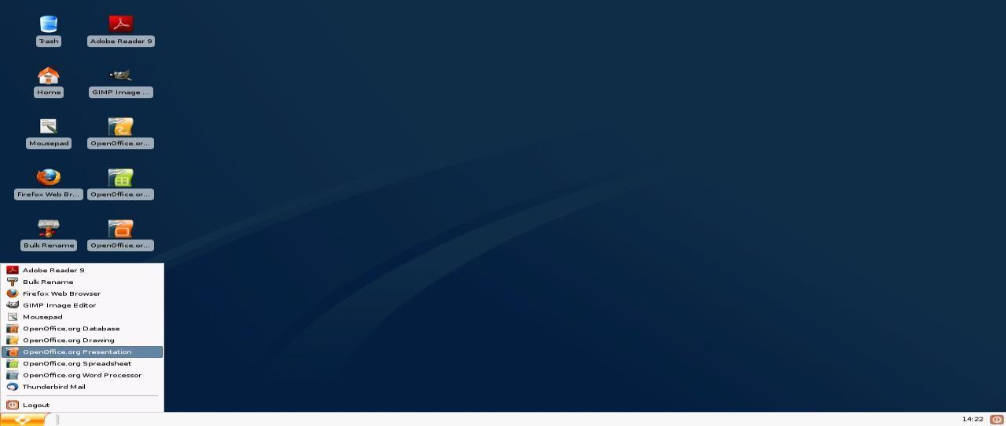

Ulteo Desktop Mode

**14. Learning Outcomes Achieved**

1. Openstack was used as cloud orchestration software
2. Students created VMs using Openstack Dashboard
3. VMs were successfully deployed and IP addresses were assigned
4. SDN with one router with public IP and 3 VMs network was created
5. Remote VM access was made using console
6. Overall instance monitoring and configuration was done using dashboard

**15. Conclusion:**

1. **Applications of the studied technique in industry**
   1. As an integral part of IaaS at Enterprise level
   2. Main technology for cloud orchestration
2. **Engineering Relevance** 
   1. Openstack is one of the widely used software for setup of Private clouds and cloud management
   2. Openstack is Open source software with large community support
3. **Skills Developed**
   1. Using Openstack Dashboard for performance monitoring and VM configuration
   2. SDN Creation and access

**References** :

[1] Ocata Release Notes — OpenStack". Wiki.openstack.org. Retrieved 22 February 2017.

Jump up ^ "ReleaseAnnouncement/Ocata — OpenStack". www.openstack.org. Retrieved 22 February 2017.

[2] "OpenStack Open Source Cloud Computing Software". Retrieved 29 November 2013.

[3] "OpenStack Launches as Independent Foundation, Begins Work Protecting, Empowering and Promoting OpenStack". BusinessWire. 19 September 2012. Retrieved 7 January 2013.