|  |  |  |  |  |  |  |  |  |  |  |  |
| --- | --- | --- | --- | --- | --- | --- | --- | --- | --- | --- | --- |
|  | | **Hope Foundation’s**  **Finolex Academy of Management and Technology, Ratnagiri** | | | | | | | | | |
| **Information Technology Department** | | | | | | | | | |
| Subject name: Cloud Computing | | | | | | | | Subject Code: ITL803 | | | |
| Class | | BE IT | | Semester – VIII (CBGS) | | | | Academic year: 2022-23 | | | |
| Name of Student | |  | | | | | **QUIZ Score :** | | | | |
| Roll No | |  | | | Assignment/Experiment No. | | | | | 04 | |
| **Title:**  To demonstrate installation and Configuration of Open stack Private cloud. | | | | | | | | | | | |
|  | | | | | | | | | | | |
| **1. Course objectives applicable**  **COB1**. To make students familiar with key concepts of architecture of open stack.  **COB4**. To make students familiar with various implementations of open stack for cloud computing. | | | | | | | | | | | |
| **2. Course outcomes applicable:**  **CO1**.Students will be able to understand the concept of open stack architecture.  **CO4 –**Students will be able to learn open stack architecture use for cloud implementation. | | | | | | | | | | | |
| **3. Learning Objectives:**   1. To study the architecture of open stack. 2. To learn installation steps of open stack. 3. To study implementation of instances using open stack. 4. Explore the steps of open stack architecture. 5. Logon to the remote VMs. 6. Monitor and configure remote resources. | | | | | | | | | | | |
| **4. Practical applications of the assignment/experiment: Open stack architecture.** | | | | | | | | | | | |
| **5. Prerequisites**:   1. Knowledge of Openstack 2. Internet Access 3. Knowledge of CIDR, IP Addressing | | | | | | | | | | | |
| **6. Hardware Requirements**:   1. Internet Access with Browse 2. Fedora or Linux   **7. Software Requirements:**  Browser like Chrome, Internet Explorer Edge | | | | | | | | | | | |
|  | | | | | | | | | | | |
| **8. Quiz Questions (if any): (Online Exam will be taken separately batchwise, attach the certificate/ Marks obtained)**   1. What is Open stack? 2. List steps to install open stack? 3. Which version of Openstack is under development now? | | | | | | | | | | | |
|  | | | | | | | | | | | |
| **9. Experiment/Assignment Evaluation:** | | | | | | | | | | | |
| **Sr. No.** | **Parameters** | | | | | | | | **Marks obtained** | | **Out of** |
| **1** | Technical Understanding (Assessment may be done based on Q & A **or** any other relevant method.) Teacher should mention the other method used - | | | | | | | |  | | 6 |
| **2** | Neatness/presentation | | | | | | | |  | | 2 |
| **3** | Punctuality | | | | | | | |  | | 2 |
| **Date of performance (DOP)** | | |  | | | **Total marks obtained** | | |  | | **10** |
| **Date of checking (DOC)** | | |  | | | **Signature of teacher** | | | | | |

**10. Theory:**

The OpenStack installation can be done using many ways like RDO Pack stack, Mirantis or Devstack who have series of shell scripts which carries automated installation of OpenStack. The DevStack is a series of extensible scripts used to quickly bring up a complete OpenStack environment based on the latest versions of everything from git master.

To install OpenStack using Devstack the Prerequisites are Intel or AMD Multicore CPU, Minimum 6-8GB RAM, 250 GB Hard disk and preinstalled Ubuntu server/Desktop Operating system version 16.04 or above and internet speed should be minimum 4 MBPS. (The installation steps can be found at https://docs.openstack.org/devstack/latest/)

The steps for installing Openstack using Devstack in a single server (All in one Single machine setup) are given as follows

# Step 1-: Update the ubuntu repository and install git package

The current version of Ubuntu OpenStack is Newton. So, that’s what we are going to install. To begin with the installation, first, we need to use the git command to clone devstack.

$sudo apt-get update

$sudo apt-get install git

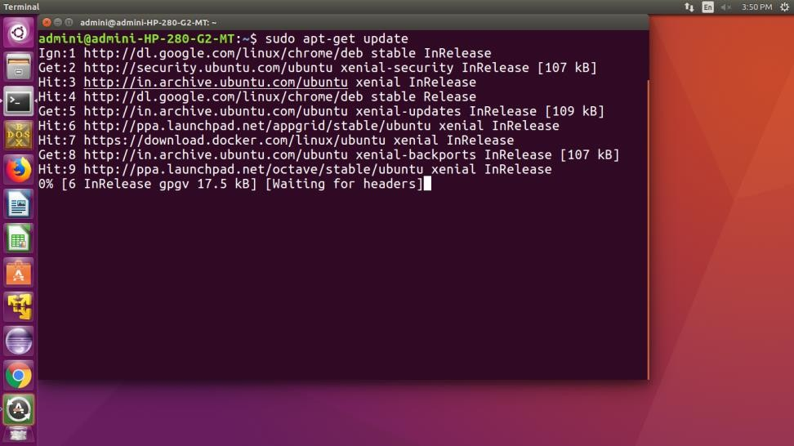

# Step 2 -: Download the latest git repository for openstack

$ git clone https://git.openstack.org/openstack-dev/devstack

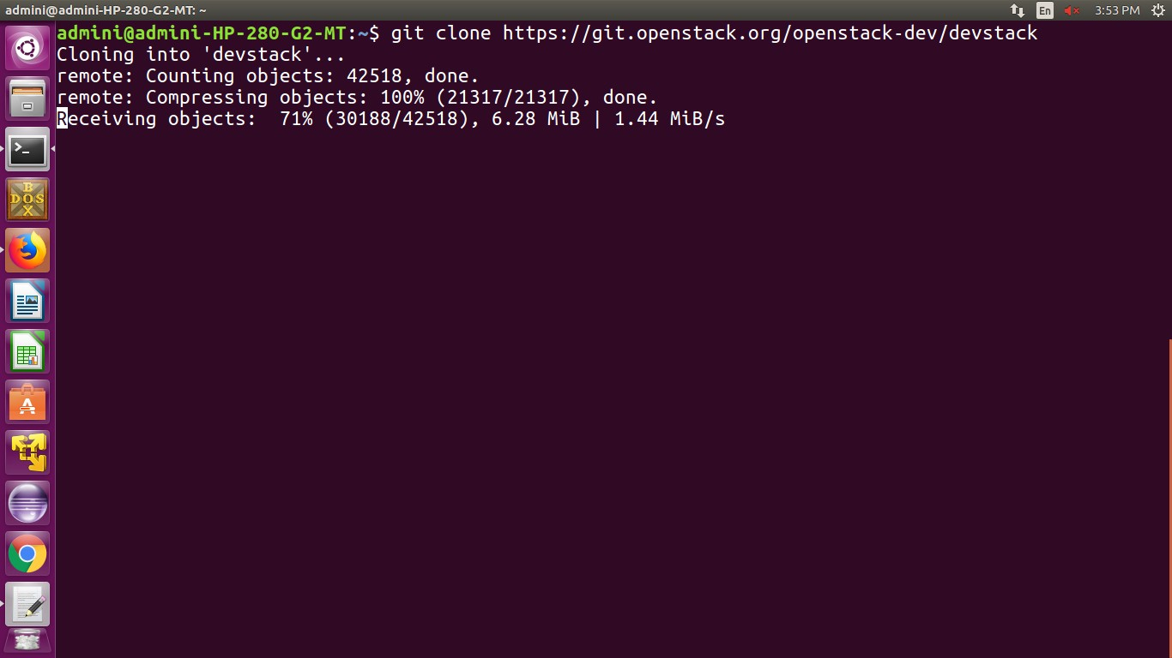

# Step 3-: Open Devstack directory and start installation by executing stack.sh shell script

$cd Devstack

$./stack.sh

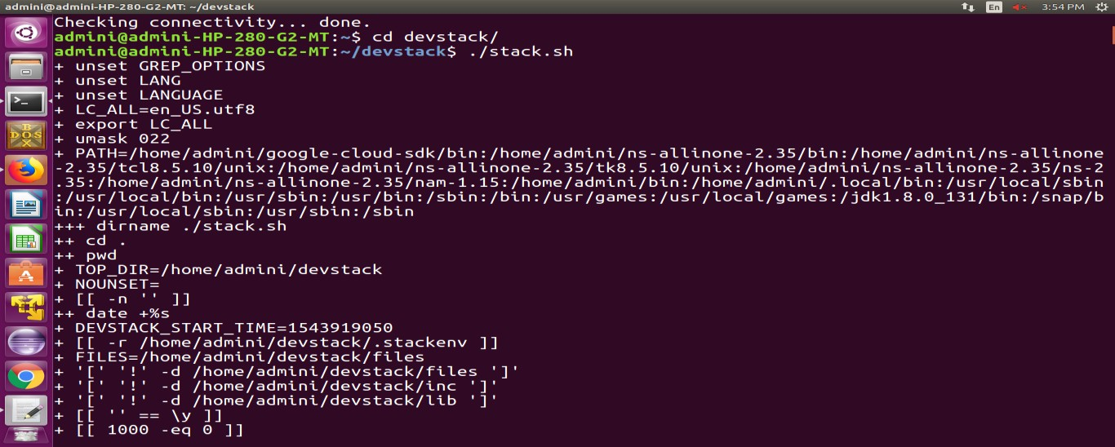

At the initial stage, the installer will ask passwords for database, rabbit, service authentication, horizon and keystone.

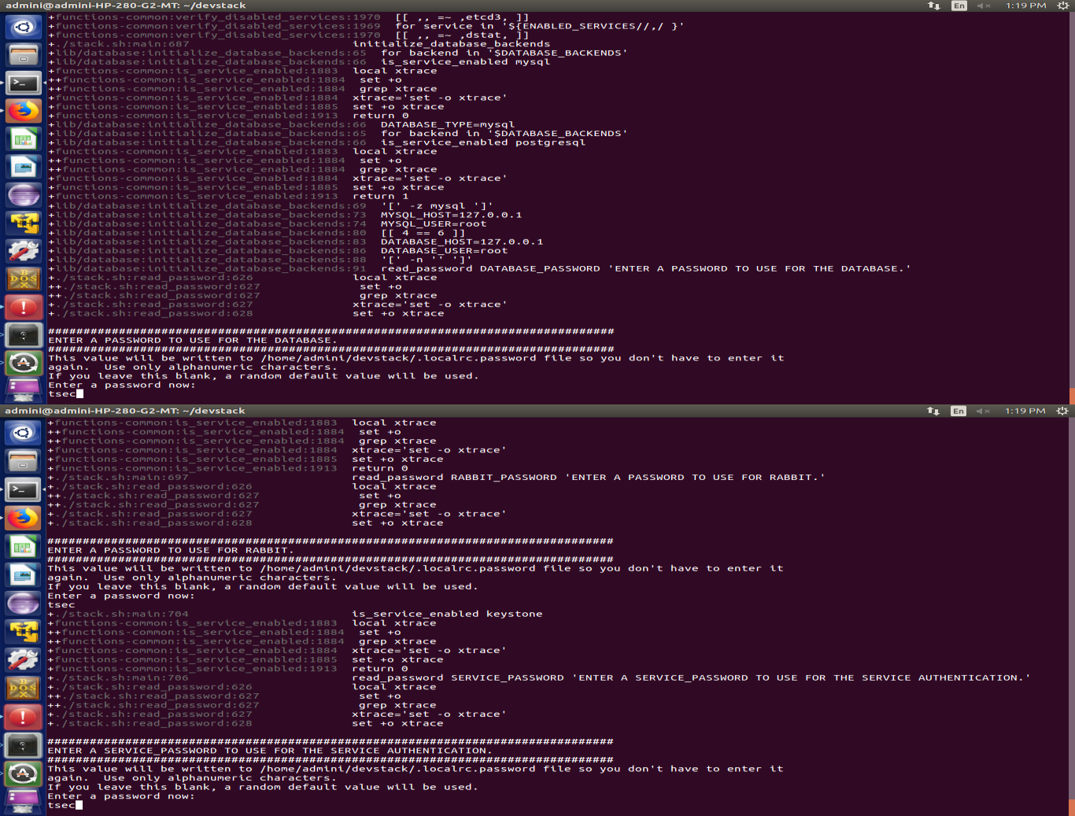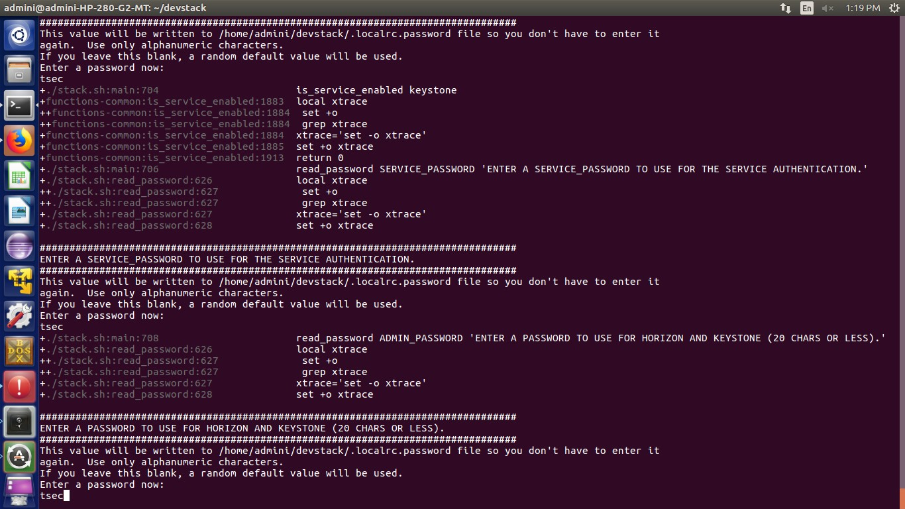

The installer may take up to 30 minutes to complete the installation depends on the internet bandwidth. Once installation is done you may see the following screen which displays ip address of dashboard i.e. horizon through which you can gain access to open stack VMs and resources

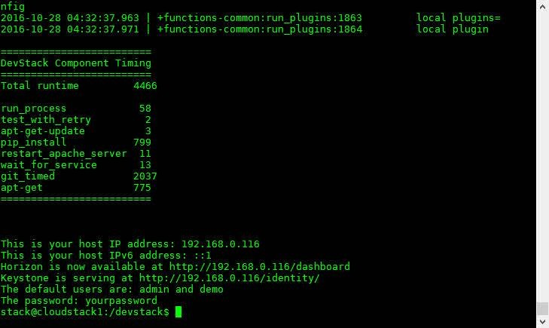

As you can see, two users have been created for you; admin and demo. Your password is the password you set earlier. These are the usernames you will use to login to the OpenStack Horizon Dashboard.

Open up a **browser**, and put the **Horizon Dashboard address** in your address bar. [http://*192.168.0.116*/dashboard](http://192.168.0.116/dashboard) you should see a **login page** like this.

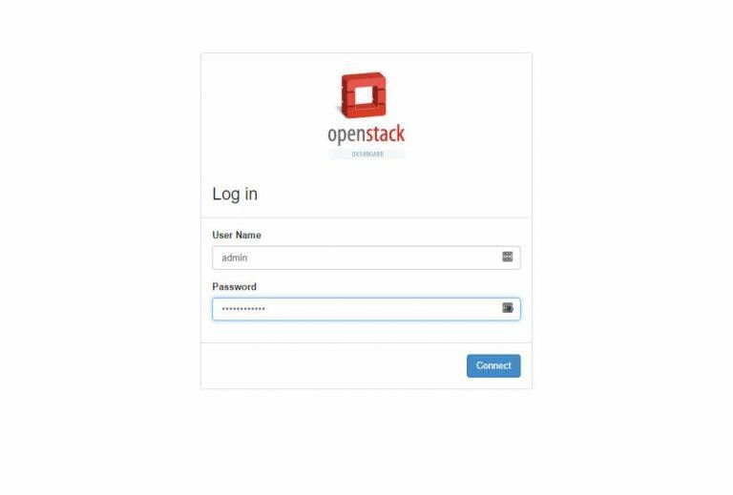

To start with, log in with the admin users credentials. In admin panel, you will need to use the demo user, or create a new user, to create and deploy [instances.](http://www.techsupportpk.com/2016/12/configuring-openstack-network-settings.html) As you can see, two users have been created for you; admin and demo. Your password is the password you set earlier. These are the usernames you will use to login to the OpenStack Horizon Dashboard. Take note of the Horizon web address listed in your terminal.

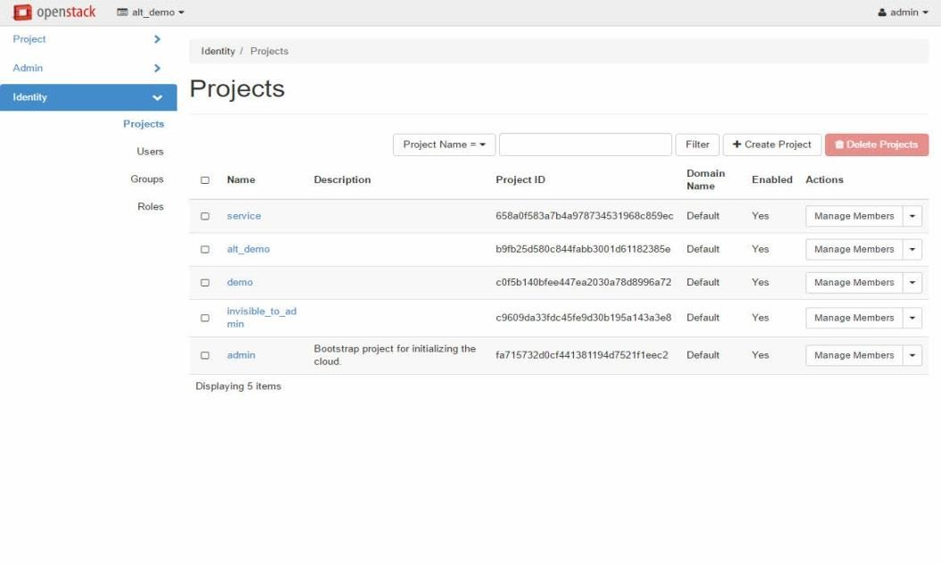

# Creating and running Instances

To launch an instance from OpenStack dashboard, first we need to finish following steps:

* Create a Project and add a member to the Project.
* Create Image and Flavor
* Create Network for the Project.
* Create Router for the Project.
* Create a Key pair

# Create a Project and add a member to the Project.

Login to the dashboard using Admin credentials and Go to **Identity Tab –> Projects and Click on Create Project.**

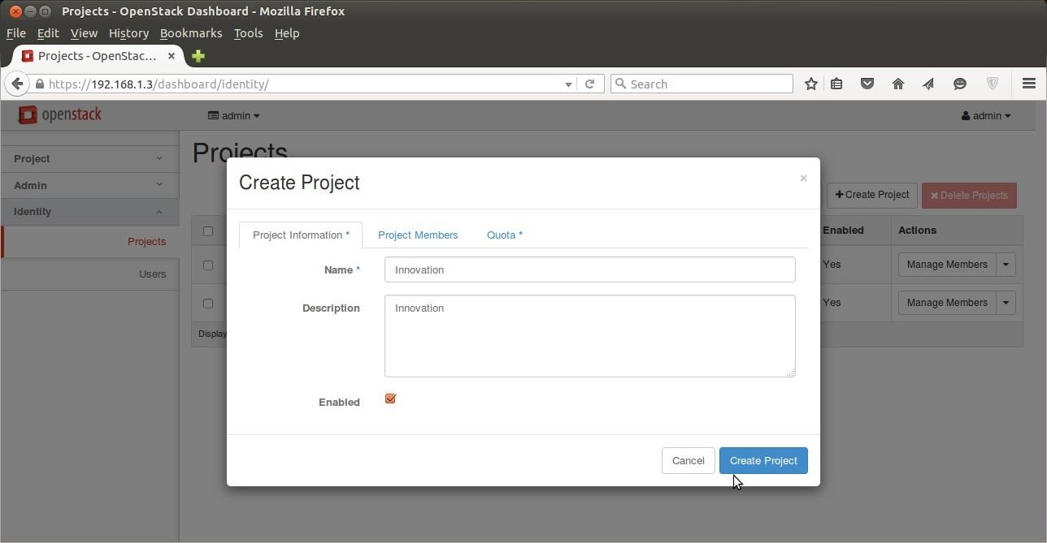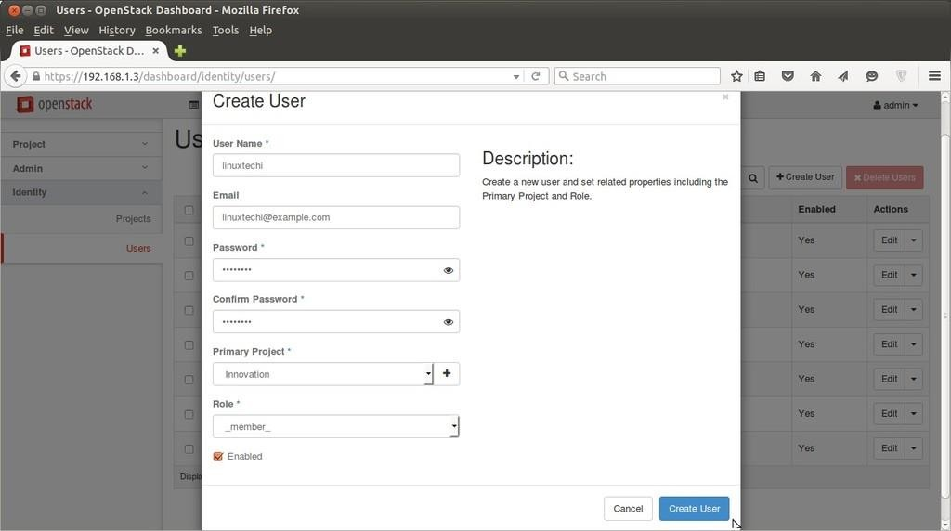

Click on “Create Project” , We can also set the Quota for the project from Quota Tab. **To create Users ,** Go to **Identify Tab–> Users–> Click on ‘Create User’ Button then specify** User Name, email, password, Primary Project and Role and click on create user to add in to OpenStack workspace.

# Create Image and Flavor

To create a flavor login in dashboard using admin credentials, Go to **Admin Tab –> Flavors –> Click on create Flavor.**

Specify the Flavor Name (fedora.small) , VCPU , Root Disk , Ephemeral Disk & Swap disk.

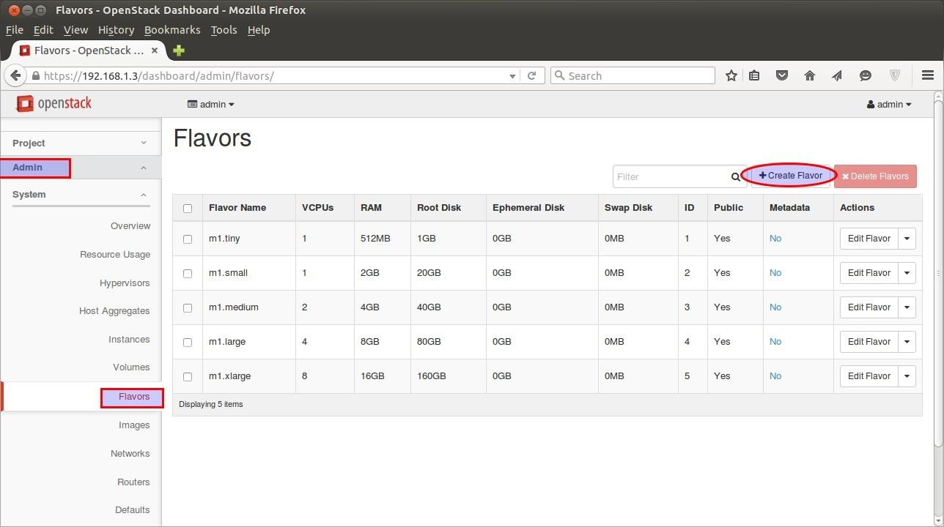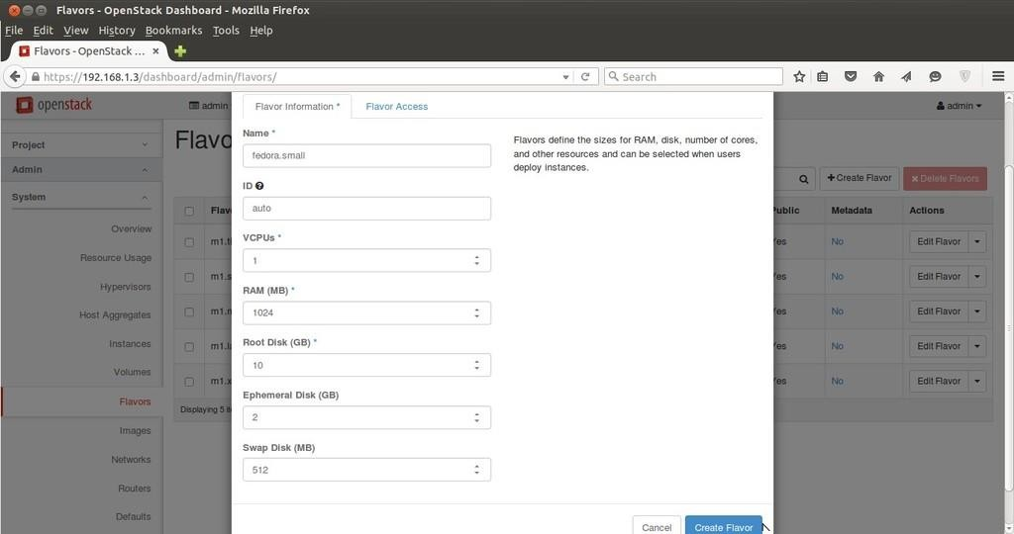

# To Create Image , Go to Admin Tab –> Images—> Click on Create Image.

Specify the Image Name , Description, Image Soure ( in my case i am using Fedora Image File which i have already downloaded from fedora website with Format QCOW2)

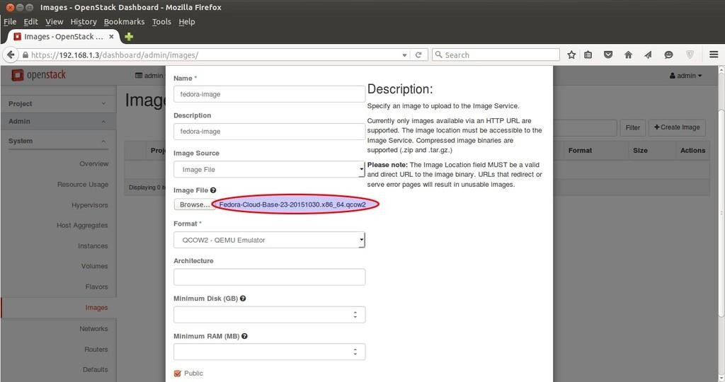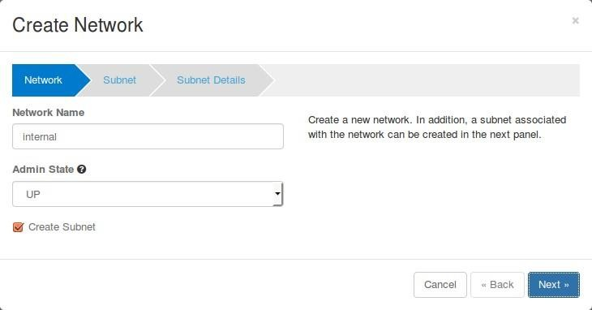

**C) Create Network for the Project.**

To create Network and router for Innovation project sign out of admin user and login as local user in dashboard.

For my convenience i have setup my network as above Internal Network = 10.10.10.0/24

External Network or Floating IP Network = 192.168.1.0/24 Gateway of External Network = 192.168.1.1

Now, Go to **the Network Tab —> Click on Networks —> then Click on Create Network**

Specify the Network Name as Internal

Click on Next. Then Specify the Subnet name (sub-internal) and Network Address (10.10.0.0/24)

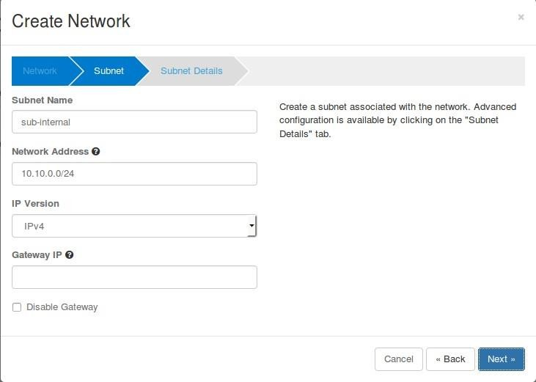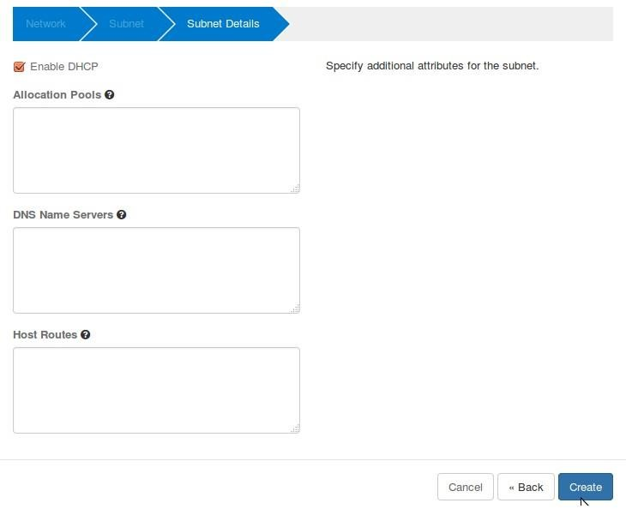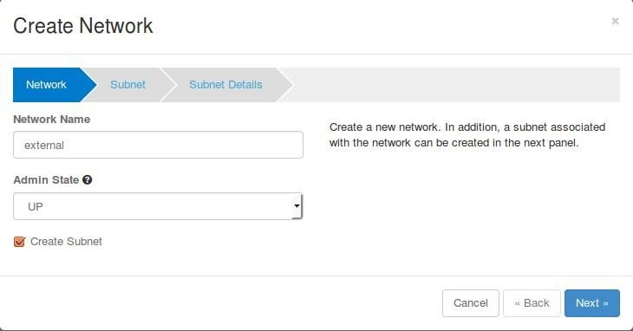

Click on Next. Now, VMs will be getting internal IP from DHCP Server because we enable DHCP option for internal network.

Now **Create External Network**. Click on **“Create Network”** again, Specify Network Name as

# “external”

Click on Next. Specify subnet Name as “**sub-external**” & Network Address as “**192.168.1.0/24**”

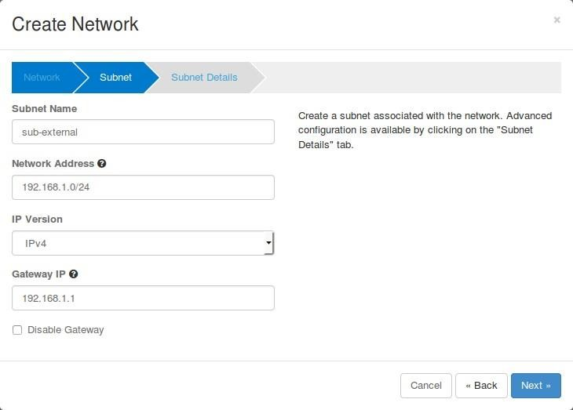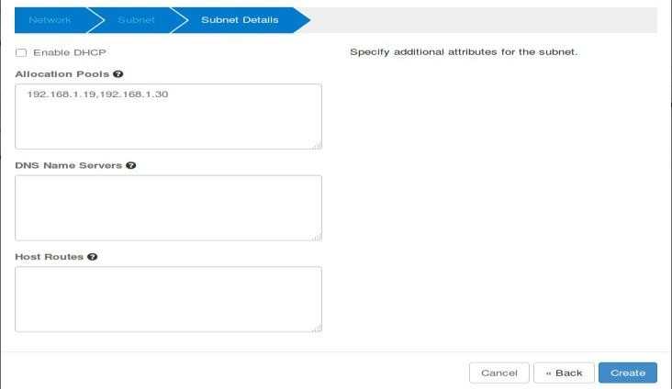

Click on Next

Untick “**Enable DHCP”** option and Specify the ip address pool for external network.

Click on Create.

# Create Router for the Project

**Now time to create a Router. To create router** Go To **Network Tab –> Routers –> Click on ‘+ Create Router’**

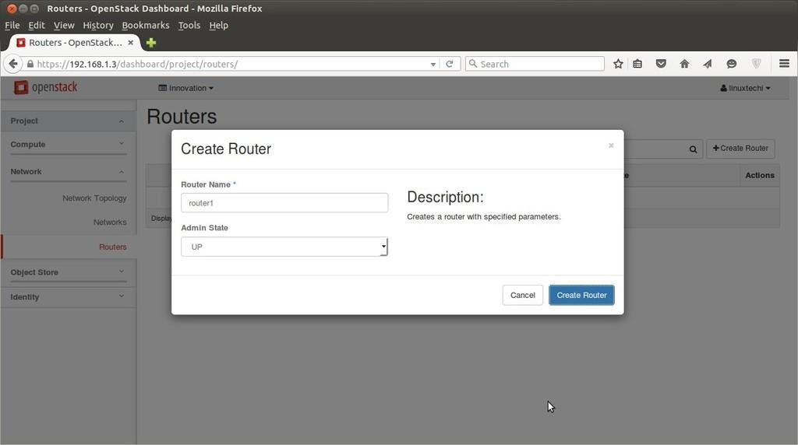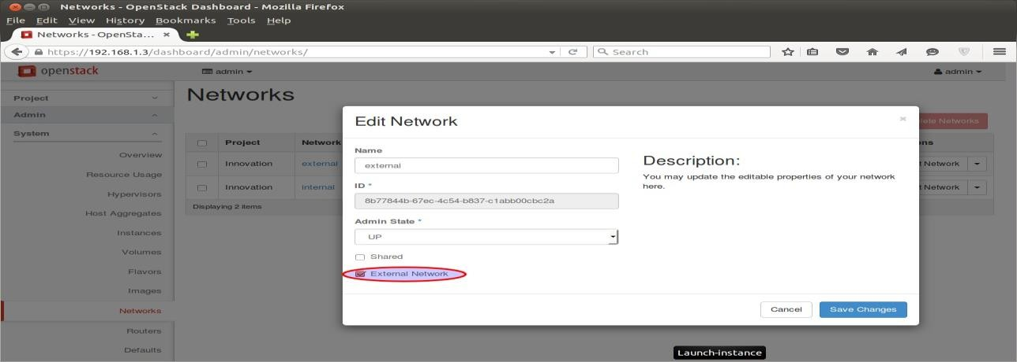

Now Mark External network as “External” , this task can be completed only from admin user , so logout from linuxtechi user and login as admin.

Go to **Admin Tab —> Networks–> Click on Edit Network for “External”**

Click on Save Changes. Now Logout from admin user and login as local user. Go to **Network**

**Tab —> Routers –> for Router1 click on “Set Gateway”**

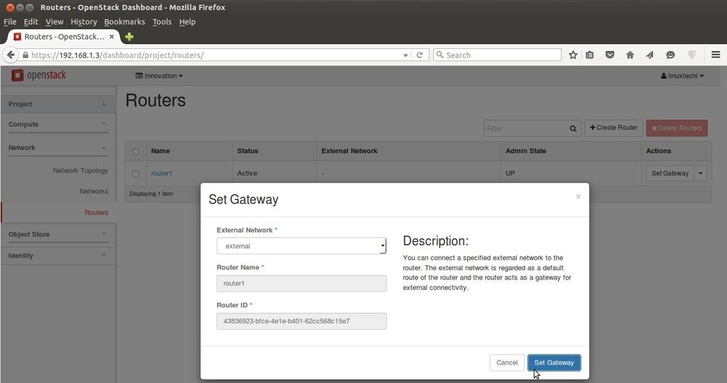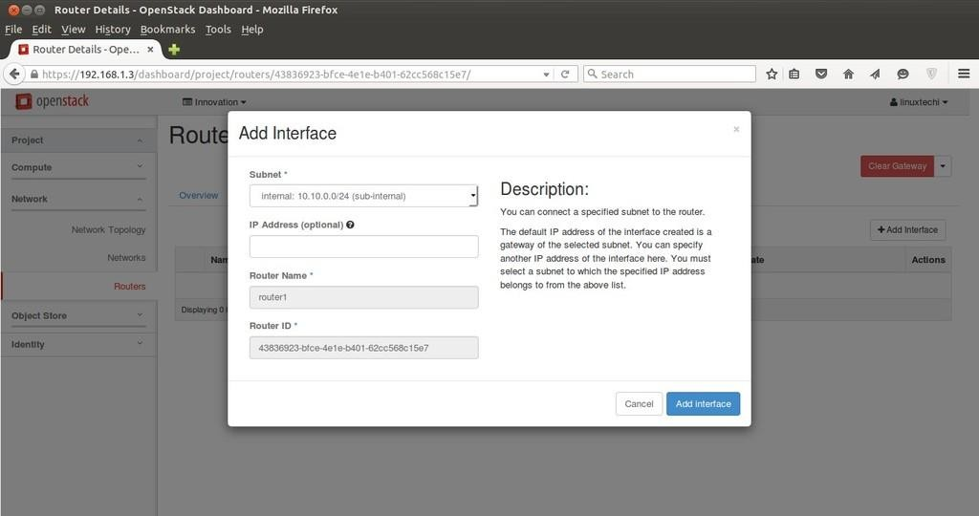

Click on **“Set Gateway”,** this will add a interface on router and will assign the first ip of external

subnet (192.168.1.0/24).

Add internal interface to router as well , Click on the **“router1″** and select on **“interfaces”** and then click on **“Add interface”**

Now, Network Part is completed now & we can view Network Topology from **“Network**

**Topology”** Tab as below.

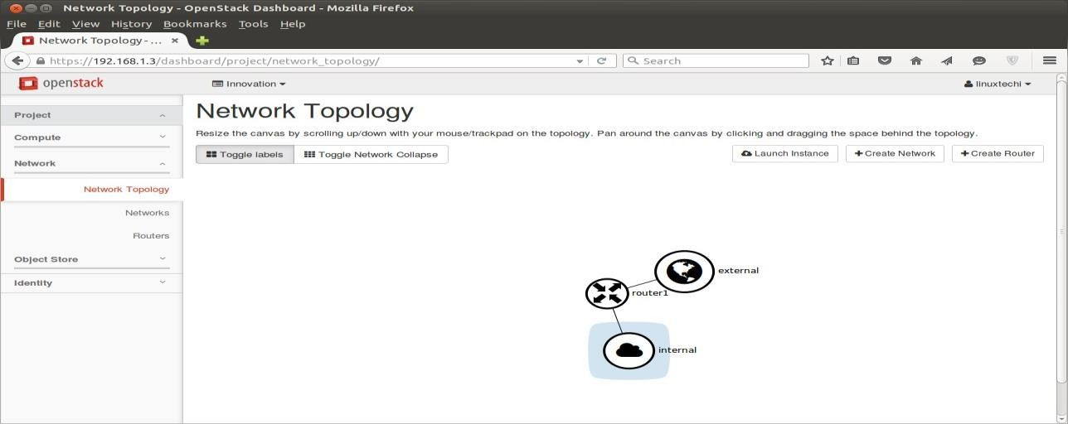

Now Create a key pair that will be used for accessing the VM and define the Security firewall rules.

# Create a key pair

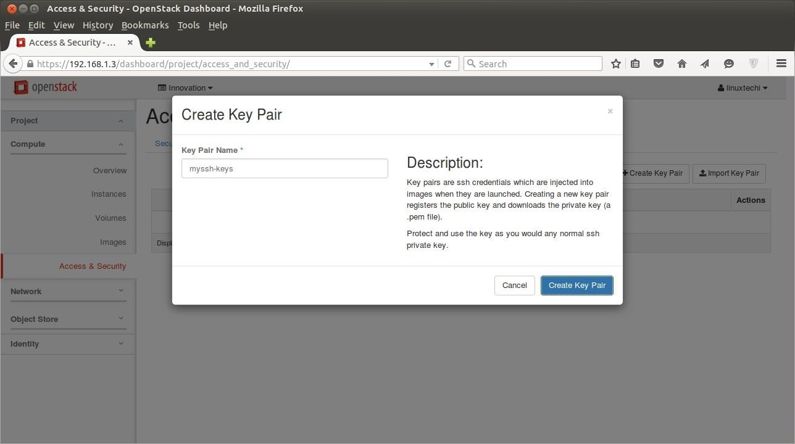

Go to **‘Access & Security’ Tab —> Click on Key Pairs –> then click on ‘Create Key Pair‘**

It will create a Key pair with name **“myssh-keys.pem”** Add a new Security Group with name

**‘fedora-rules’** from Access & Security Tab. Allow 22 and ICMP from Internet ( 0.0.0.0 ).

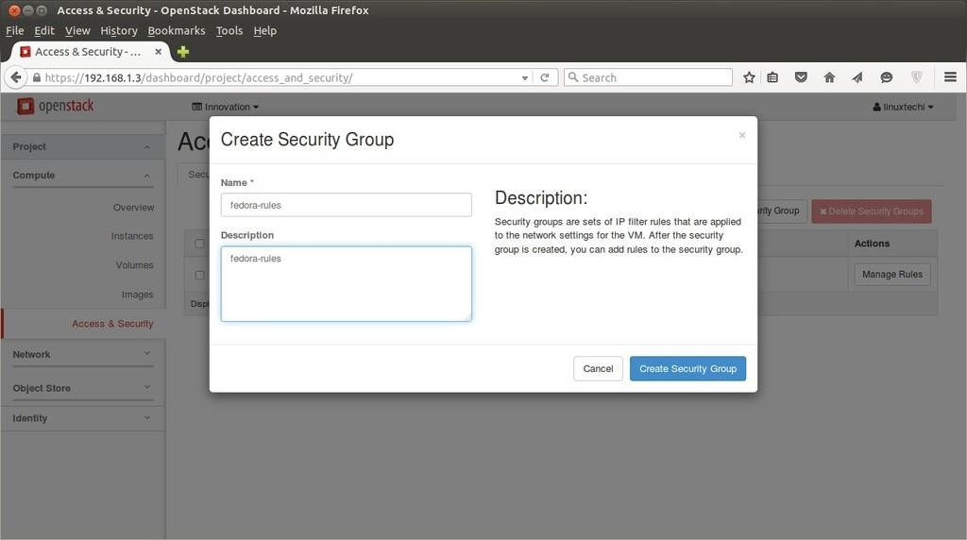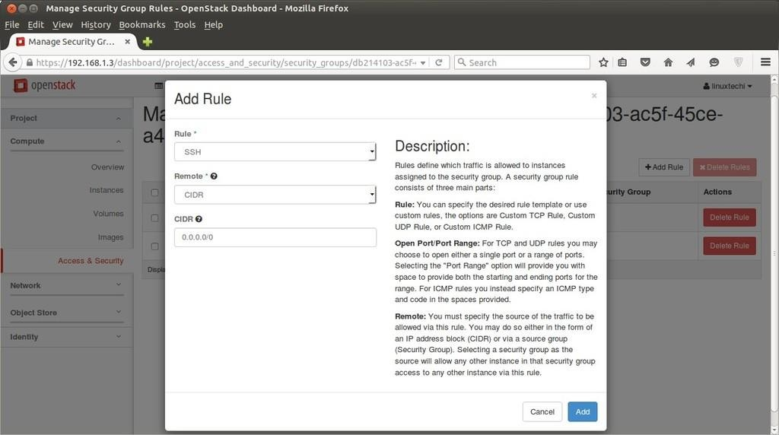

Once the Security Group ‘fedora-rules’ created , click on Manage Rules and allow 22 & ICMP

ping.

Click on Add , Similarly add a rule for ICMP.

1. **Launch Instance**

Now finally it’s time to launch an instance. To launch instance, Go to **Compute Tab –> Click on Instances –> then click on ‘Launch Instance’ Then** Specify the Instance Name, Flavor that we created in above steps and ‘**Boot from image’** from Instance Boot Source option and Select Image Name **‘fedora-image’**.

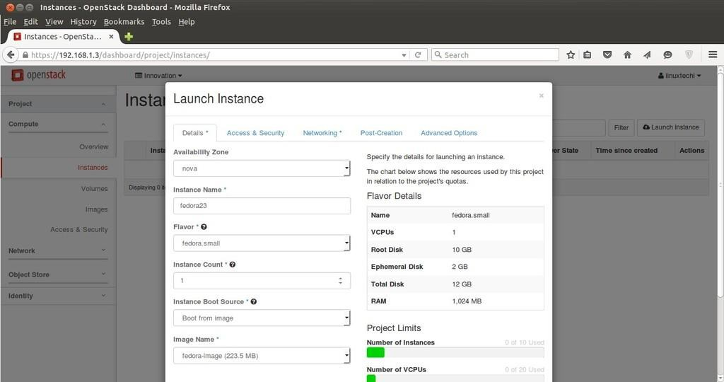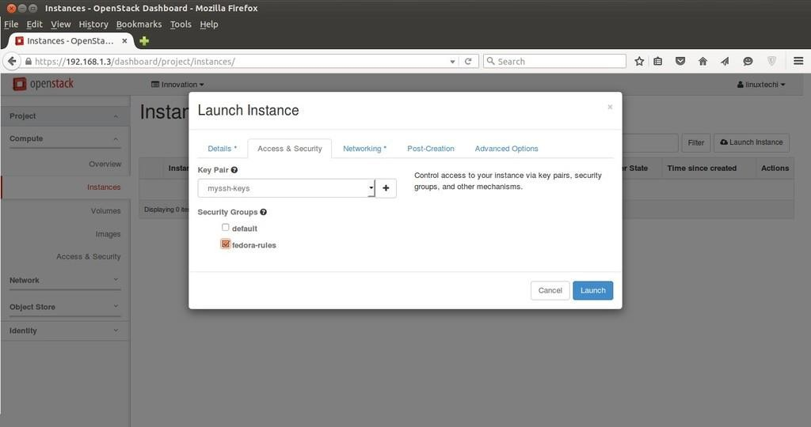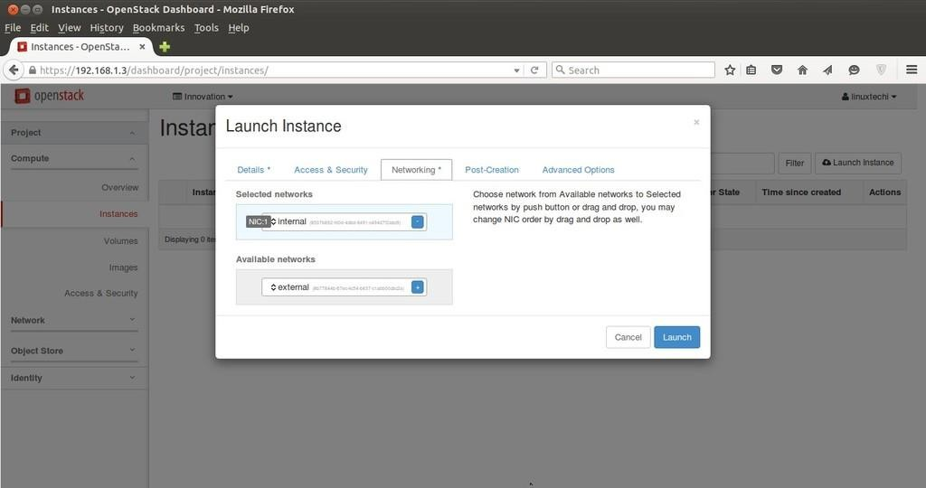

Click on ‘**Access & Security’** and Select the Security Group ‘**fedora-rules’** & Key Pair ”**myssh- keys‘**

Now Select **Networking** and add ‘Internal’ Network and the Click on Launch ….

Once the VM is launched , Associate a floating ip so that we can access the VM.

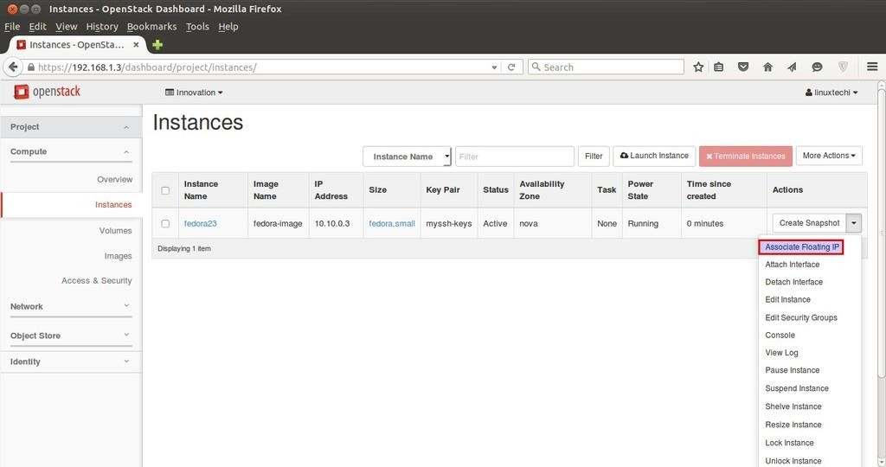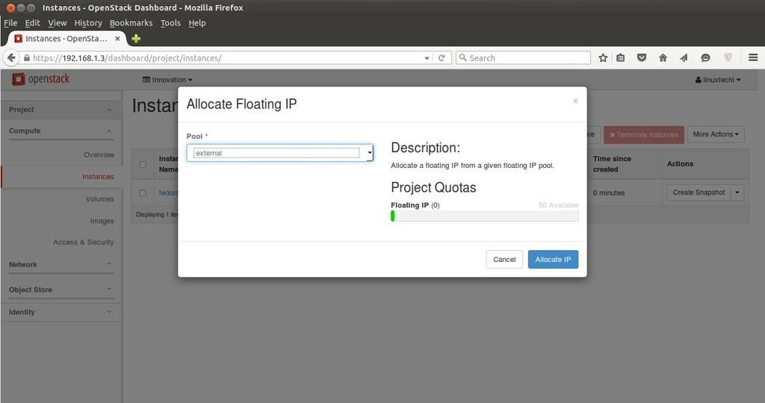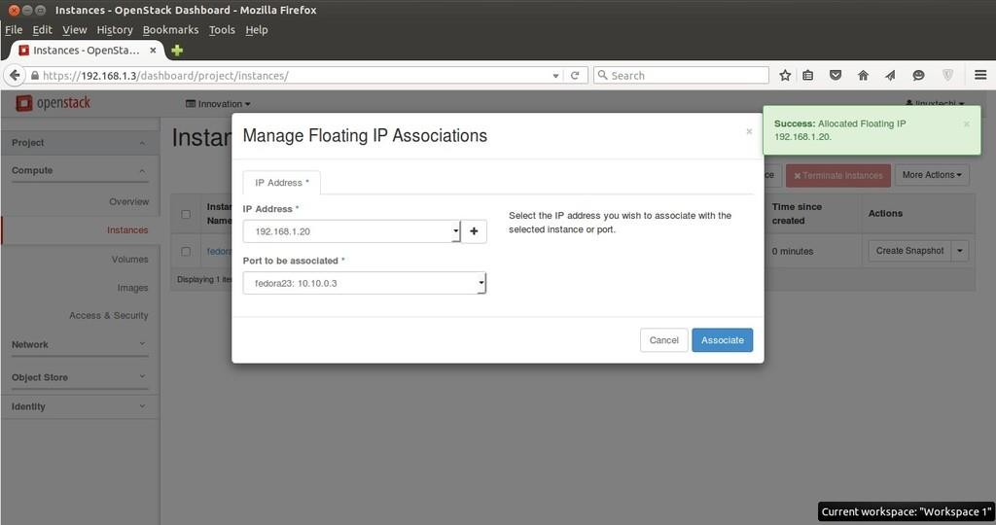

Click on ‘**Associate Floating IP‘** to get public IP addresses

Click on Allocate IP.

Click on Associate

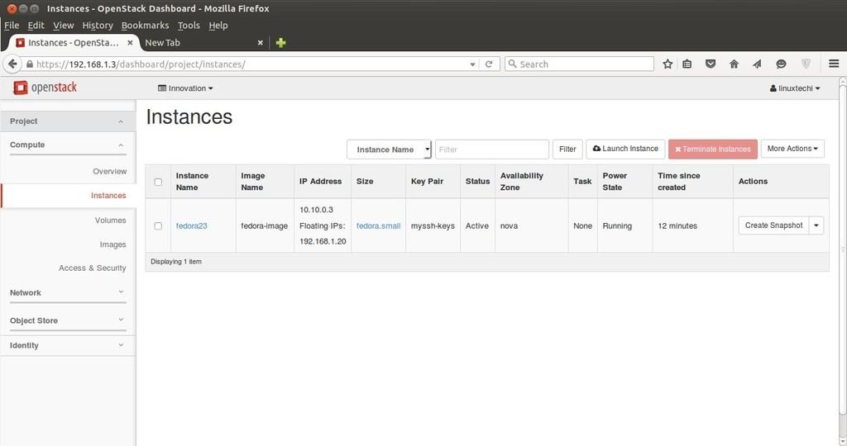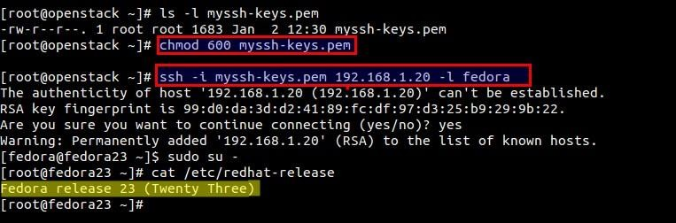

Now try to access the VM with floating IP ( 192.168.1.20) using keys.

As we can see above that we are able to access the VM using keys. Our task of launching a VM

from Dashboard is Completed Now.

**14. Learning Outcomes Achieved**

1. Openstack was used as cloud orchestration software
2. Students created VMs using Openstack Dashboard
3. VMs were successfully deployed and IP addresses were assigned
4. SDN with one router with public IP and 3 VMs network was created
5. Remote VM access was made using console
6. Overall instance monitoring and configuration was done using dashboard

**15. Conclusion:**

1. **Applications of the studied technique in industry**
   1. As an integral part of IaaS at Enterprise level
   2. Main technology for cloud orchestration
2. **Engineering Relevance** 
   1. Openstack is one of the widely used software for setup of Private clouds and cloud management
   2. Openstack is Open source software with large community support
3. **Skills Developed**
   1. Using Openstack Dashboard for performance monitoring and VM configuration
   2. SDN Creation and access

**References** :

[1] Ocata Release Notes — OpenStack". Wiki.openstack.org. Retrieved 22 February 2017.

Jump up ^ "ReleaseAnnouncement/Ocata — OpenStack". www.openstack.org. Retrieved 22 February 2017.

[2] "OpenStack Open Source Cloud Computing Software". Retrieved 29 November 2013.

[3] "OpenStack Launches as Independent Foundation, Begins Work Protecting, Empowering and Promoting OpenStack". BusinessWire. 19 September 2012. Retrieved 7 January 2013.