Week 1 Exploratory Data Analysis
IEEE CIS Fraud Detection
The cleaned training table contains 590,540 transactions, with 20,663 fraud cases (3.50%). The analysis also finds a long-tailed transaction amount distribution and substantial missingness in identity fields. Product and card categories have different observed fraud rates; these are descriptive patterns and do not establish cause.

Project Objective
This Week 1 analysis describes fraud prevalence, transaction amounts, missing values, and selected categorical patterns in the IEEE-CIS training data. It provides a clear baseline for later project work without using test data or training a model.

Dataset Description
The input is the cleaned training transaction table joined to training identity data by TransactionID. Each transaction remains one row; identity fields are missing when no linked identity row or source value is available. The analysis uses the preserved isFraud target.
Dataset | Rows | Columns | Use
Merged training transactions and identity | 590,540 | 434 | EDA input; includes isFraud
Training target - legitimate | 569,877 | — | isFraud = 0
Training target - fraudulent | 20,663 | — | isFraud = 1

Input file: .\cleaned_data\train_cleaned.csv
No test dataset or test labels were opened for this analysis.

Data Cleaning Methodology
- The analysis reads the previously cleaned training transaction and identity merge. It does not alter or overwrite any source or cleaned dataset.
- TransactionID was used for the earlier one-to-one left join. The cleaned training table preserves all 590,540 transaction rows and the original isFraud target.
- No duplicate rows were removed during the earlier cleaning, and columns with high missingness were retained.
- Numeric-looking features were kept in their recorded numeric types. ProductCD, card4, card6, and email domain fields were treated as categories for grouped summaries.

Missing Value Treatment Decisions
For EDA, missing values were kept as missing so the analysis could describe their extent and location. No column was dropped and no value was imputed for the charts or statistics. In the separate model-preparation output, numeric imputation uses medians fitted on training-fit rows only; categorical values use a dedicated missing code and an unseen-category code. Those transformations were not used to calculate the EDA findings.
- Across the merged training table, the average missing rate is 84.5% across identity fields and 41.3% across transaction features.
- The most-missing field is id_24 (99.20% missing). Several identity fields exceed 99% missingness, so their potential value should be assessed before any later feature removal.

EDA Methodology
- Counted the full target distribution and calculated class percentages.
- Compared TransactionAmt summaries by target and plotted the positive amounts on a log10 scale to make the long tail visible.
- Calculated missing counts and percentages for every column in the merged training table.
- Calculated ProductCD, card4, and card6 fraud rates from grouped counts. ProductCD and card category charts include Wilson 95% intervals; card charts show categories with at least 1,000 rows for readability.
- All category-rate comparisons are descriptive. They do not show that a category causes fraud or account for other variables.

Findings and Insights
- Fraud is uncommon in the labeled training data: 20,663 of 590,540 rows are fraudulent (3.50%); the remaining 569,877 rows are legitimate (96.50%). This imbalance matters when interpreting later model metrics.
- TransactionAmt has a long right tail. Its mean is 135.03, above its median of 68.77; the 99th percentile is 1104.00, while the maximum is 31937.39.
- The fraudulent group has a median transaction amount of 75.00, compared with 68.50 for legitimate rows. Its 90th percentile is 335.00 versus 267.11. These summaries describe the sample and do not explain why the amounts differ.
- ProductCD C has the highest observed fraud rate at 11.69% across 68,519 rows. ProductCD W has the most rows (439,670) and an observed rate of 2.04%. Category rates should be read with their sample sizes and intervals.
- Missingness is concentrated in identity fields: their average missing rate is 84.5%, versus 41.3% for transaction features. id_24 is missing in 585,793 rows (99.20%).
- At least one joined identity field is present for 11,318 of 20,663 fraud rows (54.77%) and 132,915 of 569,877 legitimate rows (23.32%). This is an observed difference in coverage, not evidence that identity availability causes fraud.
- Among card4 categories with at least 1,000 rows, discover has a 7.73% observed fraud rate (n=6,651); visa is 3.48% (n=384,767). The different group sizes affect how precisely the rates are estimated.
- Among card6 categories with at least 1,000 rows, credit has a 6.68% observed fraud rate (n=148,986), compared with 2.43% for debit (n=439,938). This comparison is descriptive and unadjusted.

Fraud and legitimate transaction counts
This chart compares the number and share of legitimate and fraudulent transactions in the training data.
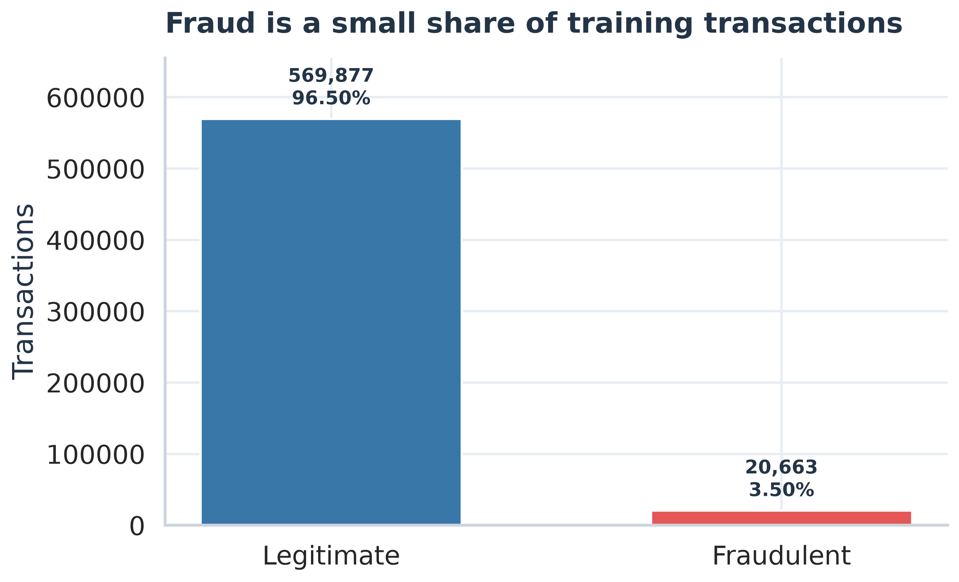
Figure 1. Fraud and legitimate transaction counts.
Fraud represents about 3.5% of rows. The imbalance matters because a model could appear strong by predicting the majority class; later evaluation should report metrics that reflect fraud detection.

Transaction amount distributions
The chart compares amount distributions by target on a log10 scale. Dashed vertical lines mark the median amount for each class.
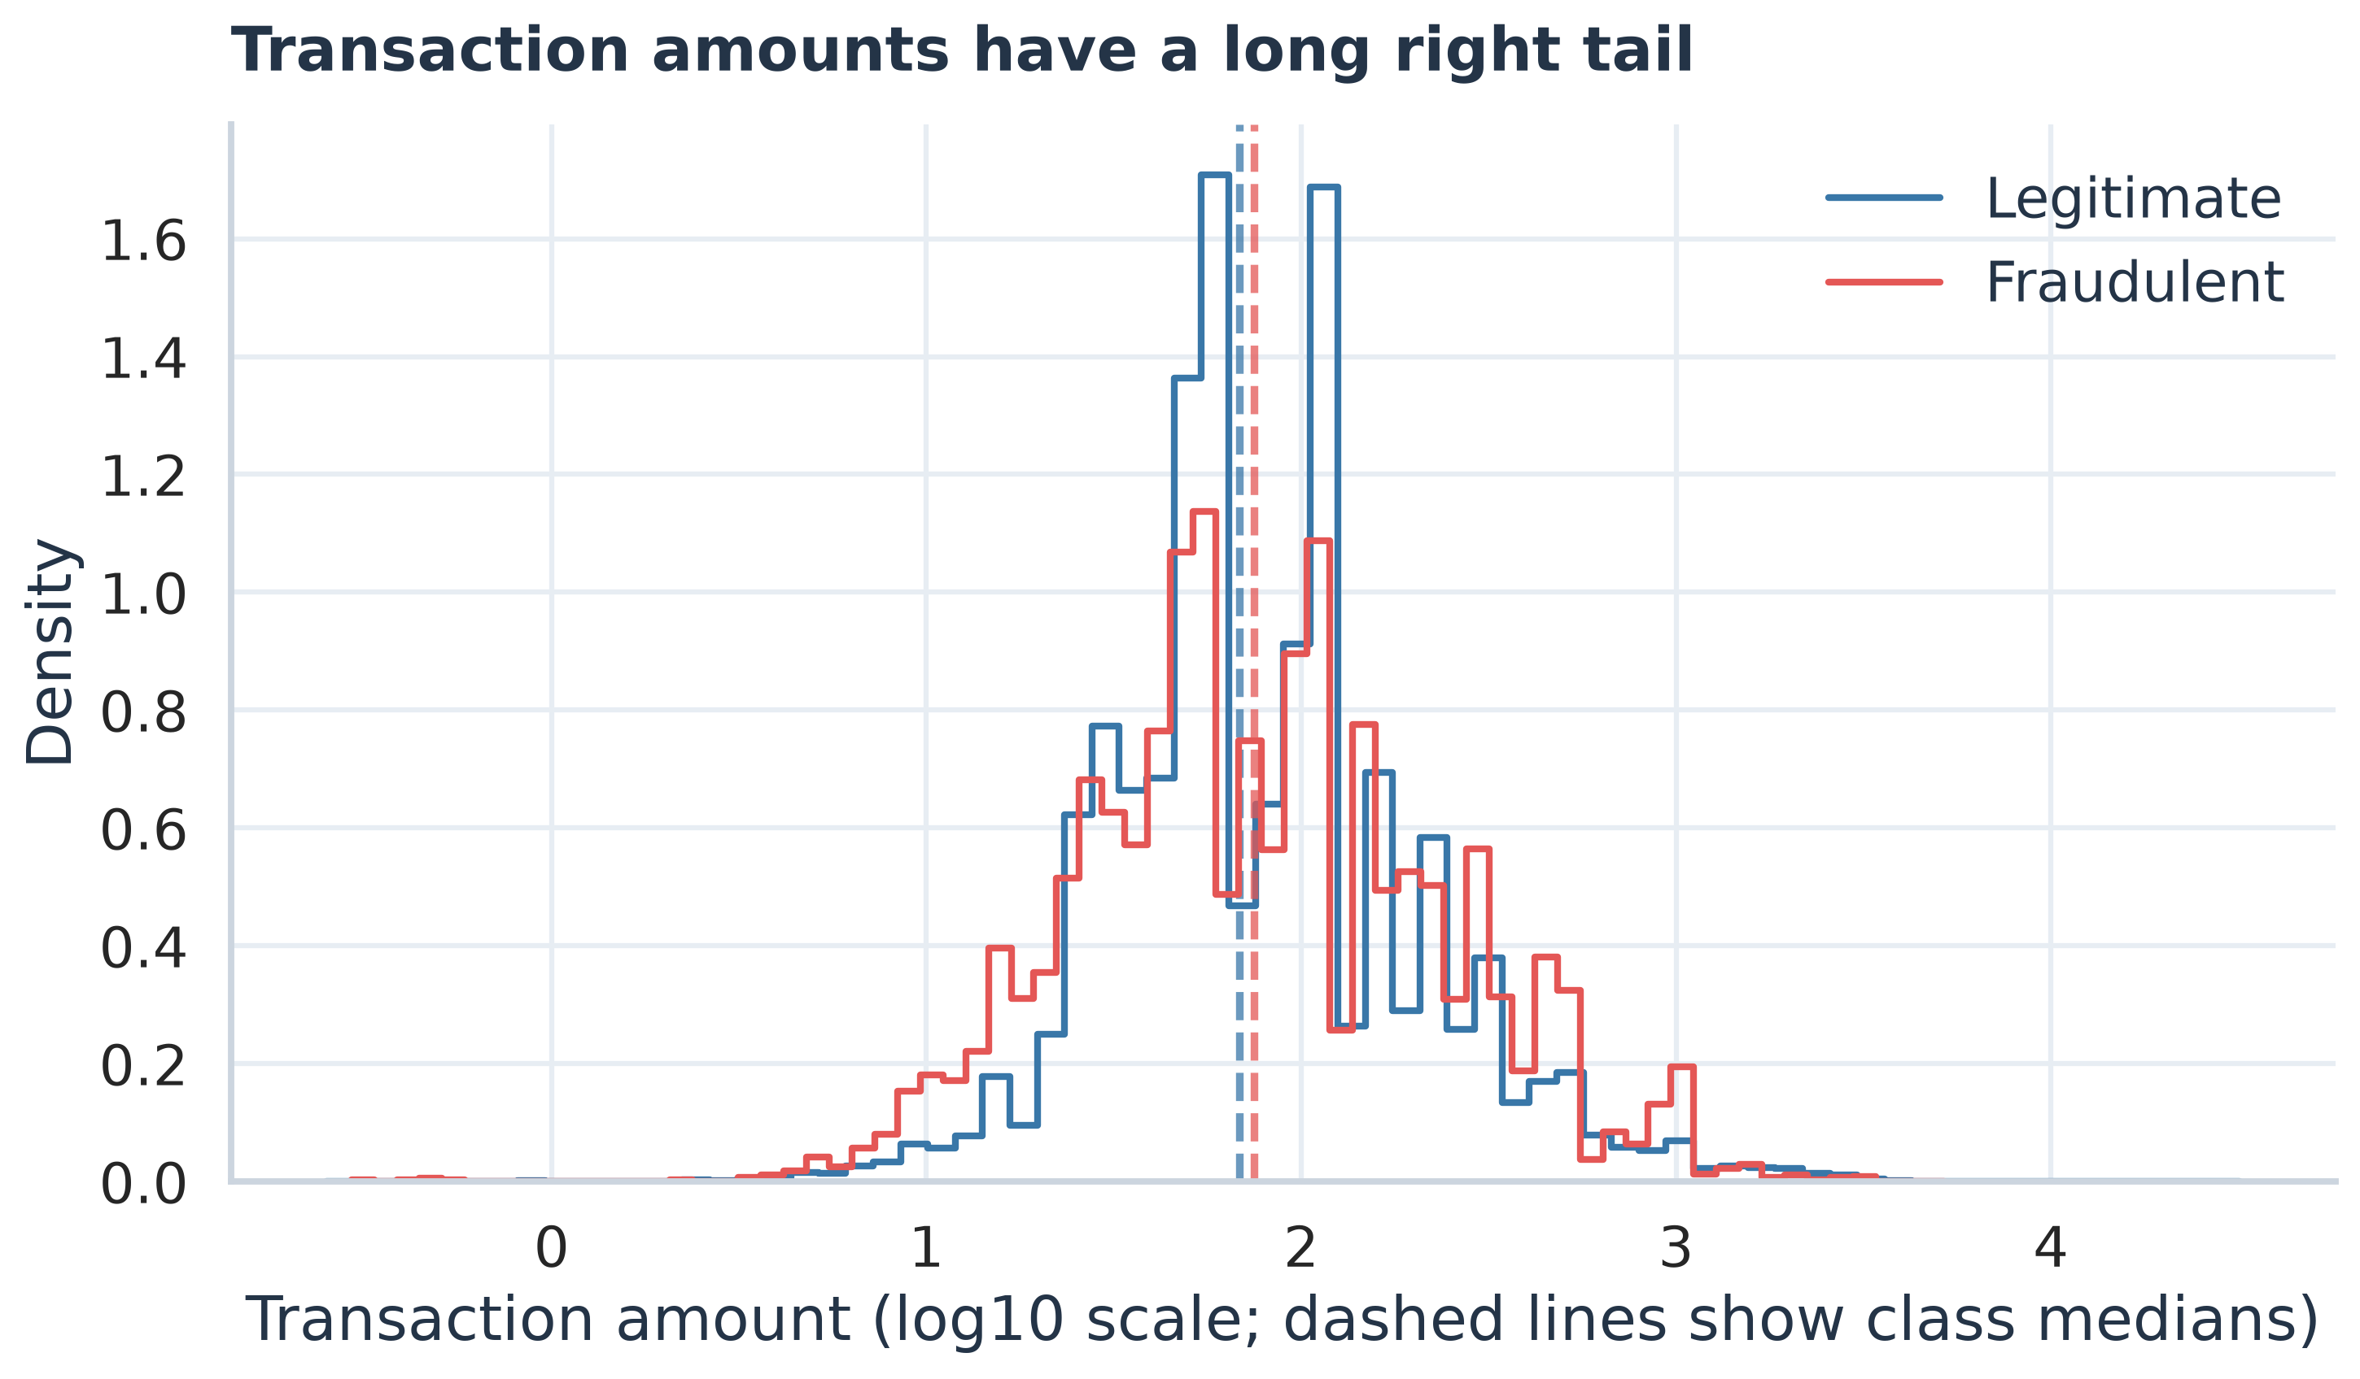
Figure 2. Transaction amount distributions.
The median is slightly higher for the fraud group, while the distributions overlap substantially. The long tail makes the log scale useful for seeing both common amounts and less common high amounts.

Missing values across the most incomplete fields
This chart ranks the 20 fields with the largest missing percentages in the merged training table. Colors distinguish identity fields from transaction fields.
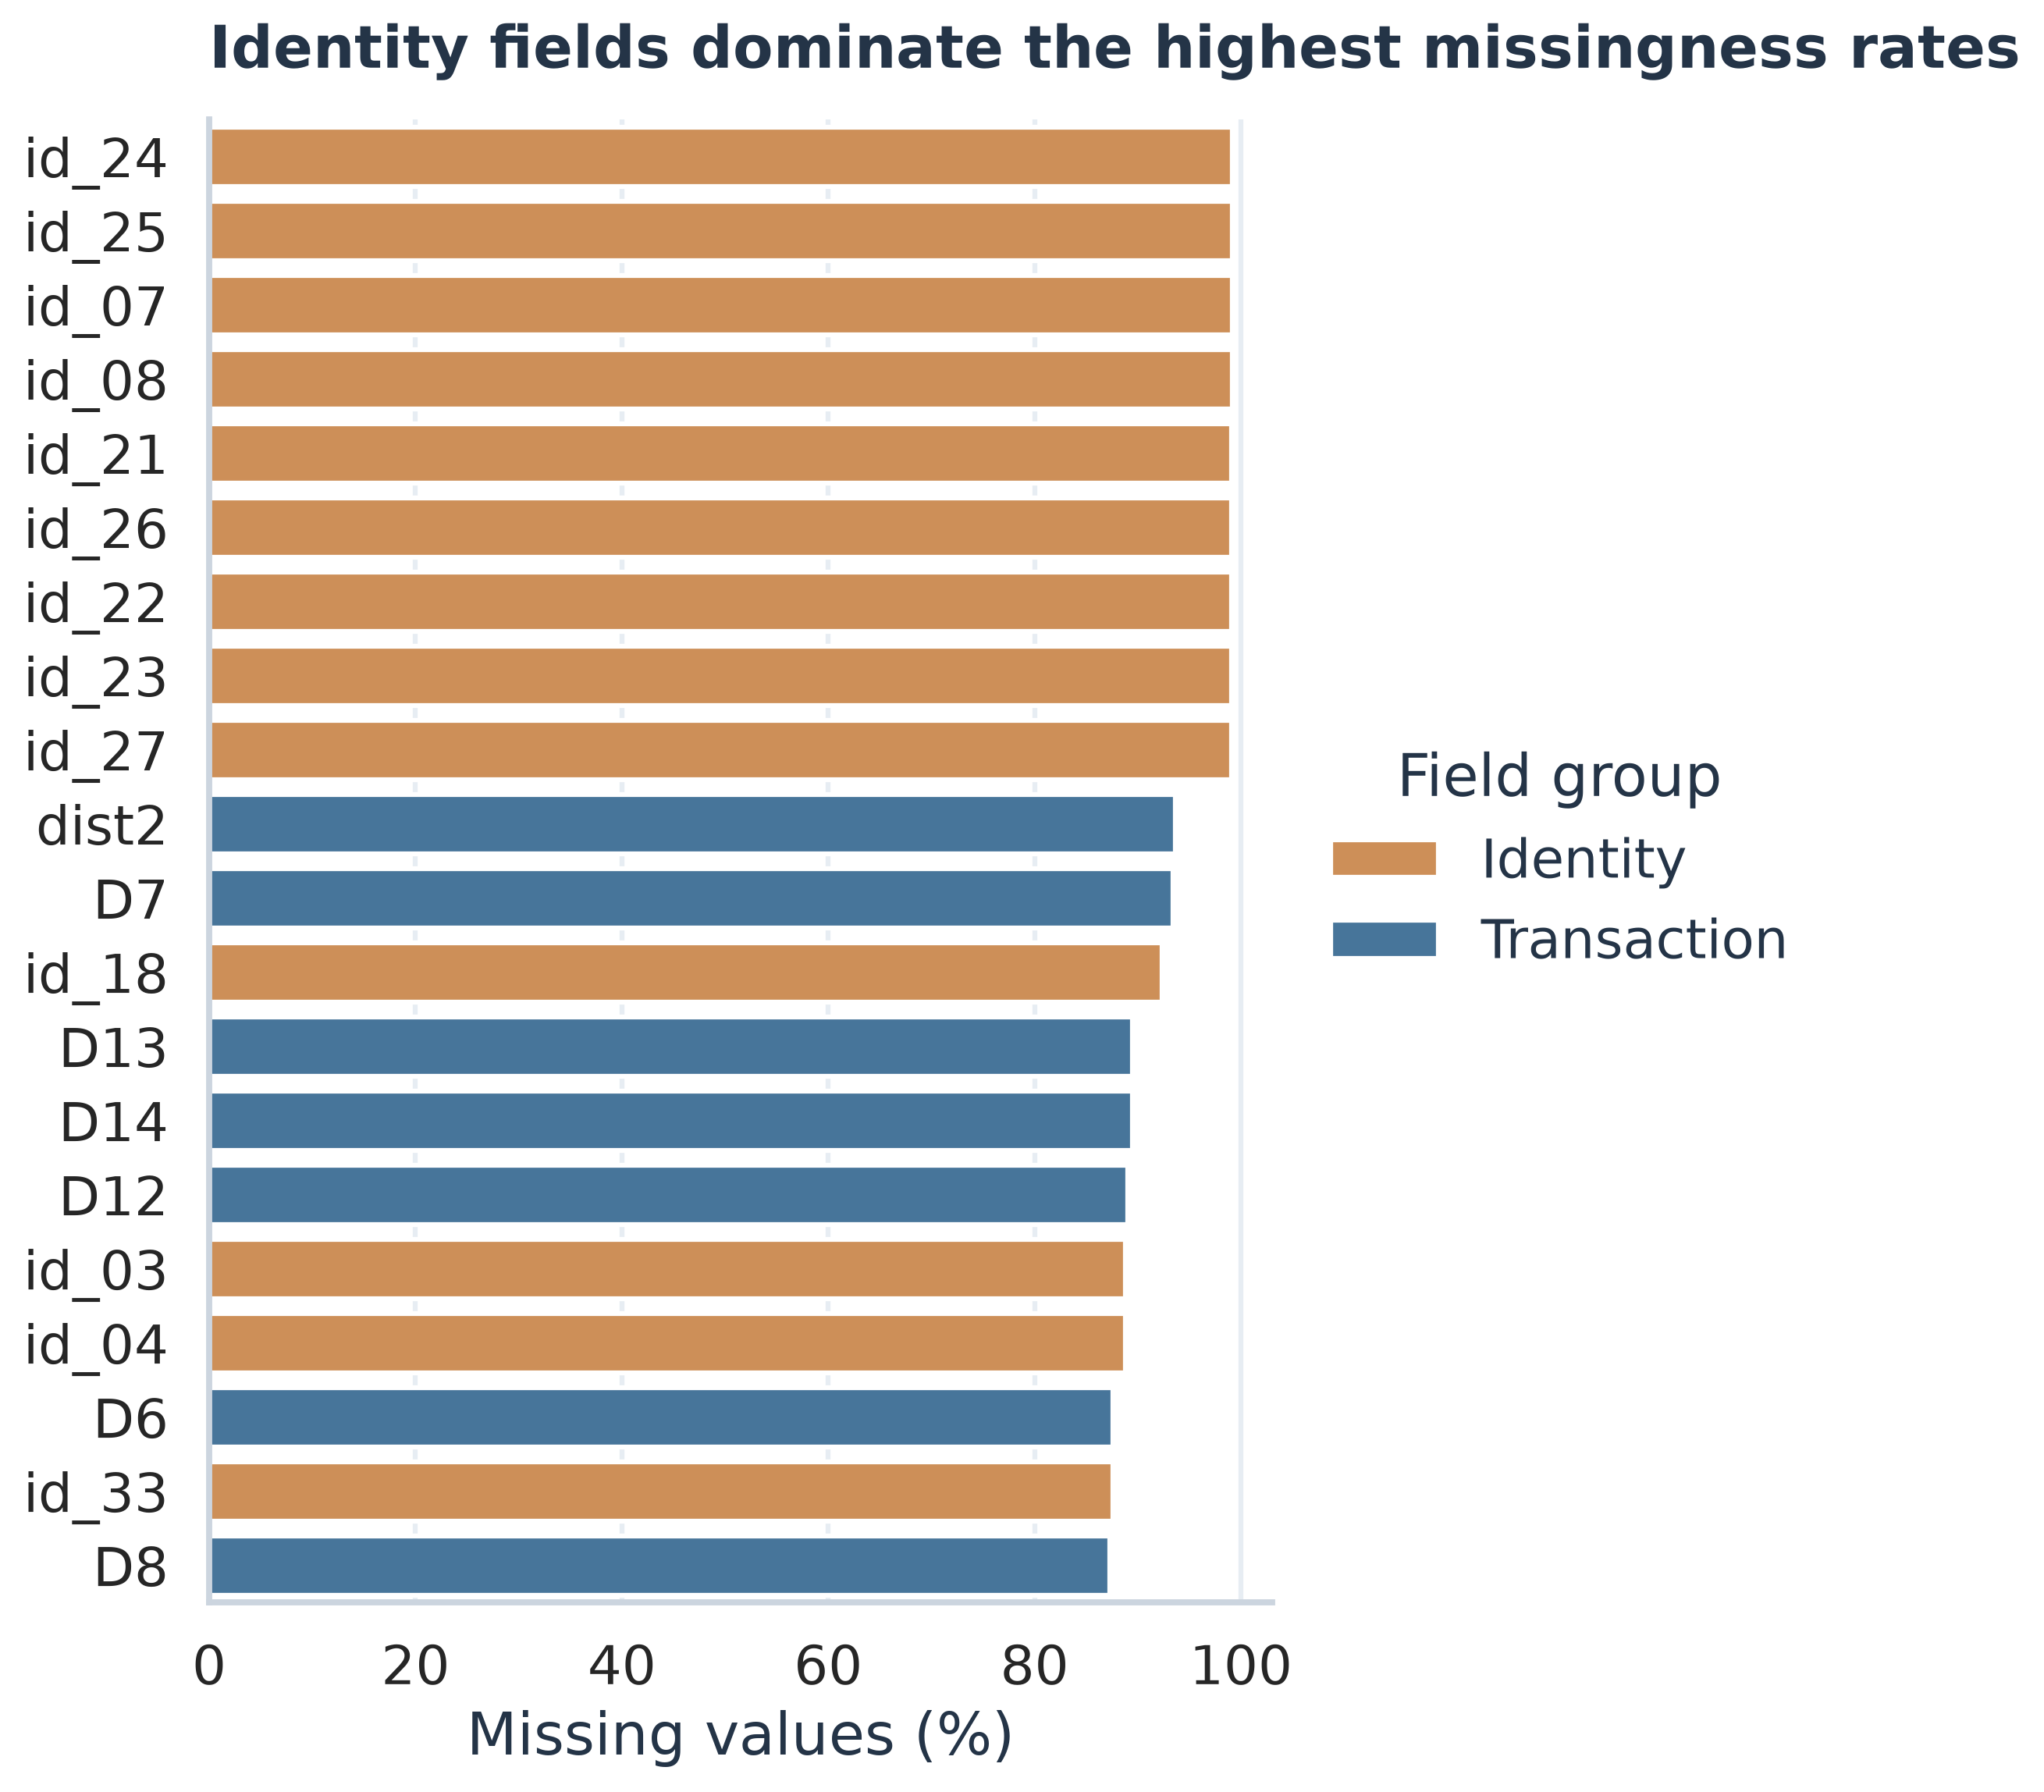
Figure 3. Missing values across the most incomplete fields.
Identity features dominate the top of the chart. Many transactions have no linked identity record, so these missing values can represent unavailable identity information rather than a lost transaction.

Fraud rates by ProductCD
Each bar shows the fraction of transactions labeled fraud within a ProductCD category. Labels show category row counts; whiskers show Wilson 95% intervals.
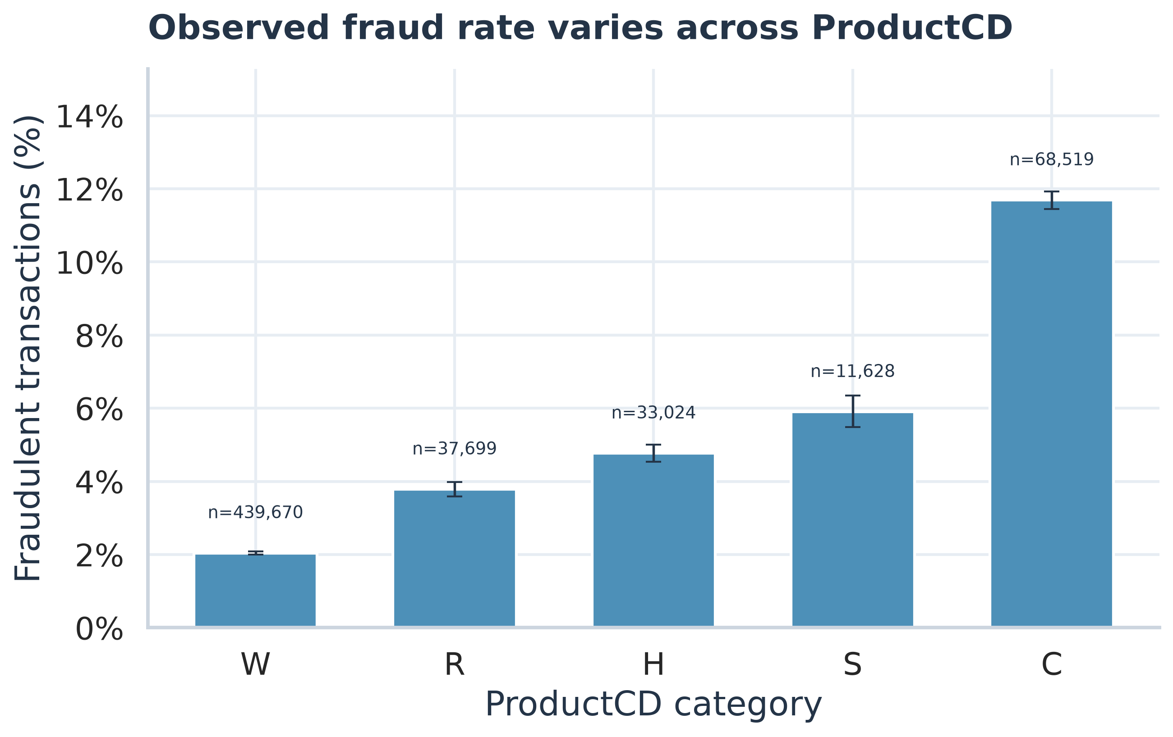
Figure 4. Fraud rates by ProductCD.
ProductCD C has the highest observed rate and W has the largest volume. The rates are useful for describing the data but are not causal effects or adjusted comparisons.

Fraud rates by card category
The panels compare observed rates by card brand (card4) and card type (card6). The chart includes categories with at least 1,000 transactions and shows Wilson 95% intervals.
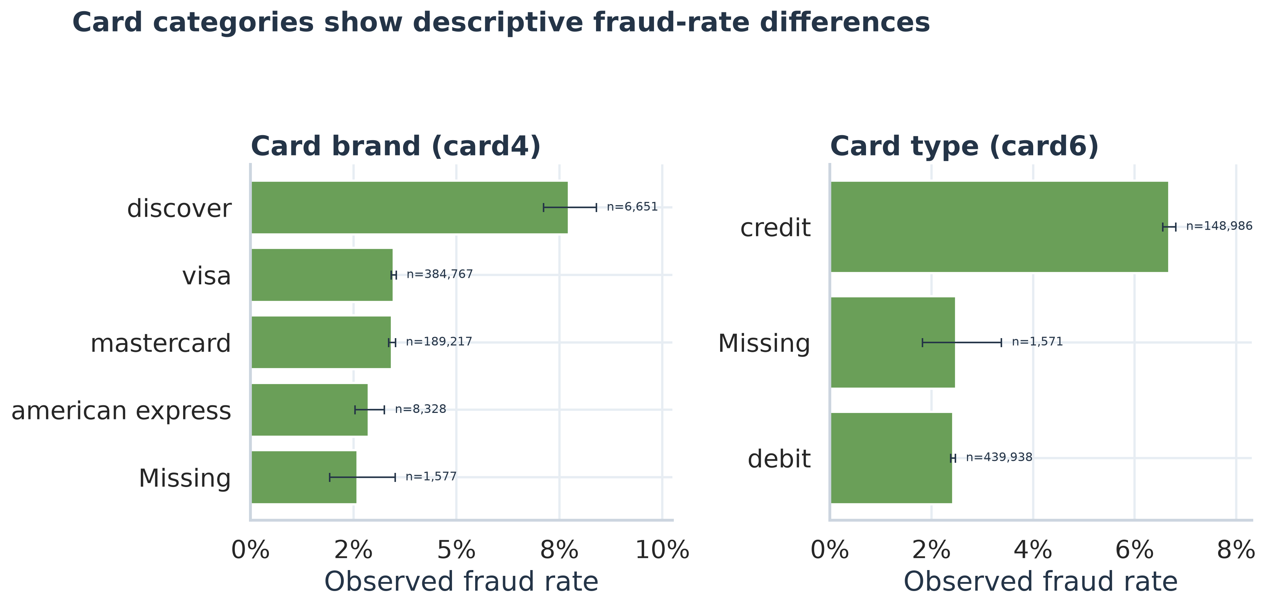
Figure 5. Fraud rates by card category.
Discover and credit have higher observed rates than the most common categories in this sample. The chart is descriptive and does not account for differences in other transaction features.

Conclusion
The Week 1 EDA confirms that the training target is highly imbalanced, transaction amounts have a long right tail, identity features are often missing, and observed fraud rates differ across ProductCD and card categories. These patterns can guide later analysis, but they do not establish causes or predictive value on their own.
Missing values and high-missingness fields were preserved for this descriptive work. No test data was used, no machine learning model was trained, and no Week 2 work was started.

Reproducible Files and Exact Locations
- EDA report: .\week1_eda\Week1_IEEE_CIS_Fraud_EDA_Report.docx
- EDA script: .\week1_eda\eda_analysis.py
- Word report builder: .\week1_eda\build_report.py
- Findings summary: .\week1_eda\findings.md
- Full EDA metrics: .\week1_eda\eda_summary.json
- Per-column missingness: .\week1_eda\missingness_by_column.csv
- ProductCD rates: .\week1_eda\productcd_fraud_rates.csv
- card4 rates: .\week1_eda\card4_fraud_rates.csv
- card6 rates: .\week1_eda\card6_fraud_rates.csv
- Email-domain rates: .\week1_eda\email_domain_fraud_rates.csv
- Class distribution chart: .\week1_eda\charts\01_class_distribution.png
- Amount distribution chart: .\week1_eda\charts\02_amount_distribution.png
- Missingness chart: .\week1_eda\charts\03_missingness_top20.png
- ProductCD fraud-rate chart: .\week1_eda\charts\04_productcd_fraud_rate.png
- Card category chart: .\week1_eda\charts\05_card_category_rates.png

Reproduction Command
python ".\week1_eda\eda_analysis.py"
The analysis script reads only the cleaned training table and writes charts and summaries under the week1_eda folder.

