Week 2 Advanced Visualization and Storytelling
IEEE-CIS Fraud Detection project

Executive summary
This report adds seven advanced views using the existing Week 1 cleaning and EDA outputs. The calculations use 472,432 training-fit rows from the already stratified v2 split, including 16,530 fraudulent transactions (3.499%). They explore amount concentration, relative-time variation, category combinations, and selected numeric associations. No test records were read and no model was trained.

Project objective
Use the existing IEEE-CIS Fraud Detection work to explain how fraud rates and transaction exposure vary across supported training-fit segments. The charts are descriptive and intended to support clear communication and later monitoring decisions.

Dataset description
The existing cleaned training table contains 590,540 rows and 434 columns. This Week 2 analysis uses 472,432 rows from the training-fit partition, with the isFraud target and selected transaction, category, and numeric fields. The validation partition is used only to show the preserved split fraud rate. Test files were not read.

Reuse of Week 1 cleaning
No cleaning was repeated. The existing Week 1 cleaned training file and corrected cleaned_data_v2 split manifest and training-fit keys were reused read-only. No columns were dropped, no rows were removed, and the source datasets and Week 1 outputs were left unchanged.

Missing-value handling
These are descriptive group summaries, so no imputer or encoder was fitted. Missing values in card6 are shown as an explicit Missing category rather than discarded. Numeric point-biserial associations use pairwise complete rows for each field, and each chart reports its usable row count. No missingness-based column deletion or imputation was performed in Week 2.
Main takeaway: observed fraud rates differ across supported amount, time, and category segments. These are descriptive training-fit patterns for monitoring and later validation, not causal explanations or model performance claims.

Data and method
Item | Scope
Training-fit rows | 472,432
Fraudulent / legitimate | 16,530 / 455,902
Fit fraud rate | 3.499%
v2 split seed | 42
Feature columns read | TransactionID, TransactionDT, TransactionAmt, isFraud, ProductCD, card4, card6, C1, C2, D1, D2, V258, V307
Test data | Not read
TransactionDT is an elapsed-time value. The time charts use relative days from the first observed value, not calendar dates or time-of-day. Amount quantiles are defined on the training-fit partition. Two-way rate cells with fewer than 200 rows are not ranked; heatmaps label low-support cells. Numeric associations are point-biserial correlations with the binary target and must not be read as causal effects.

Visualization 1 Stratified split and class imbalance
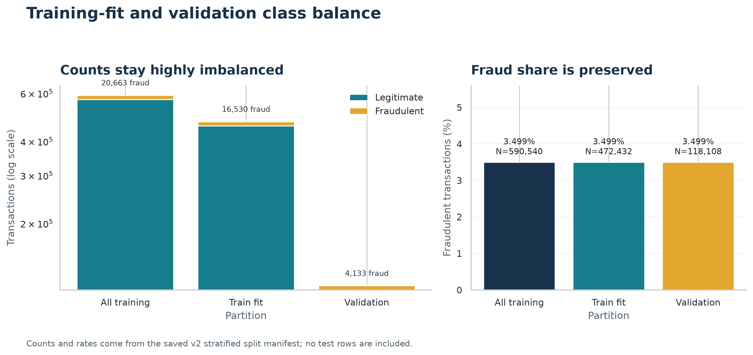
Figure 1. Stratified split and class imbalance.

What it shows
Fraud remains rare in every partition: 3.499% in train-fit and 3.499% in validation, using the documented v2 counts.

Why it matters
Fraud is rare, so later model evaluation should emphasize fraud-sensitive measures and the business cost of missed cases, not accuracy alone.
Calculation: Counts and fraud rates are read from the saved v2 split manifest; the chart compares all training, fit, and validation partitions.

Visualization 2 Transaction amount exposure by quantile
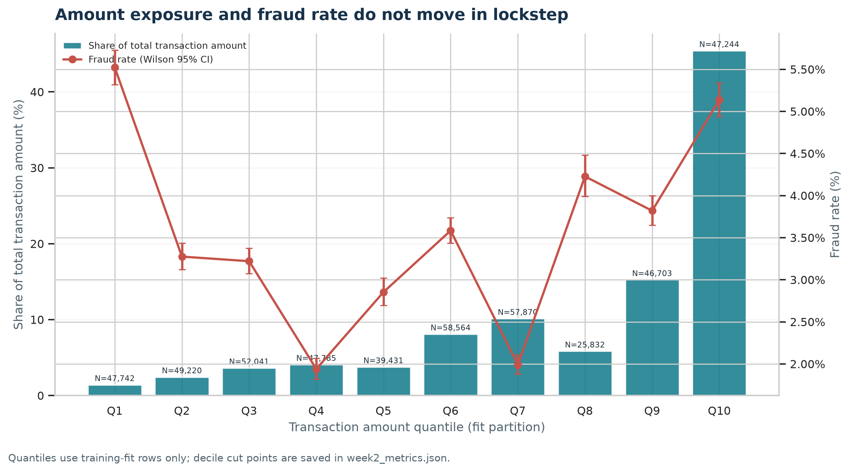
Figure 2. Transaction amount exposure by quantile.

What it shows
The largest amount-sum share belongs to Q10 (45.4% of the total amount sum); its observed fraud rate is 5.14%.

Why it matters
Amount exposure and fraud frequency are separate signals. This helps teams assess both how much transaction amount sits in a segment and how often fraud appears there.
Calculation: Amount quantiles, amount sums, fraud counts, rates, and Wilson 95% intervals are calculated from the selected fit rows.

Visualization 3 Daily volume and fraud rate over relative time
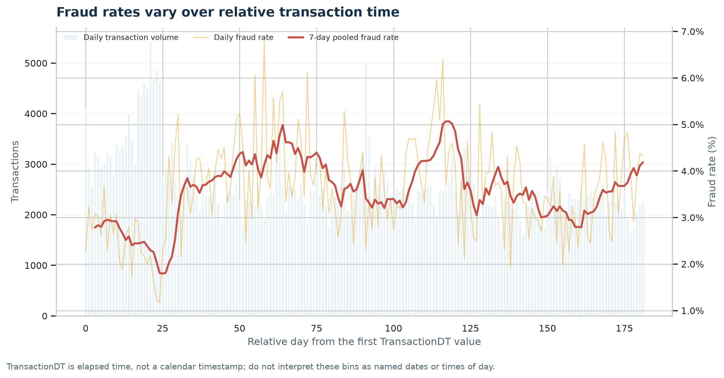
Figure 3. Daily volume and fraud rate over relative time.

What it shows
The rolling daily series spans 182 relative days. The largest supported 30-day window contains 3,113 frauds among 78,816 rows; TransactionDT is not a calendar clock.

Why it matters
A changing rate can motivate drift monitoring and review of operational changes. The relative timestamp does not identify calendar seasonality.
Calculation: Rows are grouped by elapsed 86,400-second days; the smoothed line pools seven adjacent daily counts and frauds.

Visualization 4 Product category by card type
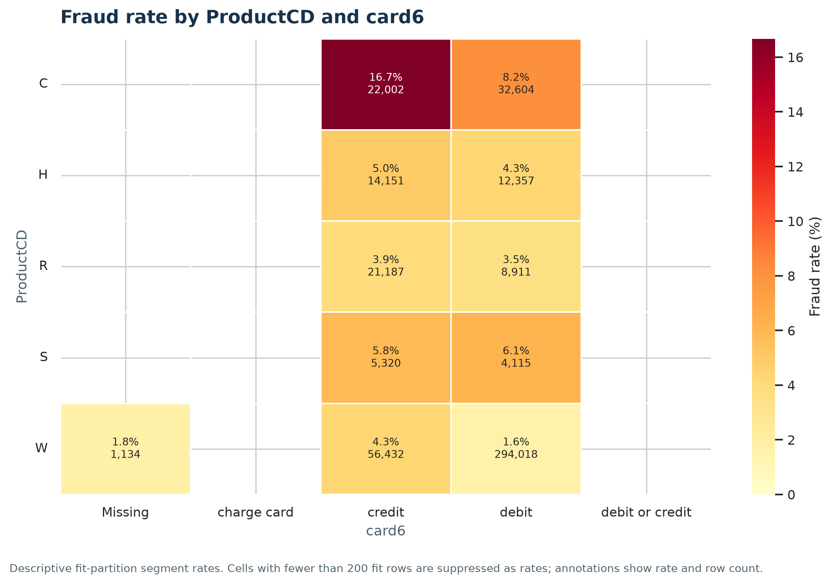
Figure 4. Product category by card type.

What it shows
The highest supported ProductCD × card6 cell is C / credit at 16.68% (22,002 rows).

Why it matters
A category-wide average can hide higher- or lower-rate combinations. Supported segments can be tracked for later validation, with small cells treated cautiously.
Calculation: The heatmap shows fraud rates and cell counts for ProductCD × card6; cells below 200 rows are suppressed as rates.

Visualization 5 Product category by amount quantile
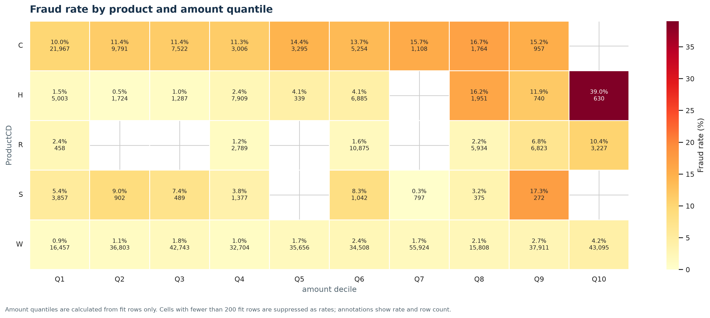
Figure 5. Product category by amount quantile.

What it shows
The highest supported cell is ProductCD H / Q10 at 39.05% (630 rows).

Why it matters
This view checks whether amount bands behave similarly across product categories. Any segment-specific rule would need validation on later data.
Calculation: Rates are grouped by ProductCD and training-fit amount quantile; cells below 200 rows are suppressed.

Visualization 6 Relative time by amount risk heatmap
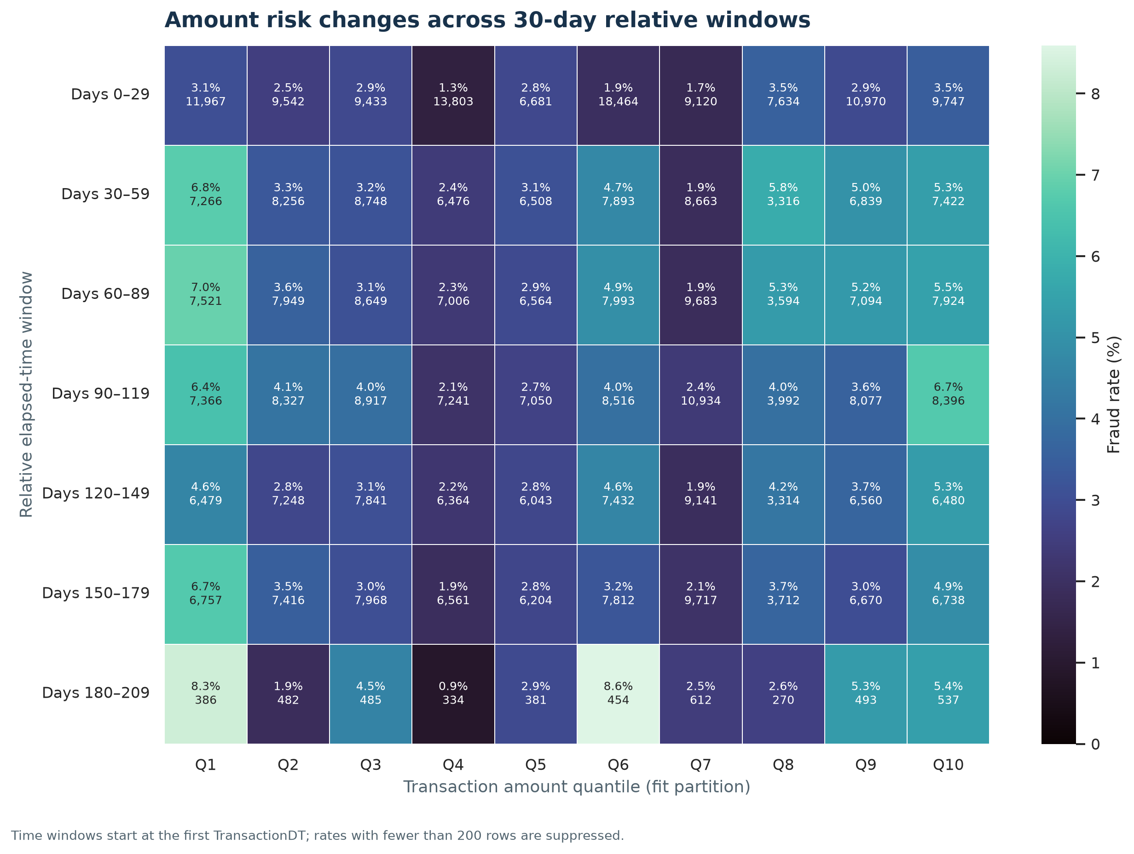
Figure 6. Relative time by amount risk heatmap.

What it shows
The highest supported time × amount cell is elapsed window 7 / Q6 at 8.59% (454 rows).

Why it matters
The view can help prioritize time-aware monitoring of amount bands. It does not establish why a rate changes or predict future performance.
Calculation: Rows are grouped into 30-day elapsed windows and amount quantiles; supported cells show fraud rate and transaction count.

Visualization 7 Numeric field associations with fraud
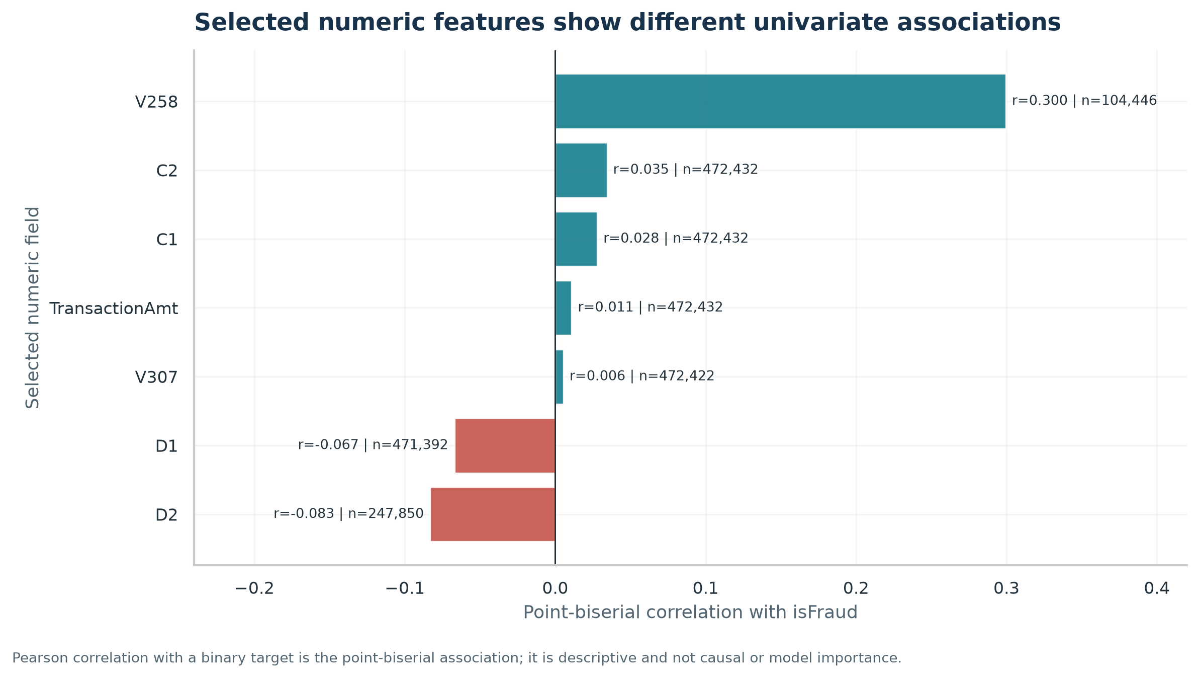
Figure 7. Numeric field associations with fraud.

What it shows
Among selected numeric fields, V258 has the largest absolute point-biserial association (r=0.300; n=104,446).

Why it matters
These associations can guide later feature review, but they are not causal effects, adjusted comparisons, or trained-model importance scores.
Calculation: For each selected field, Pearson correlation with the binary target is calculated over its nonmissing fit rows; this is the point-biserial correlation.

Evidence-based findings
1. The v2 split retained nearly identical fraud rates: 3.499% in 472,432 fit rows and 3.499% in 118,108 validation rows.
Business implication: The held-out validation partition preserves the rare-event mix, so later model evaluation can compare performance without a large class-rate shift.
Evidence: split_manifest.json: fit fraud=16,530; validation fraud=4,133; random_state=42.
2. Q10 contributes 45.4% of the total transaction-amount sum; its observed fraud rate is 5.14% across 47,244 fit rows.
Business implication: Amount exposure and fraud frequency are different views. Monitoring should retain both, rather than treating the largest-amount segment as automatically the highest-rate segment.
Evidence: Training-fit amount quantiles; amount sums and fraud rates are computed directly from the selected rows.
3. Across supported 30-day relative windows, the highest pooled rate is 4.35% in window 7 (193/4,434); the lowest is 2.51% in window 1 (2,698/107,361).
Business implication: The observed variation motivates time-based monitoring. The dataset uses elapsed time, so it cannot support calendar-season explanations by itself.
Evidence: 30-day bins begin at the minimum TransactionDT; periods below 1,000 rows are excluded from this comparison.
4. The highest supported ProductCD × card6 cell is ProductCD C with card6 credit: 16.68% fraud across 22,002 rows.
Business implication: Category combinations may be useful segments for further review, with counts and uncertainty checked before operational use.
Evidence: Two-way group aggregation; only cells with at least 200 rows are ranked.
5. The highest supported ProductCD × amount-quantile cell is ProductCD H / Q10, at 39.05% across 630 rows.
Business implication: Risk differences can vary within a product category by amount band; aggregate category rates can hide these pockets.
Evidence: Rates are computed from raw TransactionAmt quantiles and isFraud in the training-fit partition; support threshold=200.
6. The highest supported 30-day-time × amount-quantile cell is window 7 / Q6, at 8.59% across 454 rows.
Business implication: Amount-band monitoring may need to account for changes over the transaction sequence rather than relying on one global rate.
Evidence: Time windows are 30 elapsed days from the first TransactionDT; cells below 200 rows are not ranked.
7. Among the seven selected numeric fields, V258 has the largest absolute point-biserial association with isFraud (r=0.300, pairwise n=104,446).
Business implication: This is a screening signal for later feature review, not a claim of causation or evidence that a trained model would rank it as important.
Evidence: Pairwise Pearson correlation with the binary target, calculated on all nonmissing training-fit values for each selected field.

Conclusion
The training-fit data show measurable variation by amount band, relative time, and combinations of transaction categories. The v2 split retains the rare fraud class at nearly the same rate in fit and validation. These charts support careful feature review and monitoring design; they do not demonstrate causation or model quality. No Week 3 work or machine-learning model is included.

Reproducible files
- .\week2_visualization\Week2_Advanced_Visualization_Storytelling.docx
- .\week2_visualization\week2_visualization.py
- .\week2_visualization\week2_metrics.json
- .\week2_visualization\findings.md
- .\week2_visualization\verification.json
- .\week2_visualization\charts

