Week 3 Statistical Analysis and Hypothesis Testing
IEEE-CIS Fraud Detection project

Objective and scope
Test selected, evidence-led questions about differences between fraudulent and legitimate transactions using only the 472,432-row v2 training-fit partition (16,530 fraud, 455,902 legitimate). Week 1 EDA and Week 2 findings guide the questions; no earlier work is repeated. The validation/test labels and all test records are excluded from these tests.

Data and methods
The script reads six selected columns from the existing cleaned training table, filters rows by TransactionID from the v2 training-fit file, and verifies row counts and target values against the split manifest. TransactionID is only a join key and is not tested as a feature. Amount is right-skewed, so Mann–Whitney U is primary; Welch’s t-test on log1p amount is a sensitivity analysis. Pearson chi-square is used for categorical associations. All expected cell counts are checked. Six p-values are adjusted together with Holm’s method to limit familywise false positives.
Effect sizes are reported with 95% intervals: Cliff’s delta uses an asymptotic placement-based standard error; Hedges’ g uses a large-sample approximate interval; Cramér’s V intervals use 600 multinomial bootstrap replicates from the observed contingency table. Wilson intervals support the descriptive category and availability charts. Results are observational and do not show causes.

Hypotheses and results

Transaction amount distribution
H₀: Fraudulent and legitimate transaction amounts have the same distribution.
H₁: Their transaction-amount distributions differ.
Two-sided Mann–Whitney U, asymptotic with tie correction; statistic=3.7546e+09; p=0.4354; Holm-adjusted p=0.8708; n fraud=16,530, legitimate=455,902. Effect: Cliff's delta (fraud minus legitimate)=-0.0036, 95% CI [-0.0136, 0.0065].
Do not reject H₀ at familywise α=0.05. Transactions are treated as independent observational units. Amounts are continuous/ordinal with ties allowed; distributions are highly skewed, so the test is interpreted as a distribution/rank difference, not a pure median test.
Observed medians: fraud=$75.00; legitimate=$68.50. The rank test compares the full distributions, so a significant result does not by itself prove only the medians differ.

Mean log transaction amount (sensitivity)
H₀: The mean log1p transaction amount is equal for fraudulent and legitimate transactions.
H₁: The mean log1p transaction amount differs.
Two-sided Welch t-test on log1p(TransactionAmt), unequal variances; statistic=-0.72686; p=0.4673; Holm-adjusted p=0.8708; n fraud=16,530, legitimate=455,902. Effect: Hedges' g on log1p amounts=-0.0067, 95% CI [-0.0223, 0.0088].
Do not reject H₀ at familywise α=0.05. Independent groups; unequal variances are allowed by Welch's test. Log1p reduces amount skew; with large group sizes, the mean difference is asymptotically robust. The result is on the transformed scale.
Mean log1p difference (fraud minus legitimate)=-0.0063, 95% CI [-0.0234, 0.0107]. This sensitivity result checks whether the amount conclusion is also visible on a transformed mean scale.

ProductCD and fraud status
H₀: ProductCD category and fraud status are independent.
H₁: ProductCD category and fraud status are associated.
Pearson chi-square test of independence; statistic=13090; p=<1e-300 (floating-point underflow); Holm-adjusted p=<1e-300 (floating-point underflow); n=472,432. Effect: Cramer's V=0.1665, 95% CI [0.1623, 0.1704].
Reject H₀ at familywise α=0.05. Rows are independent observational units. All expected cell counts must be at least 5; checked from the computed expected-frequency table.

card6 and fraud status
H₀: card6 category and fraud status are independent.
H₁: card6 category and fraud status are associated.
Conditional Monte Carlo Pearson chi-square test (fixed margins; sparse expected counts); statistic=4726.8; p=5e-05; Holm-adjusted p=0.00015; n=472,432. Effect: Cramer's V=0.1000, 95% CI [0.0970, 0.1034].
Reject H₀ at familywise α=0.05. Rows are independent observational units. Sparse expected cells make the asymptotic chi-square approximation unsuitable; the p-value is estimated under fixed margins by conditional Monte Carlo simulation.

V258 missingness and fraud status
H₀: Whether V258 is missing is independent of fraud status.
H₁: V258 missingness is associated with fraud status.
Pearson chi-square test of independence (2×2); statistic=7059.1; p=<1e-300 (floating-point underflow); Holm-adjusted p=<1e-300 (floating-point underflow); n=472,432. Effect: Cramer's V=0.1222, 95% CI [0.1189, 0.1255].
Reject H₀ at familywise α=0.05. Rows are independent observational units. All expected cell counts must be at least 5; checked from the computed expected-frequency table.
V258 is observed for 48.7% of fraud rows and 21.1% of legitimate rows. Missingness may encode availability/collection processes and should not be interpreted as a fraud mechanism.

Observed V258 value distribution
H₀: Among transactions with observed V258, its distribution is the same for fraudulent and legitimate transactions.
H₁: The observed V258 distributions differ.
Two-sided Mann–Whitney U, asymptotic with tie correction; pairwise-complete rows only; statistic=5.7924e+08; p=<1e-300 (floating-point underflow); Holm-adjusted p=<1e-300 (floating-point underflow); n fraud=8,058, legitimate=96,388. Effect: Cliff's delta (fraud minus legitimate)=0.4915, 95% CI [0.4800, 0.5030].
Reject H₀ at familywise α=0.05. Independent observational rows; missing V258 values are excluded pairwise. Because V258 is missing for many transactions, this complete-case comparison can describe only the observed subset; missingness is tested separately.
This comparison includes only observed V258 values (fraud n=8,058; legitimate n=96,388); it does not represent rows where V258 is missing.

Consolidated test table
Measure | Test | Statistic | p-value | Holm p | Effect size (95% CI)
TransactionAmt | Two-sided Mann–Whitney U | 3.75e+09 | 0.4354 | 0.8708 | Cliff's delta (fraud minus legitimate): -0.004 [-0.014, 0.006]
log1p(TransactionAmt) | Two-sided Welch t-test on log1p(TransactionAmt) | -0.727, df=17392.1 | 0.4673 | 0.8708 | Hedges' g on log1p amounts: -0.007 [-0.022, 0.009]
ProductCD | Pearson chi-square test of independence | 1.31e+04, df=4.0 | <1e-300 (floating-point underflow) | <1e-300 (floating-point underflow) | Cramer's V: 0.166 [0.162, 0.170]
card6 | Conditional Monte Carlo Pearson chi-square test (fixed margins; sparse expected counts) | 4.73e+03, df=4.0 | 5e-05 | 0.00015 | Cramer's V: 0.100 [0.097, 0.103]
V258 missingness | Pearson chi-square test of independence (2×2) | 7.06e+03, df=1.0 | <1e-300 (floating-point underflow) | <1e-300 (floating-point underflow) | Cramer's V: 0.122 [0.119, 0.126]
Observed V258 values | Two-sided Mann–Whitney U | 5.79e+08 | <1e-300 (floating-point underflow) | <1e-300 (floating-point underflow) | Cliff's delta (fraud minus legitimate): 0.492 [0.480, 0.503]
Interpret p-values alongside effect sizes, intervals, sample sizes, and the Holm-adjusted decision. Very small p-values can occur for modest effects in large datasets. Values below the floating-point range are displayed as <1e-300 rather than as zero in this report; the raw JSON stores the numeric underflow as 0 and flags it.

Visual evidence and business interpretation

Figure 1. Amount by target
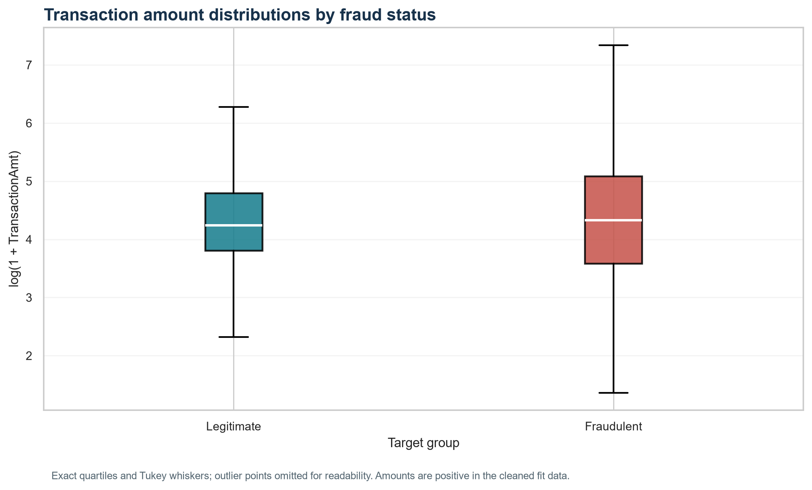
The box plots show the shifted and skewed amount distributions on log1p scale. The difference motivates segment monitoring, while the rank effect size describes how often a randomly selected fraud amount exceeds a legitimate amount, with ties handled neutrally.

Figure 2. ProductCD fraud rates
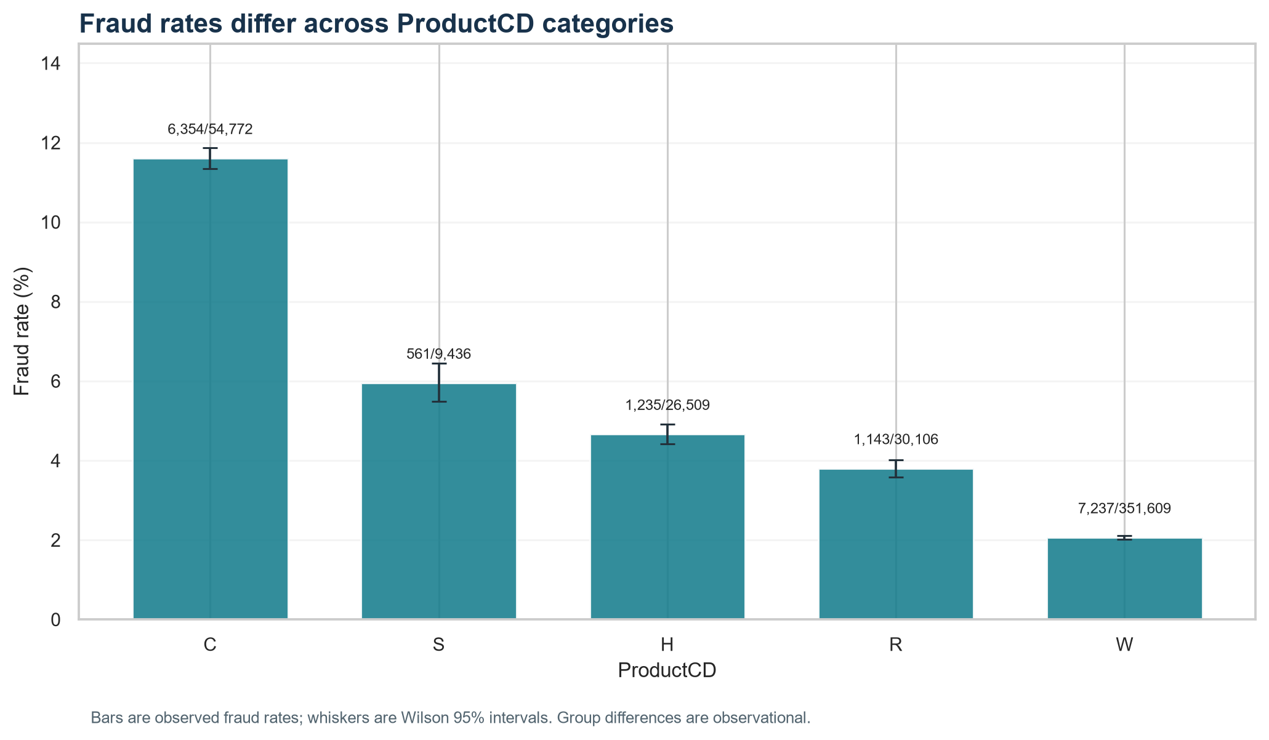
Observed fraud rates differ among product categories; Wilson intervals and numerator/denominator labels show uncertainty and support. Category-level rates can help prioritize review, but this dataset cannot tell why categories differ.

Figure 3. card6 fraud rates
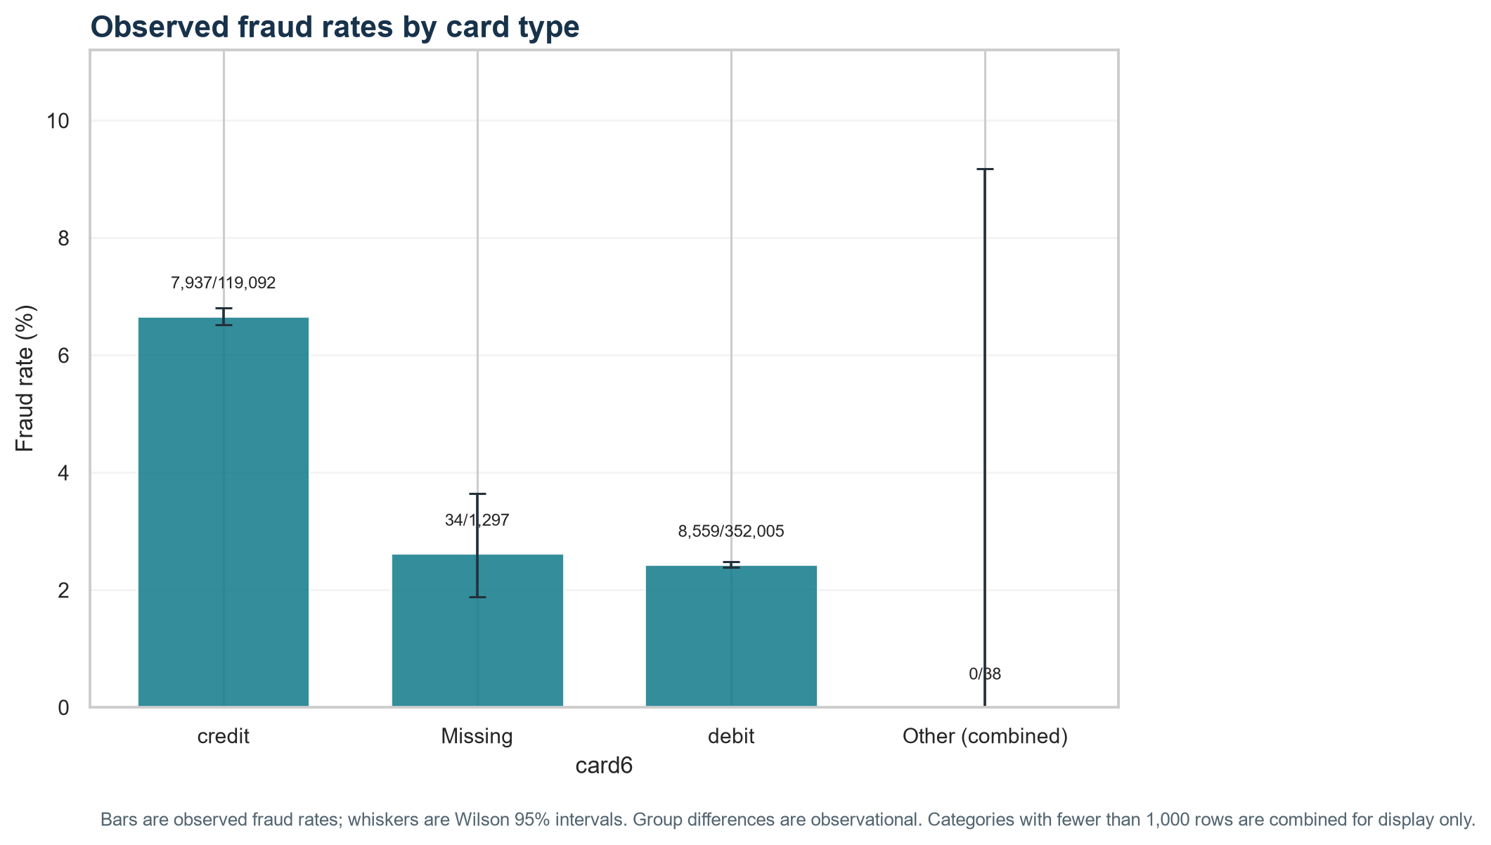
Card type segments have different observed fraud rates. Keep segment volume and uncertainty in view before using such patterns for operational decisions.

Figure 4. V258 availability
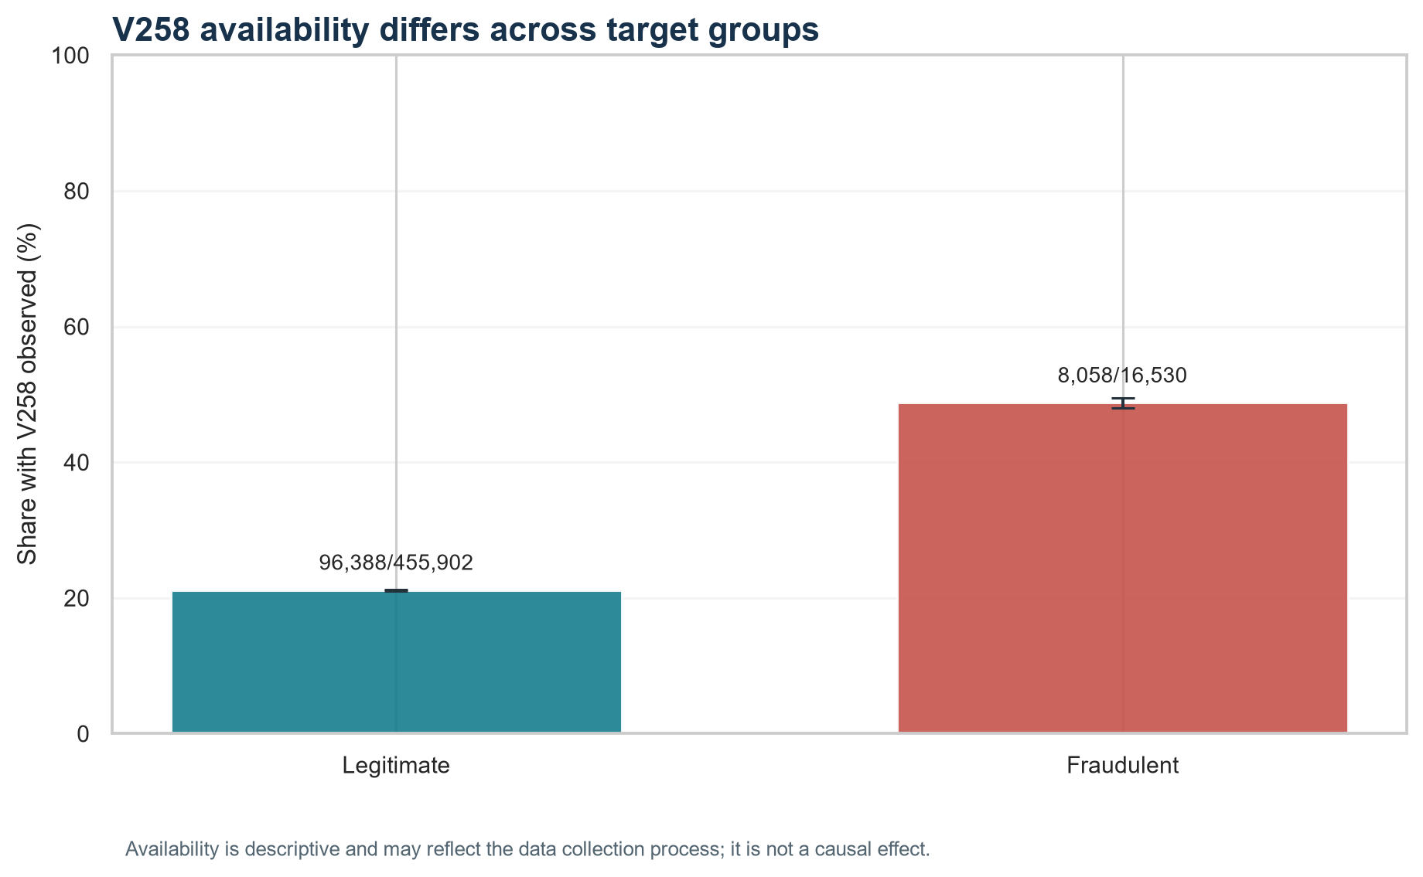
The fraction of rows with V258 present differs by target group. This is a data availability pattern and could reflect collection processes, so it should not be treated as causal evidence.

Reproducibility and code snippets
The full script and exact run command are in the Week 3 folder. Core tests are:
stats.mannwhitneyu(fraud_amount, legitimate_amount, alternative='two-sided', method='asymptotic')
stats.ttest_ind(np.log1p(fraud_amount), np.log1p(legitimate_amount), equal_var=False)
stats.chi2_contingency(pd.crosstab(category, isFraud), correction=False)
The workflow verifies the v2 training-fit key count, unique IDs, target agreement, and fraud counts before testing. Bootstrap confidence intervals use a fixed random seed. Holm correction is implemented in the script and all result values are serialized in week3_results.json.

Limitations
These are unadjusted, observational group comparisons; they do not establish causality or predictive usefulness. Treating transactions as independent is an approximation because cardholders/merchants may contribute multiple transactions. The time-ordered data may have dependence, so this report does not use TransactionDT to claim calendar or causal effects. V258 value comparisons exclude missing rows. Statistical significance does not equal business importance.

Conclusion
After Holm correction, the tests with evidence of differences/association are: ProductCD and fraud status; card6 and fraud status; V258 missingness and fraud status; Observed V258 value distribution. Effect sizes and confidence intervals quantify their magnitude. These patterns can guide later validation and monitoring questions, but no causal interpretation or model performance claim is made. Week 3 only is complete; no test data or model was used.

Output files
- .\week3_statistics\Week3_Statistical_Analysis_and_Hypothesis_Testing.docx
- .\week3_statistics\week3_statistics.py
- .\week3_statistics\verify_week3_statistics.py
- .\week3_statistics\week3_results.json
- .\week3_statistics\week3_group_summaries.csv
- .\week3_statistics\verification.json
- .\week3_statistics\charts

