Week 4 Machine Learning Model Development and Evaluation
IEEE-CIS Fraud Detection project

Objective and data scope
Build and compare compact fraud classifiers using the existing v2 training-fit partition (472,432 rows; fraud rate 3.499%) and evaluate once on its separate stratified validation partition (118,108 rows). The test partition was not opened or used. No earlier cleaning, EDA, or statistical analysis was repeated.

Methodology
A prior-only DummyClassifier provides the baseline. Class-weighted LogisticRegression is a linear model; class-weighted HistGradientBoostingClassifier tests nonlinear splits and interactions. The selected compact inputs are seven numeric fields and four categorical fields informed by Week 1–3 findings. TransactionID is a key only; isFraud is the label; TransactionDT is excluded from features.
The v2 train-fit and validation matrices already contain imputed values and v2 category codes from transforms fitted on train-fit only. StandardScaler and OneHotEncoder are additionally fit on training-fit only, then applied to validation. Category code 0 (missing) and 1 (reserved unseen) receive explicit one-hot columns; an unseen validation code is handled consistently. No resampling or row deletion is used. Class imbalance is addressed by balanced class weights / sample weights without discarding legitimate rows.
The threshold is fixed at 0.50 for precision, recall, F1, and confusion matrices; it is not tuned on validation. PR-AUC is reported as average precision (AP), with the validation fraud prevalence as the no-skill reference. ROC-AUC is included but given less weight because the negative class is much larger.

Code snippets
preprocessor.fit_transform(X_train)
X_valid_t = preprocessor.transform(X_valid)
logit.fit(X_train_t, y_train)
hist.fit(X_train_t, y_train, sample_weight=class_weights[y_train])
average_precision_score(y_valid, model.predict_proba(X_valid_t)[:, 1])
precision_score(y_valid, prob >= 0.50)
recall_score(y_valid, prob >= 0.50)

Model comparison
Model | Accuracy | Precision | Recall | F1 | ROC-AUC | PR-AUC/AP
Prior baseline (Dummy) | 0.9650 | 0.0000 | 0.0000 | 0.0000 | 0.5000 | 0.0350
Logistic Regression (balanced) | 0.7899 | 0.1014 | 0.6366 | 0.1750 | 0.7886 | 0.2748
HistGradientBoosting (weighted) | 0.8343 | 0.1397 | 0.7239 | 0.2341 | 0.8569 | 0.4218
Best validation PR-AUC/AP: HistGradientBoosting (weighted) (0.4218). Baseline AP is the positive-class prevalence (3.499%); accuracy alone would reward predicting the majority legitimate class and can conceal missed fraud.

Train versus validation and error types
Model | Train AP | Validation AP | AP gap | False positives | False negatives
Prior baseline (Dummy) | 0.0350 | 0.0350 | -0.0000 | 0 | 4,133
Logistic Regression (balanced) | 0.2599 | 0.2748 | -0.0149 | 23,309 | 1,502
HistGradientBoosting (weighted) | 0.4090 | 0.4218 | -0.0128 | 18,432 | 1,141
For the selected model at the fixed threshold, 18,432 legitimate transactions were flagged (false positives) and 1,141 fraud cases were missed (false negatives); it detected 2,992 fraud cases. False positives can increase manual review cost; false negatives represent missed fraud exposure. The train–validation AP gap is shown as a basic generalization check, not proof of absence of overfitting.
For this run, HGB AP was 0.4090 on train-fit and 0.4218 on validation (train minus validation=-0.0128); logistic AP was 0.2599 and 0.2748 (gap=-0.0149). Validation AP is slightly higher in both cases, so this comparison shows no conventional train-higher-than-validation AP gap; it does not rule out overfitting on other measures or splits. AP close to the prior baseline on both partitions would suggest underfitting; here both learned models exceed that baseline. Threshold changes trade precision against recall and should be chosen later from operational costs, not by looking at test outcomes.

Evaluation visualizations

Figure 1. 01 Precision Recall Curve
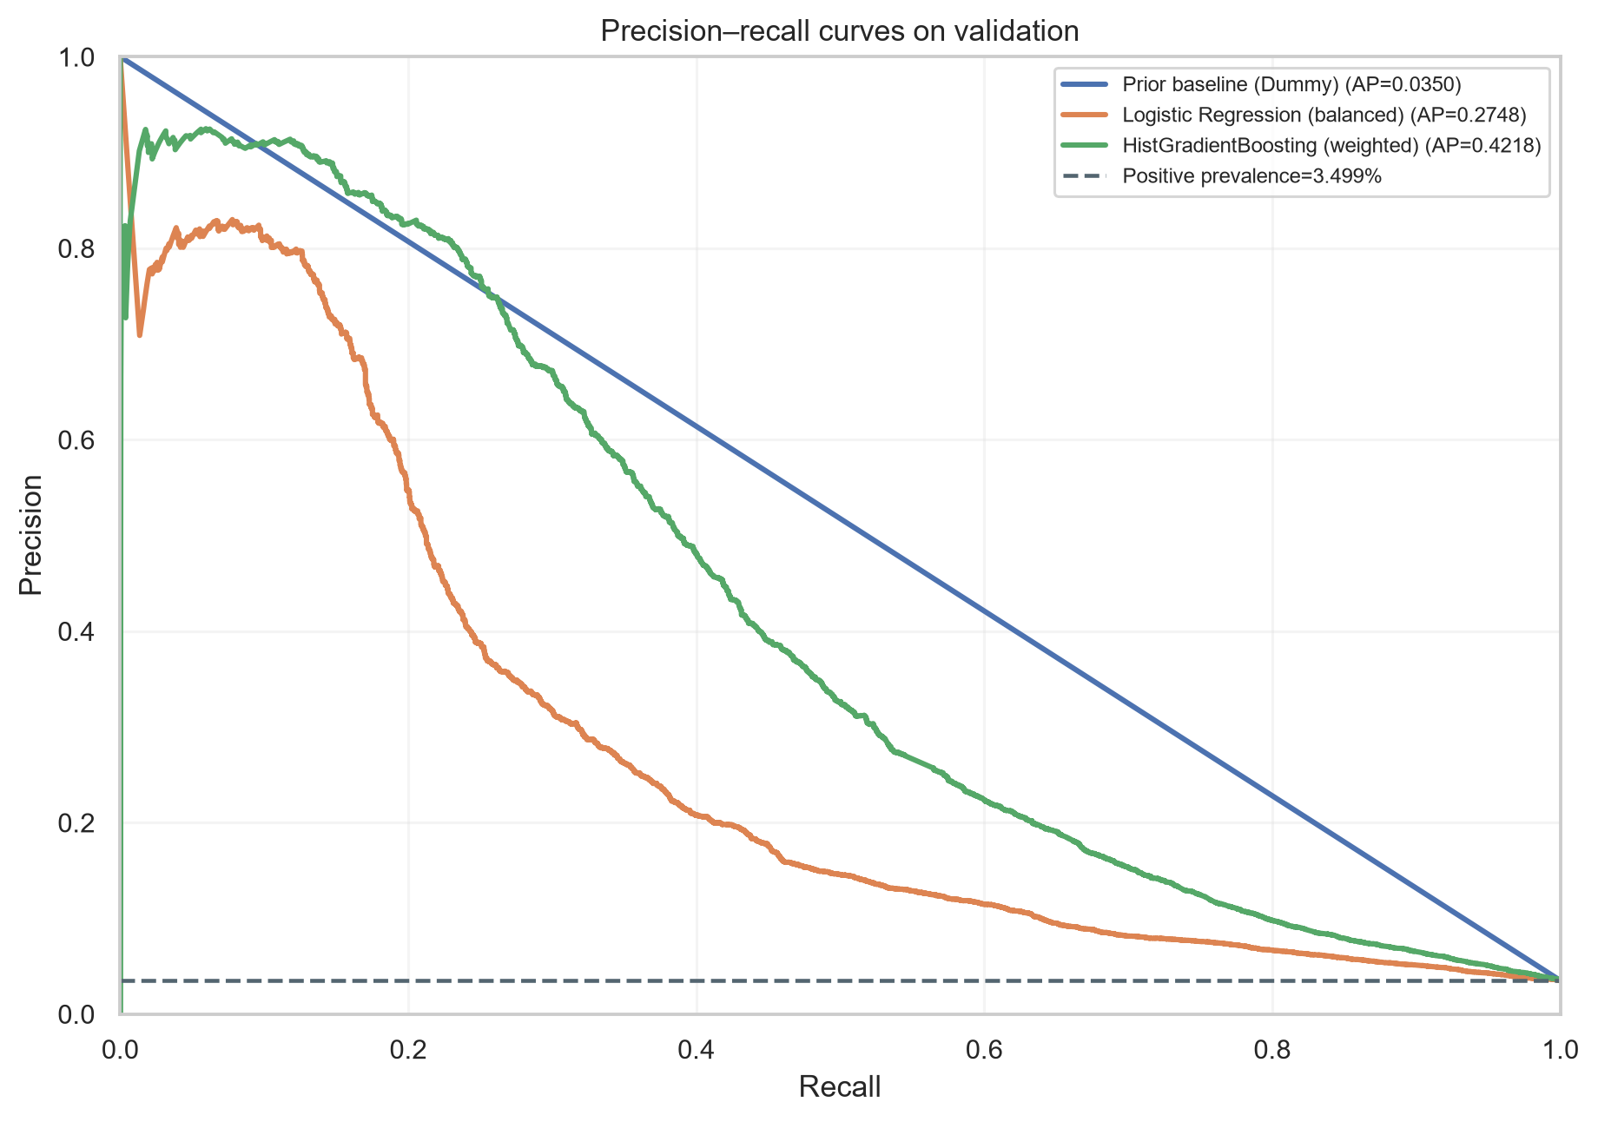
Precision–recall curves focus on the positive fraud class. The dashed baseline is the validation fraud prevalence; curves above it show better ranking than a prior-only score.

Figure 2. 02 Roc Curve
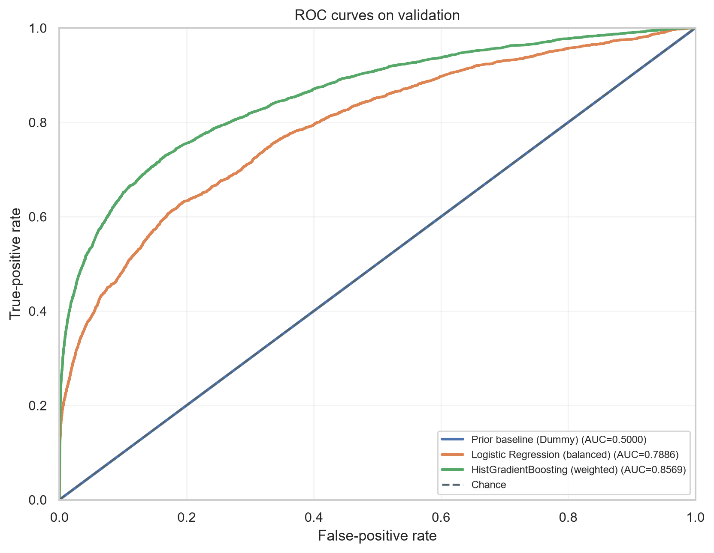
ROC curves compare true-positive and false-positive rates across thresholds. With a dominant legitimate class, ROC-AUC can look strong while precision remains low, so interpret it alongside AP.

Figure 3. 03 Confusion Matrix Best Model
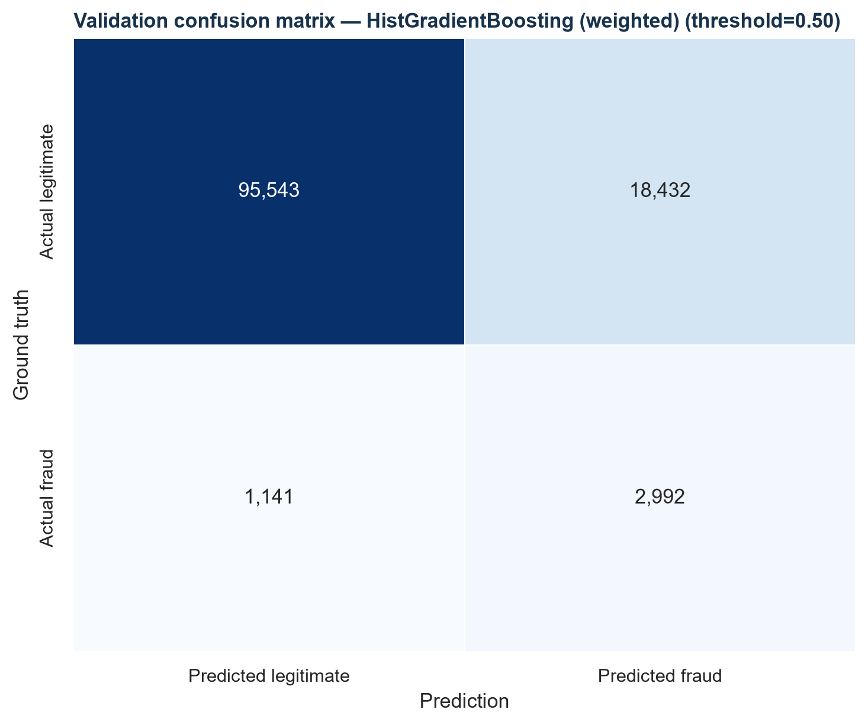
This confusion matrix shows errors at the fixed 0.50 threshold for the model selected by validation AP. The false-positive and false-negative counts support concrete review-cost and missed-fraud discussions.

Findings and possible improvements
The best validation PR-AUC is 0.4218; the prior baseline is 0.0350. The confusion matrix shows the threshold-dependent balance of review alerts and missed fraud. Use PR-AUC to compare ranking, then evaluate threshold-specific business costs. The compact feature subset and fixed model settings make this a Week 4 development baseline, not a final challenge solution.
Possible next improvements include broader feature use with resource-aware validation, tuning based on training-only cross-validation or a separate validation plan, time-aware validation to test drift, threshold selection from explicit review capacity/costs, calibration, and error analysis by supported segments. Do not treat validation repeatedly as a tuning set, and keep the test partition sealed until the agreed final evaluation.

Conclusion
The workflow compares a prior-only baseline with two imbalance-aware classifiers, evaluates them on the fixed validation partition, and reports fraud-focused metrics, error counts, and train–validation AP gaps. No test data, target-derived feature, or earlier output modification was used. Results indicate the next modeling steps, but no Week 5 work is included.

Output files
- .\week4_machine_learning\week4_machine_learning.py
- .\week4_machine_learning\verify_week4_outputs.py
- .\week4_machine_learning\week4_metrics.json
- .\week4_machine_learning\validation_predictions.csv
- .\week4_machine_learning\verification.json
- .\week4_machine_learning\models
- .\week4_machine_learning\charts

