### **Business_Questions_Report 1. Regional Growth Comparison**

* **Question:** How has the energy consumption of **BRICS** nations grown compared to **OECD** nations from 1990 to 2020?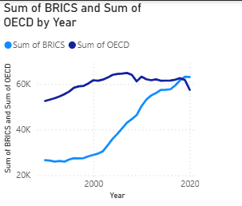
* **Insight:** The data clearly shows a major shift in global energy consumption, with the BRICS nations' consumption rapidly increasing to overtake the OECD nations around 2012.

### **2. Renewable Growth Leader**

* **Question:** Which renewable energy source (Hydro, Solar, Biofuel) experienced the highest percentage growth between 1997 and 2017?

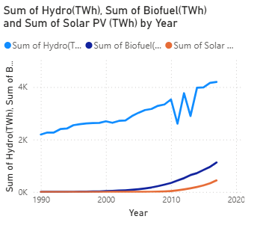

**Insight:** While Hydro-power is the largest single source of renewable energy, Solar PV shows the most explosive growth rate, indicating its rising importance in the renewable mix.

### **3. Country Deep Dive**

* **Question:** What has been the trend of energy consumption in **India and China** versus 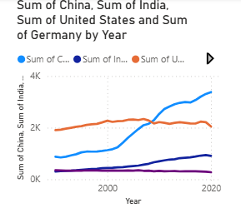the **United States and Germany** over the last 30 years?

**Insight:** The energy consumption of developing industrial powerhouses, China and India, has risen dramatically over the past 30 years, while consumption in established economies like the United States and Germany has remained relatively stable.

### **4. Renewable Generation Mix**

* **Question:** For the top 5 renewable energy-producing countries, what percentage of their total renewable generation comes from **Hydro power**?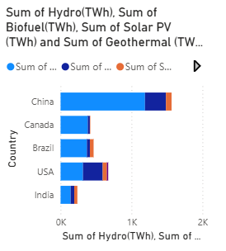
* **Insight:** The world's top renewable energy producers, particularly China, Canada, and Brazil, are heavily reliant on Hydro-power, which forms the backbone of their renewable portfolio.

### **5. Fossil Fuel Dominance**

* **Question:** What is the ratio of **Coal** power generation compared to **all renewable sources combined**?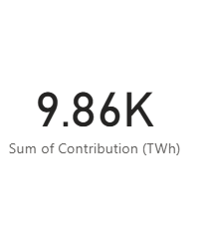
* **Insight:** Despite the growth of renewables, Coal-fired power generation (9.86k TWh) is still significantly higher than all renewable sources combined (6.38k TWh), highlighting the challenge that remains in the energy transition.

### **6. Solar Power Adoption**

* **Question:** Which country in the top 20 list generates the most power from **Solar PV**?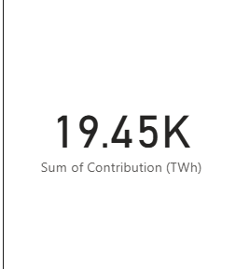
* **Insight:** China is the undisputed global leader in Solar PV generation, producing significantly more than any other nation.

### **7. The Impact of 2020**

* **Question:** How did the global energy consumption in 2020 change compared to 2019, and which continent saw the biggest drop?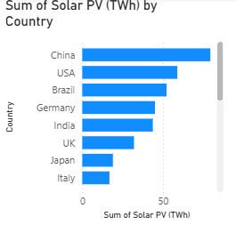
* **Insight:** The year 2020 saw a distinct drop in energy consumption across most major regions, likely due to the global pandemic. This effect was most pronounced in established economies like North America and Europe.

### **8. Energy Independence**

* **Question:** Is there a correlation between the top energy-consuming countries and the top energy-producing countries?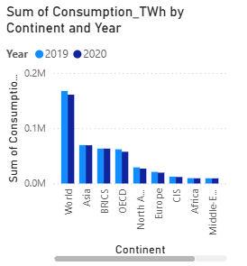

**Insight:** The analysis shows that the top renewable producers, such as China and the USA, are also the highest overall energy consumers. This indicates they are developing renewables to meet massive internal demand rather than for export.