**login.aspx**

<%@ Page Language="C#" AutoEventWireup="true" CodeBehind="login.aspx.cs" Inherits="WebApplication2.login" %>

<form id="form1" runat="server">

<center>

&nbsp;&nbsp;&nbsp;&nbsp;&nbsp;&nbsp;&nbsp;&nbsp;&nbsp;&nbsp;&nbsp;&nbsp;&nbsp;&nbsp;&nbsp;&nbsp;<h1> LOGIN </h1><br />

<br />

Username :&nbsp; <asp:TextBox ID="TextBox1" runat="server" Width="213px"></asp:TextBox>

<br />

<br />

Password :&nbsp;

<asp:TextBox ID="TextBox2" runat="server" Width="213px" TextMode="Password"></asp:TextBox>

<br />

&nbsp;<asp:Label ID="Label1" runat="server" Text=""></asp:Label>

<br />

&nbsp;<asp:Button ID="Button1" runat="server" Height="32px" OnClick="Button1_Click" Text="LOGIN" Width="95px" />

<asp:SqlDataSource ID="SqlDataSource1" runat="server" OnSelecting="SqlDataSource1_Selecting" ConnectionString="<%$ ConnectionStrings:ConnectionString2 %>" SelectCommand="SELECT * FROM [Table]"></asp:SqlDataSource>

</center>

</form>

**login.aspx.cs**

using System;

using System.Collections.Generic;

using System.Configuration;

using System.Data.SqlClient;

using System.Linq;

using System.Web;

using System.Web.UI;

using System.Web.UI.WebControls;

namespace WebApplication2

{

public partial class login : System.Web.UI.Page

{

protected void Page_Load(object sender, EventArgs e)

{

}

protected void Button1_Click(object sender, EventArgs e)

{

SqlConnection d = new SqlConnection(ConfigurationManager.ConnectionStrings["ConnectionString2"].ConnectionString);

d.Open();

string cekuser = "SELECT COUNT(*) FROM [Table] WHERE username = '" + TextBox1.Text + "'";

SqlCommand query = new SqlCommand(cekuser, d);

int jumlah = Convert.ToInt32(query.ExecuteScalar().ToString());

d.Close();

if (jumlah == 1)

{

d.Open();

string passwordsql = "SELECT password FROM [Table] WHERE username ='" + TextBox1.Text + "'";

SqlCommand passquery = new SqlCommand(passwordsql, d);

string password = passquery.ExecuteScalar().ToString();

d.Close();

if (password == TextBox2.Text)

{

Response.Redirect("Biodata.aspx");

}

}

else

{

Label1.Text = "Your username and password is incorect";

}

}

protected void SqlDataSource1_Selecting(object sender, SqlDataSourceSelectingEventArgs e)

{

}

}

}

**Biodata.aspx**

<%@ Page Language="C#" AutoEventWireup="true" CodeBehind="Biodata.aspx.cs" Inherits="WebApplication2.Biodata" %>

<!DOCTYPE html>

<html xmlns="http://www.w3.org/1999/xhtml">

<head runat="server">

<title>Biodata</title>

</head>

<body style="background-color:skyblue">

<font color="blue">

<form id="form1" runat="server">

<center>

<h1>BIODATA</h1>

<table style="width:50%" >

<tr>

<td>Nama</td>

<td>Saidatul Arifah</td>

</tr>

<tr>

<td>Tempat/Tanggal Lahir</td>

<td>Pekalongan, 13 Juli 1999</td>

</tr>

<tr>

<td>Alamat</td>

<td>Bojong, Pekalongan</td>

</tr>

<tr>

<td>Jenis Kelamin</td>

<td>Perempuan</td>

</tr>

<tr>

<td>Agama</td>

<td>Islam</td>

</tr>

</table>

</center>

</form>

</font>

</body>

</html>

**Konfigurasi Database dan Membuat Tabel**

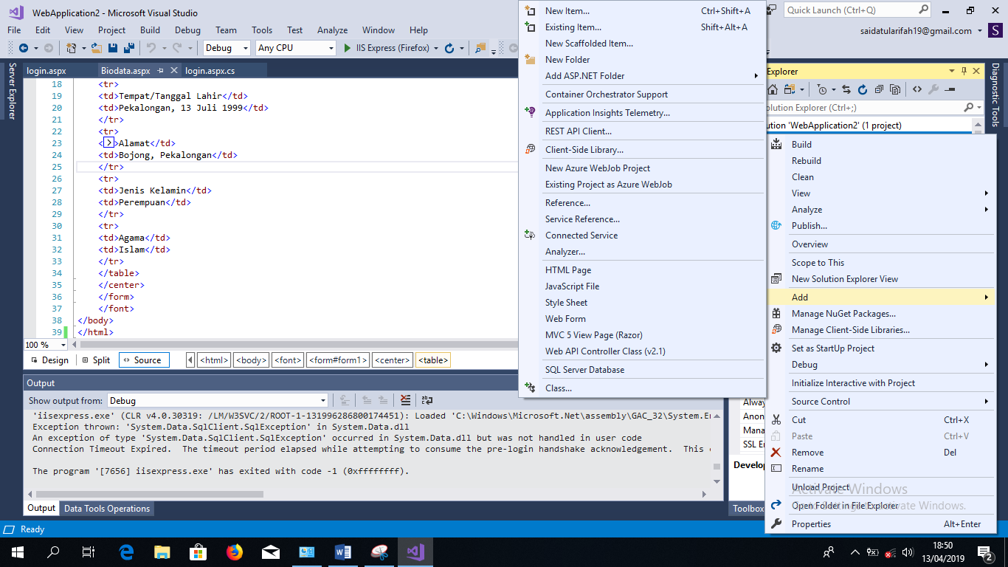

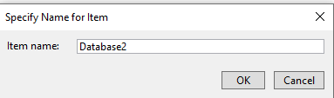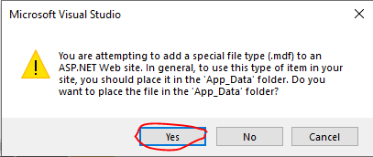

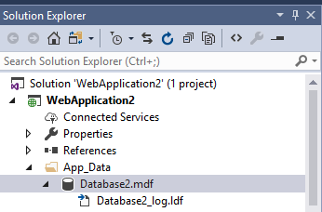

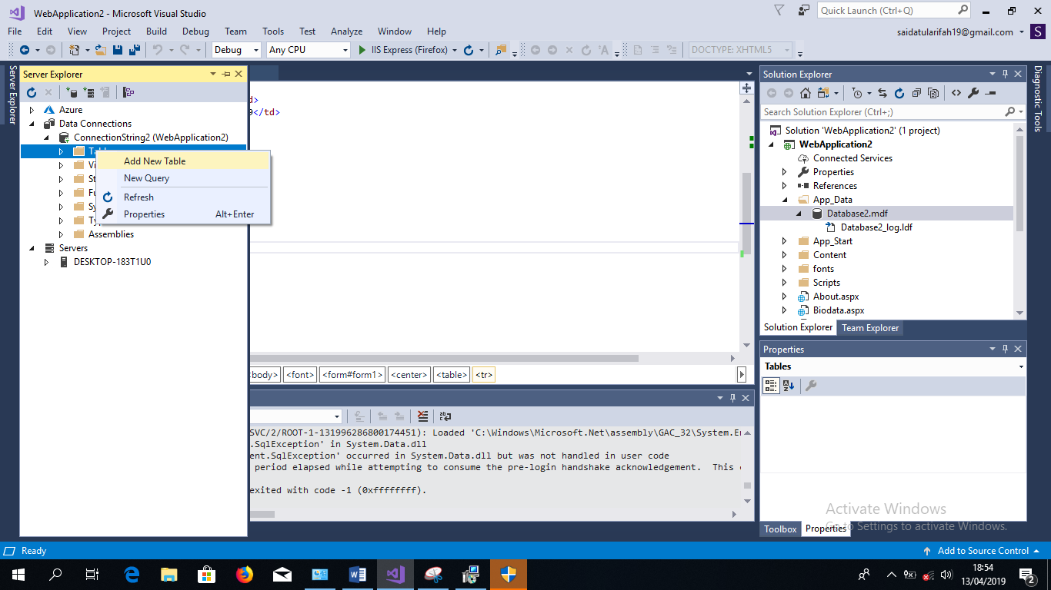

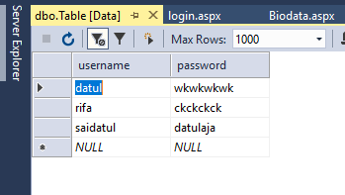

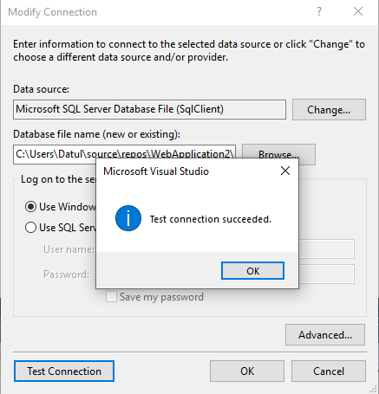

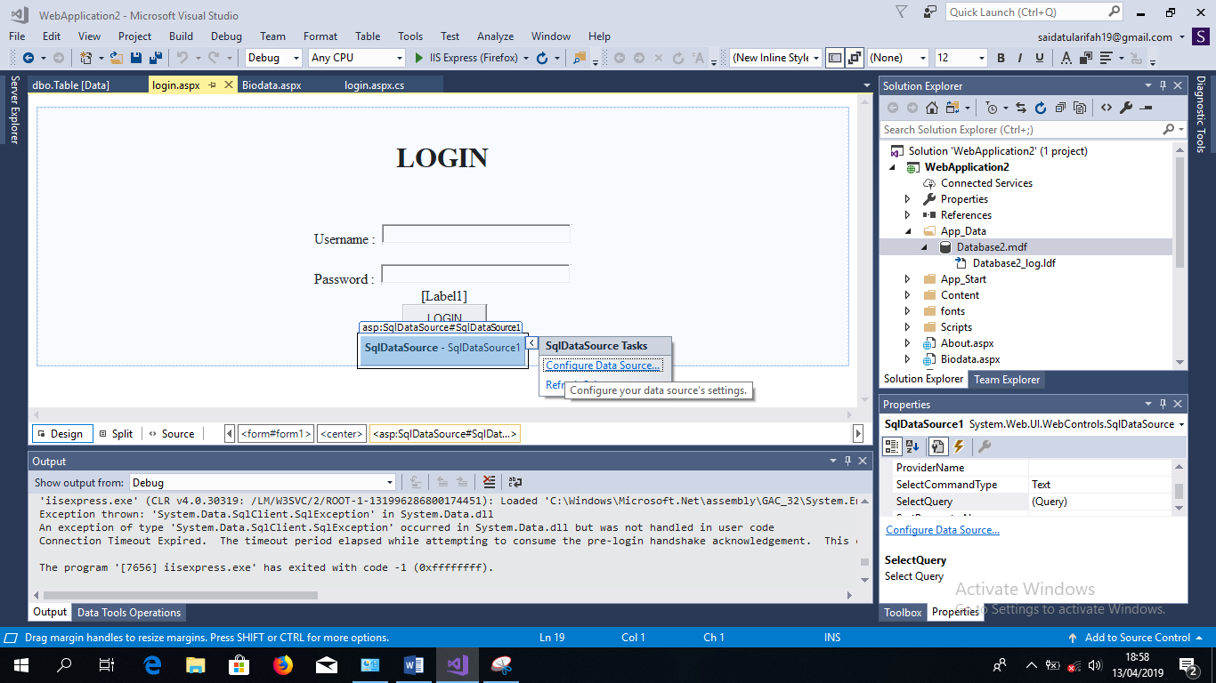

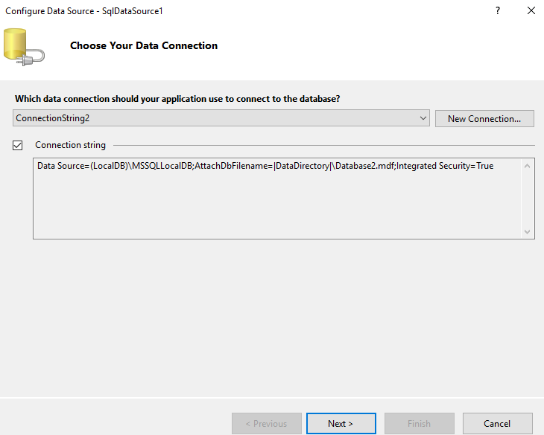

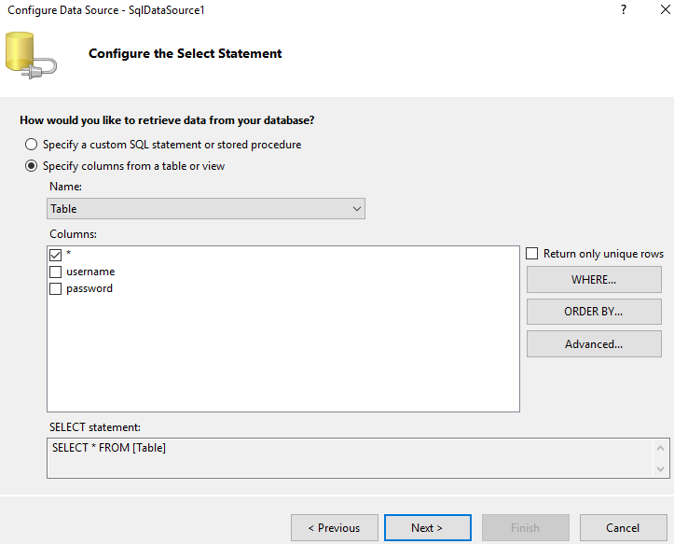

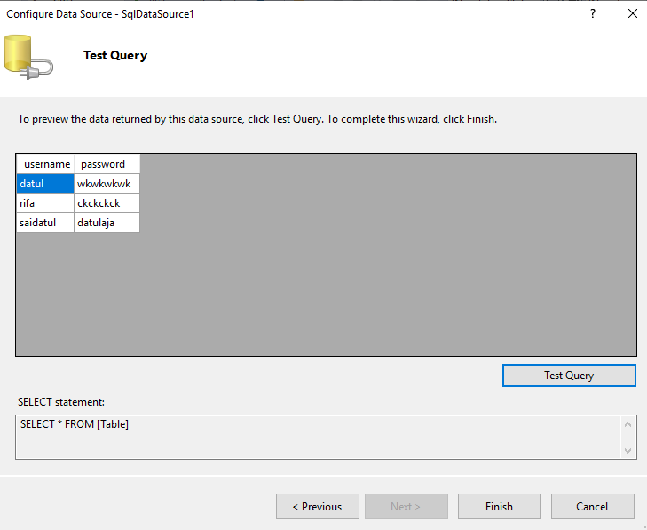

**Output**

