**CODINGAN :**

**login.aspx**

<%@ Page Language="C#" AutoEventWireup="true" CodeBehind="login.aspx.cs" Inherits="WebApplication1.login" %>

<!DOCTYPE html>

<html xmlns="http://www.w3.org/1999/xhtml">

<head runat="server">

<title></title>

</head>

<body>

<form id="form1" runat="server">

<center>

<h1>LOGIN</h1>

<p>

Username :

<asp:TextBox ID="TextBox1" runat="server" Width="193px"></asp:TextBox>

</p>

<p>

Password :

<asp:TextBox ID="TextBox2" runat="server" Width="193px" TextMode="Password"></asp:TextBox>

</p>

<p>

<asp:Label ID="Label1" runat="server" Text=""></asp:Label>

</p>

<asp:Button ID="Button1" runat="server" Height="32px" Text="LOGIN" Width="78px" OnClick="Button1_Click" />

<br />

<asp:SqlDataSource ID="SqlDataSource1" runat="server" ConnectionString="<%$ ConnectionStrings:ConnectionString %>" SelectCommand="SELECT * FROM [Table]"></asp:SqlDataSource>

</center>

</form>

</body>

</html>

**login.aspx.cs**

using System;

using System.Configuration;

using System.Data.SqlClient;

namespace WebApplication1

{

public partial class login : System.Web.UI.Page

{

protected void Page_Load(object sender, EventArgs e)

{

}

protected void Button1_Click(object sender, EventArgs e)

{

SqlConnection d = new SqlConnection(ConfigurationManager.ConnectionStrings["ConnectionString"].ConnectionString);

d.Open();

string cek = "SELECT COUNT(*) FROM [Table] WHERE username = '" + TextBox1.Text + "'";

SqlCommand query = new SqlCommand(cek, d);

int jumlah = Convert.ToInt32(query.ExecuteScalar().ToString());

d.Close();

if (jumlah == 1)

{

d.Open();

string password = "SELECT password FROM [Table] WHERE username = '" + TextBox1.Text + "'";

SqlCommand passquery = new SqlCommand(password, d);

string pass = passquery.ExecuteScalar().ToString();

d.Close();

if (password == TextBox2.Text) ;

{

Response.Redirect("Data.aspx");

}

}

else

{

Label1.Text = "Username atau Password Salah";

}

}

}

}

**Data.aspx**

<%@ Page Language="C#" AutoEventWireup="true" CodeBehind="Data.aspx.cs" Inherits="WebApplication1.WebForm1" %>

<!DOCTYPE html>

<html xmlns="http://www.w3.org/1999/xhtml">

<head runat="server">

<title></title>

</head>

<body>

<form id="form1" runat="server">

<center>

<h1>DATA MAHASISWA</h1>

<asp:GridView ID="GridView1" runat="server" Height="59px" Width="667px" AutoGenerateColumns="False" BackColor="White" BorderColor="#999999" BorderStyle="None" BorderWidth="1px" CellPadding="3" DataKeyNames="NPM" DataSourceID="SqlDataSource1" GridLines="Vertical" OnSelectedIndexChanged="GridView1_SelectedIndexChanged" AllowPaging="True">

<AlternatingRowStyle BackColor="#DCDCDC" />

<Columns>

<asp:CommandField ShowDeleteButton="True" ShowEditButton="True" />

<asp:BoundField DataField="NPM" HeaderText="NPM" ReadOnly="True" SortExpression="NPM" />

<asp:BoundField DataField="NAMA" HeaderText="NAMA" SortExpression="NAMA" />

<asp:BoundField DataField="KELAS" HeaderText="KELAS" SortExpression="KELAS" />

<asp:BoundField DataField="JURUSAN" HeaderText="JURUSAN" SortExpression="JURUSAN" />

<asp:BoundField DataField="FAKULTAS" HeaderText="FAKULTAS" SortExpression="FAKULTAS" />

</Columns>

<FooterStyle BackColor="#CCCCCC" ForeColor="Black" />

<HeaderStyle BackColor="#000084" Font-Bold="True" ForeColor="White" />

<PagerStyle BackColor="#999999" ForeColor="Black" HorizontalAlign="Center" />

<RowStyle BackColor="#EEEEEE" ForeColor="Black" />

<SelectedRowStyle BackColor="#008A8C" Font-Bold="True" ForeColor="White" />

<SortedAscendingCellStyle BackColor="#F1F1F1" />

<SortedAscendingHeaderStyle BackColor="#0000A9" />

<SortedDescendingCellStyle BackColor="#CAC9C9" />

<SortedDescendingHeaderStyle BackColor="#000065" />

</asp:GridView>

<p>

NPM&nbsp;&nbsp;&nbsp;&nbsp; :

<asp:TextBox ID="npm" runat="server" Width="193px"></asp:TextBox>

</p>

<p>

Nama&nbsp;&nbsp;&nbsp; : <asp:TextBox ID="nama" runat="server" Width="193px"></asp:TextBox>

</p>

<p>

Kelas&nbsp;&nbsp;&nbsp; :

<asp:TextBox ID="kelas" runat="server" Width="193px"></asp:TextBox>

</p>

<p>

Jurusan&nbsp; : <asp:TextBox ID="jurusan" runat="server" Width="193px"></asp:TextBox>

</p>

<p>

Fakultas :

<asp:TextBox ID="fakultas" runat="server" Width="193px"></asp:TextBox>

</p>

<p>

&nbsp;&nbsp;&nbsp;&nbsp;&nbsp;&nbsp;&nbsp;&nbsp;&nbsp;&nbsp;&nbsp;&nbsp;&nbsp;&nbsp;&nbsp;&nbsp;

<asp:Button ID="Button1" runat="server" Height="30px" OnClick="Button1_Click" Text="INSERT" Width="73px" />

&nbsp;&nbsp;&nbsp;&nbsp;&nbsp;&nbsp;&nbsp;&nbsp;&nbsp;&nbsp;&nbsp;&nbsp;&nbsp;&nbsp;&nbsp;

<asp:Button ID="Button2" runat="server" Height="30px" Text="RESET" Width="73px" OnClick="Button2_Click" />

</p>

<asp:SqlDataSource ID="SqlDataSource1" runat="server" ConnectionString="<%$ ConnectionStrings:ConnectionString2 %>" SelectCommand="SELECT * FROM [Table]" OnSelecting="SqlDataSource2_Selecting" DeleteCommand="DELETE FROM [Table] WHERE [NPM] = @NPM" InsertCommand="INSERT INTO [Table] (NPM, NAMA, KELAS, JURUSAN, FAKULTAS) VALUES (@NPM, @NAMA, @KELAS, @JURUSAN, @FAKULTAS)" UpdateCommand="UPDATE [Table] SET NAMA = @NAMA, KELAS = @KELAS, JURUSAN = @JURUSAN, FAKULTAS = @FAKULTAS WHERE (NPM = @NPM)">

<DeleteParameters>

<asp:Parameter Name="NPM" Type="Int32" />

</DeleteParameters>

<InsertParameters>

<asp:Parameter Name="NPM" Type="Int32" />

<asp:Parameter Name="NAMA" Type="String" />

<asp:Parameter Name="KELAS" Type="String" />

<asp:Parameter Name="JURUSAN" Type="String" />

<asp:Parameter Name="FAKULTAS" />

</InsertParameters>

<UpdateParameters>

<asp:Parameter Name="NAMA" Type="String" />

<asp:Parameter Name="KELAS" Type="String" />

<asp:Parameter Name="JURUSAN" Type="String" />

<asp:Parameter Name="FAKULTAS" />

<asp:Parameter Name="NPM" Type="Int32" />

</UpdateParameters>

</asp:SqlDataSource>

</center>

</form>

</body>

</html>

**Data.aspx.cs**

using System;

using System.Collections.Generic;

using System.Configuration;

using System.Data.SqlClient;

using System.Linq;

using System.Web;

using System.Web.UI;

using System.Web.UI.WebControls;

namespace WebApplication1

{

public partial class WebForm1 : System.Web.UI.Page

{

private object cmd;

protected void Page_Load(object sender, EventArgs e)

{

}

protected void Button1_Click(object sender, EventArgs e)

{

SqlConnection d = new SqlConnection(ConfigurationManager.ConnectionStrings["ConnectionString2"].ConnectionString);

d.Open();

string cekNpm = "SELECT COUNT(*) FROM [Table] WHERE NPM='" + npm.Text + "'";

SqlCommand query = new SqlCommand(cekNpm, d);

int jumlah = Convert.ToInt32(query.ExecuteScalar().ToString());

d.Close();

if(jumlah != 0)

{

Response.Write("NPM sudah digunakan");

npm.Text = null;

nama.Text = null;

kelas.Text = null;

jurusan.Text = null;

fakultas.Text = null;

}

else

{

d.Open();

string insert = "INSERT INTO [Table] (npm,nama,kelas,jurusan,fakultas) VALUES (@NPM, @Nama, @Kelas, @Jurusan, @Fakultas)";

SqlCommand insertquery = new SqlCommand(insert, d);

insertquery.Parameters.AddWithValue("@NPM", npm.Text);

insertquery.Parameters.AddWithValue("@Nama", nama.Text);

insertquery.Parameters.AddWithValue("@Kelas", kelas.Text);

insertquery.Parameters.AddWithValue("@Jurusan", jurusan.Text);

insertquery.Parameters.AddWithValue("@Fakultas", fakultas.Text);

insertquery.ExecuteNonQuery();

GridView1.DataBind();

d.Close();

npm.Text = null;

nama.Text = null;

kelas.Text = null;

jurusan.Text = null;

fakultas.Text = null;

}

}

protected void Button2_Click(object sender, EventArgs e)

{

npm.Text = null;

nama.Text = null;

kelas.Text = null;

jurusan.Text = null;

fakultas.Text = null;

}

protected void GridView1_SelectedIndexChanged(object sender, EventArgs e)

{

}

protected void SqlDataSource2_Selecting(object sender, SqlDataSourceSelectingEventArgs e)

{

}

}

}

**KONFIGURASI DATABASE DAN TABEL :**

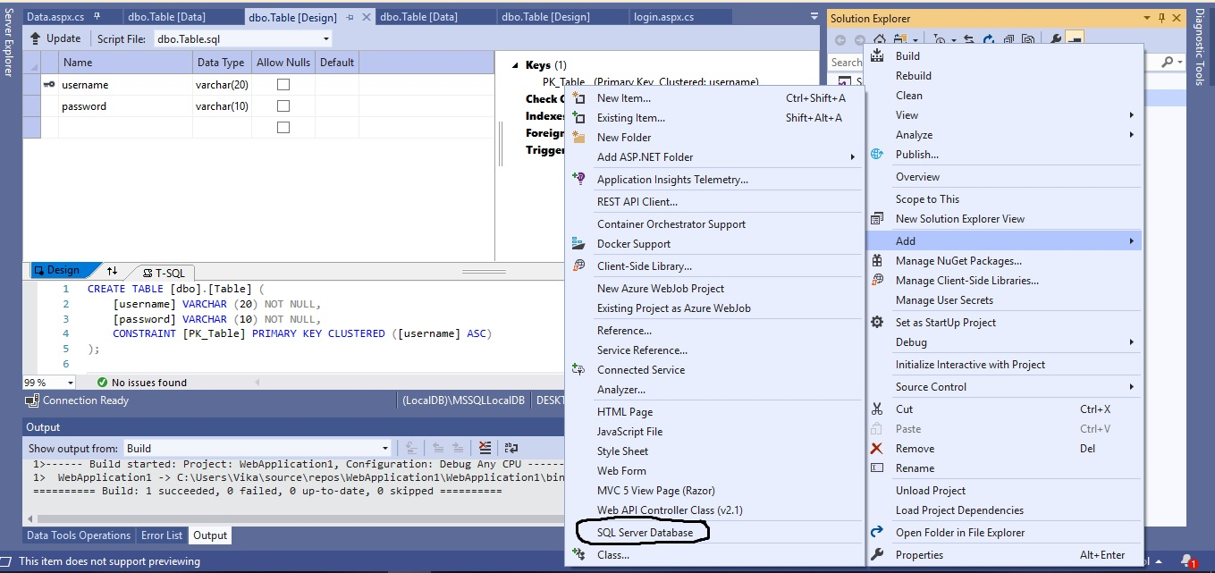

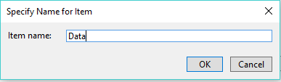 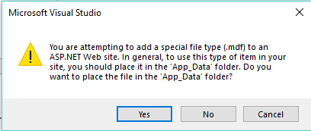

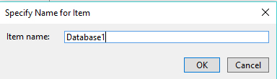 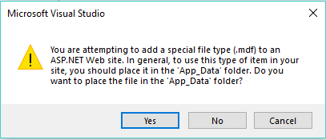

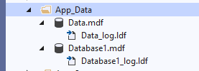 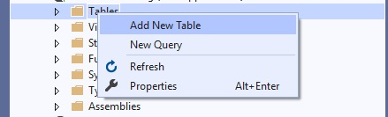

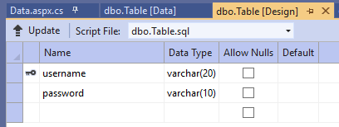 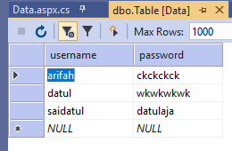

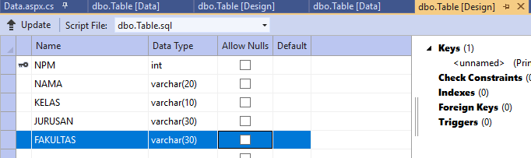 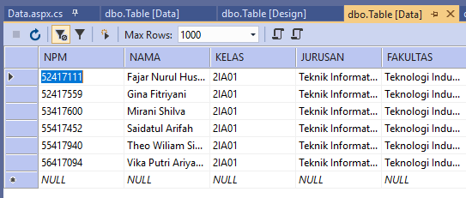

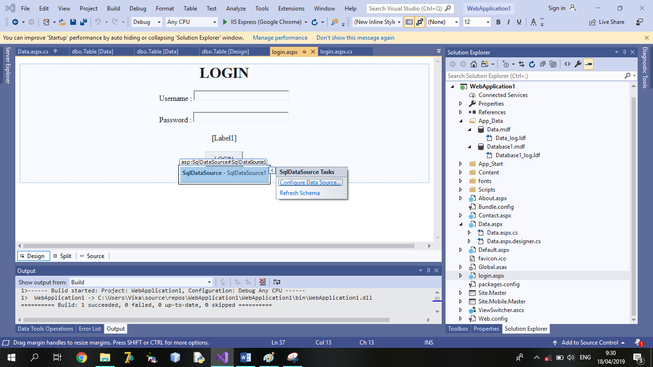

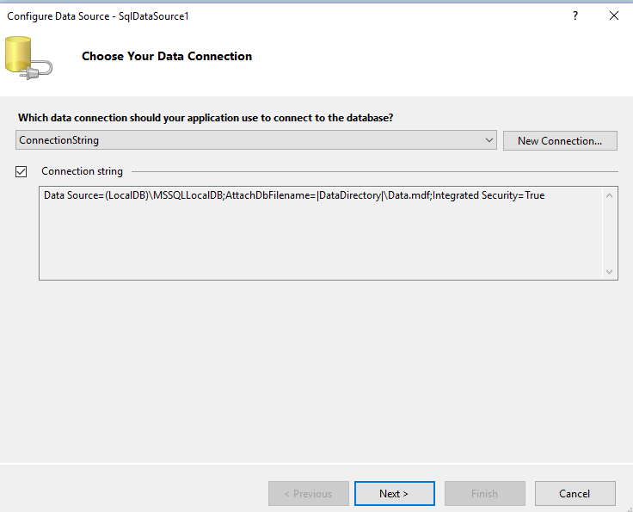

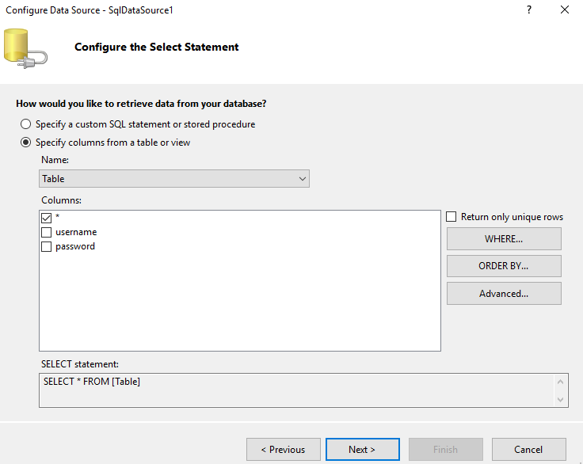

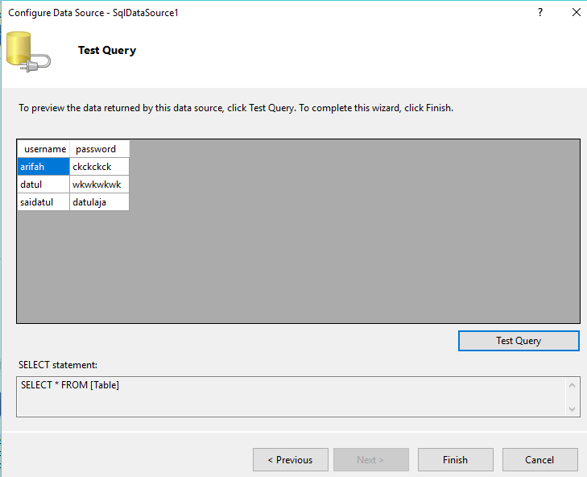

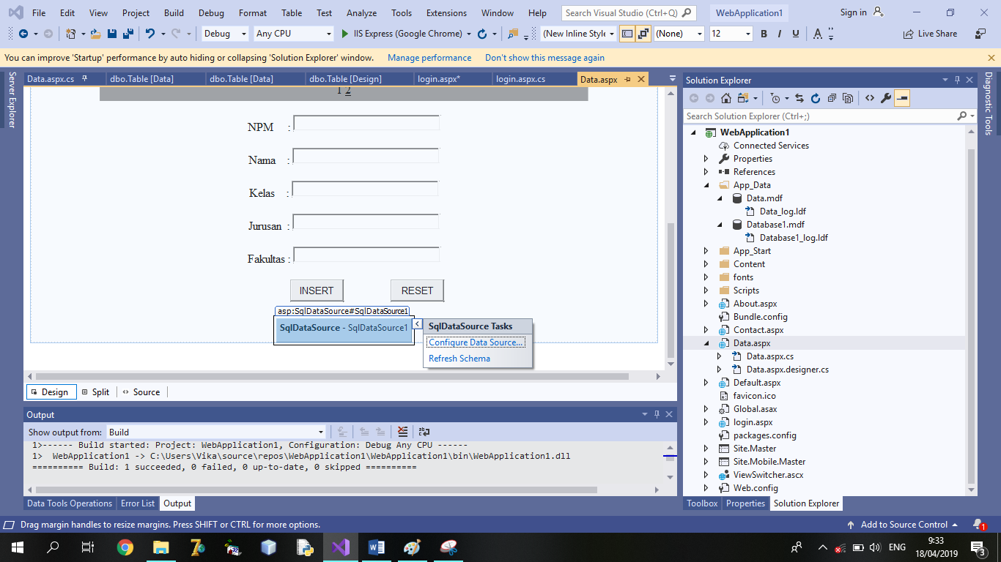

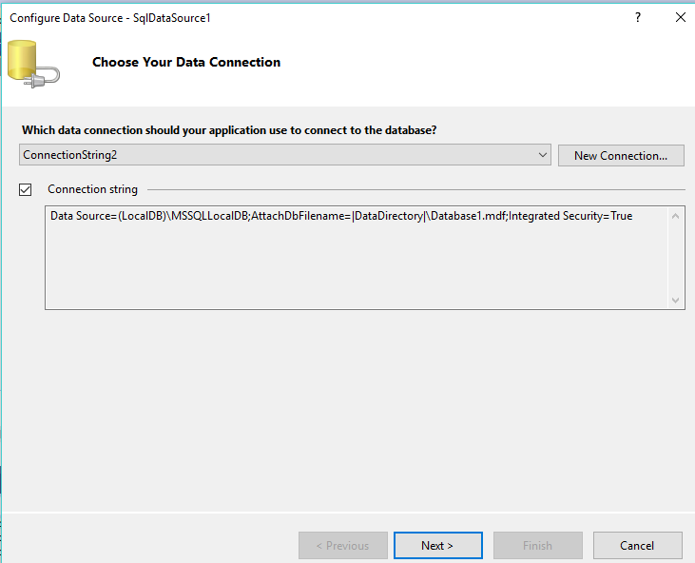

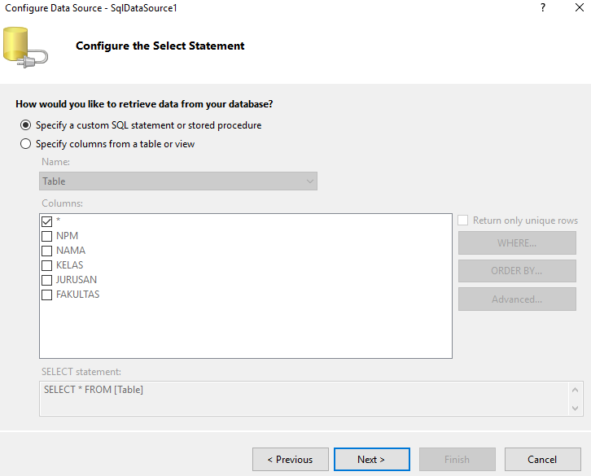

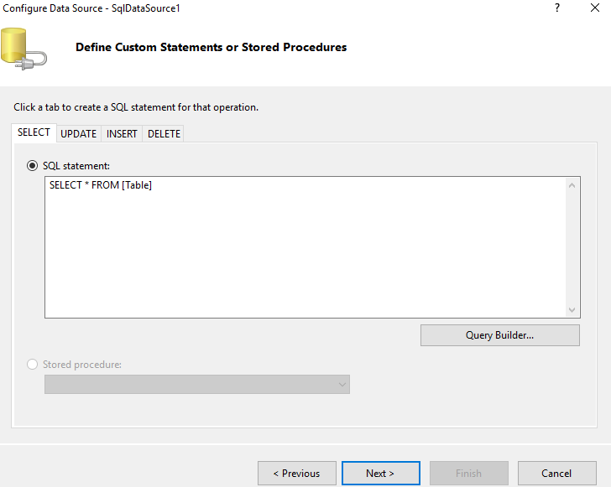

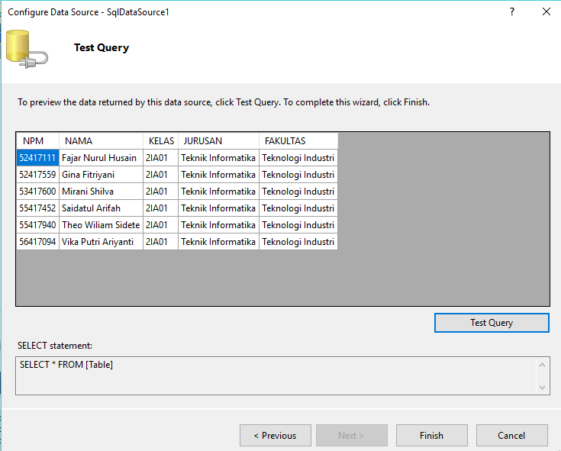

**OUTPUT :**

