

ĐẠI HỌC QUỐC GIA TP. HỒ CHÍ MINH

TRƯỜNG ĐẠI HỌC CÔNG NGHỆ THÔNG TIN

KHOA HỆ THỐNG THÔNG TIN

**Lecture: Trần Vĩnh Khiêm**

**Authors: Đậu Đình Quang Anh**

**Assignment in class** **MSIS207.O11.CTTT**

**Web Application Development**

|  |  |
| --- | --- |
| **STUDENT** | Đậu Đình Quang Anh (20521059) |
| **COMPLETION LEVEL** | Done |
| **SELF-SCORING** | 9/10 |
| **Code of Lap2** |  |

**EXERCISE**

**Ex0**

**EX0.1**

**EX0.2**

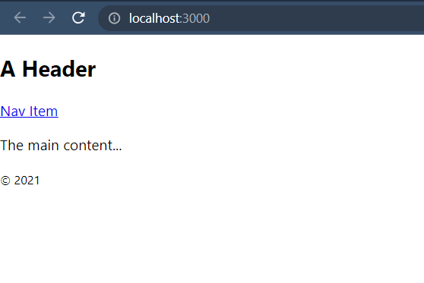

**EX03**

**EX0.4**

**EX1.0**

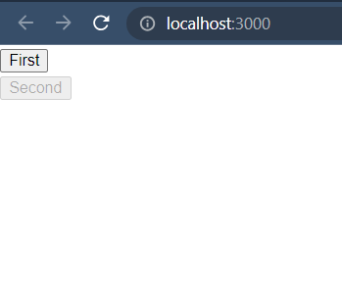

**EX1.1**

**EX1.2**

**EX1.3**

**EX2.1**

**EX2.2**

**EX2.3**

**EX3**

**EX4.1**

**EX4.2**

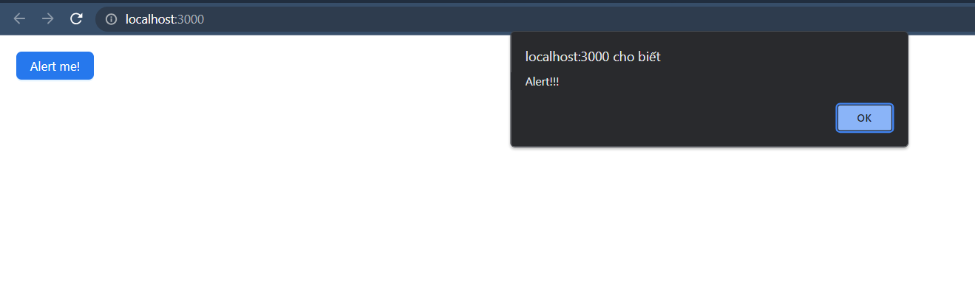

**EX4.3**

**EX4.4**

**EX4.5**

**EX4.6**

**EX4.7**

**HOMEWORK**

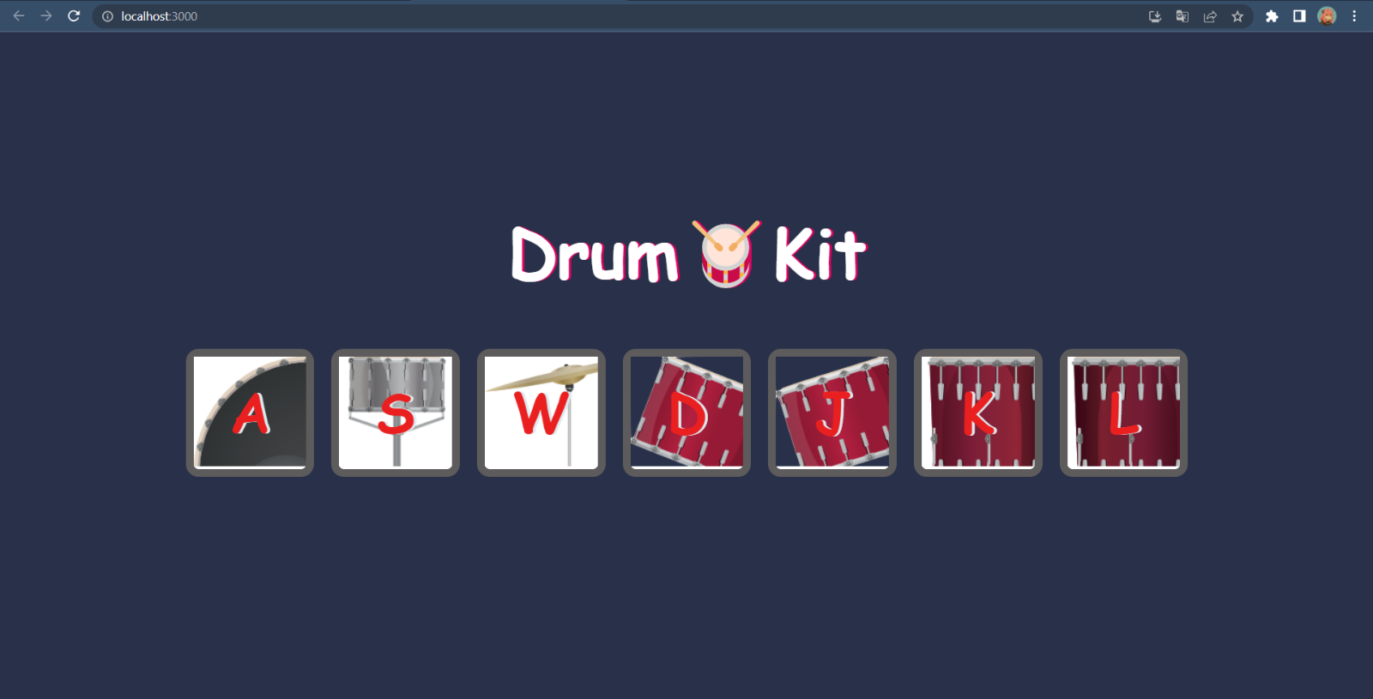**HW1:**

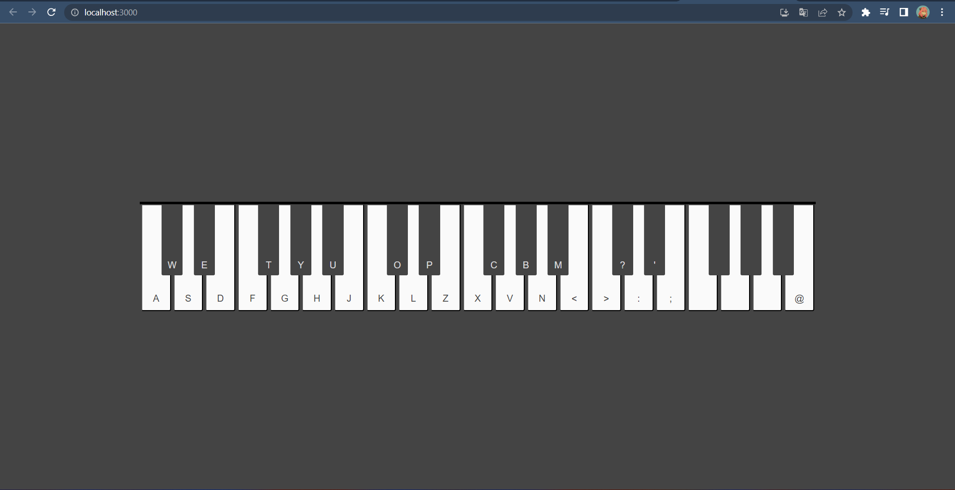**HW2:**

**HW3:**

**HW4:**