Assignment#3

Daud Raza

401920

Advanced Programming for Python

Towers of Hanoi

# Problem Statement:

The towers of Hanoi problem deals with the stacking of discs from one pole to the other pole using and auxiliary pole to add the process.

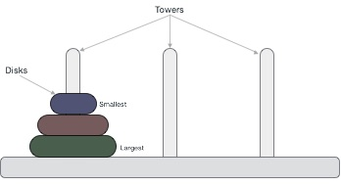

The minimum number of moves to move an **n** number of plates from the starting pole to the end pole can be defined as:

Min_moves = 2n-1

This problem has already been solved via the recursive method, but for this assignment, we will be using an iterative method to solve the problem. After many iterations, the looping was found to be inaccurate for the process using iteration.

