Name:

Dawood Sarfraz

Roll no:

20P-0153

Section:

BSCS-5B

Computer Networks Lab:

Q#01:

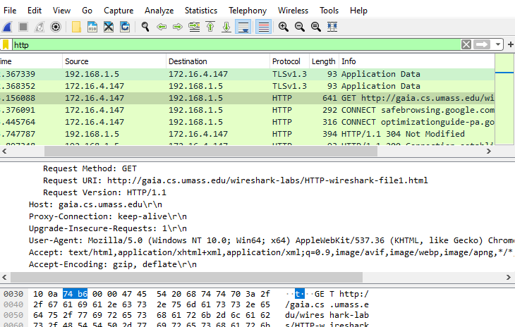

Q#2

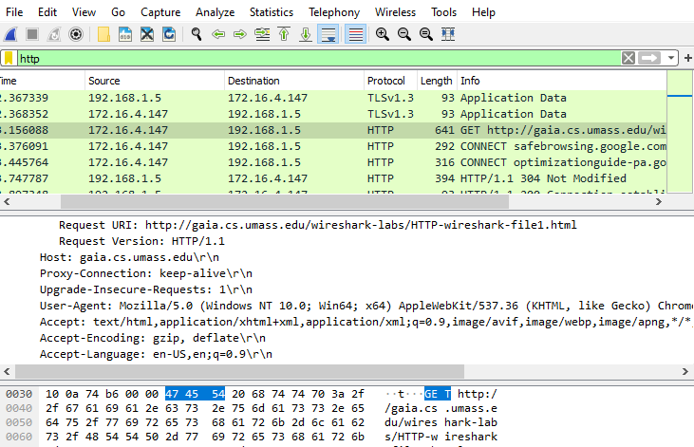

Q#3:

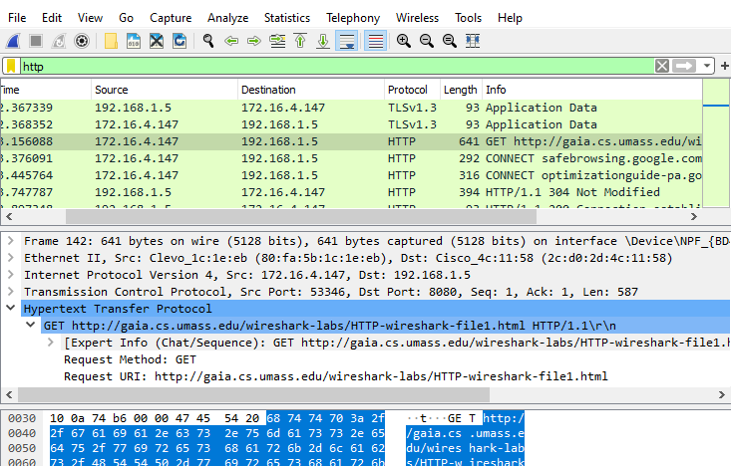

Q#4:

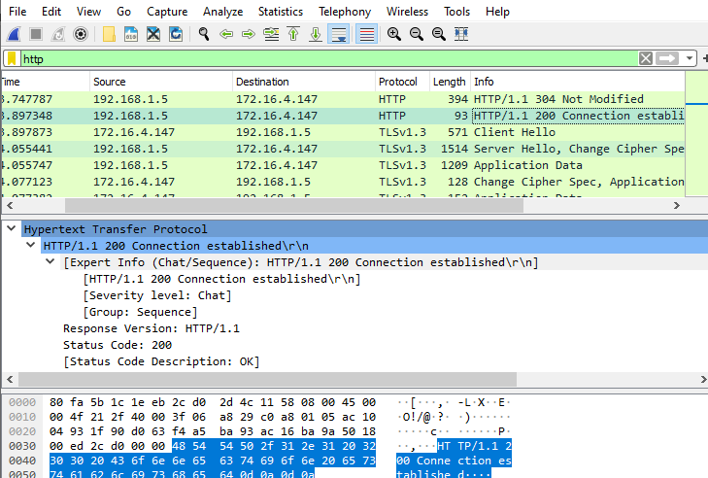

Q#5:

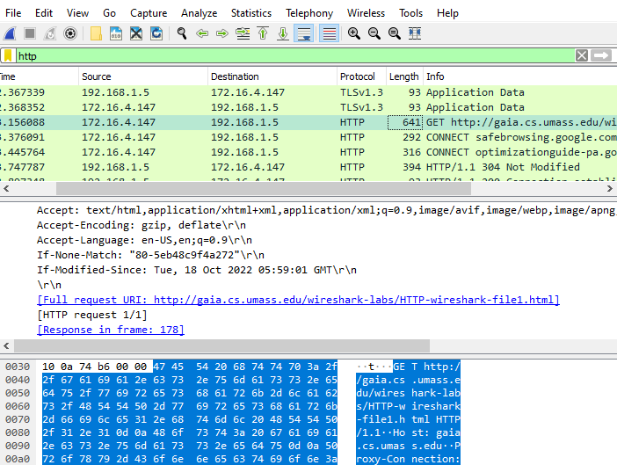

Q#6:

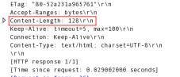

Q#7:

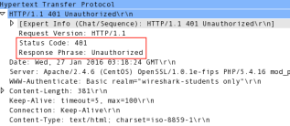 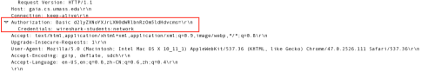 Q#8: