*Name:*

**Dawood Sarfraz**

*Roll no:*

**20p-0153**

*Section:*

**BSCS-5B**

*Lab:*

**#12**

*Quiz:*

**Computer Networks**

**FAST-NUCES Peshawar Campus**

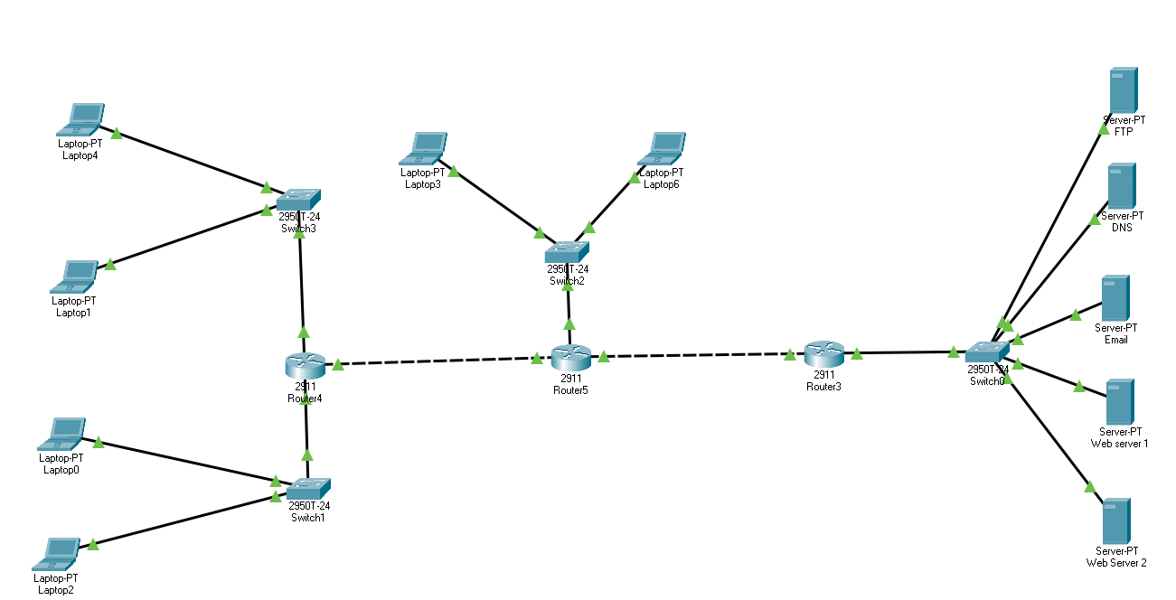

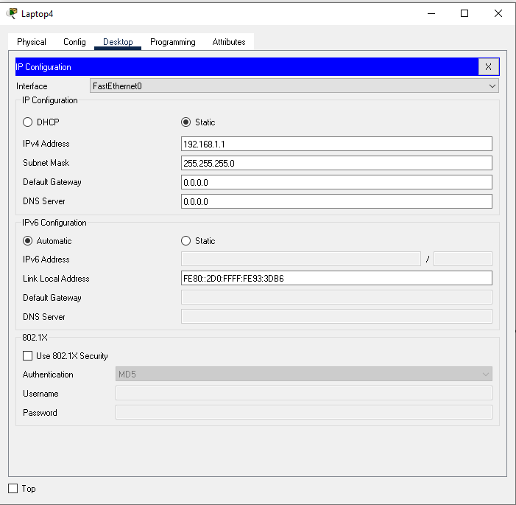

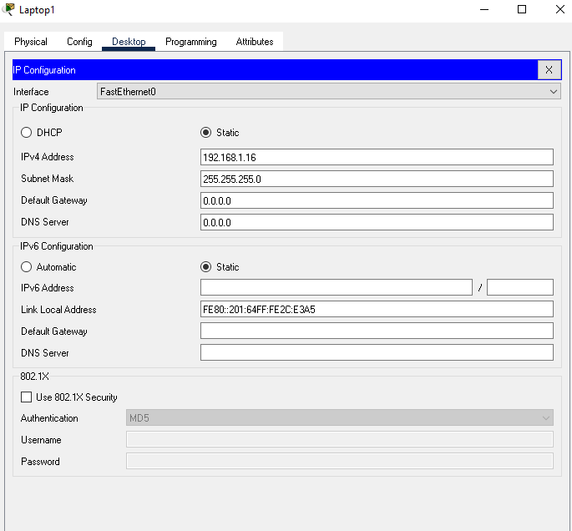

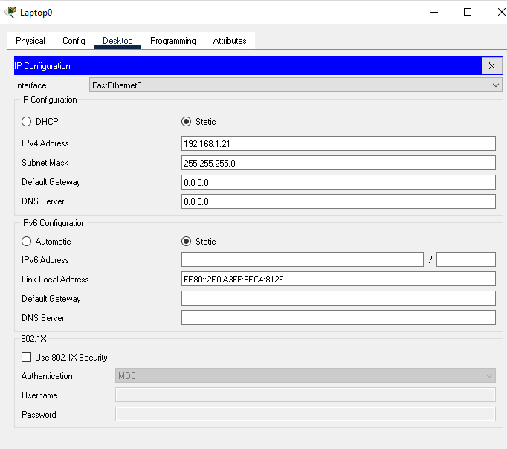

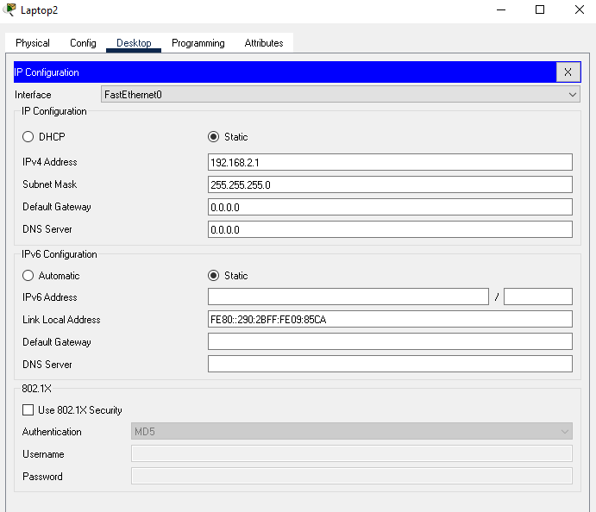

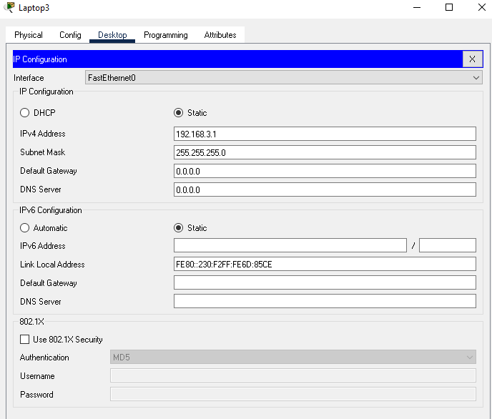

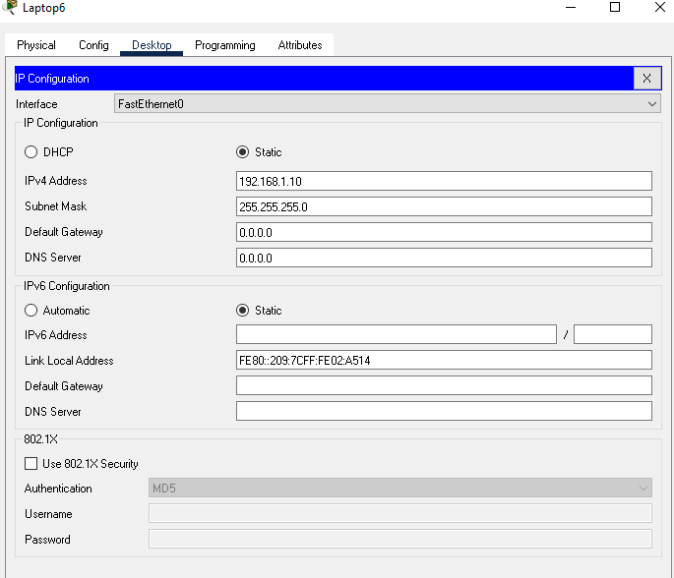

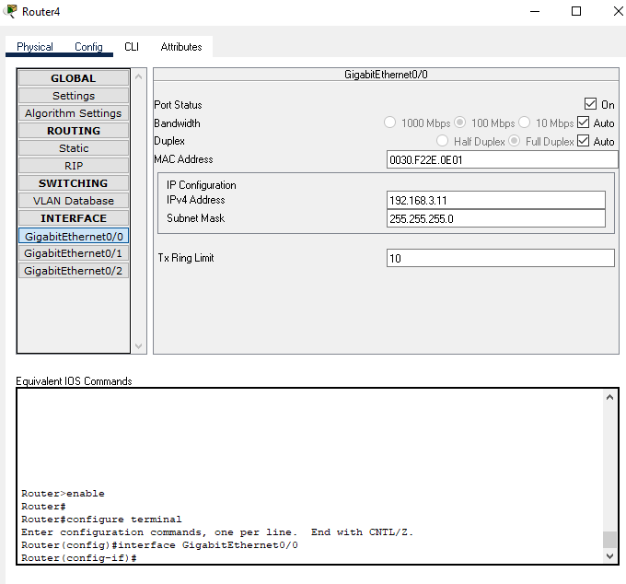

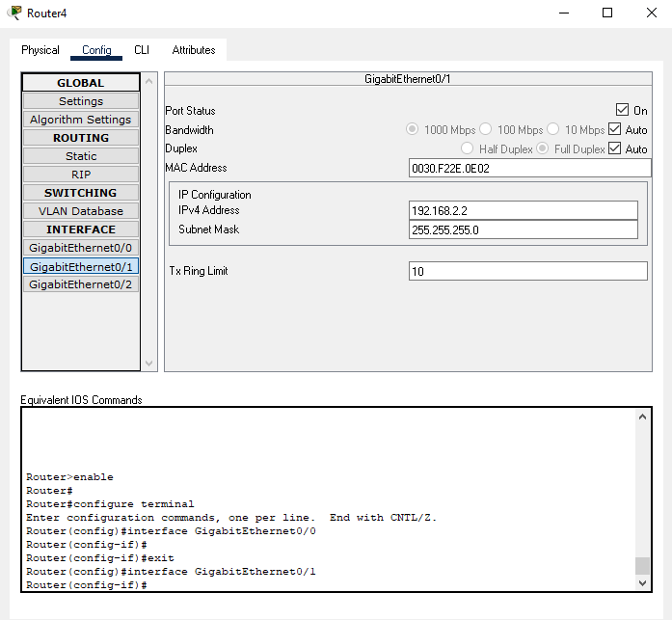

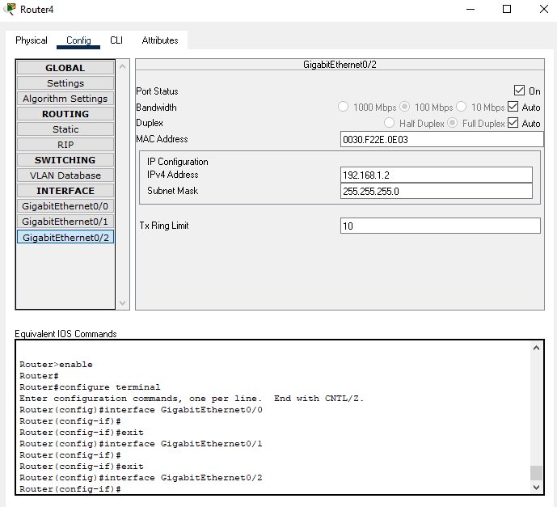

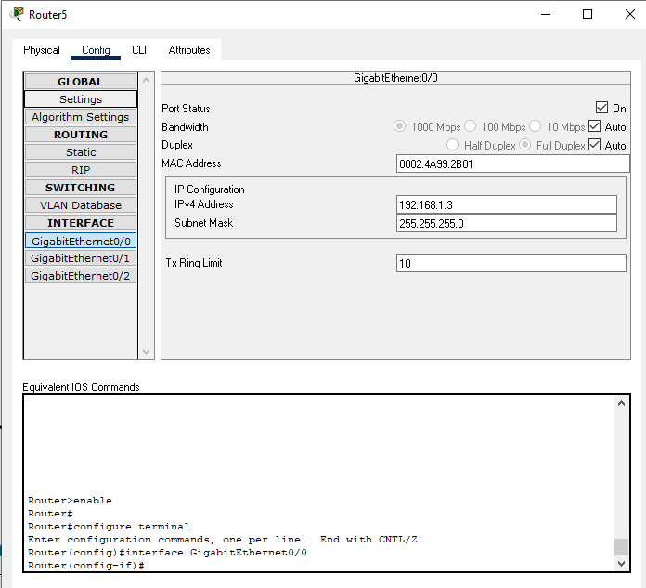

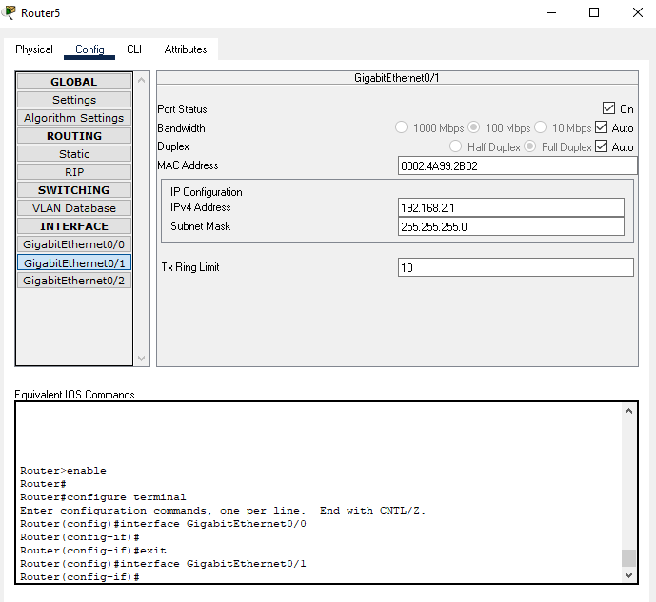

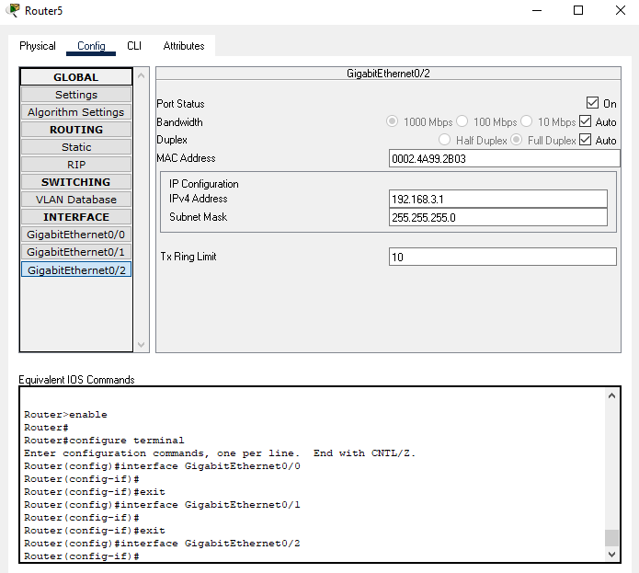

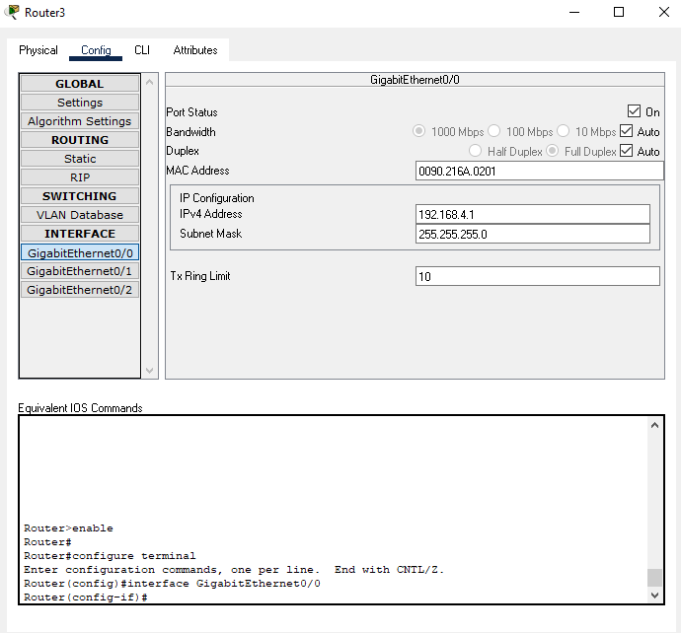

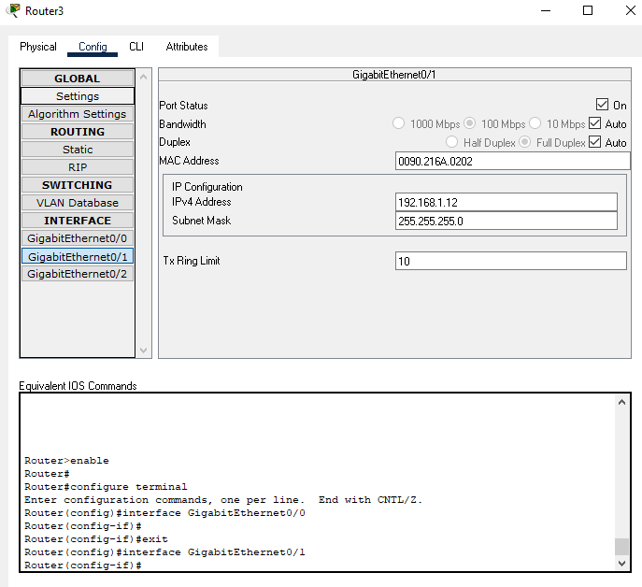

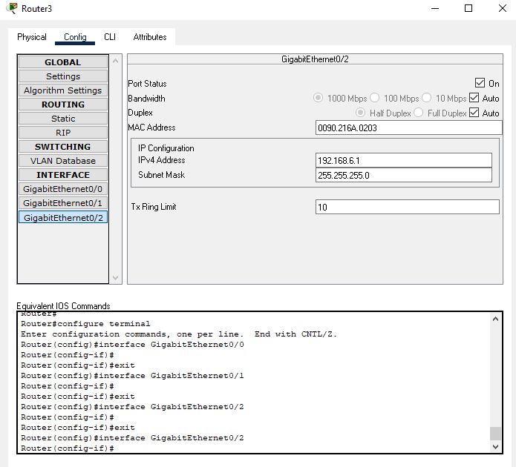

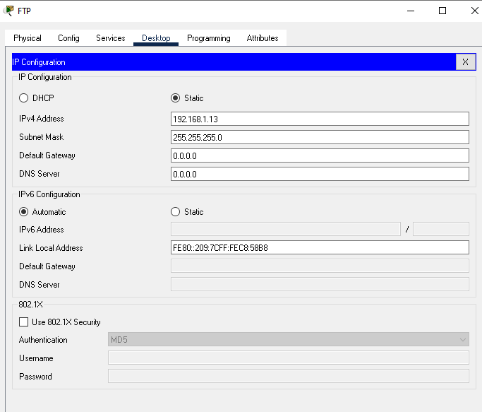

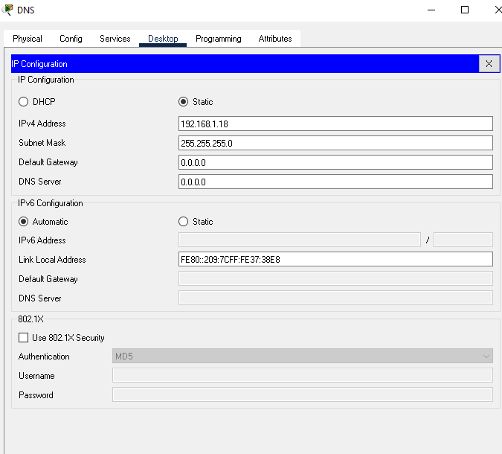

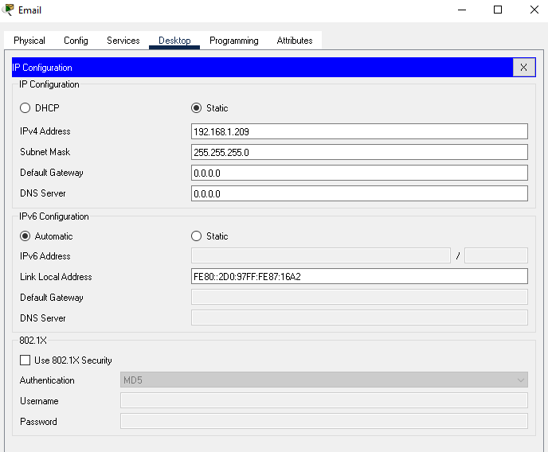

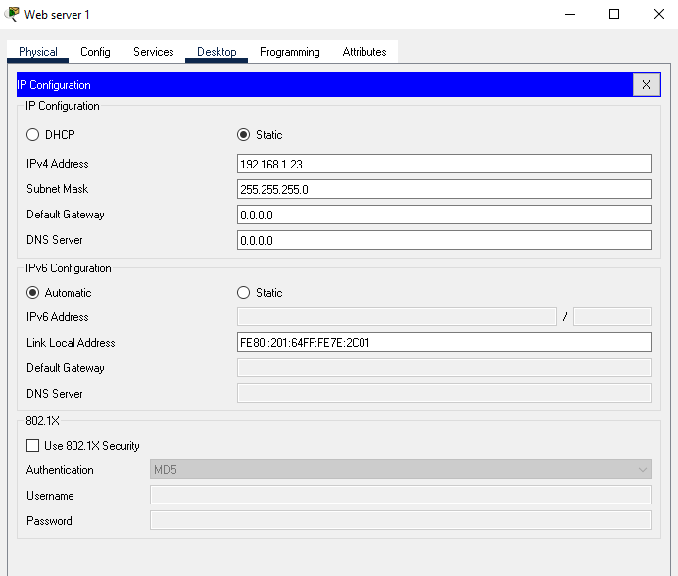

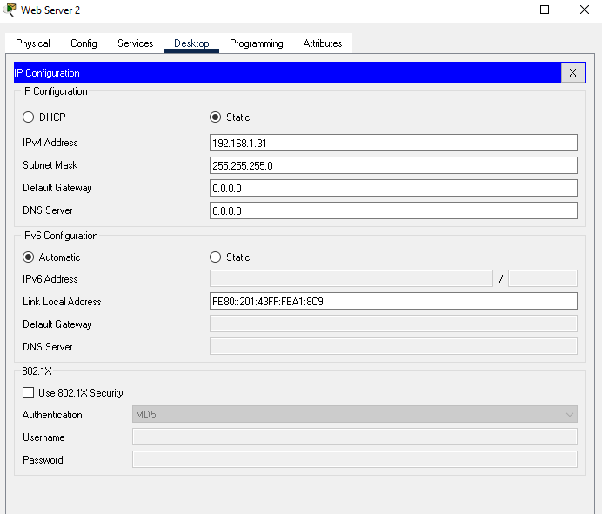

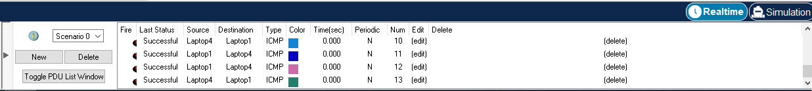

**Q#2**

##### Step 1: Subnet the 172.31.1.0/24 network based on the maximum number of hosts required by the largest subnet.

1. Based on the topology, how many subnets are needed?

**7**

2. How many bits must be borrowed to support the number of subnets in the topology table?

**4**

3. How many subnets does this create?

**16**

**Note:** If your answer is less than the 14 maximum hosts required for the R3 LAN, then you borrowed too many bits.

4. Calculate the binary value for the first five subnets. Subnet zero is already shown.

Net 0: 172 . 31 . 1 . **0 0 0 0 0 0 0 0**

Net 1: 172 . 31 . 1 . **0 0 0 1 0 0 0 0**

Net 2: 172 . 31 . 1 . **0 0 1 0 0 0 0 0**

Net 3: 172 . 31 . 1 . **0 0 1 1 0 0 0 0**

Net 4: 172 . 31 . 1 . **0 1 0 0 0 0 0 0**

5. Calculate the binary and decimal value of the new subnet mask.

11111111.11111111.11111111. **1 1 1 1 0 0 0 0**

255 . 255 . 255 . **240**

6. Complete the Subnet Table, listing all available subnets, the first and last usable host address, and the broadcast address. The first subnet is done for you. Repeat until all addresses are listed.

#### Subnet Table

| 0 | 172.31.1.0 | 172.31.1.1 | 172.31.1.14 | 172.31.1.15 |
| --- | --- | --- | --- | --- |
| 1 | 172.31.1.16 | 172.31.1.17 | 172.31.1.30 | 172.31.1.31 |
| 2 | 172.31.1.32 | 172.31.1.33 | 172.31.1.46 | 172.31.1.47 |
| 3 | 172.31.1.48 | 172.31.1.49 | 172.31.1.62 | 172.31.1.63 |
| 4 | 172.31.1.64 | 172.31.1.65 | 172.31.1.78 | 172.31.1.79 |
| 5 | 172.31.1.80 | 172.31.1.81 | 172.31.1.94 | 172.31.1.95 |
| 6 | 172.31.1.96 | 172.31.1.97 | 172.31.1.110 | 172.31.1.111 |
| 7 | 172.31.1.112 | 172.31.1.13 | 172.31.1.126 | 172.31.1.127 |
| 8 | 172.31.1.128 | 172.31.1.129 | 172.31.1.142 | 172.31.1.143 |
| 9 | 172.31.1.144 | 172.31.1.145 | 172.31.1.158 | 172.31.1.159 |
| 10 | 172.31.1.160 | 172.31.1.161 | 172.31.1.174 | 172.31.1.175 |
| 11 | 172.31.1.176 | 172.31.1.177 | 172.31.1.190 | 172.31.1.191 |
| 12 | 172.31.1.192 | 172.31.1.193 | 172.31.1.206 | 172.31.1.207 |
| 13 | 172.31.1.208 | 172.31.1.209 | 172.31.1.222 | 172.31.1.223 |
| 14 | 172.31.1.224 | 172.31.1.225 | 172.31.1.238 | 172.31.1.239 |
| 15 | 172.31.1.240 | 172.31.1.241 | 172.31.1.254 | 172.31.1.255 |