***Name:***

***Dawood Safraz***

***Roll no:***

***20p-0153***

***Section:***

***BSCS-5B***

***Lab:***

***Computer Networks***

***FAST NUCES PWR Campus***

***Lab Manual Tasks # 1:***

***TASK 3:***

***Using Task Manger:***

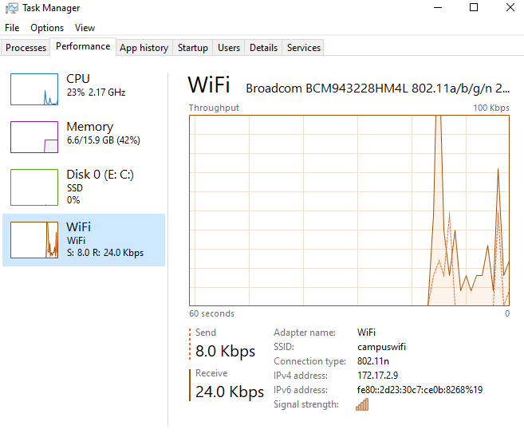

***IP ADDRESS THROUGH SETTINGS:***

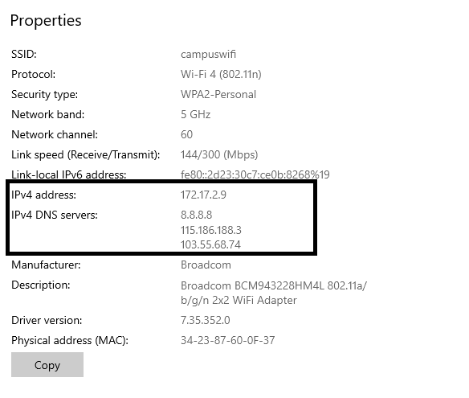

***Through System information:***

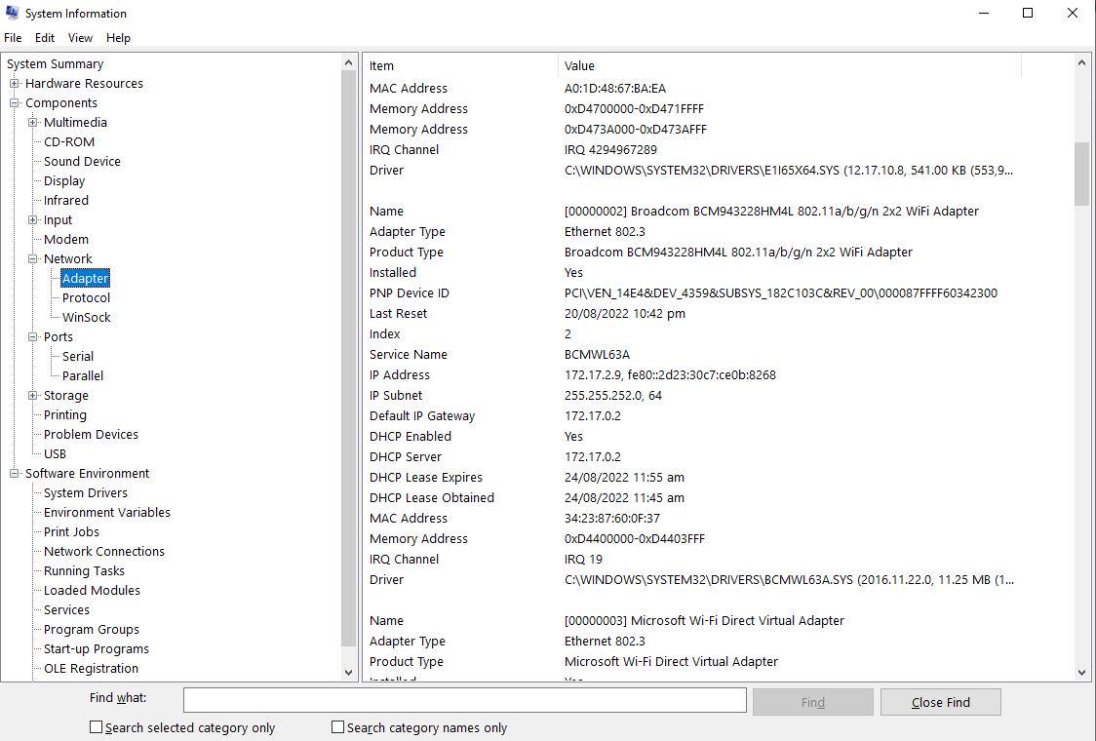

***Through Network:***

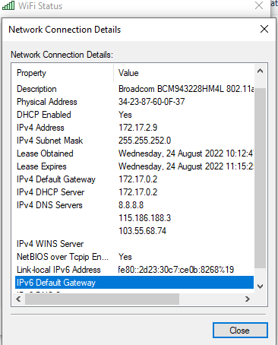

***IP ADDRESS THROUGH PowerShell:***

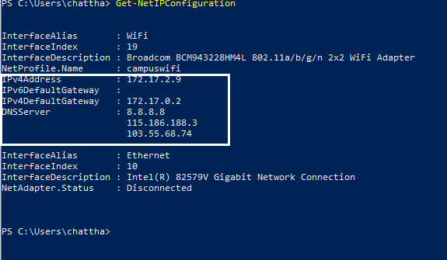

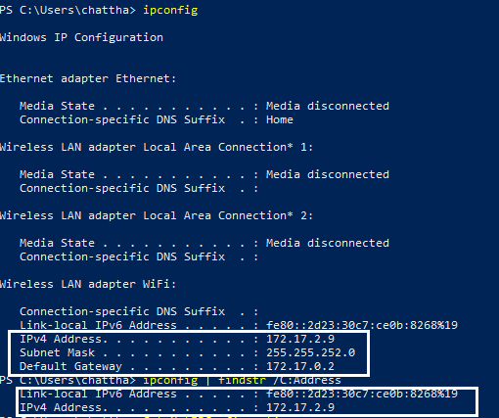

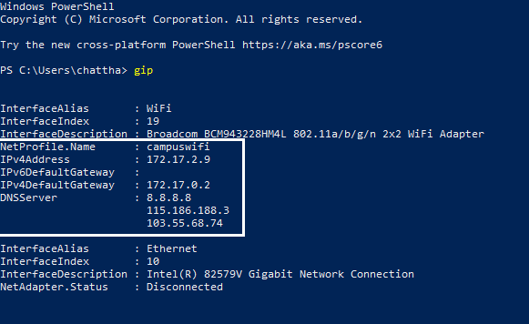

***Task2: Record a couple of IP addresses of your nearby hosts.***

***a. IP address***

***b. IP address***

***c. IP address***

***Steps:***

***Open cmd through windows+R***

***Then put command arp -a***

***Then take screenshot***

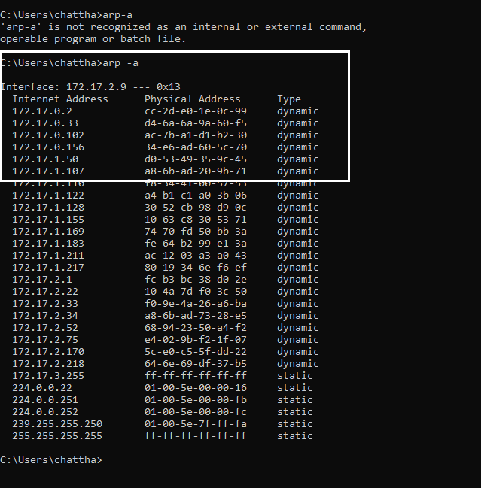

***Task 1: Using Ipconfig retrieve TCP/IP information for your computer. Write down the following information:***

***a. IP address***

***b. Subset mask:***

***c. Default gateway:***

***Steps:***

***Open cmd through windows+R***

***Then put command ipconfig***

***Then take screenshot***

