­­­­­

WAleed akram 20p-0640

Computer networks lab #07

Task#01: WLAN Configuration on Packet Tracer

Terminology:

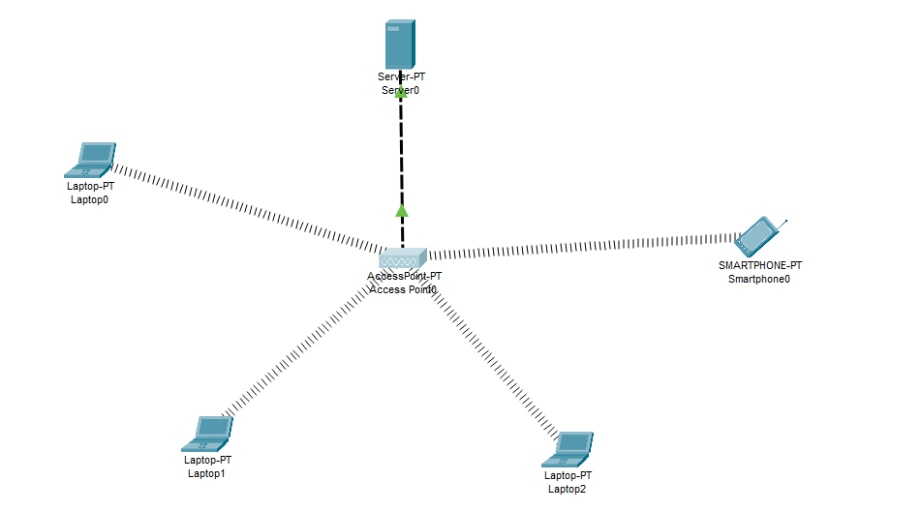

By default laptops has classic Ethernet card. To involve in a wireless network, we should have

wireless interface card. So, in each laptop, we should turn off the laptop, remove the classical

Ethernet, instead of it we place Wireless Interface Card (WPC300N). Then, we power on the laptop

again.

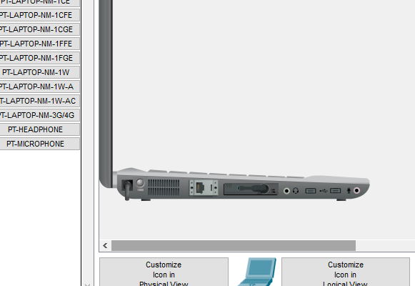

After DHCP Services configuration on DHCP Server, we will configure one more thing on this DHCP

Server. This is the IP address and subnet mask of the Server. Here, our Servr IP address will be

172.16.0.1 and the mask will be 255.255.255.0.

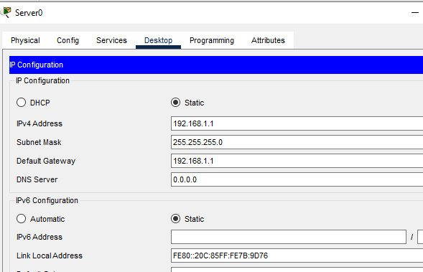

We will check the IP addresses of the laptops. For now, checking only one of them is enough.

Because, at the beginning if there is no Static IP Configuration and no DHCP, an IP from a special

block is assigned to the devices. This is APIPA (Automatic Private IP Addressing) addresses. These

addresses are from the block “169.254.x.x/25”. Simple, when we say this type of IP address in a

device, we can say that it has no IP address.

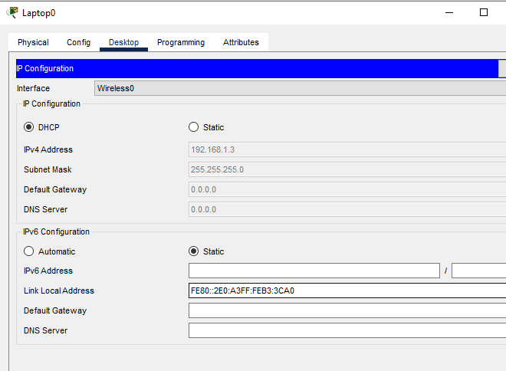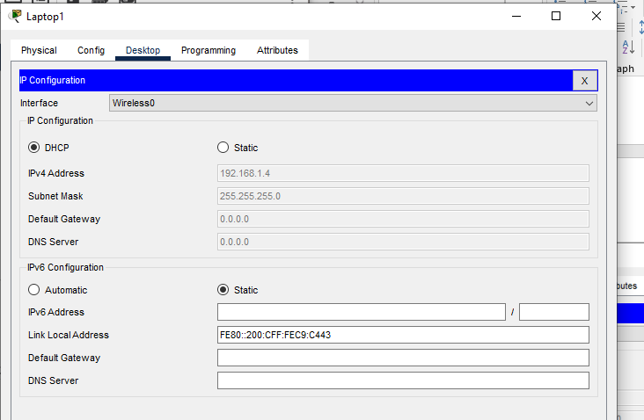

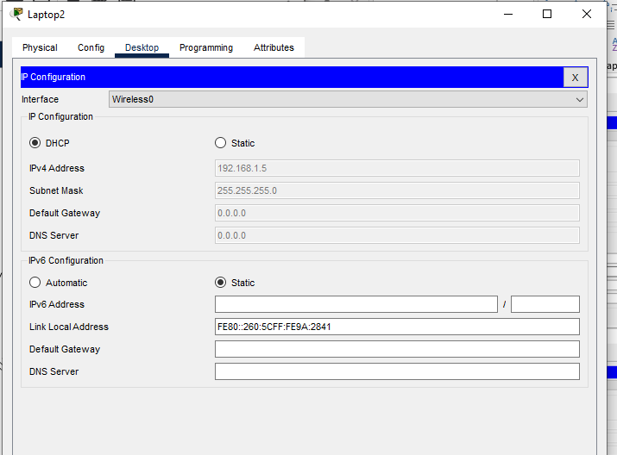

Pinging laptop1 form laptop 2

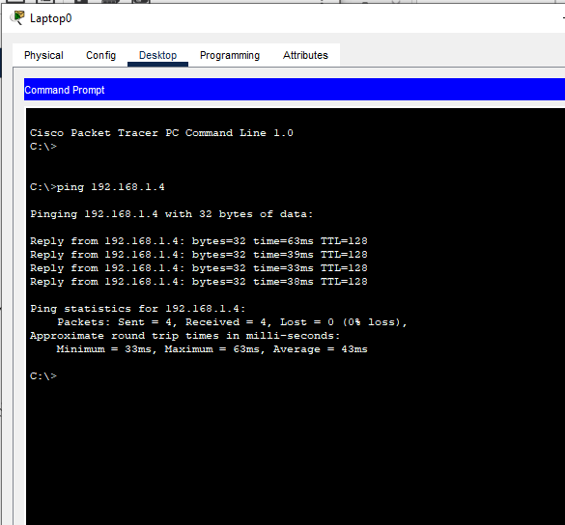

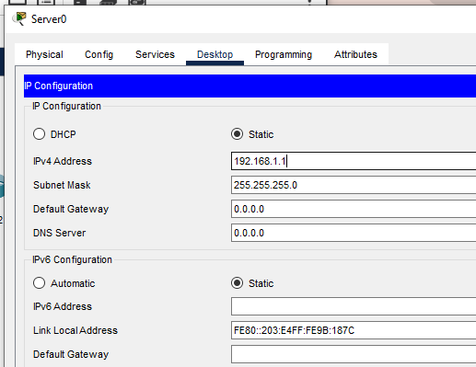

**TASK #02**

First get into Cisco Packet Tracer and in the physical mode, pick a wireless router and two  laptops,a PC, a generic server and a 2800-series router(or just any other router other than wireless).

Now connect the PC to the **Ethernet 1**of the wireless router.

For the laptops, replace the already-installed wired LAN module with a wireless adapter module (**WMP 300N**) .

Make sure that you first power off  each laptop before you make any replacement then restore the power back after replacement. That’s easy to do!

Once you have the wireless modules in place, you’ll see the wireless connections come up between the laptops and the wireless router as shown below.

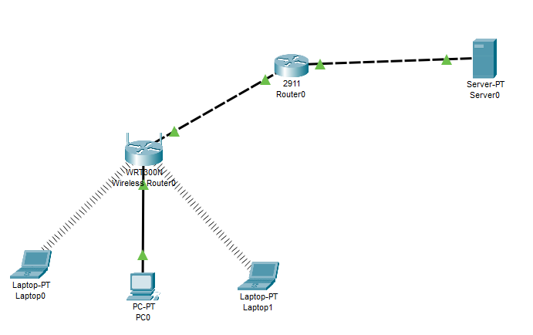

To do any configuration on the wireless router, we’ll use its GUI(Graphical User Interface) which we can access either by:

Clicking the Wireless Router icon then **GUI tab**

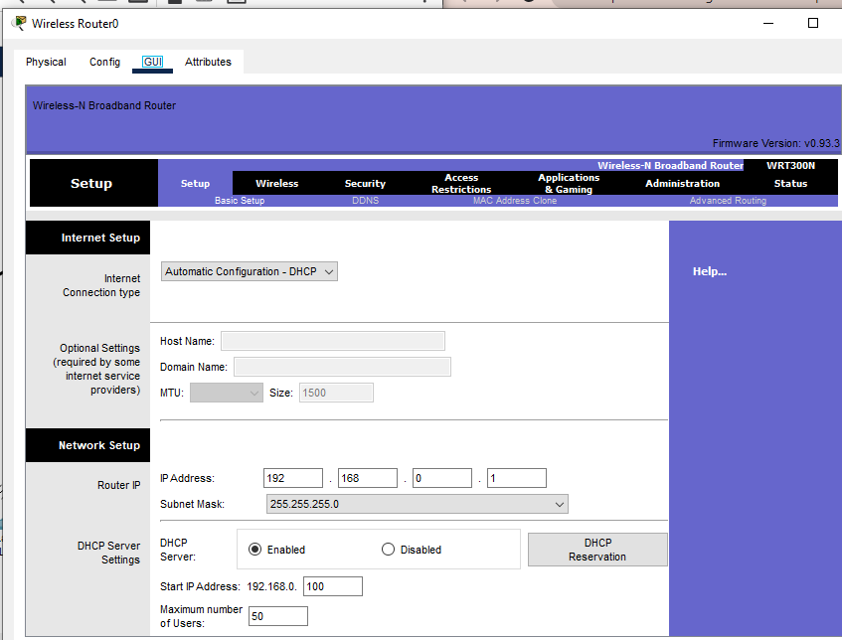

Click on the **Administration** tab and set a new **password** for administrative access. Scroll down and **Save settings.**You will be prompted for a username and the new password you just set.Type them and click OK. Wait a bit. A new screen appears confirming settings are successful. You can click on **continue** to continue with configurations.

Here I provided password as qwerty

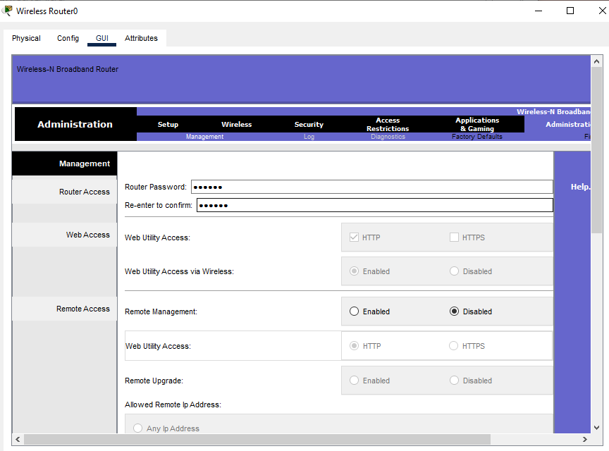Network setup means LAN setup. Already, we have a  PC and three laptops in the LAN.We’ll assign the them IP addresses either statically or dynamically (using a DHCP pool set up in the wireless router).

The default LAN network address given here is 192.168.0.0 with a subnet  mask of 255.255.255.0 .The first address in this network (192.168.0.1 by default) has been assigned to the LAN interface of the router. It has just been named **IP address.**Obviously, all the PCs in the LAN will use the LAN interface as their default interface(to communicate to hosts in outside networks).

Now, in the router’s network settings, you may choose to enable DHCP to dynamically assign IP addresses to the PCs. On the other hand, if you choose to disable DHCP, then obviously, you’ll have to configure static IP addresses on the PCs.

When you choose to enable DHCP, set the **start address** for the LAN pool, **maximum  hosts** to be allowed in your LAN and the **DNS server** for the LAN. The PCs will receive addresses automatically from the pool.

Now, going the DHCP way:

* Ensure DHCP is checked.
* Leave the**IP address**as  192.168.0.1 (This is the default LAN gateway address).
* Set a start address of 192.168.0.50 and set **maximum users**to 100 (or any number of users you want)
* You can leave the DNS server entry as it is (0.0.0.0) or specify the address of a DNS server of your choice.
* Scroll down and **Save settings.**

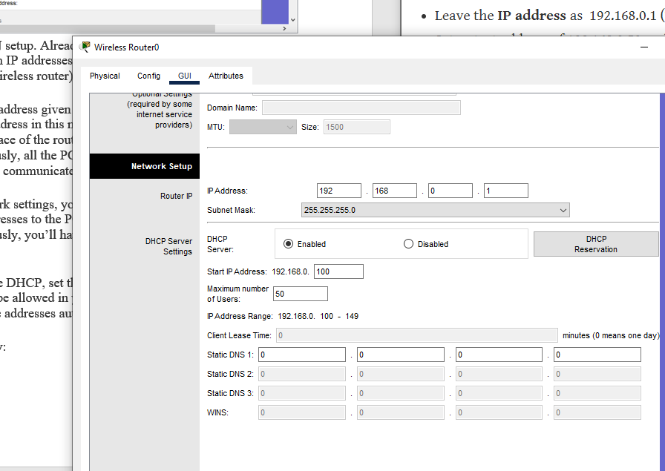

Moving on, let’s enable DHCP on each PC for dynamic configuration. Go to the **IP configuration** tab  for each PC  and enable DHCP. Each PC should automatically  obtain an IP address from the router.

As an example, here is the IP configuration for**Laptop1:**

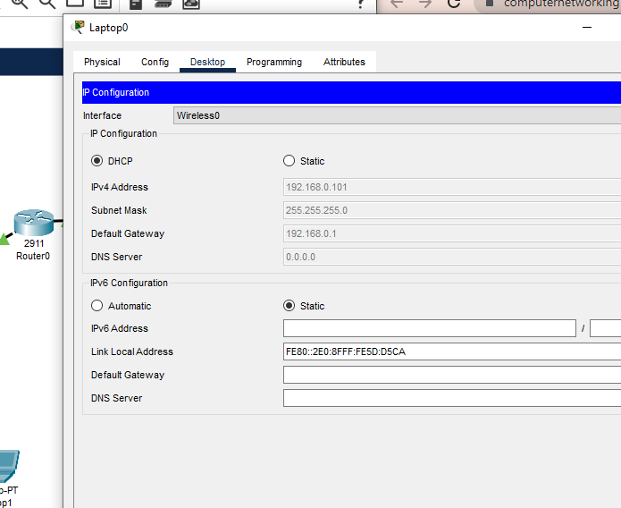

**Now let’s  test our wireless LAN.**

Ping PC2 from PC1. Ping succeed as you can see in figure below.

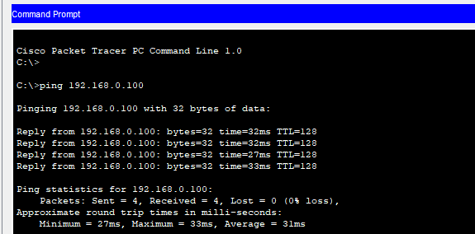

**Adding security for wireless LAN access**

Access  the GUI of wireless router (either by clicking on Router icon or from Admin PC browser), then click on **Wireless** tab. Under the Basic Wireless Settings  sub tab, change the default wireless**SSID** to any name of your choice. I have named mine ‘**LAN**‘.

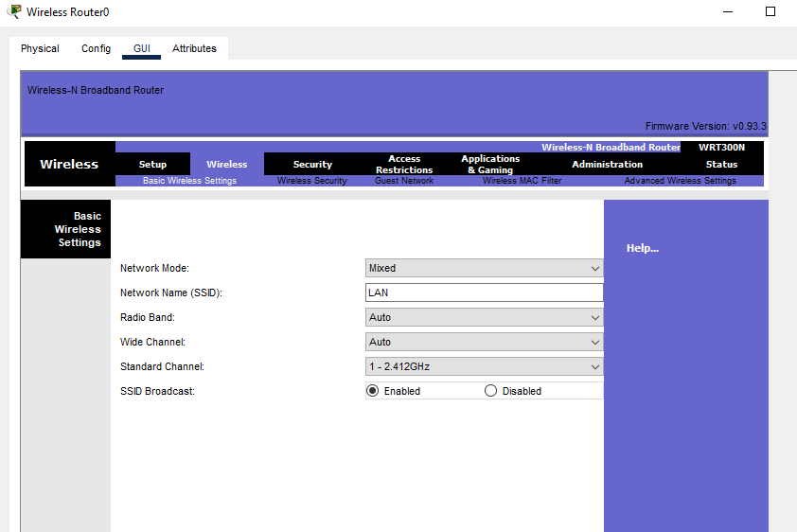

in the **Wireless**  tab, under  the **Wireless security**  sub tab, change security mode to **WPA  personal ,**then set **passphrase**field to a password of your choice. Scroll down and **Save settings**

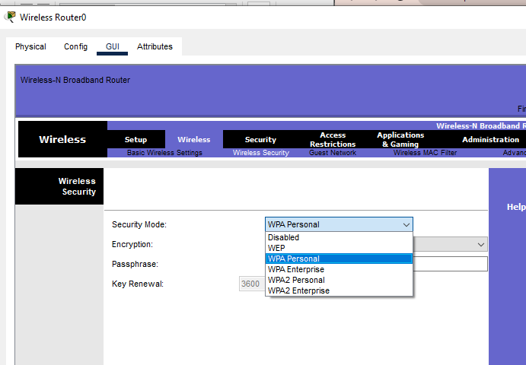

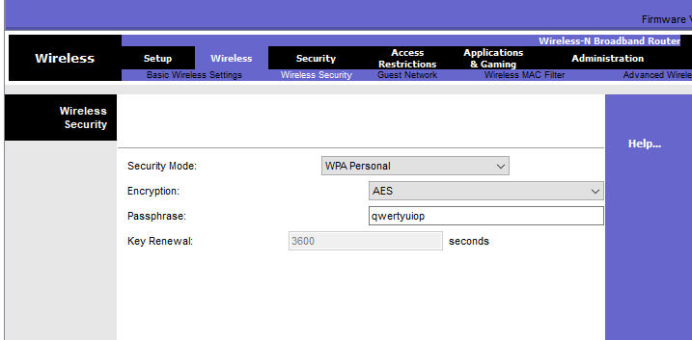

The LAN network is now secured for wireless access. To test whether its really protected, click**Laptop1->Desktop->Wireless.**

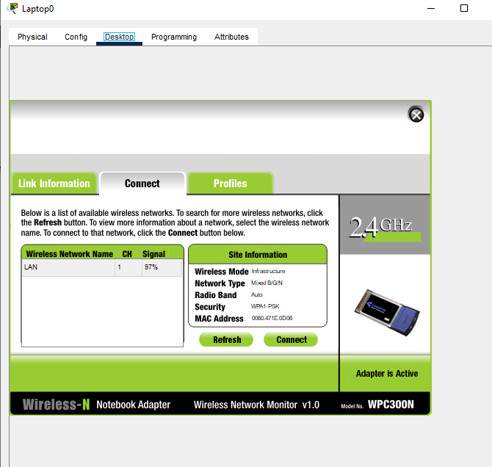

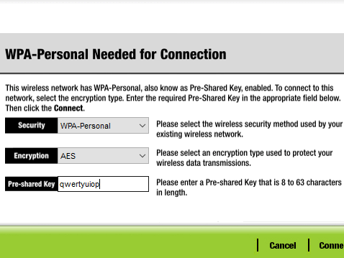

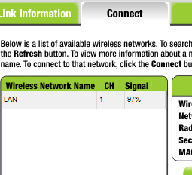

#### ****Internet Setup****

#### For now, we’ll set the internet interface to act as a DHCP client (with the DHCP server configured on the ISP router) For now, we’ll set the internet interface to act as a DHCP client (with the DHCP server configured on the ISP router)

#### 

#### Now make the internet interface a DHCP client by enabling DHCP on it.

#### 

#### To verify DHCP configuration,click on the wireless router icon, then go to ****Config tab.****Pick****DHCP.****The interface is now configured with an IP address from the pool set in the ISP router.

#### 

, you can ping the server from Laptop1. Ping succeed can be seen in below figure

