2ASICYA Project Overview
Solar Inverter Cyber Attack Simulation & Dashboard

Table of Contents
1. Project Objective
2. Data Sources
3. Simulation Steps (Code Pipeline)
4. Dashboard Overview
5. Dashboard Tabs and Graphs
6. How to Run (Quick Guide)
7. Limitations
8. Deployment (Vercel)
Screenshots of Key Graphs

List of Figures
Figure 1: Resilience Curve
Figure 2: Risk Matrix

1. Project Objective
Model, simulate, and evaluate the impact of coordinated cyberattacks on distributed solar PV inverters in a French distribution grid using pandapower and synthetic datasets.

2. Data Sources
A) France Sprint3 Synthetic Grid
Files:
- fr_grid_buses.csv
- fr_grid_lines.csv
- fr_grid_loads.csv
- fr_grid_pv_generators.csv
- fr_inverter_parameters.csv
- fr_load_profile_15min.csv
- fr_attack_scenarios_S1_S5.csv
B) Kaggle Datasets (for dashboard enrichment)
- Solar Power Generation Data: https://www.kaggle.com/datasets/anikannal/solar-power-generation-data
- Smart Grid Intrusion Detection: https://www.kaggle.com/datasets/hussainsheikh03/smart-grid-intrusion-detection-dataset

3. Simulation Steps (Code Pipeline)
- Load grid topology (buses, lines, loads, PV generators).
- Load time-series profile (15-min load multiplier).
- Apply PV daily shape (sunrise → sunset).
- Inject attack scenario (S1–S5) at 12:00.
- Run AC power flow at each timestep with pandapower.
- Collect outputs: min/max voltage, line loading, PV output.
- Monte Carlo loop for variability across runs.

4. Dashboard Overview
The dashboard is a static HTML (2ASICYA_Dashboard.html) that reads a JSON object (const D = {...}) generated from the combined datasets. A RUN + RELOAD button refreshes the data when hosted via a local server.

5. Dashboard Tabs and Graphs

5.1 Overview Tab
- KPI tiles: Grid Frequency, Installed PV, Grid Buses, Peak Load, Grid Status.
- PV Production & Irradiance (24h) – line + area chart.
- Load Profile & Temperature (24h) – line + area chart.
- Voltage by Bus (p.u.) – multi-line plot.
- Line Loading (%) – multi-line plot.

5.2 Attack Simulation Tab
- Scenario selector S1–S5 (with affected power levels).
- KPIs: Lost Power, Compromised Inverters, Attack Duration, Frequency Deviation.
- PV Production: Normal vs Attack (area comparison).
- Frequency Impact (Hz) with UFLS thresholds.
- Voltage Impact (p.u. deviation) area chart.
- Scenario Comparison — Lost Power (bar chart).

5.3 IDS & Security Tab
- KPIs: total alerts, detected, missed, detection rate.
- Alerts by Hour (bar chart).
- Severity Breakdown (donut/pie chart).
- Alert Types by MITRE ATT&CK ICS (horizontal bar).
- Latest Alerts feed (table-like list).

5.4 Grid & Topology Tab
- Network topology visualization (33-bus).
- Inverter parameters table.
- PV generators table.
- Daily profile by PV generator (stacked area).
- Load distribution by bus (bar chart).

5.5 Risk Matrix Tab
- Risk matrix (Likelihood vs Impact) scatter plot.
- Risk Score by Scenario (bar chart).
- Risk Scenario Details table.
- Risk scores are computed from voltage, frequency, and line loading metrics.

5.6 Resilience Curve Tab
- Resilience Differentiation Curve (Collapse Probability vs Attack Magnitude).
- Two lines: No Mitigation vs Mitigation Enabled.
- Interpretation: mitigation curve should be lower to indicate improved resilience.

Screenshots of Key Graphs
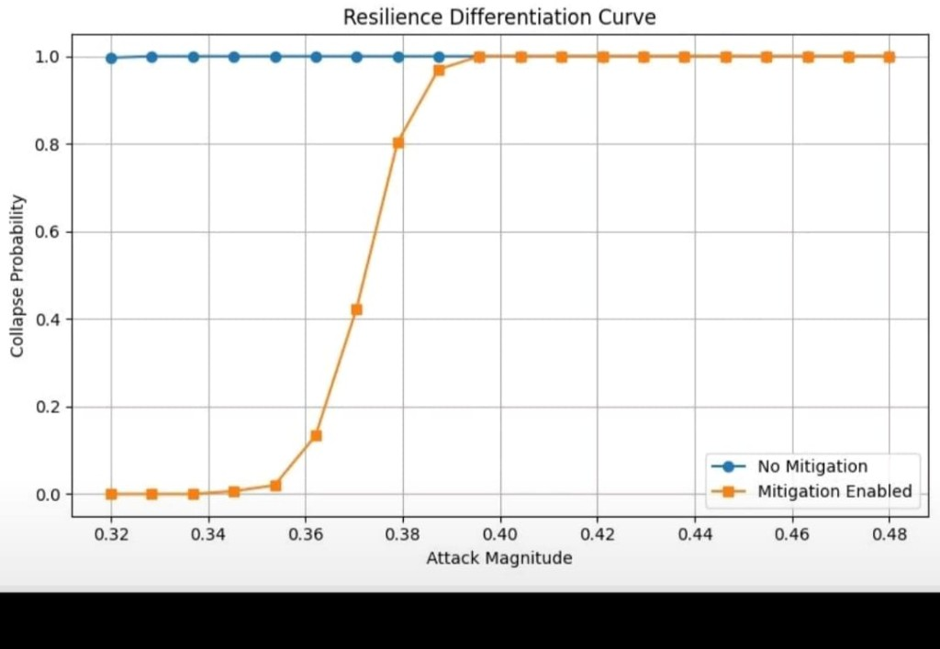
Figure 1: Resilience Curve

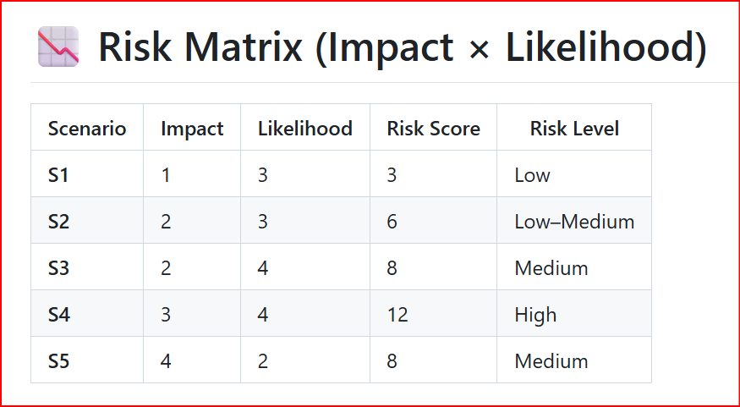
Figure 2: Risk Matrix

6. How to Run (Quick Guide)
- Install dependencies: pip install -r requirements.txt
- Run simulation: python -m src.main
- Smoke test scenarios: python scripts/smoke_scenarios.py
- Build combined dashboard data: python dashboard/build_dashboard_data.py --html 2ASICYA_Dashboard.html --out dashboard/data/combined_dashboard.json --france-dir data/france_sprint3 --kaggle-dir dashboard/data --inject
- Serve dashboard locally: python -m http.server 8000
- Open: http://localhost:8000/2ASICYA_Dashboard.html

7. Limitations
- Frequency model is simplified (no inertia or FCR).
- Local feeder scale is extrapolated to GW scenarios.
- IDS is conceptual; not a real-time implementation.

8. Deployment (Vercel)
- Vercel serves 2ASICYA_Dashboard.html at the root.
- The index.html redirect provides a clean URL.
- Production URL: https://inverter-cyberattack-simulation.vercel.app/

