Question 3

(a)
A Bessel process $R_{t}$ of order $δ≥1$ has the SDE:
$$dR_{t}=\frac{δ-1}{2R_{t}} dt+dW_{t}, R_{0}=1$$
Consider the SDE for the squared Bessel process $Y_{t}=R_{t}^{2}$, by Itô’s formula:
$$dY_{t}=2R_{t} dR_{t}+\frac{1}{2}⋅2 d{\left[R\right]}_{t}, \text{where }d{\left[R\right]}_{t}=dt$$
$$=2R_{t}\left(\frac{δ-1}{2R_{t}} dt+dW_{t}\right)+dt$$
$$=δ dt+2\sqrt{Y_{t}} dW_{t}, dW_{t}∼\sqrt{dt}⋅N\left(0,1\right)$$
$$Y_{t}=Y_{0}+\int_{0}^{t}{δ} ds+\int_{0}^{t}{2}\sqrt{Y_{s}} dW_{s}, Y_{0}=R_{0}^{2}=1$$
Check:
$$E\left(Y_{t}\right)=Y_{0}+δt, \text{since }E\left(\int_{0}^{t}{2}\sqrt{Y_{s}} dW_{s}\right)=0$$
set.seed(1)
T = 10
N = 1000
dt = T/N
Rt_sim <- function(delta, N, dt){
Y <- numeric(N+1)
Y[1] <- 1
for (i in 1:N){
dW <- sqrt(dt)*rnorm(1)
Y[i+1] <- max(Y[i] + delta*dt+ 2*sqrt(Y[i])*dW, 0)
}
return(sqrt(Y))
}
t <- seq(0, T, by = dt)
delta <- c(1,2,3,4)
Rt1 <- Rt_sim(delta[1], N=1000, dt=10/1000)
Rt2 <- Rt_sim(delta[2], N=1000, dt=10/1000)
Rt3 <- Rt_sim(delta[3], N=1000, dt=10/1000)
Rt4 <- Rt_sim(delta[4], N=1000, dt=10/1000)
ymin <- min(c(Rt1, Rt2, Rt3, Rt4))
ymax <- max(c(Rt1, Rt2, Rt3, Rt4))
plot(t, Rt1, "l", col = "yellow", ylim = c(ymin, ymax), main = "Sample Paths of Bessel Process", xlab = "Time t", ylab = expression(R[t]))
lines(t, Rt2, "l", col="red")
lines(t, Rt3, "l", col="blue")
lines(t, Rt4, "l", col="green")
legend("topleft",
legend = c(expression(delta *' = 1'), expression(delta *' = 2'), expression(delta *' = 3'), expression(delta *' = 4')),
col = c("yellow", "red", "blue", "green"),
lty = 1)
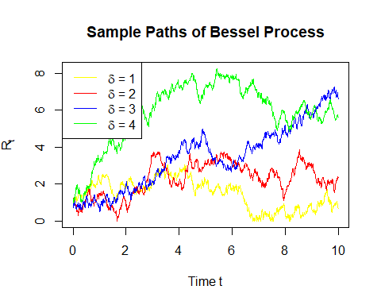

(b)
Generate more paths over $t∈\left[0,10\right]$ with $δ=1$:
set.seed(1)
M <- 100 # Number of sample paths
t <- seq(0, T, by = dt)
# choose delta = 1, generate more paths
Rt_matrix <- sapply(1:M, function(m) Rt_sim(delta[1], N, dt)) # row: dt, col: Rt
matplot(t, Rt_matrix, type = "l", lty = 1, col = rainbow(M),
main = "Sample Paths of Bessel Process (δ = 1)",
xlab = "Time t", ylab = expression(R[t]))
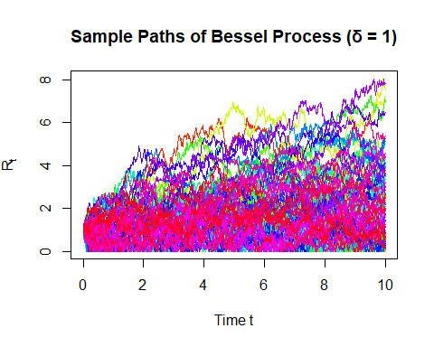
Simulate maximum for each path and calculate the mean of this maximum:
max_Rt <- apply(Rt_matrix, 2, max) # calculate maximum for each column of Rt_matrix
hist(max_Rt, breaks = 20, prob = T,
main = expression("Histogram of Max " * R[t] * " over [0,10] (δ = 1)"),
xlab = expression("Max " * R[t]))
mean(max_Rt)
## [1] 3.812538
legend("topright", legend = "mean = 3.812538")
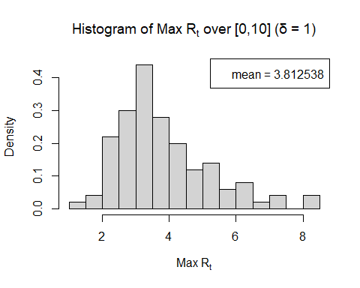

(c)
Consider a Bermudan call option with the following characteristics:
- Underlying stock price: $R_{t}$, a Bessel process with order $δ=1.2$
- Strike price: $K=2$
- Maturity: $T=10$
- Exercisable at discrete times: $t_{k}=k$, for $k=1,2,…,10$
- Exercise time: $τ$ is a stopping time chosen from $\{t_{1},t_{2},…,t_{10}\}$
- Payoff at exercise: ${\left(R_{τ}-K\right)}^{+}=max\left(R_{τ}-K,0\right)$
First, generate sample paths for stock price $R_{t}$ with $δ=1.2$.
set.seed(1)
delta = 1.2
K = 2
T = 10
M <- 100 # Number of sample paths
t <- seq(0, T, by = dt)
Rt_matrix <- sapply(1:M, function(m) Rt_sim(delta, N, dt)) # rows: t, cols: mth path of Rt
matplot(t, Rt_matrix, type = "l", lty = 1, col = rainbow(M),
main = "Sample Paths of Bessel Process (δ = 1.2)",
xlab = "Time t", ylab = expression(R[t]))
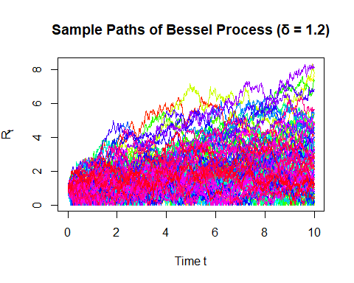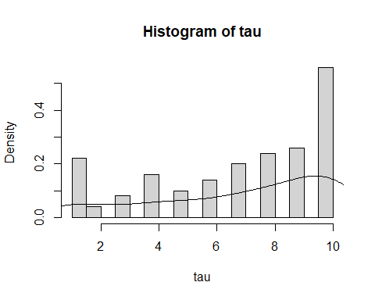
Second, construct payoff matrix for exercisable dates. The option will be exercised when the highest payoff is reached. Assign this values to the exercise time $τ$.
tk_index <- (1:10)/(10/1000) + 1
Rtk <- Rt_matrix[tk_index, ] # rows: tk, cols: mth path of Rt
tk_payoff <- pmax(Rtk - K, 0) # (Rt - K)+
exercise_time <- apply(tk_payoff, 2, function(payoffs) {
idx <- which.max(payoffs) # highest positive payoff
if (is.na(idx)) return(NA) # never exercised
return(idx) # tk index 1:10
})
# Convert index to actual time τ
tau <- ifelse(is.na(exercise_time), NA, exercise_time) # τ in 1:10
hist(tau, prob = T, breaks = 20)
lines(density(tau[!is.na(tau)]))

summary(tau) # median = 8, mean = 6.89
## Min. 1st Qu. Median Mean 3rd Qu. Max.
## 1.00 4.75 8.00 6.89 10.00 10.00
In conclusion, the result(median=8,mean=6.89) shows that there are no incentives to exercise early. Since there are no discounting factors, most options are exercised close to maturity.

(d)
Assuming no discounting factor, i.e. $r=0$ thus $e^{-rt}=1$, the pricing formula of the Bermuda call option is $E\left(max\left({\left(R_{t_{i}}-K\right)}^{+},E\left(V_{i+1}|Fi\right)\right)\right)$, where $V_{i+1}$ is the future value. Hence this is equivalent to find the maximum value of the payoffs all along the exercisable times, i.e. $max\left({\left(R_{t_{1}}-K\right)}^{+},...,{\left(R_{t_{10}}-K\right)}^{+}\right)$
Bermuda_payoffs <- sapply(1:M, function(m) {
payoffs <- tk_payoff[, m]
holding_values <- numeric(10)
holding_values[10] <- payoffs[10]
for (t in 9:1) {
if (payoffs[t] > 0) {
immediate_exercise <- payoffs[t]
future_payoff <- holding_values[t + 1]
holding_values[t] <- max(immediate_exercise, future_payoff)
} else {
holding_values[t] <- holding_values[t + 1]
}
}
return(holding_values[1])
})
Bermuda_price <- mean(Bermuda_payoffs)
cat("Bermuda call price =", Bermuda_price, "\n")
## Bermuda call price = 1.681711
The European call option price $=E\left({\left(R_{10}-K\right)}^{+}\right)$.
# European call option price = E((R10-K)+)
European_payoff <- tk_payoff[10,]
European_price <- mean(European_payoff)
cat("European call price =", European_price, "\n")
## European call price = 1.050808
Calculate how much more expensive Bermuda call option is than an European call option:
diff_price = Bermuda_price - European_price
cat("Extra cost of Bermuda over European =", diff_price, "\n")
## Extra cost of Bermuda over European = 0.630903

(e)

(1)
We used a single “average of future payoffs” or just “the next time step’s payoff,” that might be a coarse approximation. The more accurate method in continuous models is to do a regression across all paths’ next‐step (or multiple‐step) payoffs on the underlying Rt.

(2)
In real-world financial markets, option pricing typically incorporates a positive risk-free interest rate $r>0$, leading to exponential discounting of future payoffs.
When discounting is present, the option value at an exercise time $t_{i}$ is given by:
$$V_{i}=max\left({\left(R_{t_{i}}-K\right)}^{+}, e^{-rΔt}⋅E\left[V_{i+1}∣F_{t_{i}}\right]\right)$$
The second term represents the discounted expected continuation value, where $Δt$ is the time between exercise opportunities, and $ _{t_i} $ denotes the available information at time $t_{i}$.
In contrast to a zero-interest-rate setting where the continuation value is not discounted, a positive $r$ reduces the present value of waiting. This provides a stronger incentive for early exercise and typically increases the premium of the Bermuda option over its European counterpart.

(3)
If number of paths is relatively small (e.g. we use M=100 in this case), the variance of the estimator might be high. Checking for confidence intervals or repeating with bigger M can highlight whether results have converged.

(4)
$$R_{t}→0 ⇒ Y_{t}=R_{t}^{2}→0$$
To avoid taking the square root of negative values when simulating $R_{t}=\sqrt{Y_{t}}$, we applied a non-negativity constraint in the simulation of $Y_{t}$:
$$Y_{i+1}=max\left(Y_{i}+δ⋅Δt+2\sqrt{Y_{i}}⋅ΔW_{i}, 0\right)$$
This ensures that $Y_{t}≥0$, so that $R_{t}=\sqrt{Y_{t}}$ is always real-valued.

(5) Variance Reduction:
Control Variate Method:
The price of the Bermuda call option is equal to $max\left({\left(R_{t_{1}}-K\right)}^{+},...,{\left(R_{t_{10}}-K\right)}^{+}\right)$, which is equivalent to $max\left(max\left(R_{t}\right)-K, 0\right)$. max(R_t)
Let $X=max\left(max\left(R_{t}\right)-K, 0\right), for t=1,2,...,10$. Set $\tilde{X}=max\left(R_{t}\right)-K$, where we can use similar method in (b) to calculate $max\left(R_{t}\right)$, then $Y=\tilde{X}-E\left(\tilde{X}\right)$. Check: $E\left(Y\right)=0$.
max_Rtk <- apply(Rtk, 2, max)
X_tilde = max_Rtk - K
X = pmax(X_tilde, 0)
Y = X_tilde - mean(X_tilde)
mean(Y) # check E(Y)=0
## [1] -7.773459e-17
Calculate $c=-\frac{Cov\left(X,Y\right)}{Var\left(Y\right)}$:
c <- -cov(X,Y)/var(Y)
c
## [1] -0.9687942
Then $\hat{θ}=X+cY$, calculate $Var\left(\hat{θ}\right)$ and compare it to $Var\left(X\right)$:
theta_hat = X + c*Y
cat(var(X), var(theta_hat), "\n",
"Improved by",round((var(X)-var(theta_hat))/var(X) * 100, digits = 2), "%.")
## 2.030454 0.01265765
## Improved by 99.38 %.
Other attempts for variance reduction:
- Antithetic Variates Method: unavailable since $R_{t}$ is not a monotone function.
- Stratify Sampling: unavailable since inverse transformed estimator is needed.
- Conditioning Sampling: unavailable since $R_{t}$ is the only variable.
- Importance Sampling: unavailable since the distribution of $R_{t}$ is not given.

