Question 1

a)

The true values
We compute the exact values of C(t) for t values from 1 to 100.

Monte Carlo Methods
We take n=10^6.

Transformation 1
For transformation 1, we use $u=sinx$, then $x=arcsin\left(u\right)$. When $x=0$, then $u=0$, and when $x=π/2$, then $u=1$. We compute: Using for loop to investigate the performance of integral across different values of t:
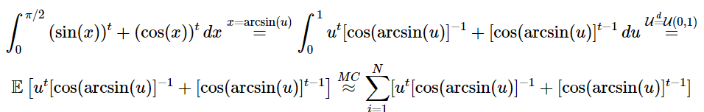

Transformation 2
For transformation 2, we use $u=cosx$, then $x=arccos\left(u\right)$. When $x=0$, then $u=0$, and when $x=π/2$, then $u=1$. We compute:
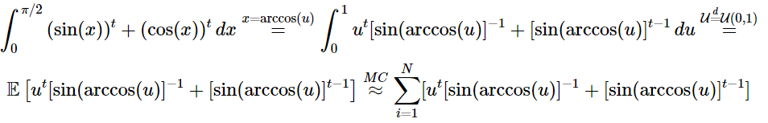
Using for loop to investigate the performance of integral across different values of t:
According to the above results, transformation 1 and 2 have exactly the same mean and standard error.

Transformation 3
For transformation 3, we use $u=\frac{2}{π}*x$, then $x=\frac{π}{2}u$. When $x=0$, then $u=0$, and when $x=π/2$, then $u=1$. We compute:
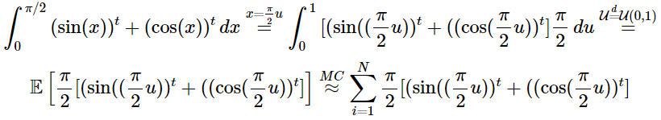
Using for loop to investigate the performance of integral across different values of t:
The following table shows the comparison between different methods:
## Transformation Mean_Diff Mean_Standard_Error
## 1 Transformation 1 -3.703208e-04 0.0026780224
## 2 Transformation 2 -3.703208e-04 0.0026780224
## 3 Transformation 3 -1.242511e-05 0.0004949451
According to the transformation methods above, transformation 3 has the smallest difference between the estimated mean and actual mean, and also the smallest standard error. Thus, we do the variance reduction based on transformation 3.
The antithetic variate reduction is not applicable since the function is not monotone. Then we try the control variates method first.

1. Control variates method
We want to find a random variable $Y$ with mean $0$ and a good constant $c$ such that $E\left(X+cY\right)≈θ$.

Control Variate Method

Stratified Sampling
We estimate:
$$h\left(U\right)=\left[{\left(sin\left(\frac{π}{2}\frac{U_{j}+j-1}{n}\right)\right)}^{t}+{\left(cos\left(\frac{π}{2}\frac{U_{j}+j-1}{n}\right)\right)}^{t}\right]\frac{π}{2}$$

Stratified Sampling + Control Variates

Compare all variance reduction methods
This table represents the differences between two variance reduction methods (SS+CV, only CV) with Monte Carlo Methods for $t=1,2,...,10$.
compare_df <- data.frame(
t = 1:10,
diff_SSCV = (abs(Diff_3) - abs(Diff_cvss))[1:10],
sd_improved_SSCV = (round((Std_Error_3 - SE_cvss)/Std_Error_3, digits = 2))[1:10],
diff_CV = (abs(Diff_3) - abs(Diff_cv3))[1:10],
sd_improved_CV = (round((Std_Error_3 - SE_cv3)/Std_Error_3, digits = 2))[1:10]
)
compare_df
## t diff_SSCV sd_improved_SSCV diff_CV sd_improved_CV
## 1 1 6.811730e-05 0.60 0 0.60
## 2 2 0.000000e+00 0.00 0 0.00
## 3 3 1.591679e-04 0.49 0 0.49
## 4 4 2.628563e-05 0.63 0 0.63
## 5 5 8.088983e-06 0.65 0 0.65
## 6 6 1.334485e-04 0.65 0 0.65
## 7 7 3.564456e-04 0.64 0 0.64
## 8 8 1.293248e-04 0.62 0 0.62
## 9 9 3.460293e-04 0.60 0 0.60
## 10 10 7.889249e-07 0.58 0 0.58

(b)

Calculate the true value of the double integral
set.seed(1)
f <- function(x, y) {
r <- sqrt(x^2 + y^2)
ifelse(r == 0, 1, sin(r) / r) # Handle the removable singularity at (0,0)
}
result <- integrate(function(y) {
sapply(y, function(yi) {
integrate(function(x) f(x, yi), -1, 1)$value
})
}, -1, 1)
# Print the result
true_integral_1b <- result$value
true_integral_1b
## [1] 3.575761

Pure Monte Carlo Methods
Since the equation is symmetric, we can compute:
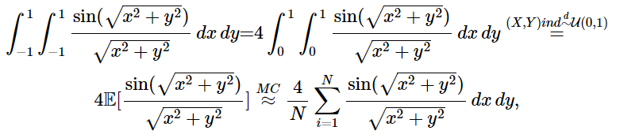
where $X_{1},…,X_{N}\overset{d}{∼}U\left(0,1\right)$, $Y_{1},…,Y_{N}\overset{d}{∼}U\left(0,1\right)$, and the samples are independent.

1. Antithetic Variate Reduction
We need to calculate
$$\frac{4}{N}\sum_{i=1}^{N}{\frac{sin\left(\sqrt{\left(x^{2}+y^{2}\right)}\right)}{\sqrt{x^{2}+y^{2}}}}=\frac{4}{N}\sum_{i=1}^{N}{\frac{sin\left(\sqrt{\left({\left(1-x\right)}^{2}+{\left(1-y\right)}^{2}\right)}\right)}{\sqrt{{\left(1-x\right)}^{2}+{\left(1-y\right)}^{2}}}},$$
where $X_{1},…,X_{N}\overset{d}{∼}U\left(0,1\right)$, $Y_{1},…,Y_{N}\overset{d}{∼}U\left(0,1\right)$, and the samples are independent.
improve_av <- (Std_Error_mc - Std_Error_av)/Std_Error_mc
improve_av
## [1] 0.7587932
The antithetic variate reduction reduces the standard error by 75.8793%.

2. Stratified Sampling
Since $1-U_{i}\overset{d}{=}U_{i}$, we can compute
$$h\left(U\right)=\frac{4}{N}\sum_{i=1}^{N}{\frac{sin\left(\sqrt{{\left(\frac{U_{i}+i-1}{n}\right)}^{2}+{\left(\frac{U_{j}+j-1}{n}\right)}^{2}}\right)}{\sqrt{{\left(\frac{U_{i}+i-1}{n}\right)}^{2}+{\left(\frac{U_{j}+j-1}{n}\right)}^{2}}}},$$
where $X_{1},…,X_{N}\overset{d}{∼}U\left(0,1\right)$, $Y_{1},…,Y_{N}\overset{d}{∼}U\left(0,1\right)$, and the samples are independent.
improve_SS <- (EstIntegral_mc - Mu_SS)/EstIntegral_mc
improve_SS
## [1] -0.001564384

Stratified Sampling + Antithetic Variate reduction
To combine the stratified sampling with antithetic variate reduction, we calculate the mean of the following to estimations:
$$h\left(U\right)=\frac{4}{N}\sum_{i=1}^{N}{\frac{sin(\sqrt{{\left(\frac{U_{i}+i-1}{n}\right)}^{2}+{\left(\frac{U_{j}+j-1}{n}\right)}^{2}})}{\sqrt{{\left(\frac{U_{i}+i-1}{n}\right)}^{2}+{\left(\frac{U_{j}+j-1}{n}\right)}^{2}}}},$$
and
$$h\left(1-U\right)=\frac{4}{N}\sum_{i=1}^{N}{\frac{sin(\sqrt{{\left(\frac{i-U_{i}}{n}\right)}^{2}+{\left(\frac{j-U_{j}}{n}\right)}^{2}})}{\sqrt{{\left(\frac{i-U_{i}}{n}\right)}^{2}+{\left(\frac{j-U_{j}}{n}\right)}^{2}}}}.$$
improve_SS <- (EstIntegral_mc - Mu_avss)/EstIntegral_mc
improve_SS
## [1] -0.001564385
The following table shows the comparison between different methods:
## Method Mean Diff Standard_error
## 1 Ture Value_1b 3.575761 NA NA
## 2 MC_1b 3.575741 2.05941642512641e-05 0.000821174490111744
## 3 AV_1b 3.575570 0.000191293603578391 0.000198072897562496
## 4 SS_1b 3.581334 -0.00557323728978476 0.00115390418221002
## 5 AVSS_1b 3.581335 -0.00557323939834831 0.00115390416790356
Therefore, the antithetic variate reduction can reduce the variance by 75.8793%, and the difference between the estimated mean and the true mean is the smallest. Therefore, the antithetic variate reduction is the best method to improve accuracy.

