Question 2

(a)
We generate 10 values for each of the parameters $m$, $ν$, $λ$, $α$, based on the conditions on their values specified in the question. They are shuffled so that ${10}^{4}=10000$ distinct sets of parameters are created.
m_list <- seq(1.6, 10, length.out = 10)
nu_list <- seq(-5, 5, length.out = 10)
lambda_list <- seq(-5, 5, length.out = 10)
alpha_list <- seq(0.1, 10, length.out = 10)
groups <- expand.grid(m_list, nu_list, lambda_list, alpha_list)
m <- groups$Var1
nu <- groups$Var2
lambda <- groups$Var3
alpha <- groups$Var4
We also calculate the theoretical mean and variance for each set of parameters using the formula from part (b):
theoretical_mean <- lambda - alpha*nu/(2*(m - 1))
theoretical_var <- alpha^2/(2*m - 3) * (1 + nu^2/(4*(m - 1)^2))
Next, we create a dataframe summarising all information about the future simulated datasets, which is called Q2_summary. This dataframe has 10000 rows, each row representing the information of one set of parameters generated before.
Later, we will run R codes across all sets of parameters to get the sample mean, sample variance and empirical acceptance rate for each envelope function and each set of parameters. These numbers will be integrated into Q2_summary dataframe as new columns so that we can compare the performance of different envelope functions later.
Q2_summary <- data.frame(m, nu, lambda, alpha,
theoretical_mean, theoretical_var)
head(Q2_summary)
## m nu lambda alpha theoretical_mean theoretical_var
## 1 1.600000 -5 -5 0.1 -4.583333 0.918055556
## 2 2.533333 -5 -5 0.1 -4.836957 0.017701537
## 3 3.466667 -5 -5 0.1 -4.898649 0.005153923
## 4 4.400000 -5 -5 0.1 -4.926471 0.002656306
## 5 5.333333 -5 -5 0.1 -4.942308 0.001738487
## 6 6.266667 -5 -5 0.1 -4.952532 0.001285305
Now we would like to deal with the target function $f\left(x\right)$. With transformation
$$y=\tan^{-1}\left(\frac{x-λ}{α}\right),y∈\left[-\frac{π}{2},\frac{π}{2}\right]$$
We get
$$f\left(y\right)∝{\left(cos\left(y\right)\right)}^{2m}e^{-νy}$$
and we are able to derive three envelop functions from that:
Envelope function 1 - this is essentially a uniform distribution
$$g\left(y\right)=\frac{1}{π}$$
Envelope function 2
$$g\left(y\right)∝e^{-νy}$$
Envelope function 3
$$g\left(y\right)∝cos\left(y\right)$$

We can derive two more envelope functions from the original form of the target function, i.e.
$$f\left(x\right)∝{\left[1+\left(\frac{x-λ}{α}\right)\right]}^{-m}e^{-ν arctan\left(\frac{x-λ}{α}\right)}$$
Envelope function 4 - after writing it down, we noticed that this is essentially a Cauchy distribution
$$g\left(y\right)∝{\left(1+{\left(\frac{y-λ}{α}\right)}^{2}\right)}^{-1}$$
Envelope function 5
$$g\left(y\right)∝{\left(1+{\left(\frac{y-λ}{α}\right)}^{2}\right)}^{-m}$$
By setting $m=\frac{k+1}{2}$ and $z=\frac{\sqrt{k}\left(y-λ\right)}{α}$, we transform it to a form similar to a t-distribution:
$$g\left(y\right)∝{\left(1+\frac{z^{2}}{k}\right)}^{-\frac{k+1}{2}}$$
Unfortunately, due to the limit on number of pages, we are unable to explain every algorithm we wrote in R. We will elaborate on the best envelope function we picked later on, after the best envelope function is picked.
R will take approximately 12 minutes to run the codes for all 5 envelope functions. That is a reasonable efficiency for 10000 sets of parameters.

Pick the best envelope function
When writing the codes, we noticed that envelope function 2 is not a practical choice, as it will collapse every time $m$ becomes a decimal. Hence, we kicked it out from the further analysis of performances.
To pick the best envelope function, we compare a) the empirical rate of acceptance and b) the time of running the acceptance-rejection algorithm.
We summarise the empirical rate of acceptance of these envelope function in the boxplot below:
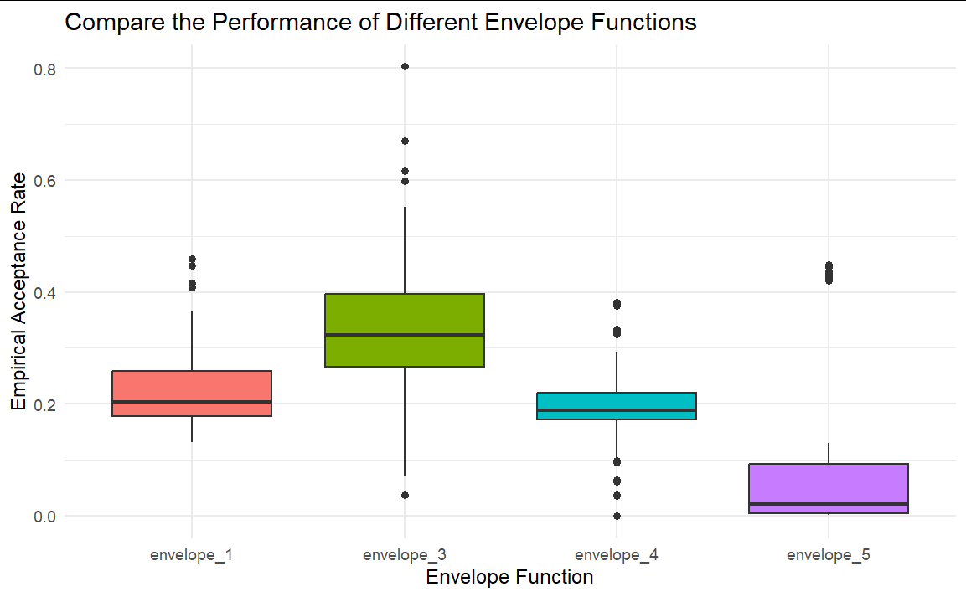
We summarised the time consumed to run different algorithms in the following table:
## elapsed
## sim_envelope_1 196.09
## sim_envelope_3 190.15
## sim_envelope_4 290.75
## sim_envelope_5 82.25
We can see that generally, envelope 3 has significantly better acceptance rates than the others, while it has relatively good computational efficiency. Thus, pick envelope 3 as our envelope function.
Below is extra details about the algorithm we used for envelope 3:
With transformation $y=arctan\left(\frac{x-λ}{α}\right)$, we have
$$f\left(y\right)∝{\left(\cos\left(y\right)\right)}^{2m}e^{-νy} \\ g\left(y\right) = \frac{1}{2}\cos\left(y\right)$$
$Y$ is generated by using inverse transform algorithm:
$$F^{-1}\left(U\right)=sin^{-1}\left(2U-1\right)$$
As we decided to pick it as our best envelope function, we need to perform variance reduction on it. Control variate method is used at this stage to reduce the variance of the sample $Y_{original}$ generated from $g\left(y\right)$. With $Y'=\frac{1}{2}-U$ being the zero-mean random variable, $Y=Y_{original}=cY'$
(where $c=-\frac{Cov\left(Y_{original},Y^{'}\right)}{Var\left(Y^{'}\right)}$). This method reduced the variance by 89.88%.
Accept the sample from the envelope function when
$$U<\frac{{\left(cos\left(y\right)\right)}^{2m-1}e^{-νy}}{\left[cos\left(arctan\left(-\frac{ν}{2m-1}\right)\right)\right]e^{-ν arctan\left(-\frac{ν}{2m-1}\right)}}$$
Below are the codes:
# Generate Y
set.seed(1)
n <- 10^5
U <- runif(n)
Y_original <- asin(2*U-1)
SE_original <- sd(Y_original)/sqrt(n)
# Control variate method
set.seed(1)
Y_prime <- 1/2 - U
c <- -12*cov(Y_original, Y_prime) # 1/12 is the population variance of 1 - U
Y <- Y_original + c*Y_prime
SE_cv <- sd(Y)/sqrt(n)
(SE_original - SE_cv)/SE_original # percentage of standard error improved
## [1] 0.8987566
# Generate the sample using AR
set.seed(1)
ptm <- proc.time()
U <- runif(n)
temp <- atan(-nu/(2*m-1))
sample_envelope_3 <- lapply(1:length(nu), function(i){
temp <- temp[i]
m <- m[i]
nu <- nu[i]
Y[U < (cos(Y)^{2*m-1}*exp(-nu*Y))/(cos(temp)^{2*m-1}*exp(-nu*temp))]
})
sim_envelope_3 <- (proc.time()- ptm)[3]
# Produce X, and check mean and variance
X_envelope_3 <- lapply(1:length(nu), function(i) tan(sample_envelope_3[[i]]) * alpha[i] + lambda[i])
envelop_3_empirical_mean_cv <- unlist(lapply(1:length(nu), function(i) mean(X_envelope_3[[i]])))
envelop_3_empirical_var_cv <- unlist(lapply(1:length(nu), function(i) var(X_envelope_3[[i]])))
As a result of the control variates method, the empirical acceptance rate of the envelope function 3 has been improved significantly. The mean here is clearly higher than what we had in the previous boxplot.
# empirical rate of acceptance
envelope_3_empirical_acceptance_cv <- unlist(lapply(1:length(nu), function(i) length(sample_envelope_3[[i]])/10^5))
summary(envelope_3_empirical_acceptance_cv)
## Min. 1st Qu. Median Mean 3rd Qu. Max.
## 0.00657 0.41200 0.68174 0.63328 0.89993 0.99770

The question also asks which values of parameters will give the most efficient simulation. We will answer this question here.
By analysing the information from the updated Q2_summary dataframe with dplyr package, we are able to observe that the rate of acceptance is not affected by either $λ$ or $α$. Thus, check the relationship between rate of acceptance and $m$, $ν$, using ggplot2:
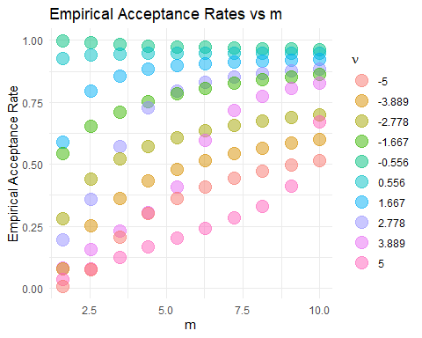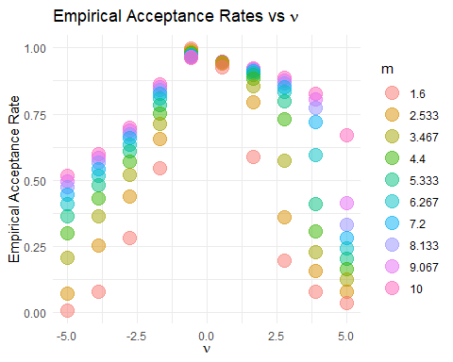
From the plot, we can see that the acceptance rate is highest when $m$ is small, AND $ν$ is close to zero.

(b)
We have already calculated the theoretical mean and variances when we defined Q2_summary early on. Now, we compare them with the sample mean and variances using the dplyr package, and the differences between them are plotted. From the dataframe, we noticed that $λ$ has no effect on either the deviation from theoretical mean or the deviation from theoretical variances. Use plots to investigate the effects of other parameters:
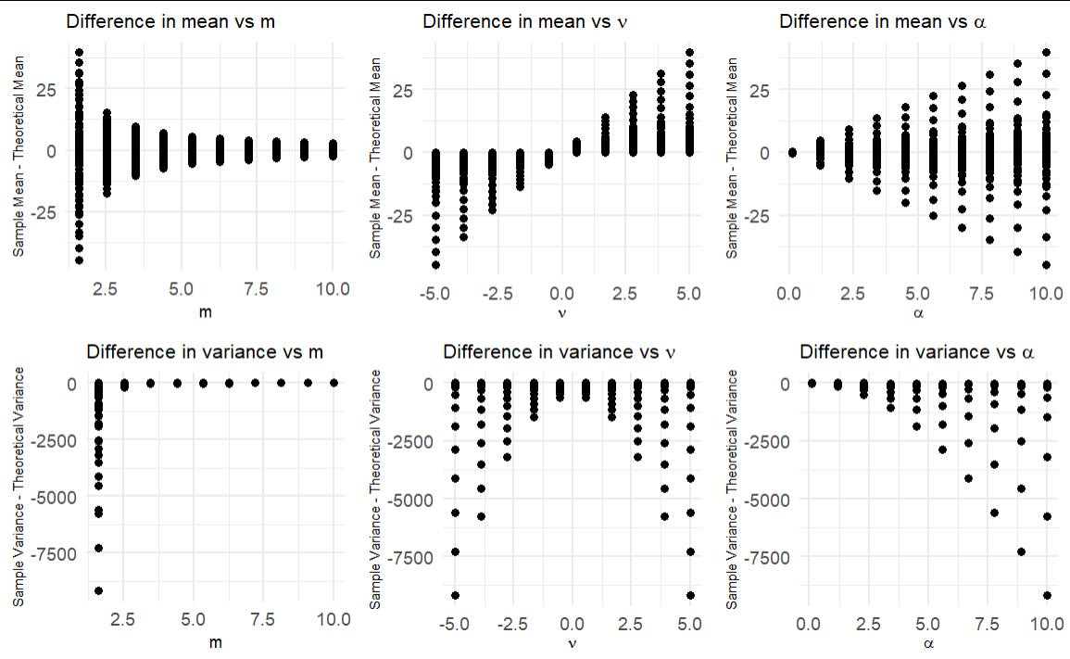
From the plots and the other analysis from the dataframe, we draw the following conclusions:
1. The differences between the sample and theoretical mean/variance is the smallest when
- m is large;
- $ν$ is close to zero;
- $α$ is small.
2. The mean of all differences in mean is small.
3. The mean of all differences in variance is large, and there is no empirical variance that is higher than the theoretical variance.

(c)
With the help of matrix, list and for loops, it is fairly easy to find the sample quantile for each of the 10000 sets of parameters.
For CLT quantiles, we make the unrealistic assumption of $\frac{X-E\left(X\right)}{\sqrt{Var\left(X\right)}}∼N\left(0,1\right)$, i.e. assuming that $X$ follows a normal distribution. The expectations and variances used here are the theoretical means and variances calculated in part (b).
As a result, similar to the previous Q2_summary, we are able to store the difference between sample quantiles and CLT quantiles for each set of parameters in Q2_summary_quantiles_diff. We focus on 5%, 10%, 25%, 50%, 75%, 90% and 95% percentiles. We plot these information using ggplot2.
Note that we remove $m=1.6$ and $m=2.53$ from the plot, just to make the trend looks clearer.
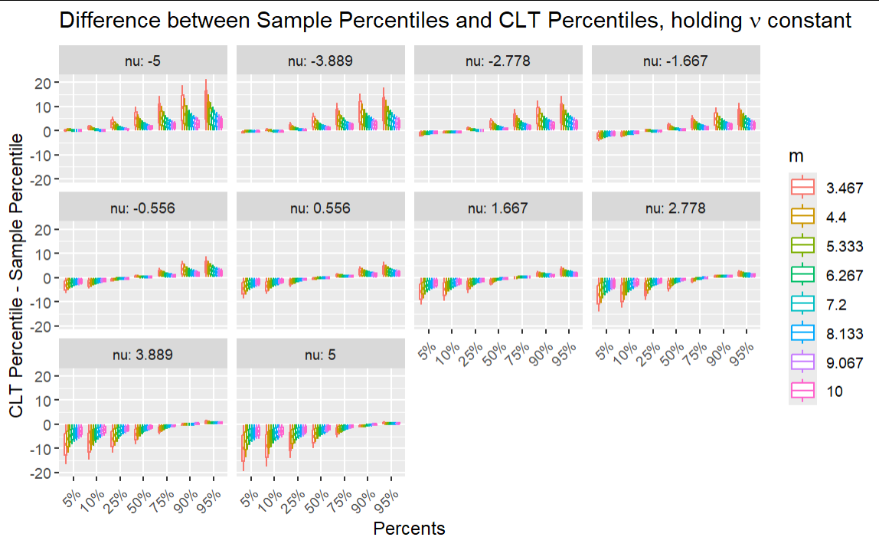
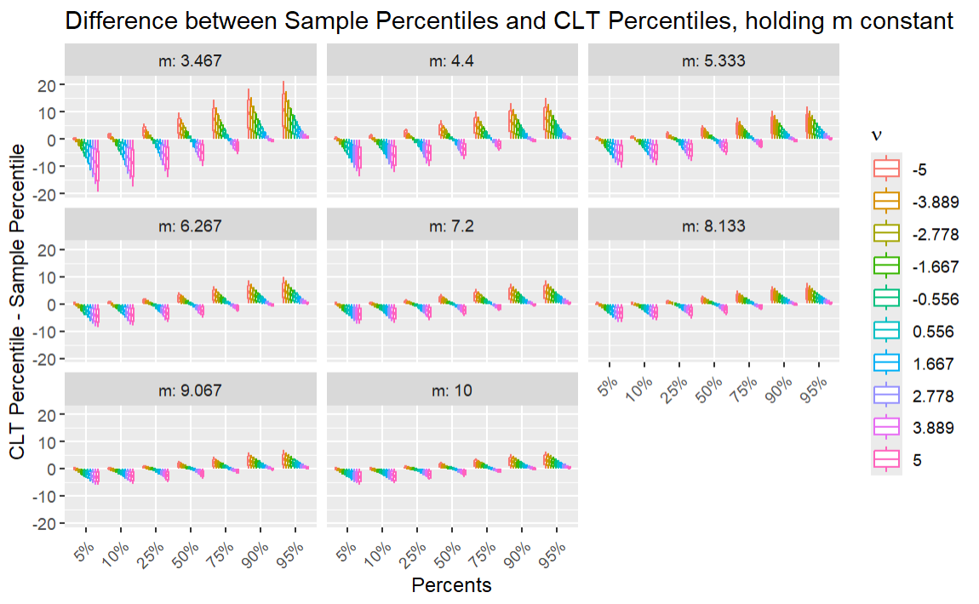

From these plots one can notice the following:
1. CLT percentiles are lower than the sample percentiles when the percentage is low. CLT percentiles are higher than the sample percentiles when the percentage is high. Therefore, we can conclude that compared to a normal distribution, our sample distribution has heavier tails on both sides.
2. The higher the $m$, the lower the discrepancies between the CLT percentiles and the sample percentiles. Hence, as $m$ gets higher, the sample distribution converges to a normal distribution.
3. The closer $ν$ is to zero, the lower discrepancies between the CLT percentiles and the sample percentiles. Hence, as $ν$ gets closer to zero, the sample distribution converges to a normal distribution.

d)
We set $m=100$ (a large value!) and $sigma=2$ to test the arguments. We generate $X∼f\left(x\right)$ with our best envelope function, perform sampling from a $N\left(λ,σ^{2}\right)$, and make comparison between the sample distribution and the normal distribution. With use PDF flot and Q-Q plot to draw conclusions.
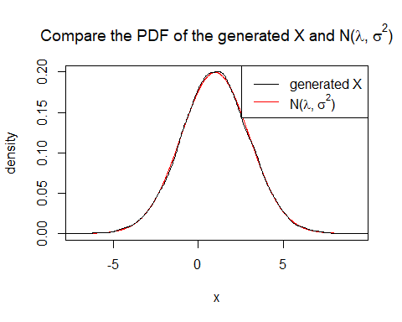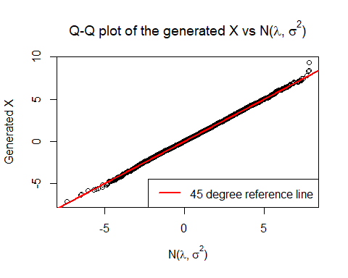
Both the PDF plot and the Q-Q plot supports the argument that, under the suggested conditions, there is indeed vast similarity between the generated X and $N\left(λ,σ^{2}\right)$. However, one should notice that when $m$ is large, the rate of acceptance tends to be very low (in this case 8.99%), which implies a big waste of computational power. Consequently, there may not be sufficient data to strongly support the argument.

