Question 4

(a)
First, we create a function that models one game and builds a deck with numbers 1-8 (with four numbers repeated).
Then, we randomly deal 4 cards to each player. The player who has the lowest sum will be the winner of the game.
sim_game <- function() {
nums <- 1:8
repeat_nums <- sample(nums, size=4, replace = FALSE)
my_deck <- c(nums, repeat_nums)
# Draw cards without replacement
cards_drawn <- sample(my_deck, size=8, replace = FALSE)
# Split cards between players
player1_cards <- cards_drawn[1:4]
player2_cards <- cards_drawn[5:8]
# Find totals
p1_total <- sum(player1_cards)
p2_total <- sum(player2_cards)
# Figure out who wins and calculate the payoff
result <- sign(p2_total - p1_total)
if (result > 0) { # Player 1 wins
pay <- min(player1_cards)
return(c(pay, -pay))
} else if (result < 0) { # Player 2 wins
pay <- min(player2_cards)
return(c(-pay, pay))
} else { # Nobody wins
return(c(0, 0))}}
# Run simulation 100,000 times
set.seed(42)
sims <- 100000
all_results <- matrix(0, nrow = sims, ncol = 2)
for (i in 1:sims) all_results[i,] <- sim_game()
# Find unique outcomes for histograms
p1_outcomes <- sort(unique(all_results[,1]))
p2_outcomes <- sort(unique(all_results[,2]))
# Make histograms
par(mfrow = c(2, 1), mar = c(4, 4, 2, 1))
hist(all_results[,1], breaks = p1_outcomes, prob = TRUE,
main = "Player 1 Payoffs", xlab = "Amount")
hist(all_results[,2], breaks = p2_outcomes, prob = TRUE,
main = "Player 2 Payoffs", xlab = "Amount")
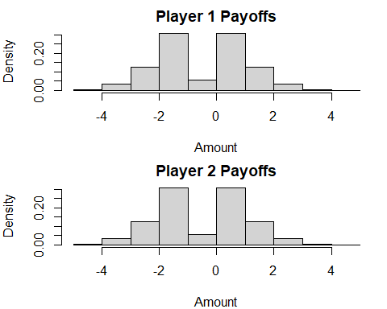
# Calculate expected values
avg_p1 <- mean(all_results[,1])
avg_p2 <- mean(all_results[,2])
cat("\nPlayer 1 expected value:", round(avg_p1, 4))
## Player 1 expected value: -0.0077
cat("\nPlayer 2 expected value:", round(avg_p2, 4))
## Player 2 expected value: 0.0077
Conclusion:
The payoff distributions for both players are mirror images of each other.
The most common outcomes are -1, 0, 1, and 2, with less frequent outcomes at -3, -2, 3, and 4.
The expected values (Player 1: -0.0077, Player 2: 0.0077) are essentially zero.
The game appears to be fair, with neither player having a significant advantage.
Ties (payoff of 0) occur frequently, as shown by the peak at 0 in both histograms.

(b)
# Create a new function where Player 1 always gets their chosen card
sim_game_modified <- function(chosen) {
nums <- 1:8
repeat_nums <- sample(nums, size=4, replace = FALSE)
my_deck <- c(nums, repeat_nums)
# Player 1 gets a chosen card plus 3 random cards
# Player 2 gets 4 random cards
if (chosen %in% my_deck) {
idx <- which(my_deck == chosen)[1]
my_deck <- my_deck[-idx]
} else {
return(sim_game_modified(chosen)) }
cards_drawn <- sample(my_deck, size=7, replace = FALSE)
player1_cards <- c(chosen, cards_drawn[1:3])
player2_cards <- cards_drawn[4:7]
p1_total <- sum(player1_cards)
p2_total <- sum(player2_cards)
if (p1_total < p2_total) {
pay <- min(player1_cards)
return(c(pay, -pay))
} else if (p2_total < p1_total) {
pay <- min(player2_cards)
return(c(-pay, pay))
} else {
return(c(0, 0))
}}
# Test each possible card choice (1-8) with 50,000 simulations
set.seed(42)
sims <- 50000
card_choices <- 1:8
choice_results <- matrix(0, nrow = 8, ncol = 2)
colnames(choice_results) <- c("Exp Value", "Win %")
for (i in 1:8) {
test_results <- matrix(0, nrow = sims, ncol = 2)
for (j in 1:sims) test_results[j,] <- sim_game_modified(i)
choice_results[i,] <- c(
mean(test_results[,1]),
mean(test_results[,1] > 0) * 100
)}
# Print results
cat("\nCard choice results (Expected Value, Win %):")
## Card choice results (Expected Value, Win %):
for (i in 1:8) {
cat("\nCard", i, ":", round(choice_results[i,1], 4),
", ", round(choice_results[i,2], 1), "%")}
## Card 1 : 0.294 , 70.9 %
## Card 2 : 0.518 , 63.4 %
## Card 3 : 0.4087 , 56.6 %
## Card 4 : 0.2018 , 50 %
## Card 5 : -0.0165 , 43.9 %
## Card 6 : -0.2471 , 37.4 %
## Card 7 : -0.4956 , 30.5 %
## Card 8 : -0.747 , 23.5 %
best <- which.max(choice_results[,1])
cat("\n\nBest choice for Player 1: Card", best)
## Best choice for Player 1: Card 2
cat("\nThis gives expected value of", round(choice_results[best,1], 4), "per game")
## This gives an expected value of 0.518 per game
cat("\nThe fair game had expected value around 0, so this is definitely better")
## The fair game had an expected value of around 0, so this is definitely better
Conclusion:
The player A should choose card 2. It gives the highest expected value of payoff equal to 0.518 per game.
While choosing card 1 offers the highest win probability (70.9%), it only yields an expected value of payoff equal to 0.294. Card 2 provides a better balance of win probability (63.4%) and a higher payoff when winning.
As card numbers increase, both expected values of payoff and win probabilities decrease steadily.
Player A now has a significant advantage.

