Omarbek Daulet

Laboratory work 5

Task 1.

Will the conversion to BCNF be dependency preserving in any case? Proofyour statement and give a reasoning for choosing BCNF design.

BCNF:

1. It should be in the **Third Normal Form**.
2. And, for any dependency A → B, A should be a **super key**.

**Third Normal Form:**

1. It should be in the **Second Normal form.**
2. And it should not have **Transitive Dependency.**

**Task 2. Given table in 1NF, convert to 3NF if PK is UnitID, StudentID**

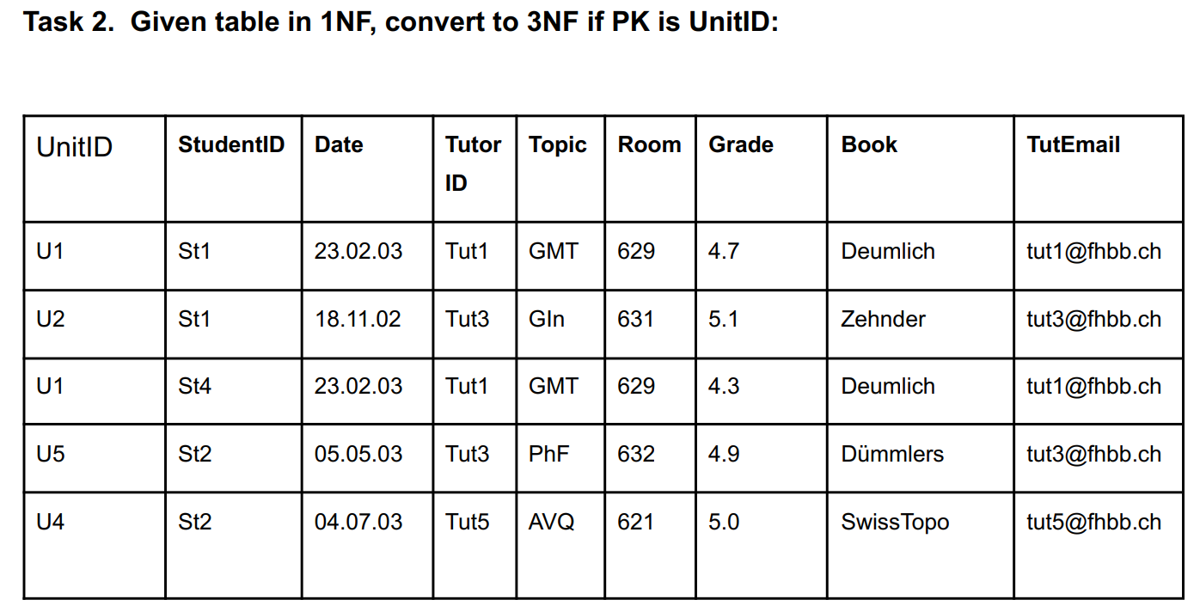

|  |  |  |  |
| --- | --- | --- | --- |
| **UnitID** | **StudentID** | **TutorID** | **Grade** |
| U1 | St1 | Tut1 | 4.7 |
| U2 | St1 | Tut3 | 5.1 |
| U1 | St4 | Tut1 | 4.3 |
| U5 | St2 | Tut3 | 4.9 |
| U4 | St2 | Tut5 | 5.0 |

|  |  |  |  |
| --- | --- | --- | --- |
| **UnitID** | **Date** | **Topic** | **Room** |
| U1 | 23.02.03 | GMT | 629 |
| U2 | 18.11.02 | Gln | 631 |
| U4 | 04.07.03 | AVQ | 621 |
| U5 | 05.05.03 | PhF | 632 |

|  |  |
| --- | --- |
| **Topic** | **Book** |
| GMT | Deumlich |
| Gln | Zehnder |
| AVQ | SwissTopo |
| PhF | Dummlers |

|  |  |
| --- | --- |
| **TutorID** | **TutEmail** |
| Tut1 | tut1@fhbb.ch |
| Tut3 | [tut3@fhbb.ch](mailto:tut3@fhbb.ch) |
| Tut5 | t[ut5@fhbb.ch](mailto:ut5@fhbb.ch) |

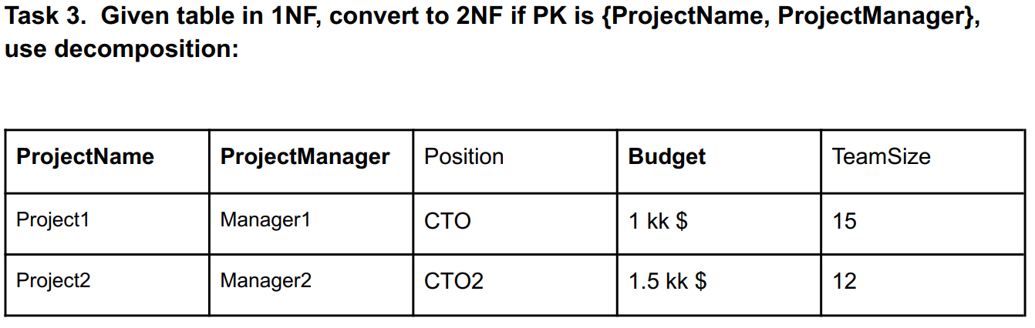

|  |  |
| --- | --- |
| **ProjectName** | **ProjectManager** |
| Project1 | Meneger1 |
| Project2 | Meneger2 |

|  |  |  |
| --- | --- | --- |
| **ProjectName** | **Position** | **TeamSize** |
| Project1 | CTO | 15 |
| Project2 | CTO2 | 12 |

|  |  |
| --- | --- |
| **ProjectManager** | **Budget** |
| Meneger1 | 1 kk $ |
| Meneger2 | 1.5 kk $ |

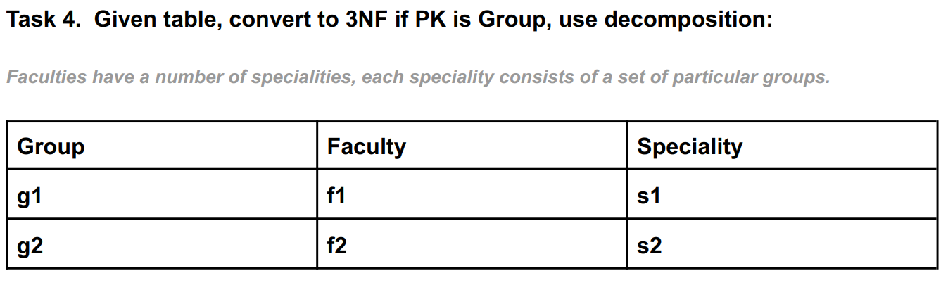

|  |  |
| --- | --- |
| **Group** | **Faculty** |
| g1 | f1 |
| g2 | f2 |

|  |  |
| --- | --- |
| **Faculty** | **Speciality** |
| f1 | s1 |
| f2 | s2 |

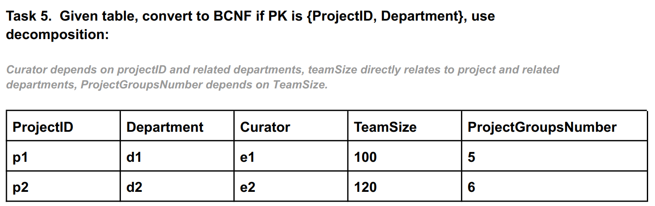

|  |  |  |  |
| --- | --- | --- | --- |
| **PrejectID** | **Department** | **Curator** | **TeamSize** |
| **p1** | **d1** | **e1** | **100** |
| **p2** | **d2** | **e2** | **120** |

|  |  |
| --- | --- |
| **TeamSize** | **ProjectGroupsNumber** |
| **100** | **5** |
| **120** | **6** |

Task 6. List the three design goals for relational databases, and explain why each isdesirable. Give an example of both desirable and undesirable types ofdecompositions.

1. Information minimization

2. No losses

3. Dependency preservation