Amazon Sales Analysis

Purposes Of The Capstone Project
The major aim of this project is to gain insight into the sales data of Amazon to understand the different factors that affect sales of the different branches.
About Data:
This dataset contains sales transactions from three different branches of Amazon, respectively located in Mandalay, Yangon and Naypyitaw. The data contains 17 columns and 1000 rows:

Analysis List
- Product Analysis
- Conduct analysis on the data to understand the different product lines, the products lines performing best and the product lines that need to be improved.
- Sales Analysis
- This analysis aims to answer the question of the sales trends of product. The result of this help us measure the effectiveness of each sales strategy the business applies and what modifications are needed to gain more sales.
- Customer Analysis
- This analysis aims to uncover the different customer segments, purchase trends and the profitability of each customer segment.
Approach Used
Data Wrangling:

- Before analysis begins, we create the database, define the table with NOT NULL constraints (so null values are automatically filtered), and load the data. No separate null-handling step is needed.

- Create a database, table and insert the data.

CREATE DATABASE IF NOT EXISTS amazon;
USE amazon;
SELECT * FROM sales;

--Create a Table

CREATE TABLE IF NOT EXISTS sales (
invoice_id VARCHAR(30) NOT NULL PRIMARY KEY,
branch VARCHAR(5) NOT NULL,
city VARCHAR(30) NOT NULL,
customer_type VARCHAR(30) NOT NULL,
gender VARCHAR(10) NOT NULL,
product_line VARCHAR(100) NOT NULL,
unit_price DECIMAL(10,2) NOT NULL,
quantity INT NOT NULL,
vat FLOAT(6,4) NOT NULL,
total DECIMAL(10,2) NOT NULL,
date DATE NOT NULL,
time TIME NOT NULL,
payment_method VARCHAR(30) NOT NULL,
cogs DECIMAL(10,2) NOT NULL,
gross_margin_percentage FLOAT(11,9) NOT NULL,
gross_income DECIMAL(10,2) NOT NULL,
rating FLOAT(2,1) NOT NULL
);

-- Add 3 new columns time_of_day,day_name,month_name

ALTER TABLE sales
ADD COLUMN time_of_day VARCHAR(20);

UPDATE sales
SET time_of_day = (
CASE
WHEN time BETWEEN '00:00:00' AND '11:59:59' THEN 'Morning'
WHEN time BETWEEN '12:00:00' AND '17:59:59' THEN 'Afternoon'
ELSE 'Evening'
END
);

-- ADD NEW COLUMN day_name

ALTER TABLE sales
ADD COLUMN day_name VARCHAR(10) NOT NULL;

UPDATE sales
SET day_name = DAYNAME(date);

-- ADD NEW COLUMN month_name

ALTER TABLE sales
ADD COLUMN monthname VARCHAR(20) NOT NULL;

UPDATE sales
SET month_name= MONTHNAME(date);
The table now contains 20 columns (17 original + timeofday + dayname + monthname).

Product Analysis

1. What is the count of distinct cities in the dataset?

SELECT count(distinct city) as count_of_distinct_cities
from sales;

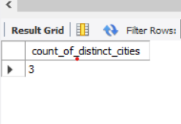
2. For each branch, what is the corresponding city?

SELECT distinct branch, city
from sales
order by branch;

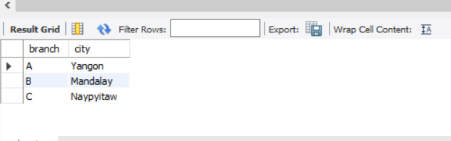

3. What is the count of distinct product lines in the dataset?

SELECT count(distinct `product line`) as Distinct_product_lines
FROM sales;
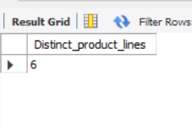
4. Which payment method occurs most frequently?

SELECT payment,count(*) as frequency
from sales
group by payment
order by frequency desc
limit 1;
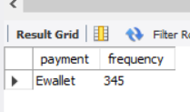
Ewallet- 345 transactions is the most frequently used payment method.

5. Which product line has the highest sales?

SELECT `product line`,SUM(quantity) AS total_units_sold
FROM sales
GROUP BY `product line`
ORDER BY total_units_sold DESC
limit 1;

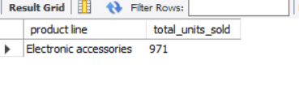
## Electronic accessories has the highest sales with 971 units sold.
6. How much revenue is generated each month?

SELECT monthname,ROUND(SUM(total), 2) as revenue
from sales
group by monthname
order by FIELD(monthname, 'January','February','March');

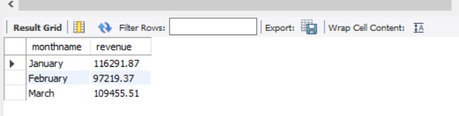

7.In which month did the cost of goods sold reach its peak?

SELECT monthname, Round(SUM(cogs),2) AS total_cogs
FROM sales
GROUP BY monthname
ORDER BY total_cogs DESC
LIMIT 1;
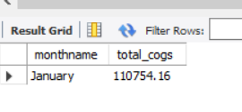
8.Which product line generated the highest revenue?

Select `product line`,round(sum(total),2) as Total_Revenue
from sales
group by `product line`
order by Total_Revenue DESC
limit 1;

## Food and beverages generated the highest revenue of $56144.84.
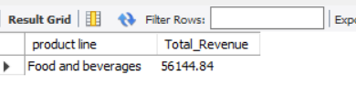
9.In which city was the highest revenue recorded?

Select city,round(sum(total),2) as Total_Revenue
from sales
group by city
order by Total_Revenue DESC
limit 1;

## Naypyitaw generated the highest revenue of $110568.71
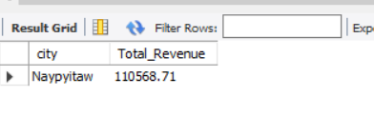

10. Which product line incurred the highest Value Added Tax?

SELECT `product line`, ROUND(SUM(`tax 5%`), 2) AS total_vat
FROM sales
GROUP BY `product line`
ORDER BY total_vat DESC
limit 1;

## Food and beverage incurred the highest Vat of $2673.56.

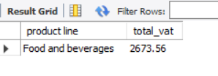
11. For each product line, add a column indicating "Good" if its sales are above average, otherwise "Bad."

SELECT `product line`,
ROUND(AVG(total), 2) AS avg_sales,
CASE
WHEN AVG(total) > (SELECT AVG(total) FROM sales)
THEN 'Good'
ELSE 'Bad'
END AS performance
FROM sales
GROUP BY `product line`
ORDER BY avg_sales DESC;

## Good: Health and beauty, Home and lifestyle, Sports and travel
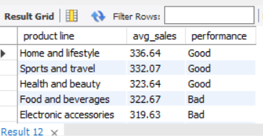

13. Which product line is most frequently associated with each gender?

SELECT gender, `product line`, cnt AS purchase_count
FROM (
SELECT gender,
`product line`,
COUNT(*) AS cnt,
RANK() OVER (PARTITION BY gender ORDER BY COUNT(*) DESC) AS rnk
FROM sales
GROUP BY gender, `product line`
) ranked
WHERE rnk = 1;

## Female - Fashion accessories, Male - Health and beauty are the product line associated with each gender.
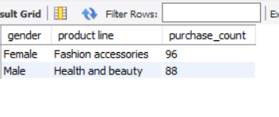

14. Calculate the average rating for each product line.

Select `product line`, Round(Avg(rating),2) as Average_rating
from sales
group by `product line`;

## Food and beverages tops with 7.11 avg rating.

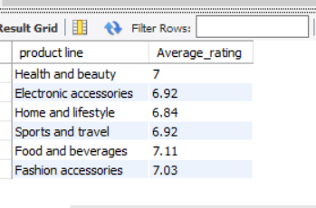

15.Count the sales occurrences for each time of day on every weekday

SELECT dayname,
time_of_day,
COUNT(*) AS num_sales
FROM sales
GROUP BY dayname, time_of_day
ORDER BY FIELD(dayname,'Monday','Tuesday','Wednesday','Thursday','Friday','Saturday','Sunday'),
FIELD(time_of_day,'Morning','Afternoon','Evening');

## Afternoon is the busiest period every day. Saturday & Wednesday peak at 81 afternoon sales
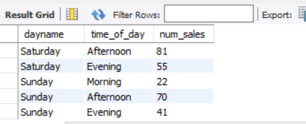

16. Identify the customer type contributing the highest revenue

Select `customer type`,round(sum(total),2) as Highest_revenue
from sales
group by `customer type`
order by Highest_revenue DESC
limit 1;

## Member customers contribute the highest with $164,223.44 in total revenue
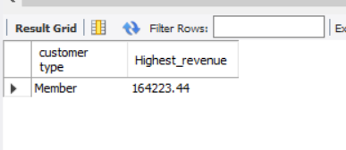
17. Determine the city with the highest VAT percentage

Select city, round(avg(`Tax 5%`),2) as Highest_vat_percentage
from sales
group by city
order by Highest_vat_percentage DESC
limit 1;

## Naypyitaw — highest VAT at 16.05%
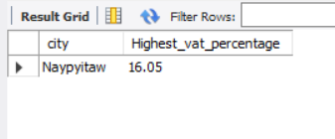

18.Identify the customer type with the highest VAT payments.

Select `Customer type`,round(sum(`tax 5%`)) as total_vat
from sales
group by `customer type`
order by total_vat DESC
limit 1;

## Member — $7,820.16 in total VAT payments
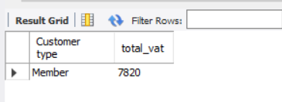

19.What is the count of distinct customer types in the dataset?

Select count(distinct(`customer type`)) as distinct_customer_types
from sales;

## two distinct customer types-Normal,Member
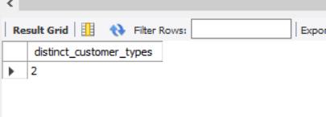
20. What is the count of distinct payment methods in the dataset?

Select count(distinct payment) as distinct_payment_methods
from sales;

## 3 distinct payment methods — Ewallet, Cash, Credit card.

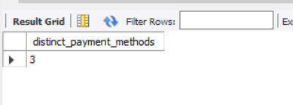
21. Which customer type occurs most frequently?

Select `customer type`,count(*) as frequency
from sales
group by `customer type`
order by frequency DESC
limit 1;

## Member — 501 occurrences (most frequent customer type).
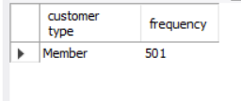

22. Identify the customer type with the highest purchase frequency.

Select `customer type`,count(*) as purchase_count
from sales
group by `customer type`
order by purchase_count DESC
limit 1;

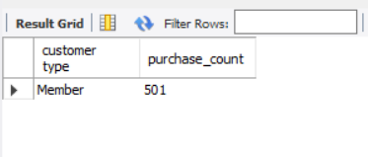
23. Determine the predominant gender among customers.

select gender,count(*) as gender_count
from sales
group by gender
order by gender_count DESC;

## Female — 501 customers is the predominant gender.
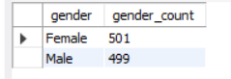

24. Examine the distribution of genders within each branch

Select branch,gender,count(*) as count
from sales
group by branch,gender
order by gender,branch;

## Branch A & B: Male-majority. Branch C: Female-majority
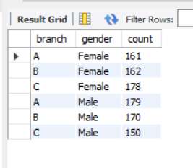

25. Identify the time of day when customers provide the most ratings

Select time_of_day, count(rating) as rating_count
from sales
group by time_of_day
order by rating_count DESC;

## Afternoon-528 is when customers provide most ratings
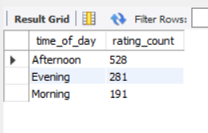

26. Determine the time of day with the highest customer ratings for each branch.

SELECT branch,
time_of_day,
avg_rating
FROM (
SELECT branch,
time_of_day,
ROUND(avg(rating), 2) AS avg_rating,
RANK() OVER (
PARTITION BY branch
ORDER BY AVG(rating) DESC
) AS rnk
FROM sales
GROUP BY branch, time_of_day
) ranked
WHERE rnk = 1;

## Branch A: Afternoon (7.06) | Branch B: Morning (6.89) | Branch C: Afternoon (7.10)

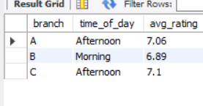

27. Identify the day of the week with the highest average ratings

Select dayname, round(avg(rating),2) as avg_rating
from Sales
group by dayname
order by avg_rating DESC
limit 1;

## Monday has the highest avg rating of 7.15 / 10

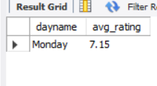

28. Determine the day of the week with the highest average ratings for each branch

WITH cte AS (
SELECT dayname,
branch,
round(AVG(rating),2) AS avg_rating,
RANK() OVER (
PARTITION BY branch
ORDER BY AVG(rating) DESC
) AS rnk
FROM sales
GROUP BY dayname, branch
)
SELECT dayname,
branch,
avg_rating
FROM cte
WHERE rnk = 1;

## Branch A: Friday (7.31) | Branch B: Monday (7.34) | Branch C: Friday (7.28)

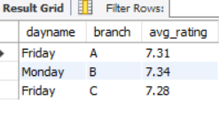

Final Analysis & Insights

Sales & Revenue Insights
- Food and Beverages generated the highest revenue, making it the strongest-performing product line.
- Naypyitaw recorded the highest overall revenue among all cities.
- E-wallet was the most preferred payment method by customers.
- Sales activity was highest during the Afternoon across most weekdays.

Customer Insights
- Member customers contributed the highest revenue and VAT payments.
- Female customers slightly outnumbered male customers overall.
- Repeat buyers showed a stronger tendency toward subscription-based purchases.
- Young and middle-aged customers contributed significantly to total revenue.

Product Performance Insights
- Electronic Accessories had the highest quantity of products sold.
- Food and Beverages received the highest average customer ratings.
- Products like Fashion Accessories and Health & Beauty showed strong gender-based purchasing patterns.
- Some product categories showed high dependency on discounts, indicating price-sensitive buying behavior.

Operational Insights
- Customers using Express Shipping had a higher average purchase value compared to Standard Shipping users.
- Afternoon hours consistently received the highest number of customer ratings and transactions.
- Certain weekdays such as Monday and Friday achieved higher customer satisfaction ratings across branches.

Overall Business Conclusion
The analysis reveals that customer purchasing behavior is heavily influenced by:
- Product category
- Membership status
- Discounts
- Shipping preferences
- Time of purchase
The business can improve profitability by:
- Strengthening loyalty programs
- Promoting high-performing products
- Optimizing discount strategies
- Focusing marketing efforts on high-revenue customer segments.

