kindred
find your people outside
The hardest part is not the trip. It is showing up alone.
Students need to know they can show up alone and still belong.
Outdoor clubs still run trips through Google Forms, GroupMe, and Slack.
Students want to go outside, but showing up without knowing anyone is the hard part. (they need a buddy)
New outdoor participants feel the pull of nature, but arrive without skills, community, or context.

Develop a problem statement

- Students use two different things - noone knows which one to download, as a freshman you feel lost by all the things.
Students want to be the kind of person who goes on adventures, but they do not know anyone yet or how to do it.
Real friendships form through repeated shared experiences, not passive profile views.
Leaders need one place for RSVPs, carpools, attendance, and trip archives.
Universities need infrastructure that turns outdoor participation into real social connection.

Noah Bolton · June 2026 · CONFIDENTIAL
Mobile: React Native + Supabase · Web: Next.js · Beachhead: Cal Poly SLO

Modeling after Instagram, Slack (messaging), tinder, Strava.

Persona | Problem statement

Freshman | The hardest part is not the trip. It is showing up alone.

Beginner | I want to get outside, but I don’t know where to start.

Lonely student | The problem is not connection. It is closeness.

Club leader | Your members want to go outside. You just need to make it easier.

Category thesis | The missing infrastructure is not trails. It is trust.

\

EXECUTIVE SUMMARY

The Case for kindred
Gen Z is the most connected generation in history and the loneliest. In 2023, 40% of U.S. high school students reported persistent sadness or hopelessness. ^{[2]} Time spent with friends in person dropped from 60 minutes per day in 2003 to just 20 minutes today. ^{[12]} Meanwhile, 175.8 million Americans went outside in 2023 — a record high. ^{[16]}
The outdoor boom and the loneliness crisis are happening simultaneously. Nobody has built the infrastructure to connect them. kindred is that infrastructure.
kindred is a free app for college students (18–24) that makes outdoor adventure trips easy to find, join, and share — and builds real friendships as a byproduct. The web portal handles trip planning for club leaders and those individuals who just want to lead a trip with their friends. The mobile app is where members find their people. The business model follows the social platform playbook: grow the network free, monetize premium membership eventually, and charge institutions that need it eventually.

01 — THE PROBLEM

A Generation in Crisis

Gen Z: Anxious, Screen-Saturated, and Alone
In 2023, 40% of U.S. high school students reported symptoms of depression — feeling so sad or hopeless for two or more weeks that they stopped their usual activities. ^{[2]} Among 18–25-year-olds broadly, 42% report struggling with depression and hopelessness — nearly twice the rate of adults over 25 (23%). ^{[3]} The timing maps to one event: mass smartphone adoption by adolescents after 2012. ^{[1]}
6h 27m Average daily phone use for Gen Z — 35% higher than any other generation ^{[4]}
3+ hrs Daily social media linked to measurable mental health decline (Haidt, 2024) ^{[1]}
80% of Gen Z reported feeling lonely in the past 12 months, vs. 45% of Baby Boomers ^{[4]}

Jonathan Haidt's 2024 book The Anxious Generation documents how, after more than a decade of stable adolescent mental health, anxiety, depression, self-harm, and suicide rates more than doubled on several measures after smartphones became ubiquitous. ^{[1]} The McKinsey Health Institute identified "digital loneliness" — heavy online connectivity that intensifies, rather than relieves, feelings of social isolation. ^{[15]}

The Friendship Recession
In May 2023, U.S. Surgeon General Vivek Murthy issued a formal advisory: "Our Epidemic of Loneliness and Isolation." ^{[12]} The headline statistic: daily in-person time with friends fell from 60 minutes (2003) to 20 minutes today — a 66% collapse in one generation. ^{[12]}
60 min → 20 min Daily in-person friend time, 2003 to present — a 66% decline ^{[12]}
Smoking 15 cigarettes/day Mortality risk of chronic loneliness — greater than obesity risk (Surgeon General, 2023) ^{[12]}
3% → 15% American men reporting zero close friends since 1990 — a fivefold increase ^{[13]}

Research by the Survey Center on American Life documented the collapse: men with six or more close friends fell from 55% to 27% since 1990. ^{[13]} Robert Putnam documented the structural preconditions in Bowling Alone (2000), drawing on 500,000 interviews to show declining participation in organizations and friendships driven by television and suburban sprawl. ^{[14]} What Putnam mapped as a trend has become a crisis.

AI Is Accelerating the Problem
MIT economist Daron Acemoglu's 2024 NBER working paper shows that AI displaces cognitive tasks specifically — the tasks of knowledge workers and educated young professionals. ^{[20]} When work compresses, meaning can collapse alongside it. For many people, professional identity is the primary source of social structure. When that erodes without replacement, extra leisure time doesn't produce flourishing — it produces drift. The question is whether this generation's freed attention gets captured by the algorithm or redirected toward something that actually repairs what's broken.

The Outdoor Boom: Demand Without Infrastructure
In 2023, a record 175.8 million Americans participated in outdoor recreation — 57.3% of the population, up 4.1% year-over-year. ^{[16]} That year, 7.7 million Americans tried an outdoor activity for the first time. ^{[16]} Outdoor recreation contributes $1.2 trillion to the U.S. economy and supports 5 million jobs. ^{[17]}
175.8M Americans participating in outdoor recreation in 2023 — a record high ^{[16]}
7.7M First-time outdoor participants in 2023 alone ^{[16]}
$1.2T Outdoor recreation's contribution to the U.S. economy, 5M jobs ^{[17]}

This growth is driven by new and first-time participants — not veterans increasing frequency. These are people who feel the pull of nature but arrive without skills, community, or context. The demand is there. The social infrastructure to meet it is not.

Nature Is the Evidence-Based Antidote
A 2025 systematic review and meta-analysis in BMJ Open found that nature-based health interventions consistently produced reductions in anxiety and psychological distress. ^{[7]} Antonelli et al. (2019) found that forest environments significantly reduce cortisol — the primary biomarker of physiological stress. ^{[6]} A 2026 Delphi study by Madsen et al. ranked the three most impactful factors for mental health outcomes: interaction with nature, social connection, and physical activity ^{[11]} — all three occur simultaneously on an outdoor adventure.

02 — WHAT THE MARKET HAS DONE

The Competitive Landscape
The loneliness-solving startup category has attracted more than $84 million in venture capital. ^{[26]} Multiple well-funded companies are attacking adjacent angles of the same problem. A16z, General Catalyst, Sequoia, and Airbnb are all writing checks into this space. ^{[26]} In 2025 alone, several direct competitors raised $10M+ rounds. The window is open — but narrowing.

Company | Raised | What They Do | Threat Level
Sweatpals | $12M Seed (Oct 2025) | Fitness marketplace: run clubs, hiking, yoga, pickleball. Kevin Hart-backed (HartBeat Ventures), a16z. 237,000+ in run clubs in 22 months. | CRITICAL [26]
WeRoad / WeMeet | $100M total ($58M Series C, May 2026) | Group adventure travel. Airbnb led Series C (10% stake). 100,000 travelers in 2025. WeMeet local events product: 2,000 events, 35 cities. U.S. expansion underway (Austin first). | CRITICAL [27]
Clyx | $14M Series A (Sep 2025) | Social events discovery. "Compatibility engine" matches people at events. Simon Sinek + Venmo co-founder investors. Gen Z founder. Miami + London, expanding to NYC. | CRITICAL [28]
222 (Two Two Two) | $13.7M (YC W23 + Series A 2024) | AI social facilitator for offline IRL experiences. No profiles, no swiping. Algorithm-matched group dinners/events. General Catalyst, Upfront Ventures. NYC-based. | HIGH [29]
Flash Pack  (Great case study) | £7.8M total | Boutique group adventure travel for solo travelers (30s–50s). "160,000+ friendships formed." Launched North America operations 2024. Friendship-through-adventure thesis. | HIGH [30]
Timeleft  (Phenomenal UI!)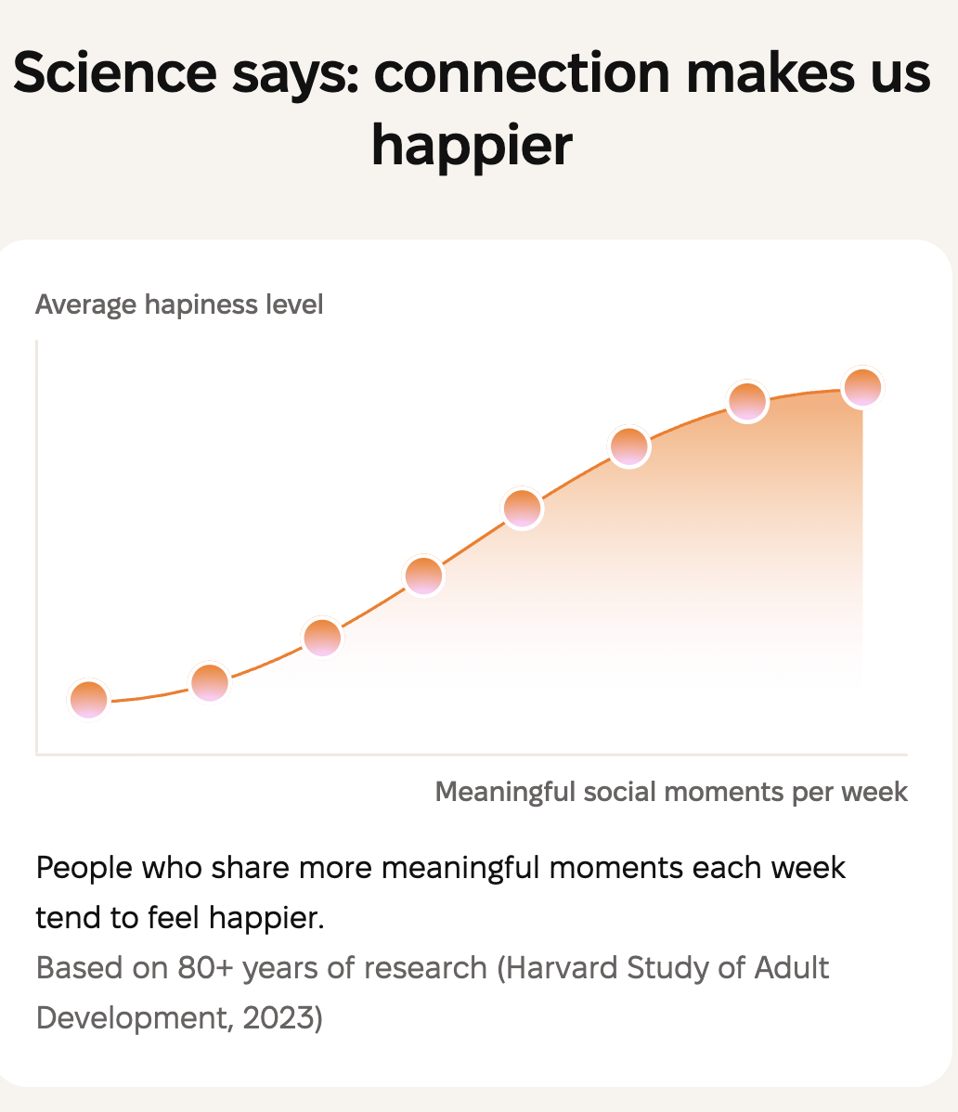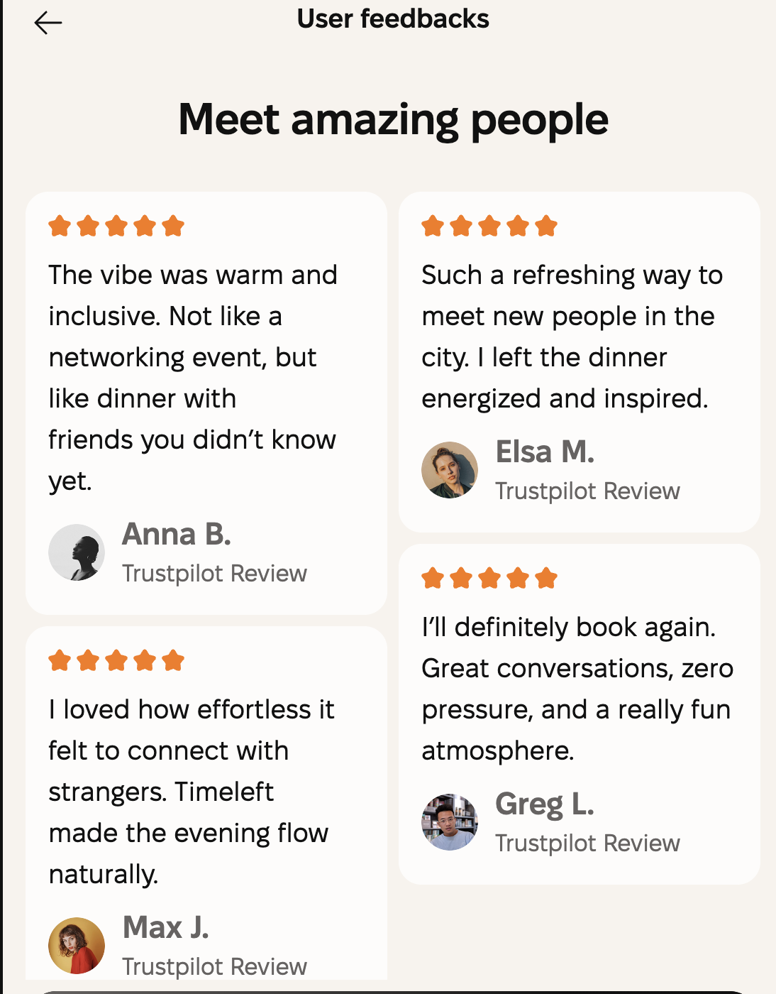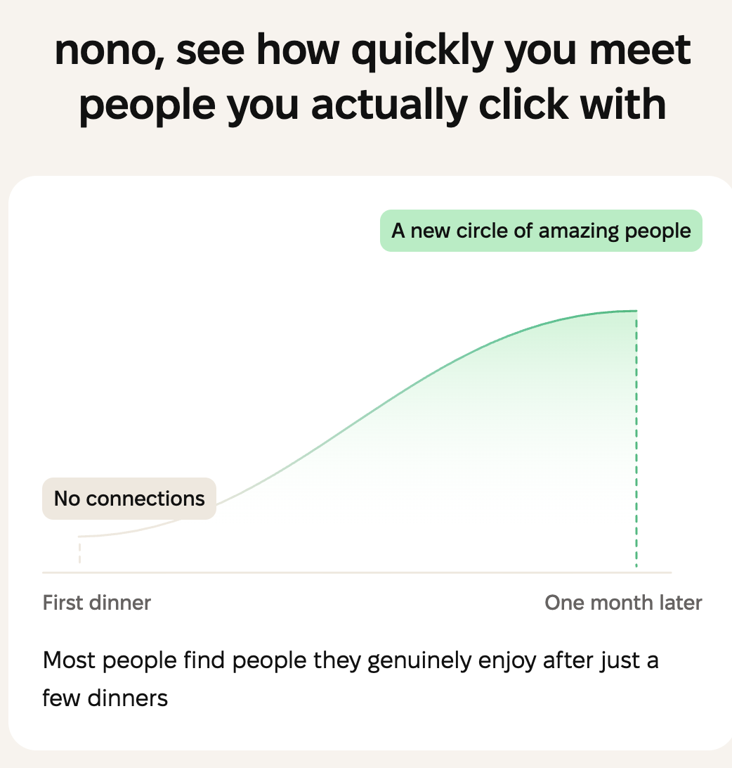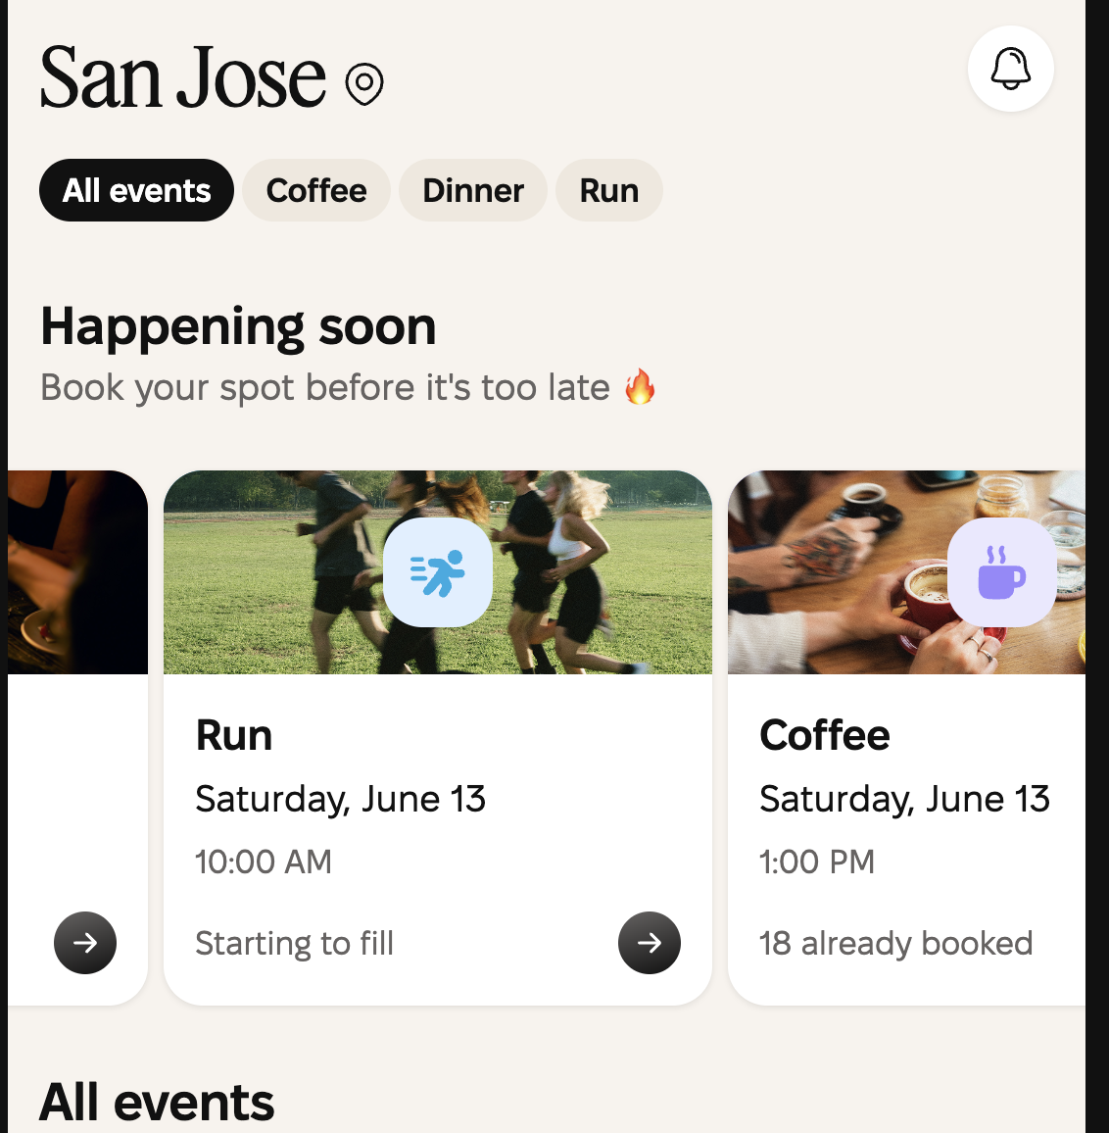 | $7M Series A (Jul 2024) | Stranger dinners in 170+ cities, 27 countries. Weekly dinners sell out. Redstone VC, FJ Labs. Proves people pay to meet strangers in structured IRL experiences. | HIGH [31]
Strava | $2.2B valuation (May 2025) | 180M users. IPO S-1 filed Feb 2026. Gen Z 39% more likely to use fitness "to meet people." Hiking clubs grew 5.8x in 2025. Could add trip-discovery layer overnight. | WILDCARD [32]
AllTrails | ~$1B valuation ($150M raised, 2021) | 65M users. Trail navigation. No social matching. Apple App of the Year 2023. Massive SEO moat — but explicitly NOT a social platform. | ADJACENT [18]

The gap: none of these companies combine campus B2B2C deployment (completely free for user) + attendance-verified friendship data + outdoor-specific + genuinely free + 18–24 only. Strava and AllTrails dominate navigation and fitness logging. Sweatpals and WeRoad and Flash Pack dominate paid fitness/travel experiences. Kindred is the only product designed to build verified friendships through free, novel outdoor adventure, starting at the club level on campus.

What They've Validated
These companies collectively prove the thesis: people will show up in-person to meet strangers through shared activities. Timeleft's dinner model works in 170 cities without being outdoor-specific. Flash Pack has formed 160,000+ friendships through adventure travel. WeRoad did €130M revenue in 2025 with 30% YoY growth. ^{[27]} The market exists. The question is who owns the 18–24 outdoor social layer.

03 — WHAT MAKES KINDRED UNIQUE

The Friendship Engine
University of Kansas professor Jeffrey Hall quantified that it takes approximately 50 hours of shared time to become a friend and ~200 hours to become a close friend. ^{[22]} Those hours accumulate fastest in shared, goal-oriented activities — not passive co-presence. ^{[22]} Harvey Whitehouse's Oxford research found that the more physically demanding a shared experience, the stronger the resulting social bonds — what researchers call "identity fusion." ^{[23]} Arthur Aron's studies show that physiological arousal from shared challenging situations produces bonding effects equivalent to deep mutual disclosure. ^{[25]}
kindred is designed around exactly these conditions. It is not a social network. It is a friendship engine: a system that creates the circumstances where genuine closeness happens inevitably.

The Web App: Trip Planning, Zero Friction
The web portal is designed for club leaders — the people who currently manage outdoor outings through Google Forms, GroupMe, and Instagram DMs. The vibe is deliberate: the same frictionless, intuitive flow as classcrunchlabs.org — you see what to do, you click through, you're done. The web app includes:
Trip creation templates — pre-built flows for hikes, rock climbing days, camping trips, surf sessions, rafting. Leaders fill in logistics, not bureaucracy.
RSVP management ("I'm Committed") — attendance tracking, not social performance. No "like" buttons.
Carpool coordination — auto-built from RSVP data, not a spreadsheet.
Trip archive — channels auto-archive 30 days post-trip, keeping the feed alive and relevant.
Cal Poly policy requires all club money to flow through ASI-managed accounts. So kindred stays completely out of payments in V1 — no Venmo, no Stripe to individuals. The product earns trust by removing friction without introducing transactions.

The Mobile App: Meet Your People
The mobile app is the main product. Five screens: Home, Create, Messaging, Communities (called circles), and Yours. Members are called kindred. The architecture is React Native + Supabase, designed to feel like the outdoor version of what Instagram was before it became an algorithm.
Every design decision is made around one person: Evan Turly. 18 years old, Cal Poly SLO freshman. He signed up for the outdoor club email list because he wants to be the kind of person who goes on adventures. He hasn't shown up yet. He doesn't know anyone. kindred is built to find Evan and give him his crew.

The Mechanic That Changes Everything: The 🔥
After two members attend three shared trips together — confirmed by attendance, not self-reported — a flame emoji appears between their profiles. It is never announced. It is never gamified. It just appears when real friendship has been earned.
This is the product articulation of what Aron ^{[25]}, Whitehouse ^{[23]}, and Hall ^{[22]} each document independently: friendship forms through repeated shared experience, not through swipes or profile views. The 🔥 is the evidence of it.

The B2B2C Go-to-Market
kindred's distribution does not rely on consumer virality. The playbook is B2B2C: pitch the club president → club adopts kindred → members find their Evan.
One club president says yes and you get 200 users in a week. The web app replaces Google Forms, GroupMe, and Instagram DMs in a single demo meeting. The pitch: "Your members already want to go outside. You just need to make it easier." No cold-start problem. No empty feed. The club brings the density.

The Three-Layer Moat
Layer 1 — Operational depth: kindred handles permit logic, carpool coordination, gear lending, and trip logistics. Switching cost = rebuilding an entire workflow.
Layer 2 — Leader relationships: Club presidents run their outdoor programs through kindred. The relationship is with the institution, not a user.
Layer 3 — The social graph: Verified, attendance-confirmed friendship data. This cannot be replicated. You cannot fake 200 hours of shared outdoor experience. The social graph is the moat that compounds forever.
Trust architecture: .edu email verification (Level 1) → attendance verification via check-in (Level 2) → verified organizer paid tier (Level 3). Each layer increases trust without increasing friction for the end user.

Why Not Just Instagram?
Gen Z clubs still live on Instagram. But Gen Z is deliberately avoiding Instagram. They know the algorithm. They know the engagement bait. They want something that feels like a home — not a performance. kindred is the non-algorithmic alternative: no ads, no engagement optimization, no follower counts. Just the trips that are happening near you and the people who are going.

04 — MONETIZATION

The Lemonade Stand Analogies
Every great social platform starts by giving away lemonade. The value isn't in the cup — it's in the crowd. Here's how the biggest players built their crowds, and how kindred follows the same logic.

Instagram's Lemonade Stand
Instagram was acquired by Facebook in April 2012 for $1 billion. ^{[33]} The app had 30 million users and zero revenue. Of that $1 billion, roughly $20 million was infrastructure and code — the rest was the crowd: 30 million users' habits, Kevin Systrom's brain, trust, and network effects.
Today, the average Instagram user generates approximately $39/year in ad revenue — calculated from $7.20 CPM × ~15 ad impressions/day × 365 days. At scale, the lemonade was always free. The advertisers paid for the crowd.
kindred's crowd is more valuable than Instagram's per capita: these are verified, attendance-confirmed outdoor adventurers, age 18–24, with confirmed friendship graphs. That audience cannot be bought on any DSP.

AllTrails' Lemonade Stand
AllTrails grew from 7 million users pre-pandemic to over 65 million by 2024. ^{[18]} It raised $150 million from Permira in 2021 ^{[18]} and is estimated to be valued near $1 billion. ^{[18]} The product is trail navigation. The business model is freemium: free trail data, $35.99/year for offline maps and safety features. Investors paid $150M for what AllTrails hadn't done yet — because the free version was already proof of demand at scale.

Strava's Lemonade Stand
Strava raised at a $2.2 billion valuation in May 2025, backed by Sequoia, TCV, and Jackson Square Ventures. ^{[32]} It filed a confidential IPO S-1 in February 2026. ^{[32]} 180 million users. Revenue approaching $500 million annually. ^{[32]} Strava's Gen Z data point matters: users aged 18–25 are 39% more likely than Gen X to use fitness apps "to meet people who share their interests." ^{[32]} Hiking clubs on Strava grew 5.8x in 2025. ^{[32]} Strava built the crowd through free route tracking. It monetizes through subscriptions.

Snapchat's Lemonade Stand
Snap Inc. (NYSE: SNAP) went public in March 2017 at a $24 billion valuation. ^{[34]} Like Instagram, Snapchat built its crowd by being free — and then sold that crowd's attention. The key insight is that $8 billion, $24 billion, $80 billion in market cap can appear to float in the air — uncaptured — when the right social layer doesn't exist yet. That floating value is what kindred is building toward. The attendance-verified friendship graph of 18–24 outdoor adventurers is exactly the kind of irreplicable asset that a Strava, a Meta, or a wellness brand would pay for.

The VC Investment in This Category
The loneliness-solving startup category as a whole has attracted more than $84 million in venture capital, with dedicated funds like Best Nights VC (Jägermeister-backed) existing specifically to fund IRL experience startups. ^{[26]} A16z, General Catalyst, Sequoia, and Airbnb have all made bets in this space. ^{[26]} The category is not speculative — it is funded, growing, and proving product-market fit across multiple vectors.

kindred's Monetization Path
V1 — Free (now): Zero revenue. Maximum trust. Build the network. Prove the social graph. One campus at a time — start with Cal Poly SLO's 5 outdoor clubs (~1,500 target users). The model works when the feed feels alive.
V2 — Club SaaS ($99/club/month): Club presidents upgrade for advanced features: carpool auto-build, attendance exports, alumni connection tools. At 15 campuses × 5 clubs each = $89K ARR. At 150 campuses = $891K ARR. ^{[35]}
V3 — Transaction fee (1.5%): When clubs process trip fees (gear rental, guided trip deposits) through kindred's Stripe integration, kindred takes 1.5%. This unlocks at scale — after the trust layer is established.
Endgame — Institutional license ($10–20K/year): University rec departments and wellness offices license kindred as mental health and community infrastructure. University counselors know Hall's 50/200 hours research. ^{[22]} kindred offers a measurable outcome: students who use kindred form meaningful outdoor friendships faster than any campus wellness program can engineer. That's a publishable outcome — and a $600K ARR path at 100 institutions. ^{[35]}

05 — POTENTIAL FUTURE OUTCOMES

Where kindred Goes

Scenario A: Acquisition
The most likely near-term outcome. Strava has 180 million users and a pending IPO. ^{[32]} Its Gen Z problem is clear: users want to meet people, not just log miles. kindred's attendance-verified friendship graph solves exactly what Strava is missing. AllTrails (65M users, ~$1B valuation) ^{[18]} has no social matching layer. A wellness-focused brand, a media company (Condé Nast Outdoor, Outside Magazine), or a consumer social player (Meta, Snap) could acquire kindred for its user base, the social graph, and the campus distribution infrastructure. The Instagram precedent — $1B for 30M users and zero revenue ^{[33]} — shows that verified, high-engagement social audiences command multiples disconnected from current revenue.

Scenario B: Independent Social Platform
At 300,000+ users across 150+ campuses (Year 3–5 SOM per market breakdown), ^{[35]} kindred becomes the dominant social layer for outdoor recreation in the college market. The 🔥 social graph — millions of verified friendships, each one attendance-confirmed — is a dataset no competitor can replicate. At that scale, brand partnerships (Patagonia, REI, Arc'teryx) become the primary revenue layer alongside SaaS: 38,000 active users in California alone is the press story that gets Patagonia on the phone. ^{[35]}

Scenario C: Institutional Mental Health Infrastructure
University counseling centers face a documented student mental health crisis. ^{[2]} They have budget, mandate, and zero good tech solutions. kindred — licensed at $10–20K/year per institution — becomes the evidence-based outdoor social intervention for campus wellness programs. With Jeffrey Hall ^{[22]} or Dacher Keltner ^{[19]} as an academic advisor, kindred publishes outcome data showing that students who attend 3+ outdoor trips form close friendships at rates that exceed any campus program. That data becomes a moat: a publishable, peer-reviewed outcome that justifies institutional budgets and creates the kind of evidence trail that gets a Surgeon General partnership. ^{[12]}

Scenario D: The Attention Economy Alternative
The largest bet. Haidt's research ^{[1]} and the Surgeon General's advisory ^{[12]} are building regulatory and cultural pressure on attention-extracting social platforms. If that pressure translates into policy — warnings on social media, school restrictions, insurance mandates around screen time — there will be demand for a provably pro-social alternative. kindred is the only platform in this space designed from the ground up to be non-algorithmic, non-engagement-bait, and evidence-backed in its prosocial outcomes. That positioning could become not just a brand advantage but a category definition: the first certified friendship platform.

The One-Sentence Version
kindred is a free friendship engine for 18–24 year olds — where shared novel outdoor adventures build real friendships, proven by data, one city at a time.

References
All claims in this document correspond to a numbered citation below.

1. Haidt, J. (2024). The Anxious Generation. Penguin Press. jonathanhaidt.com
2. Centers for Disease Control and Prevention. (2023). Youth Risk Behavior Survey. cdc.gov
3. Walton Family Foundation / Harmony Healthcare IT. (2023). Gen Z mental health data. growtherapy.com
4. GWI. (2024). Understanding Gen Z's Loneliness Epidemic. gwi.com/blog/gen-z-loneliness
5. National Institute of Mental Health. (2024). Any anxiety disorder. nimh.nih.gov
6. Antonelli, M., et al. (2019). Effects of forest bathing on cortisol. International Journal of Biometeorology, 63, 1117–1134. doi.org/10.1007/s00484-019-01717-x
7. Jessen, N.H., et al. (2025). Effect of nature-based health interventions for anxiety/depression/stress: systematic review. BMJ Open, 15(7), e098598. doi.org/10.1136/bmjopen-2024-098598
8. Barton, J., & Pretty, J. (2010). Best dose of nature and green exercise for improving mental health. Environmental Science & Technology. doi.org/10.1021/es903183r
11. Madsen, L.S., et al. (2026). Delphi study on nature-based health interventions. International Journal of Environmental Research and Public Health. doi.org/10.3390/ijerph23010126
12. Murthy, V.H. (2023). Our Epidemic of Loneliness and Isolation. U.S. Surgeon General's Advisory. hhs.gov (PDF)
13. Survey Center on American Life. (2021). The State of American Friendship. americansurveycenter.org
14. Putnam, R.D. (2000). Bowling Alone: The Collapse and Revival of American Community. Simon & Schuster.
15. McKinsey Health Institute. (2022). Gen Z mental health: The impact of tech and social media. mckinsey.com
16. Outdoor Industry Association. (2024). 2024 Outdoor Participation Trends Report. oia.outdoorindustry.org
17. Outdoor Recreation Roundtable. (2024). Outdoor recreation: $1.2 trillion economic engine. recreationroundtable.org
18. AllTrails growth: Appfigures (2024); Startup Signals (2024); $150M raise from Permira (2021) via TechCrunch. Startup Signals analysis
19. Piff, P.K., et al. (2015). Awe, the small self, and prosocial behavior. Journal of Personality and Social Psychology, 108(6), 883–899. apa.org
20. Acemoglu, D. (2024). The simple macroeconomics of AI. NBER Working Paper 32487. nber.org
21. Monroy, M., & Keltner, D. (2023). Awe as a pathway to mental and physical health. Perspectives on Psychological Science, 18(2), 309–320. doi.org
22. Hall, J.A. (2019). How many hours does it take to make a friend? Journal of Social and Personal Relationships, 36(4), 1278–1296. news.ku.edu
23. Whitehouse, H. (2021). How extreme rituals forge intense social bonds. Aeon. Oxford Anthropology, Extreme Rituals and Social Bonding Lab. aeon.co
24. Tarr, B., et al. (2016). Synchrony and physiological arousal increase cohesion and cooperation. Scientific Reports. PMC5760525
25. Aron, A., et al. (1997). The experimental generation of interpersonal closeness. Personality and Social Psychology Bulletin, 23(4), 363–377. Berkeley Greater Good
26. Alumni Ventures / Best Nights VC. Cited in: Kindred Competitive Intelligence Report (internal, June 2026). Sweatpals: $12M Seed Oct 2025 (Patron, a16z speedrun, HartBeat Ventures). Confirmed via TechCrunch and Crunchbase.
27. WeRoad/WeMeet: $100M total raised; $58M Series C (May 2026) led by Airbnb (10% stake). €130M revenue, 30% YoY growth. 100,000 travelers in 2025. Kindred Competitive Intelligence Report (internal, June 2026).
28. Clyx: $14M Series A (Sep 2025), Blitzscaling Ventures. Simon Sinek + Venmo co-founder Iqram Magdon-Ismail as investors. Kindred Competitive Intelligence Report (internal, June 2026).
29. 222 (Two Two Two): $13.7M total ($3.6M seed + $10.1M Series A 2024). Y Combinator (W23), General Catalyst, Upfront Ventures. Kindred Competitive Intelligence Report (internal, June 2026).
30. Flash Pack: £7.8M total (£5M latest round, JamJar Investments + Active Partners). 160,000+ friendships formed, 50,000 in 2024 alone. Kindred Competitive Intelligence Report (internal, June 2026).
31. Timeleft: $7M Series A (Jul 2024), Redstone VC, FJ Labs, Global Founders Capital. 170+ cities, 27 countries. Kindred Competitive Intelligence Report (internal, June 2026).
32. Strava: $2.2B valuation (May 2025, Sequoia/TCV/Jackson Square). IPO S-1 filed Feb 2026. 180M users. Approaching $500M annual revenue. Gen Z 39% more likely to use fitness to meet people (Strava Year in Sport 2025). Kindred Competitive Intelligence Report (internal, June 2026).
33. Facebook acquisition of Instagram for $1 billion (April 2012). TechCrunch
34. Snap Inc. (NYSE: SNAP) IPO March 2017. Initial valuation $24 billion. Snap IPO filing
35. kindred Market Breakdown & SOM by Segment (internal, June 2026). Revenue projections based on: $99/club/month SaaS × 5 clubs × campuses; $500/month institutional license × universities.

