BCS 120, 1, 2017

Rick Bruckner

assignment 1

9/10/2017

Problem statement: create a Text UI with the ability to take in a name and ram id that checks if its a decimal digit

Structure chart: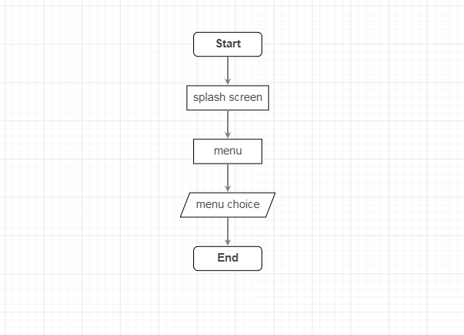

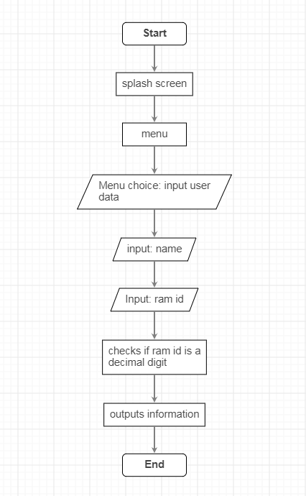

Implementation:

I used the cin.fail() function and switch statements, i also used the supplied code.

Results:

The program worked as intended allowing u to go through the menu and input your data for your farmingdale information.