**Laboratory work 8**

**We continue to work with the database from the previous laboratory works.**

**Take a full-page screenshot that covers the code and results of each task.**

VIEW.

1. Create a view to show details of all flights that are departing on a specific date.  
   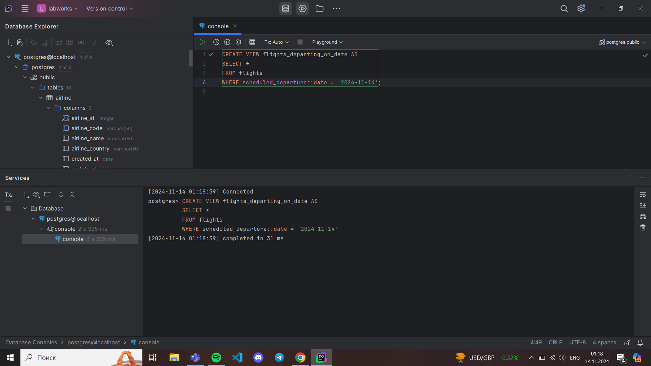
2. Create a view that shows bookings for flights scheduled to depart within the next week.  
   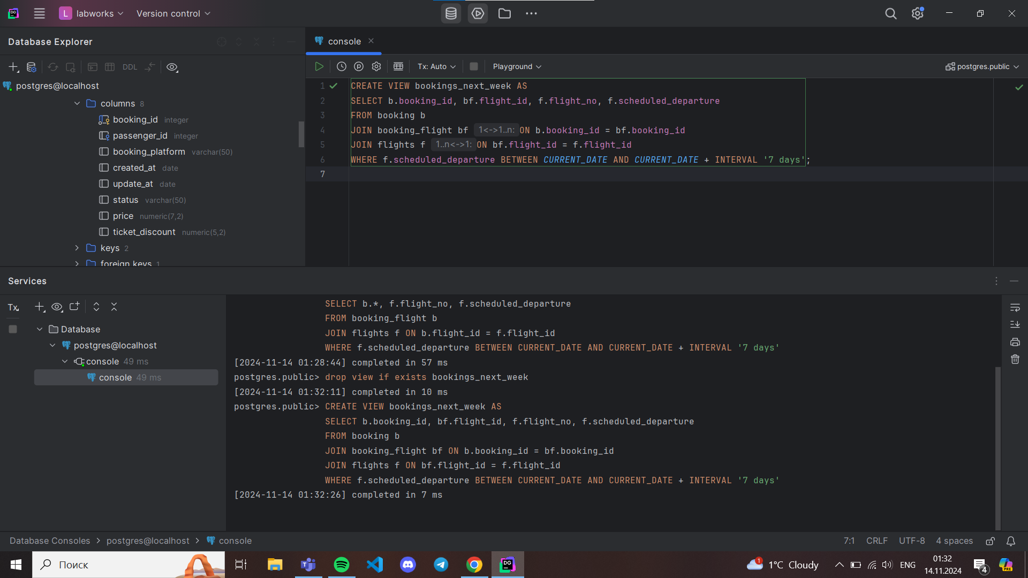
3. Create a view to show the top 5 most popular flight routes based on the number of bookings.  
   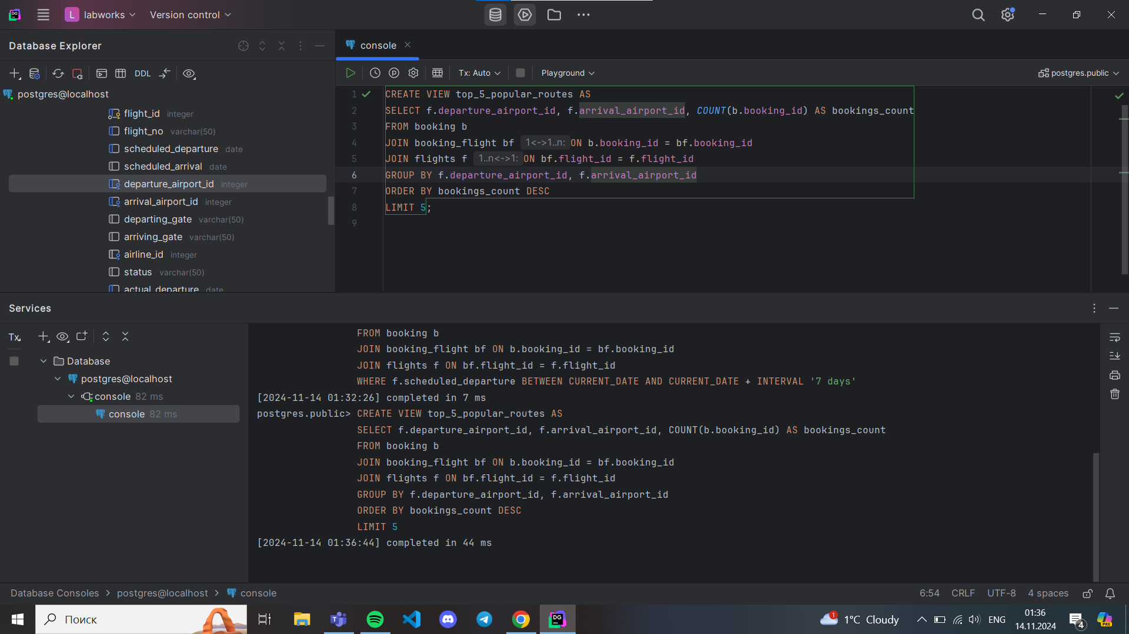
4. Create a view that lists all flights for a specific airline.  
   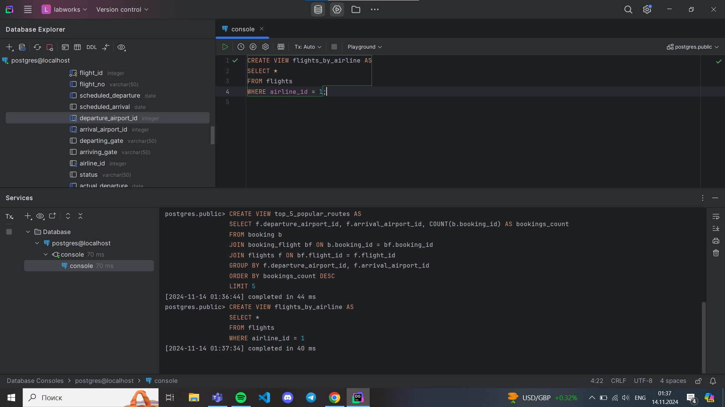
5. Modify the view created in task 4 to show only flights departing within the next 7 days for a specific airline.  
   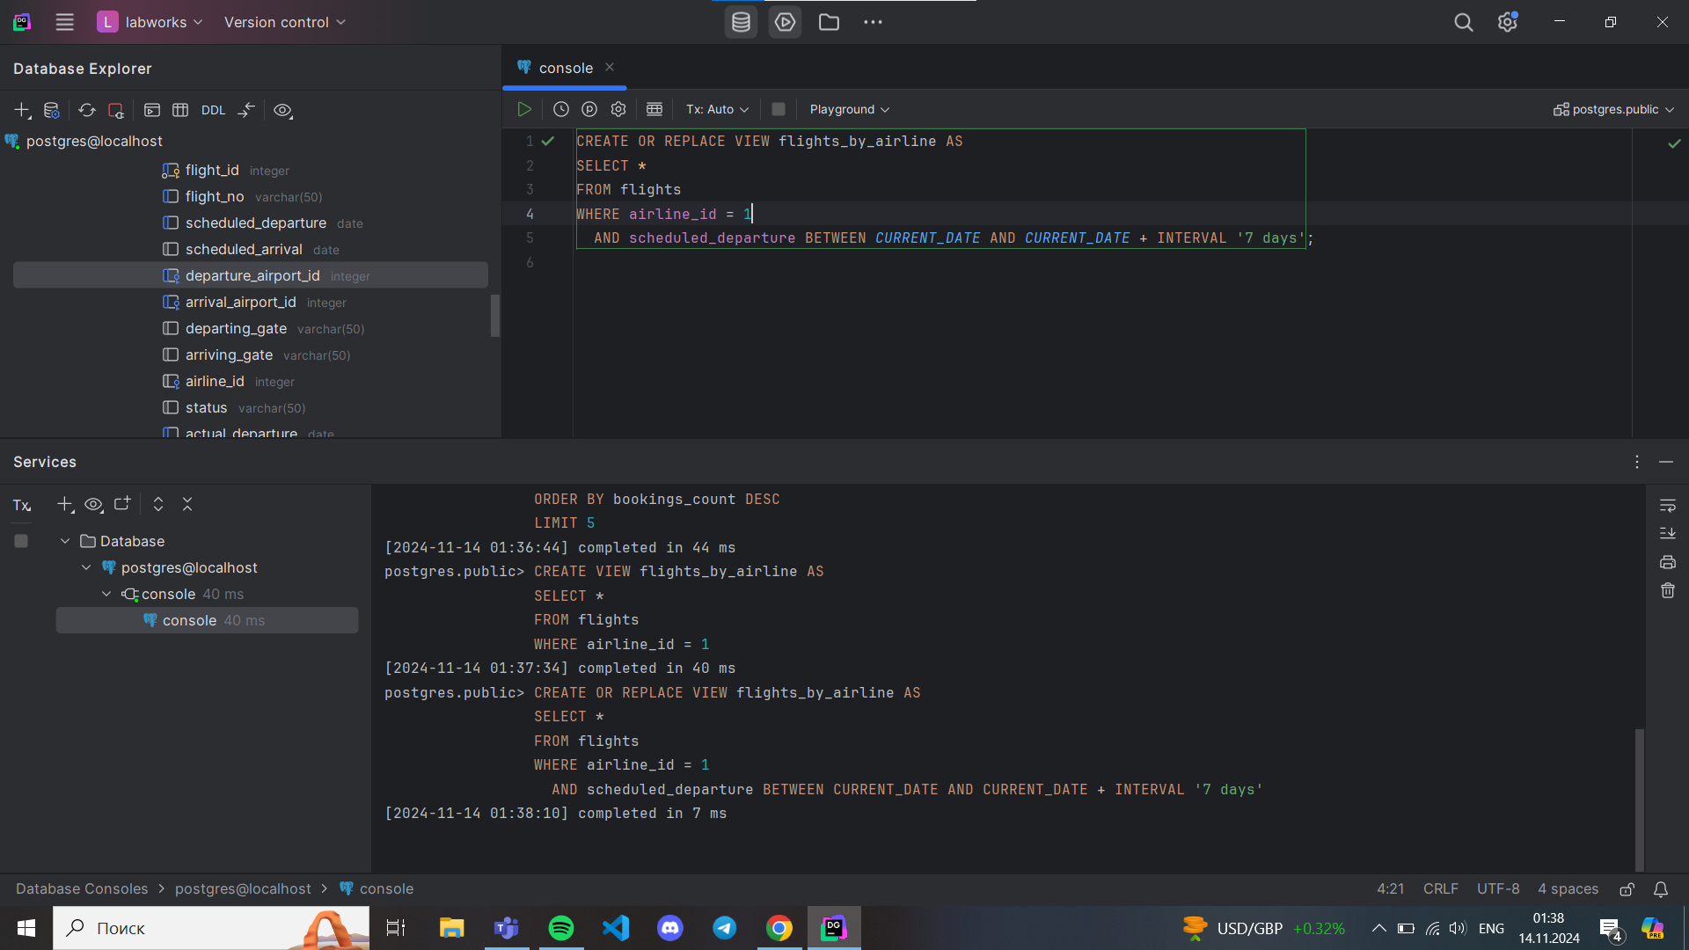
6. Create a view to show flights that are delayed by more than 24 hours.  
   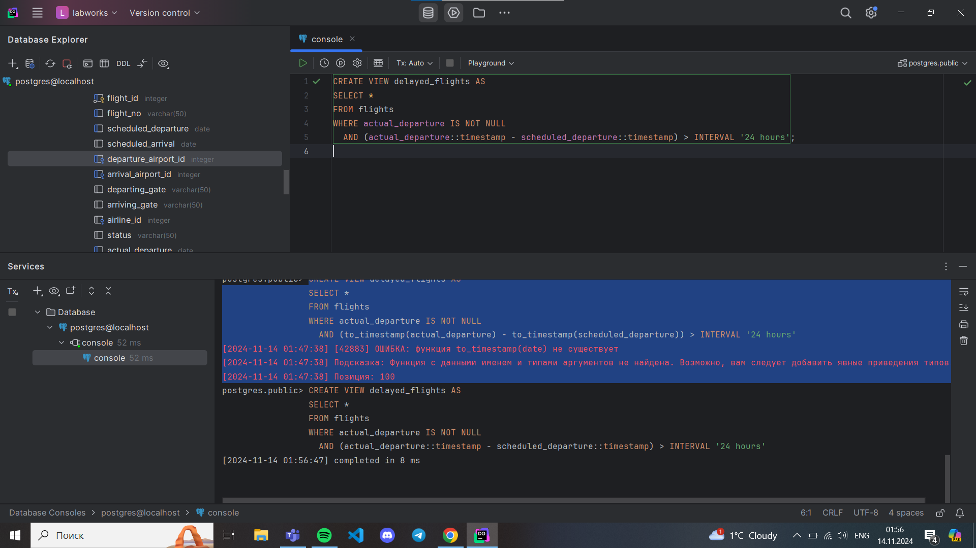
7. Create a view in which you can display the full name and country of origin of passengers who made bookings on Leffler-Thompson platform. Then show the list of that passengers.  
   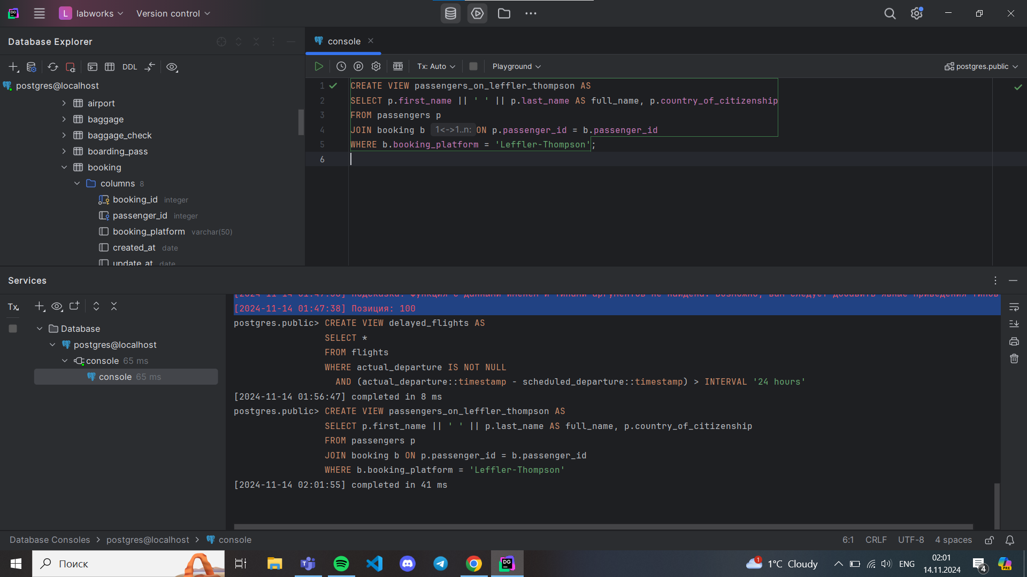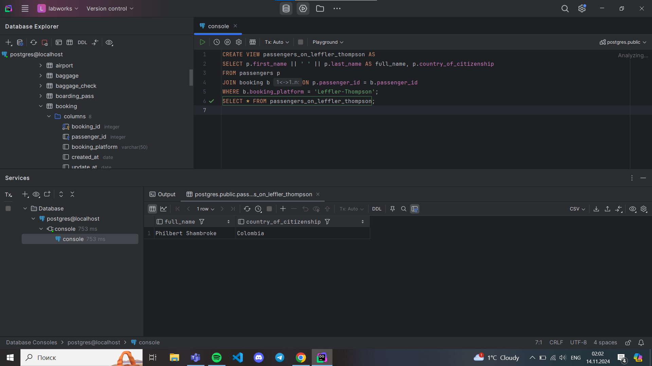
8. Create a view that shows top 10 most visited countries.  
   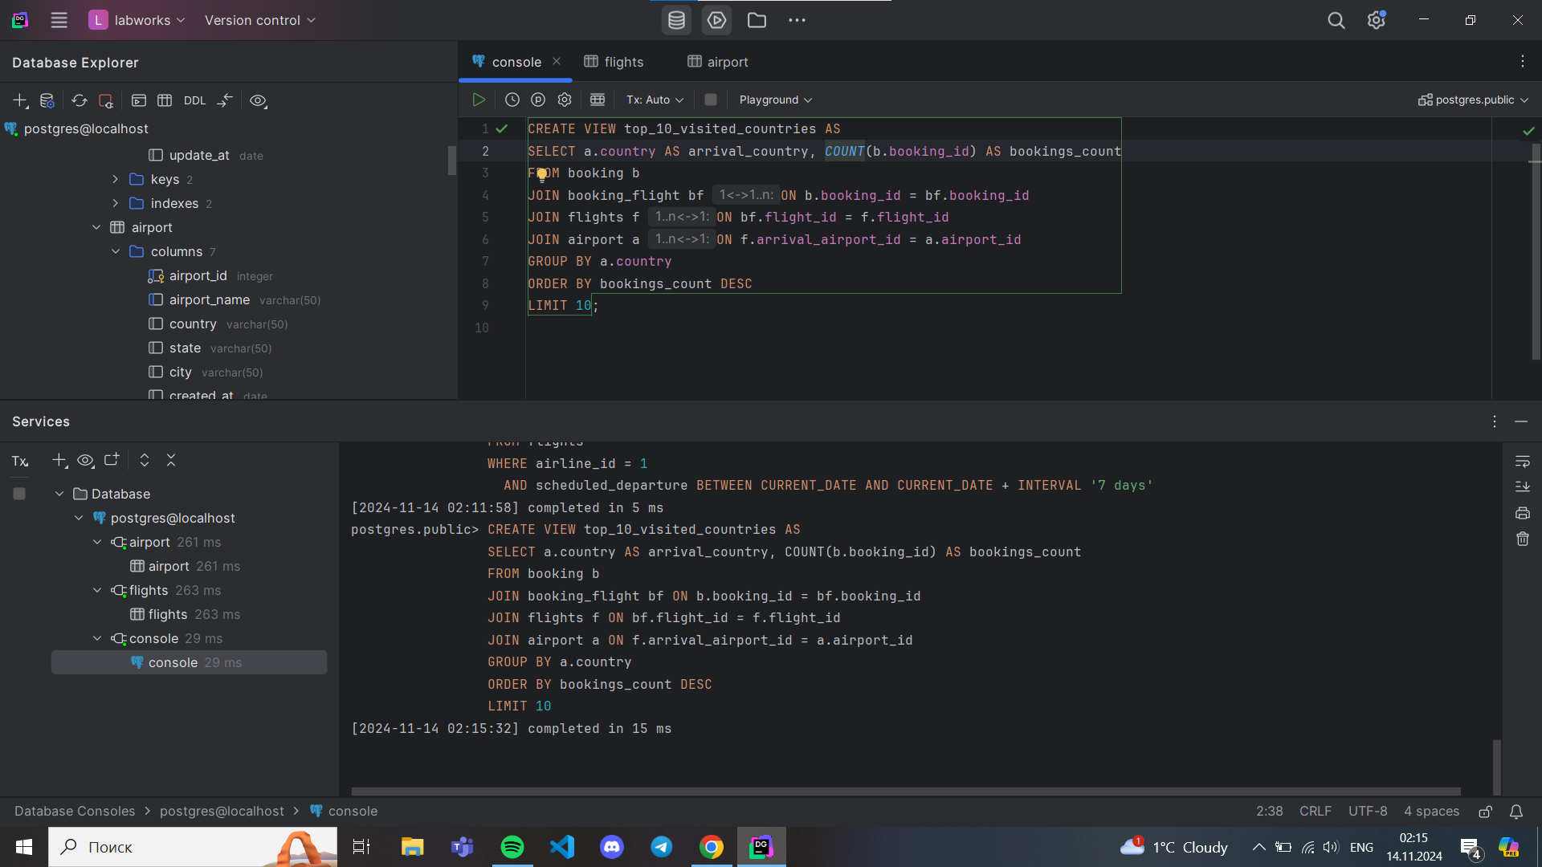
9. Update any of the created views by adding new information in the view table. Show results.  
   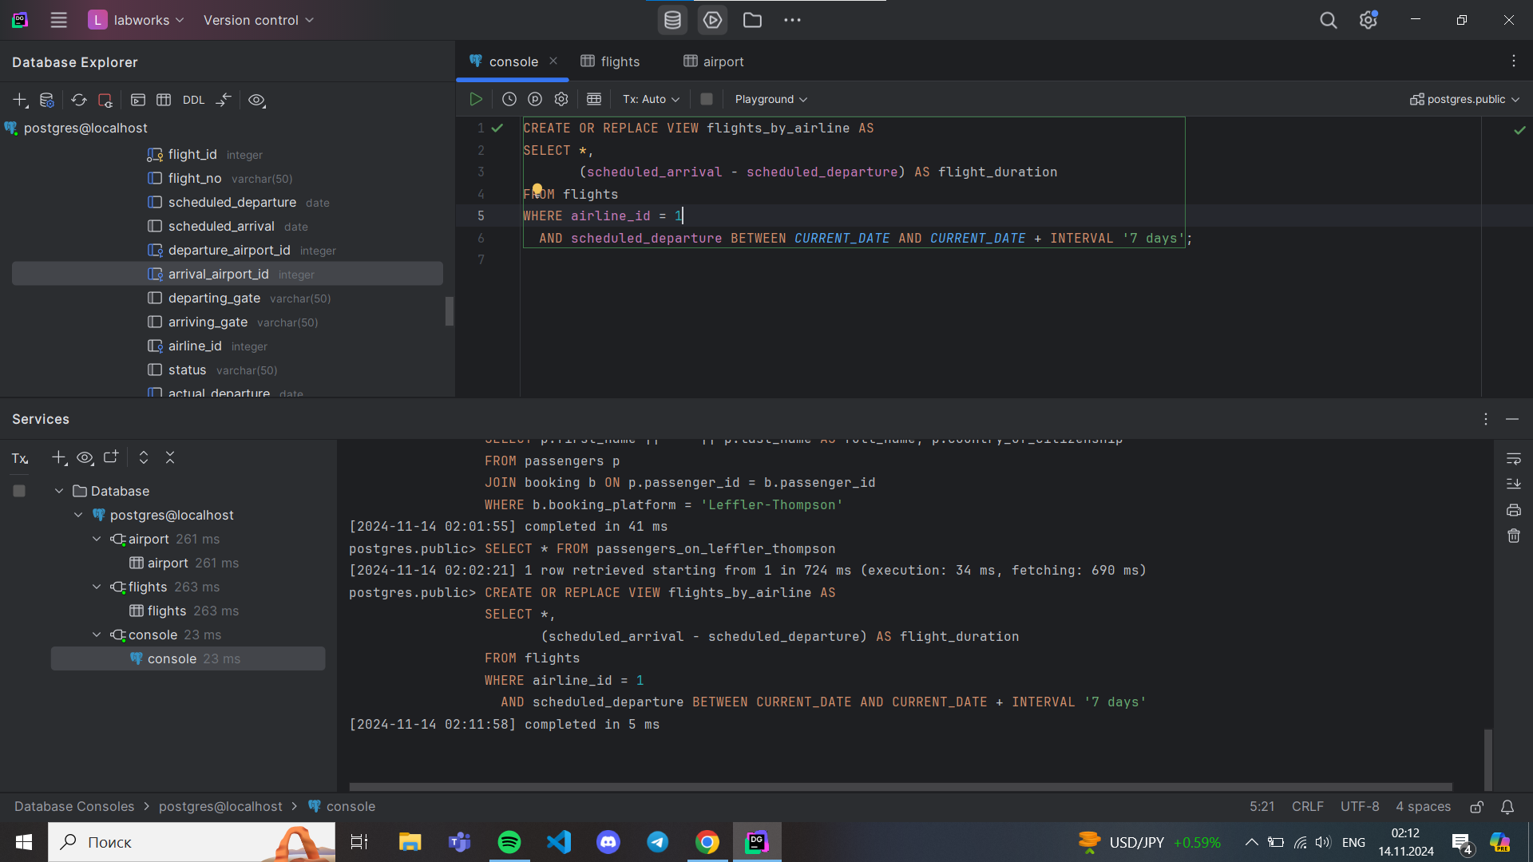
10. Drop all existing views.   
    