**JUDUL – TIDAK LEBIH DARI 14 KATA, FONT: BOOK ANTIQUA (BA), FONT SIZE 14, BOLD, CENTERED**

AUTHOR’S NAME1, AUTHOR’S NAME2, AUTHOR’S NAME3

*1Affiliation-afiliasi* (e.g. *Pendidikan Matematika, Universitas Muhammadiyah Malang*), *Country*

[Author1_email@yahoo.com](mailto:Author1_email@yahoo.com)

*2Affiliation-afiliasi* (e.g. *Pendidikan Matematika, Universitas Pendidikan Muhammadiyah Sorong), Country*

[Author2_email@yahoo.com](mailto:Author2_email@yahoo.com)

*3Affiliation-afiliasi* (e.g. *Pendidikan Matematika, Universitas Muhammadiyah Kupang*), *Country*

[Author3_email@yahoo.com](mailto:Author3_email@yahoo.com)

First Received: DD-MM-YYYY; Accepted: DD-MM-YYYY

**Abstrak**

Abstrak ditulis dalam Bahasa Indonesia dalam satu paragraf tidak lebih dari 250 kata. BA, Justify, ukuran 11, spasi 1. berisi pernyataan tentang pentingnya penelitian, tujuan penelitian, metode penelitian, temuan utama, dan simpulan. Abstrak ditulis dalam Bahasa Indonesia dalam satu paragraf tidak lebih dari 250 kata. BA, Justify, ukuran 11, spasi 1. berisi pernyataan tentang pentingnya penelitian, tujuan penelitian, metode penelitian, temuan utama, dan simpulan. Abstrak ditulis dalam Bahasa Indonesia dalam satu paragraf tidak lebih dari 250 kata. BA, Justify, ukuran 11, spasi 1. berisi pernyataan tentang pentingnya penelitian, tujuan penelitian, metode penelitian, temuan utama, dan simpulan.

**Kata kunci:** Kata kunci pertama; kata kunci kedua; kata kunci ketiga; kata kunci keempat; kata kunci kelima - BA, 11, spasi 1, Maksimal 5

**TITLE – NOT MORE THAN 14 WORDS, BOOK ANTIQUA (BA), SIZE 14, BOLD, CENTERED**

**Abstract**

The abstract must be written in english. The abstract should be written in one paragraph and should be not more than 250 words. BA, Justify, font size 11, single spacing. Follow the following pattern: General statement about the importance of the topic, purpose of study, method, main findings, and conclusion. The abstract must be written in english. The abstract should be written in one paragraph and should be not more than 250 words. BA, Justify, font size 11, single spacing. Follow the following pattern: General statement about the importance of the topic, purpose of study, method, main findings, and conclusion. The abstract must be written in english.

**Keywords:** Keyword one; keyword two; keyword three; keyword four; keyword five - BA, 11, single spacing, Maximum 5 keyword

**INTRODUCTION-PENDAHULUAN**

Artikel bisa ditulis dalam Bahasa Inggris atau Bahasa Indonesia. Panjang artikel sekitar 6 – 10 halaman (tidak lebih dari 5000 kata), spasi 1,5 huruf book antiqua ukuran 12, tidak termasuk daftar pustaka dan lampiran. Artikel menggunakan kertas A4 dengan ukuran margin: atas dan bawah 2 cm, kiri dan kanan 2 cm (Uluçinar & Aypay, 2016). Pendahuluan berisi tentang latar belakang masalah dan kajian teori (Facione, 2020; Leidman et al., 2020; Pestano, González, & Gil, 2021; Rosinger & Young, 2020). Pengutipan dapat dilihat catatan di bawah. Referensi yang digunakan dibatasi 10 tahun terakhir. Untuk penulisan tabel dan gambar mengikuti format tabel 1 dan gambar 2.

The article written in english or bahasa Indonesia. The article should be between 6-10 pages (not more than 5000 words), 1.5 spaced, 12 point book antiqua font, excluding references and appendices. The article used A4, with the margin must be set as follows: top and bottom 2cm, left and right 2cm. The introduction includes the background of the problem and theoretical review. Citations can be found in the notes below. References used are limited to the last 10 years. The formatting for tables and figures follows the format in Table 1 and Figure 2.

Tabel 1. Indokator model

|  |  |  |
| --- | --- | --- |
| Model | Indikator | Keterangan |
| A1 | B1 | huruf book antiqua ukuran 11 |
| A2 | B2 |
| Jumlah |  |

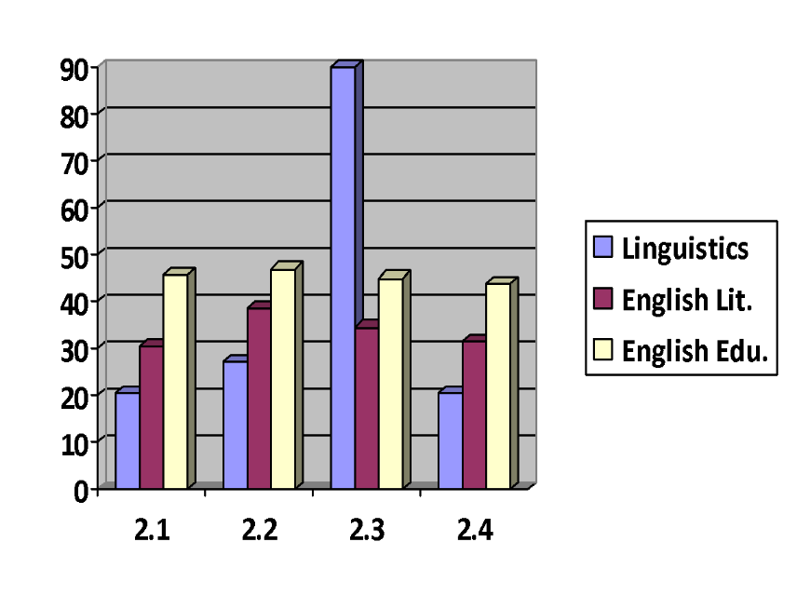

Gambar 1. Tema

**Subheadings 1**

Tuliskan jika ada. Judul dari subjudul 1 menggunakan BA ukuran 12, Tebal, Sentence case. Format isi subjudul 1 sama dengan pendahuluan. Add here if any. The tittle of subheadings 1 used 12 point book antiqua, Bold, Sentence case. The format of subheadings 1 same with the format in introduction.

***Subheadings2***

Tuliskan jika ada. Judul dari subjudul 2 menggunakan BA ukuran 12, Tebal, Miring, Sentence case. Format isi subjudul 2 sama dengan pendahuluan. Add here if any. The tittle of subheadings 2 used 12 point book antiqua, Bold, Italic, Sentence case. The format of subheadings 2 same with the format in introduction.

**METHOD-METODE PENELITIAN**

Metode penelitian menjelaskan tentang subjek atau responden, desain penelitian, langkah penelitian, dan instrumen yang digunakan. Jelaskan semuanya dengan jelas. Method is about subject or respondents, research design, research procedure, and instruments that used. Explain all in here clearly.

**FINDINGS AND DISCUSSION-HASIL DAN PEMBAHASAN**

Hasil penelitian dan pembahasan menjelaskan tentang hasil yang diperoleh dari penelitian. Jelaskan mengenai proses memperoleh hasil dan jelaskan hasil yang diperoleh dengan ringkas dan jelas. Penjelasan dapat diuraikan dalam subheading-subheading bisa juga diuraikan secara langsung. Finding and discussion is about the result. Explain process of find the result and description the result briefly and clearly. Description can be written in the subheadings or not.

**CONCLUSION-SIMPULAN**

Kesimpulan berkaitan dengan ringkasan hasil penelitian. Kesimpulan harus sesuai dengan rumusan masalah penelitian. Jika ada lebih dari satu simpulan dapat dituliskan dengan penomoran dan bukan dengan menggunakan *bullet.* Conclusion is about summary of the result. Conlusion must suitable with question of the research. If there is more than one conclusion written then the numbering uses numbers and not using bullets.

**THANKS TO-UCAPAN TERIMA KASIH**

Jika perlu berterima kasih kepada pihak tertentu, misalnya sponsor penelitian. Nyatakan dengan jelas dan singkat. Add here if any. If you need to thank certain parties, for example sponsors. Say it clearly and shortly.

**REFERENCES-DAFTAR PUSTAKA (Examples)**

Choo, S. (2004). Investigating Ideology in the Literature curriculum in Singapore. Unpublished master’s thesis. Department of English Language and Literature: National University of Singapore.

Choo, S. (2011). On literature’s use(ful/less)ness: Reconceptualising the literature curriculum in the age of globalisation. *Journal of Curriculum Studies, 43*(1), 47-67.

Curriculum Planning and Development Division. (2007). *Literature in English, teaching syllabus.* Ministry of Education: Singapore.

Facione, P. A. (2020). Insight assessment critical thinking : What it is and why it count. In Insight assessment.

Pestano, C., González, C., & Gil, M. C. (2021). Analysis of the critical attitude of university social sciences students toward the use of computing software. Revista Latinoamericana de Investigacion En Matematica Educativa, 24(1), 35–60. https://doi.org/10.12802/RELIME.21.2412

Rosinger, A. Y., & Young, S. L. (2020). The toll of household water insecurity on health and human biology: Current understandings and future directions. Wiley Interdisciplinary Reviews: Water, 7(6). https://doi.org/10.1002/wat2.1468

Uluçinar, U., & Aypay, A. (2016). A model of Decision-Making based on critical thinking. Egitim ve Bilim, 41(185), 251–268. https://doi.org/10.15390/EB.2016.4639

**APPENDIX-LAMPIRAN**

Add here if any. Jika ada.

**CITATION**:

Use APA for in-text citations and the reference list (Angeli et al, 2010). For in-text citations, use the author’s name and year (Author, 1980), and if there are direct quotes, then provide the page number (Author, 2010, p. 24). If you are citing more than one reference, put them in alphabetical order (Alpha, 2008; Beta, 1999). For a reference with up to five authors, use all the names in the first instance (Author1, Author2, Author3, Author4 & Author5, 2007), and then use the first author et al. subsequently (Author1 et al., 2007). Do not use footnotes.