Names: David Morfin and Millie Lombera

Questions
- What do you observe based on Task 1b? How many bytes are different between the two digests?
When I changed 1 bit of the input message the SHA-256 digest changed completely. This was because of the avalanche effect where a small input change creates an unpredictable change in the hash. I ran 3 tests on 3 different strings and they came back with all 32 bytes being different.

- What is the maximum number of files you would ever need to hash to find a collision on an n-bit digest? Given the birthday bound, what is the expected number of hashes before a collision on an n-bit digest? Is this what you observed? Based on the data you have collected, speculate on how long it might take to find a collision on the full 256-bit digest.
N bit digest has 2^n possible outputs, so a collision is basically guaranteed at most 2^n + 1 different inputs. And the birthday bound predicts a collision after about 2^(n/2) hashes on average.
For 50 bits I found a collision after 24,330,994 inputs in about 31.8 seconds. The expected average is around 42 million hashes so I found my result a bit earlier than average. It's still reasonable since collisions happen randomly.
A full SHA-256 collision would require about 2^128 hashes on average, this would take around 1.8 x 10^25 years, which is not possible during our lifetime.

- Given an 8-bit digest, would you be able to break the one-way property (i.e. can you find any pre-image)? Do you think this would be easier or harder than finding a collision? Why or why not?
Yes it is possible to break a 8 bit truncated digest with a pre-image because there are only 256 possible outputs, so it would only take around 2^8 (256) hash attempts on average to find that input.
But finding a pre-image is harder than finding a collision. A collision can use any two matching hashes and takes about 20 attempts on average and a pre-image must match one specific target hash.

- For Task 2, given your results, how long would it take to brute force a password that uses the format word1:word2 where both words are between 6 and 10 characters? What about word1:word2:word3? What about word1:word2:number where number is between 1 and 5 digits? Make sure to sufficiently justify your answers.

Task 1
Task1.py
import hashlib
import time
import csv
from pathlib import Path

# Task 1A
messages = [b"Hello dudes", b"Hello ", b"hi"]
def task1A():
for message in messages:
digest = hashlib.sha256(message).hexdigest()
print(digest)

#Task 1B
def task1B():
for message in messages:
if len(message) == 0:
continue

message1 = bytearray(message)
message2 = bytearray(message1)
message2[0] ^= 0b01000000

bytes1 = hashlib.sha256(message1).digest()
bytes2 = hashlib.sha256(message2).digest()

hex1 = bytes1.hex()
hex2 = bytes2.hex()

difference = 0

for byte1, byte2 in zip(bytes1, bytes2):
if byte1 != byte2:
difference += 1

print("-----")
print("Original message:", bytes(message1))
print("Changed message: ", bytes(message2))
print("Hash 1: ", hex1)
print("Hash 2: ", hex2)
print("Different digest bytes: ", difference, " of 32 bytes")

def task1C(message, bits):
digest_bytes = hashlib.sha256(message).digest()
number = int.from_bytes(digest_bytes, "big")
return number >> (256 - bits)

#print(task1C(b"Hello dudes",256))

def task1D(bits):
seen = {}
attempts = 0
startTimer = time.perf_counter()

while True:
message = f"message-{attempts}".encode()
number = task1C(message, bits)

if number in seen:
elapsed_time = time.perf_counter() - startTimer

print("Collision found was found")
print("First message:", seen[number])
print("Second message:", message)
print("Shared hash:", number)
print("Attempts:", attempts + 1)
print("Time:", elapsed_time, "seconds")

results_file = Path(__file__).with_name("results.csv")
file_already_exists = results_file.exists()

with open(results_file, "a", newline="", encoding="utf-8") as file:
writer = csv.writer(file)

if not file_already_exists:
writer.writerow([
"digest_bits",
"attempts",
"time_seconds",
"first_message",
"second_message",
"shared_truncated_hash"
])

writer.writerow([
bits,
attempts + 1,
elapsed_time,
seen[number],
message,
number
])
return

seen[number] = message
attempts += 1

def run1D():
i = 0
while(i < 51):
print(f"{i}")
task1D(i)
i+=1

def task1E(bits):
seen = {}
attempts = 0
startTimer = time.perf_counter()

while True:
message = f"message-{attempts}".encode()
number = task1C(message, bits)

if number in seen:
elapsed_time = time.perf_counter() - startTimer

print("Collision found was found")
print("First message:", seen[number])
print("Second message:", message)
print("Shared hash:", number)
print("Attempts:", attempts + 1)
print("Time:", elapsed_time, "seconds")

results_file = Path(__file__).with_name("final_results.csv")
file_already_exists = results_file.exists()

with open(results_file, "a", newline="", encoding="utf-8") as file:
writer = csv.writer(file)

if not file_already_exists:
writer.writerow([
"digest_bits",
"attempts",
"time_seconds",
"first_message",
"second_message",
"shared_truncated_hash"
])

writer.writerow([
bits,
attempts + 1,
elapsed_time,
seen[number],
message,
number
])
return

seen[number] = message
attempts += 1

def run1E():
i = 8
while(i < 51):
print(f"{i}")
task1E(i)
i+=2

graphs.py
import csv
from pathlib import Path

import matplotlib.pyplot as plt

folder = Path(__file__).parent
results_file = folder / "final_results.csv"

bits = []
times = []
attempts = []

with open(results_file, "r", newline="", encoding="utf-8") as file:
reader = csv.DictReader(file)

for row in reader:
bits.append(int(row["digest_bits"]))
times.append(float(row["time_seconds"]))
attempts.append(int(row["attempts"]))

# graph 1 Digest size vs collision time
plt.figure(figsize=(8, 5))
plt.plot(bits, times, marker="o")
plt.yscale("log")
plt.title("Truncated SHA-256 Digest Size vs Collision Time")
plt.xlabel("Digest size (bits)")
plt.ylabel("Collision time (seconds, log scale)")
plt.grid(True, which="both", linestyle="--", alpha=0.6)
plt.tight_layout()
plt.savefig(folder / "collision_time.png", dpi=300)
plt.close()

# graph 2 Digest size vs number of inputs
plt.figure(figsize=(8, 5))
plt.plot(bits, attempts, marker="o", color="orange")
plt.yscale("log")
plt.title("Truncated SHA-256 Digest Size vs Inputs Before Collision")
plt.xlabel("Digest size (bits)")
plt.ylabel("Number of inputs (log scale)")
plt.grid(True, which="both", linestyle="--", alpha=0.6)
plt.tight_layout()
plt.savefig(folder / "collision_inputs.png", dpi=300)
plt.close()

print("graph ran fine")

Task 1A:
[Running] python -u "c:\Users\David\crypto-hash-assignment\task1\task1.py"
5504a9cfd9d423a68c9818cd65145680a69afe178412fe314675958298dcafe8
2ec5a3f0c2fc3e6dcee0f6f3a5735a6c69d2056579a5452095b75802094043a8
8f434346648f6b96df89dda901c5176b10a6d83961dd3c1ac88b59b2dc327aa4

Task 1B:
[Running] python -u "c:\Users\David\crypto-hash-assignment\task1\task1.py"
-----
Original message: b'Hello dudes'
Changed message: b'\x08ello dudes'
Hash 1: 5504a9cfd9d423a68c9818cd65145680a69afe178412fe314675958298dcafe8
Hash 2: 627d525a93259c04a95a7b3a434439af1f86e3f6072128f12228b43a33304b02
Different digest bytes: 32 of 32 bytes
-----
Original message: b'Hello '
Changed message: b'\x08ello '
Hash 1: 2ec5a3f0c2fc3e6dcee0f6f3a5735a6c69d2056579a5452095b75802094043a8
Hash 2: 9e57f2fab456afac07f6ad4a225fc3a3f4c4a40ec012e4eec043e2d3651c1e00
Different digest bytes: 32 of 32 bytes
-----
Original message: b'hi'
Changed message: b'(i'
Hash 1: 8f434346648f6b96df89dda901c5176b10a6d83961dd3c1ac88b59b2dc327aa4
Hash 2: 3cbdc19488b91ca03d227fbb3909458ea150636913be05b783e5e0193aedb9d6
Different digest bytes: 32 of 32 bytes

Task 1C:
I truncated SHA-256 to every even digest size from 8 to 50 bits. And generated unique messages such as message-0 and stored each truncated hash in a dictionary. When a hash showed twice, the program recorded the collision, number of inputs, and elapsed time. The results are shown in the table below. For the 50-bit digest, a collision was found after 24,330,994 inputs in about 31.8 seconds.

final_results.csv

digest_bits | attempts | time_seconds | first_message | second_message | shared_truncated_hash
8 | 14 | 4.02E-05 | b'message-8' | b'message-13' | 92
10 | 34 | 4.49E-05 | b'message-9' | b'message-33' | 315
12 | 41 | 7.42E-05 | b'message-22' | b'message-40' | 2209
14 | 77 | 0.0001221999992 | b'message-23' | b'message-76' | 10838
16 | 134 | 0.0002415999988 | b'message-126' | b'message-133' | 26144
18 | 181 | 0.0001967999997 | b'message-131' | b'message-180' | 163678
20 | 958 | 0.001040499999 | b'message-70' | b'message-957' | 784392
22 | 2699 | 0.002978500001 | b'message-42' | b'message-2698' | 2636943
24 | 2699 | 0.002863400005 | b'message-42' | b'message-2698' | 10547773
26 | 2699 | 0.005881899997 | b'message-42' | b'message-2698' | 42191095
28 | 2699 | 0.003788900001 | b'message-42' | b'message-2698' | 168764380
30 | 2699 | 0.005169999997 | b'message-42' | b'message-2698' | 675057520
32 | 6263 | 0.01112890001 | b'message-1120' | b'message-6262' | 2089752186
34 | 103193 | 0.121407 | b'message-95442' | b'message-103192' | 4930751481
36 | 167410 | 0.1927003 | b'message-74533' | b'message-167409' | 32216857485
38 | 167410 | 0.1872524 | b'message-74533' | b'message-167409' | 128867429943
40 | 1571397 | 1.9321863 | b'message-610993' | b'message-1571396' | 966362441798
42 | 3258366 | 4.0357796 | b'message-3170618' | b'message-3258365' | 2526777202112
44 | 6280592 | 8.0890814 | b'message-708573' | b'message-6280591' | 9999423233863
46 | 7208121 | 8.9385838 | b'message-3908013' | b'message-7208120' | 25741324702695
48 | 23274627 | 30.6688684 | b'message-8430988' | b'message-23274626' | 248425170223724
50 | 24330994 | 31.8030164 | b'message-16145750' | b'message-24330993' | 141898773340055

results.csv

digest_bits | attempts | time_seconds | first_message | second_message | shared_truncated_hash
0 | 2 | 3.24E-05 | b'message-0' | b'message-1' | 0
1 | 2 | 1.25E-05 | b'message-0' | b'message-1' | 1
2 | 3 | 9.70E-06 | b'message-0' | b'message-2' | 3
3 | 3 | 8.90E-06 | b'message-0' | b'message-2' | 6
4 | 10 | 2.81E-05 | b'message-7' | b'message-9' | 4
5 | 13 | 2.14E-05 | b'message-6' | b'message-12' | 5
6 | 14 | 2.10E-05 | b'message-8' | b'message-13' | 23
7 | 14 | 2.16E-05 | b'message-8' | b'message-13' | 46
8 | 14 | 2.56E-05 | b'message-8' | b'message-13' | 92
9 | 34 | 4.28E-05 | b'message-9' | b'message-33' | 157
10 | 34 | 7.56E-05 | b'message-9' | b'message-33' | 315
11 | 41 | 8.37E-05 | b'message-22' | b'message-40' | 1104
12 | 41 | 6.22E-05 | b'message-22' | b'message-40' | 2209
13 | 77 | 0.0001086000048 | b'message-23' | b'message-76' | 5419
14 | 77 | 8.52E-05 | b'message-23' | b'message-76' | 10838
15 | 134 | 0.0001434000005 | b'message-126' | b'message-133' | 13072
16 | 134 | 0.0001411999983 | b'message-126' | b'message-133' | 26144
17 | 134 | 0.0001417999956 | b'message-126' | b'message-133' | 52288
18 | 181 | 0.0001934000029 | b'message-131' | b'message-180' | 163678
19 | 181 | 0.0001906000034 | b'message-131' | b'message-180' | 327357
20 | 958 | 0.001011100001 | b'message-70' | b'message-957' | 784392
21 | 2699 | 0.002981600002 | b'message-42' | b'message-2698' | 1318471
22 | 2699 | 0.002852200007 | b'message-42' | b'message-2698' | 2636943
23 | 2699 | 0.0027845 | b'message-42' | b'message-2698' | 5273886
24 | 2699 | 0.002768300001 | b'message-42' | b'message-2698' | 10547773
25 | 2699 | 0.003011299996 | b'message-42' | b'message-2698' | 21095547
26 | 2699 | 0.0028924 | b'message-42' | b'message-2698' | 42191095
27 | 2699 | 0.002853900005 | b'message-42' | b'message-2698' | 84382190
28 | 2699 | 0.003036499998 | b'message-42' | b'message-2698' | 168764380
29 | 2699 | 0.002835799998 | b'message-42' | b'message-2698' | 337528760
30 | 2699 | 0.002791899999 | b'message-42' | b'message-2698' | 675057520
31 | 2699 | 0.002870299999 | b'message-42' | b'message-2698' | 1350115041
32 | 6263 | 0.006847099998 | b'message-1120' | b'message-6262' | 2089752186
33 | 103193 | 0.1166983 | b'message-95442' | b'message-103192' | 2465375740
34 | 103193 | 0.1131831 | b'message-95442' | b'message-103192' | 4930751481
35 | 167410 | 0.1882824 | b'message-74533' | b'message-167409' | 16108428742
36 | 167410 | 0.185385 | b'message-74533' | b'message-167409' | 32216857485
37 | 167410 | 0.1861763 | b'message-74533' | b'message-167409' | 64433714971
38 | 167410 | 0.1974819 | b'message-74533' | b'message-167409' | 128867429943
39 | 752330 | 0.8901533 | b'message-324922' | b'message-752329' | 320224092655
40 | 1571397 | 1.853509 | b'message-610993' | b'message-1571396' | 966362441798
41 | 3258366 | 3.9451275 | b'message-3170618' | b'message-3258365' | 1263388601056
42 | 3258366 | 3.963192 | b'message-3170618' | b'message-3258365' | 2526777202112
43 | 5248402 | 6.3360703 | b'message-910710' | b'message-5248401' | 8060513009733
44 | 6280592 | 7.8565558 | b'message-708573' | b'message-6280591' | 9999423233863
45 | 6280592 | 7.9291149 | b'message-708573' | b'message-6280591' | 19998846467727
46 | 7208121 | 8.8978788 | b'message-3908013' | b'message-7208120' | 25741324702695
47 | 23274627 | 30.4092871 | b'message-8430988' | b'message-23274626' | 124212585111862
48 | 23274627 | 30.3660127 | b'message-8430988' | b'message-23274626' | 248425170223724
49 | 24330994 | 31.6793974 | b'message-16145750' | b'message-24330993' | 70949386670027
50 | 24330994 | 31.5131182 | b'message-16145750' | b'message-24330993' | 141898773340055

Figure 1: Collision Time by Digest Size, Collision time generally increased as the digest size increased. The log scale makes both the very small and large times visible.

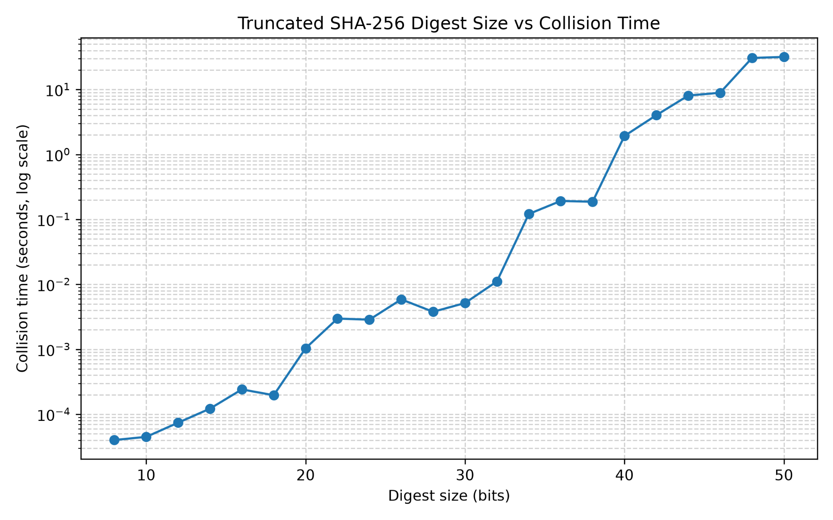

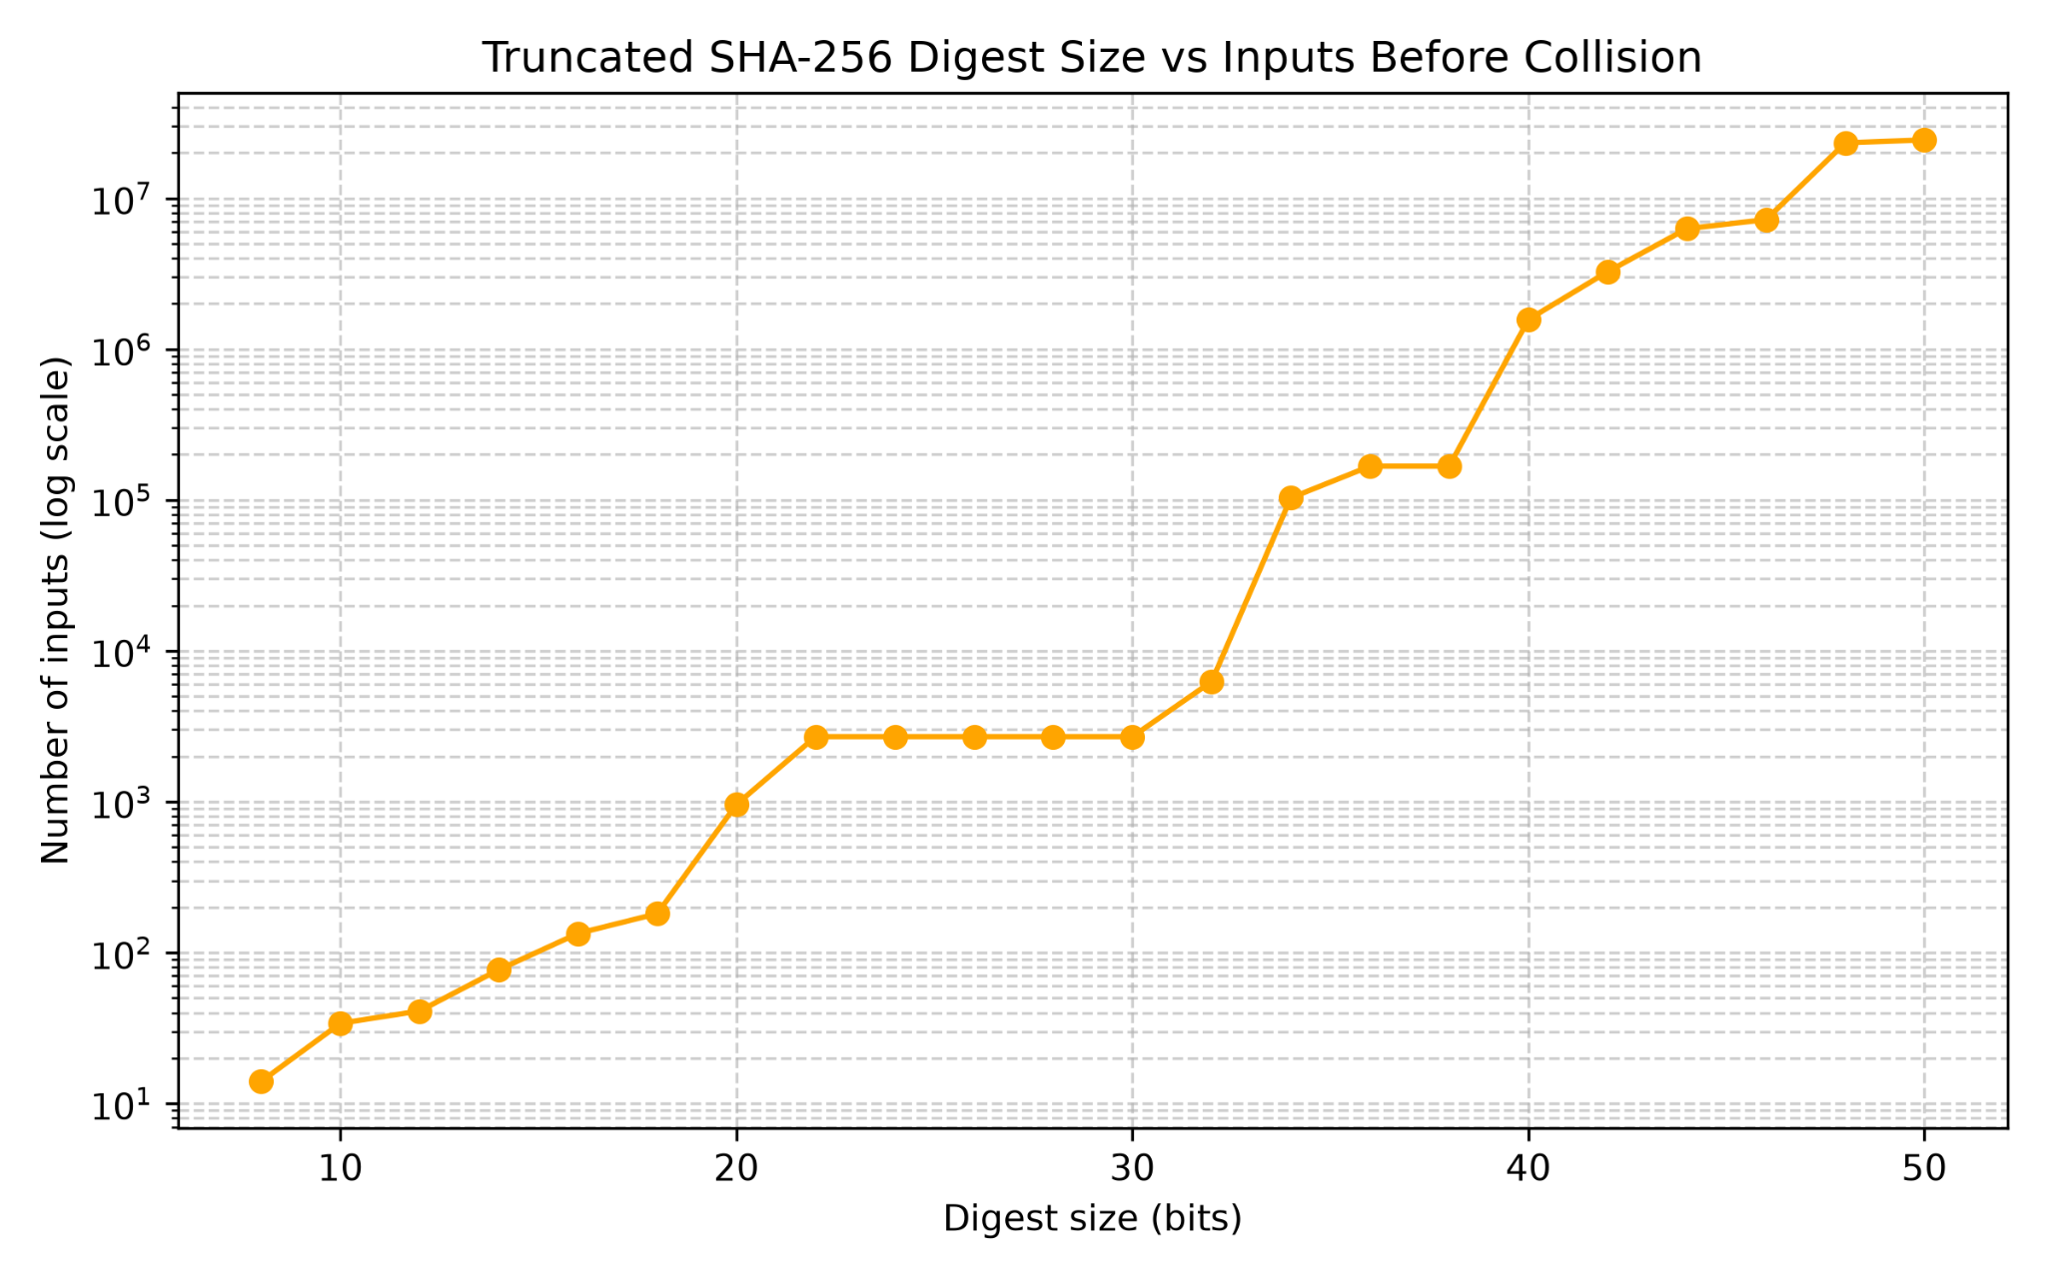
Figure 2: Inputs Before Collision by Digest Size. More inputs were generally needed as the digest size increased, which follows the birthday bound trend.

Task 2

