ARCHITECTURE

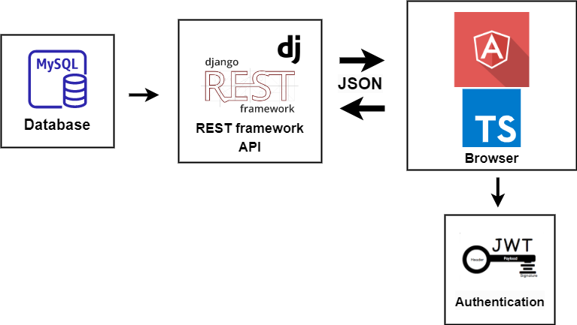

APIs

API routes that would be created for the web client to communicate with the web server

* /api/admin

GET: Returns admin functionalities

POST: Takes bodies needed to execute admin functionalities

* /api/users

GET: Returns the user's informations

* /api/assignments

GET: Returns assignments

POST: Takes bodies needed for assignments

* /api/graded-assignments

POST: Returns assignments that have been graded

List of 3rd party APIs to be used

* <https://numbersapi.p.rapidapi.com>
* <https://periodictable.p.rapidapi.com>
* <https://country-facts.p.rapidapi.com>
* YouTube API: To integrate YouTube search and video watching functionality into the website.

DATA MODELS

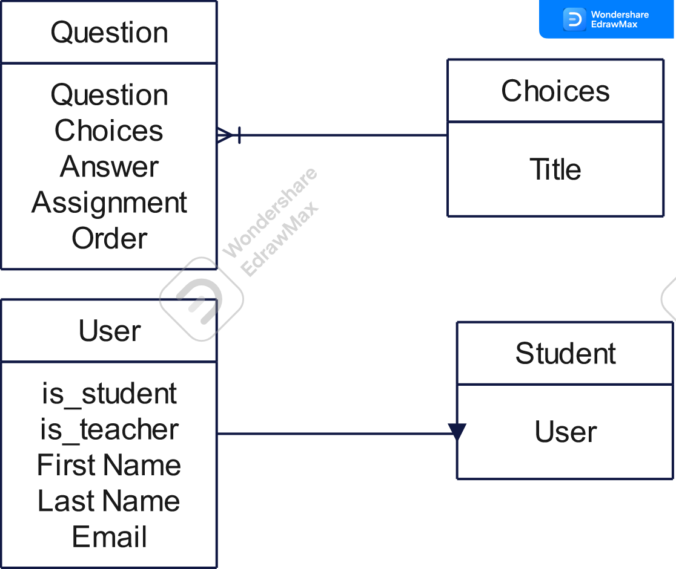

Assignment

Title

Teacher

Graded

Assignment

Student

Assignment

Grade

USER STORIES

1. Akin is a young student, akin saw a website the helps learners by providing e learning facilities online akin wants to see a list of tests and quizzes that is relevant to his course and possibly other materials so he can get better at a subject and excel in his studies relatively easily.
2. As a kid on holiday Bisi loves to play games in her free time. Bisi has being looking for a way to play educational games and read fun materials online to help her academically. Bisi would like to do so on the website she saw on her nerd cousin Musa phone.
3. Chidinma is a mother of 2 that teaches in a primary school. Chidinma like to give back to the community. Chidinma would love to help children learn as much as possible in her free time she would like to see the updated list of courses offered to learners so she can make decisions about adding additional modules and courses.

MOCKUP

Mockup of the website homepage

