**Step 1: Install the file**

Click the green "Code" button and download the .zip file to your systems desktop

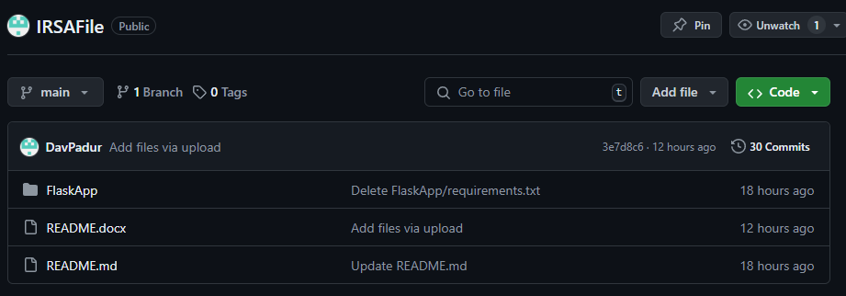

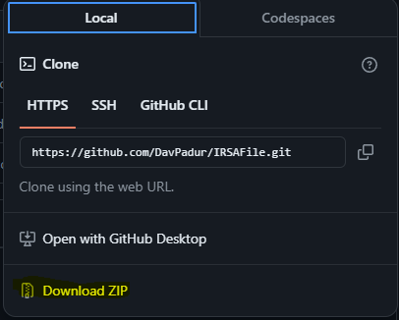

From your desktop then extract it back again to your desktop.

**Step 2: Install Python**

Make sure Python is installed on your system. You can download and install Python from [python.org](https://www.python.org/downloads/).

(DOWNLOAD THE LATEST VERSION AND CLICK THE BOX AT THE BOTTOM OF THE INSTALLER TO INSTALL TO PATH)

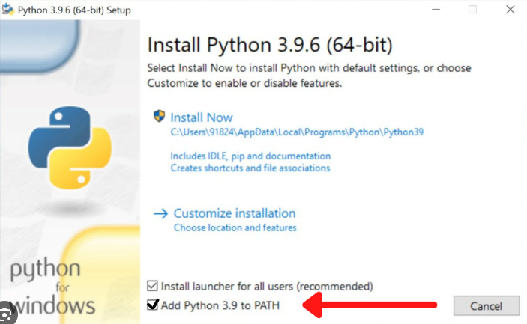

**Step 3: Install Dependencies**

Install the required dependencies by copy and pasting the command below into your respective terminal. (mac: terminal / windows: command prompt)

pip install -U pyvo selenium flask

**Step 4: Install ChromeDriver**

Paste the following link into your web browser, and install into the FlaskApp folder

**Windows:**

https://storage.googleapis.com/chrome-for-testing-public/126.0.6478.126/win64/chromedriver-win64.zip

**Mac (M1+):**

https://storage.googleapis.com/chrome-for-testing-public/126.0.6478.126/mac-arm64/chromedriver-mac-arm64.zip

**Mac (Intel):**

https://storage.googleapis.com/chrome-for-testing-public/126.0.6478.126/mac-x64/chromedriver-mac-x64.zip

**Step 5: Extract the .zip file**

Once you have extracted the files, install chrome driver by entering the extracted file

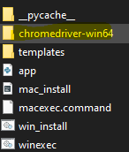

Then clicking on chromedriver

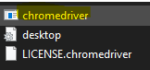

**Step 6: Running the Program**

Now click on your systems respective exec command (winexec/macexec)

Then enter the URL: http://127.0.0.1:5001/

**Step 7: GOOD JOB**

Navigate to the respective tab of what you would like to do, Query to find the star position in the database or IRSA to open that new .tbl file in the IRSA viewer

**Every time you would like to use the site, repeat Step 6**