Market Basket Analysis Using Association Rule and Apriori Algorithm on Groceries Sales Products
Market Basket Analysis Menggunakan Association Rule dan Algoritma Apriori Pada Produk Penjualan Bahan Makanan

Dava Virgio Kertawijaya¹,
¹ Information System, Universitas Multimedia Nusantara, Tangerang, Indonesia
dava.virgio@student.umn.ac.id

Abstract—Market Basket Analysis is. The fundamental goal of market basket analysis in sales is to convey a significant message to the business about the patterns of consumer behavior so that the business may make decisions. This study produced 62 rules by limiting the minimum support value to 1% or 0.01 and the minimum confidence value to 40% or 0.4.
Keywords—Market Basket Analysis; Association Rule; Apriori Algorithm; Data Mining

Introduction

Background and Purpose
The rapid development of technology encourages business actors to work even harder in facing the dynamics of technological advances in the business sector. These technological advances force business actors to keep up with the current technological developments. Data and information are important components in running a company's business. The bigger a company is, of course, the greater the data it has. These data include consumer data, sales data, purchase transaction data, payroll data, etc. All transaction data is usually stored by the company in a database center. It would be a pity if the pile of data obtained by the company in transactions and activities is only as an archive or unused files, because these data can be empowered using data mining tools that can be used to forecast business strategies and improve the company in the future. Sales transaction data can be useful for companies by reprocessing the data so that it can produce information that is useful for the company and can help companies in determining the decision-making process.
Data mining is the process of collecting useful information from a data that is processed so that it can produce useful information for the company. Data mining is also referred to as the process of obtaining important information from a large database which is then processed to produce new information so as to assist companies in the decision-making process [1]. Processing transaction data in this paper by utilizing the association rule method so that it can find out information on the purchase of products or goods made by consumers at the same time. So, companies can use the information obtained to make changes to the sales or marketing system and arrange the placement of products in stores so that they are easily accessible to consumers. In the association rule method, there are several algorithms used to perform Market Basket Analysis. The most commonly used algorithm is the Apriori algorithm. The Apriori algorithm was first proposed by R. Agrawal and R. Srikant in 1994. The algorithm is based on previously known frequent itemsets [2]. Several studies using Market Basket Analysis and Association Rule show that the relationship between product purchases by consumers is very important to increase product sales in a store.
Based on the explanation mentioned above, this study is titled "Market Basket Analysis Using Association Rule and Apriori Algorithm on Groceries Sales Products." This study uses an Apriori algorithm by utilizing Market Basket Analysis to determine the relationship between purchasing goods at groceries stores using Association Rules. By knowing the relationship between purchasing goods, the hope is that the arrangement of in-store goods can change to increase sales in the Groceries Store more than before. This study analyzes products purchased at the same time, in order to find out the dominant products purchased at the same time. The data that supports the research is data on the purchase of goods made by consumers and then processed and analyzed so that they can find out information on the relationship between products purchased simultaneously. So that it can change the layout of the display close to each other so that it causes an impulse buying effect (purchases that are not planned by the buyer).

Related Works
Several researchers have conducted some studies related to Association Rule Method. In the literature, at least six (6) papers associated with Association Rule Method. These six academic papers will be briefly discussed here. First paper was written by Qomariyah [3]. This study compares a priori, FP-Growth, and Squeezer algorithms. The results obtained that the A priori algorithm has the fastest processing time and produces more buying patterns than other algorithms.
Second paper was released in 2018. This study used the Association Rules Networks algorithm. In his research, he visually showed the degree of interrelationship between each two goods in different societies. This information gives an idea of the items collected together in the dataset. Next, he applied different techniques to analyze the communities of products found. To find which goods play a major role in society and use the dencity of networks [4].
Third paper was written by Mateus Paga Tana and Fitri Marisa in 2018. This research concerns about Application of Data Mining Market Basket Analysis to Product Sales Data at Oase Stores Using a Apriori Algorithm. The purpose of this research is to be able to assist in improving decision making in the future. One of the benefits of making this decision is the preparation of product catalogs in supermarkets such as products that are sold the most are placed in places that are easy to find and so are products that are often sold together, so these products need to be placed in a place. The results of the data mining process are product purchasing patterns that are often purchased together. This pattern can be used to place products that are purchased frequently together into an adjacent area, designing the appearance of products in a catalog. The application of the Apriori Algorithm to the Data Mining technique is very efficient and can speed up the process of forming trends in the itemset combination pattern resulting from the sale of goods at the OASE Store, namely cigarettes, coffee snacks, fried noodles, and Nabati with the highest support and confidence [5].
Fourth paper was written by Feresia Panjaitan and Ade Surahman in 2020. This research concerns about Market Basket Analysis with Hash-Based Algorithm on Sales Transactions (Case Study: TB. Menara). The results of this study were the discovery of 2 frequent itemsets, namely asbestos, asbestos rubber, tacks with support 93 and ceramics, Holcim cement, ceramic grout cement with support 75. The association rules that were formed were when buying asbestos rubber, buy asbestos with 96% confidence. When buying asbestos rubber, buying tacks has 93% confidence. When buying asbestos and asbestos rubber, buying tacks has 93% confidence. When buying asbestos and tacks, buy asbestos rubber with 96% confidence. When buying tacks and asbestos rubber, buy asbestos with 96% confidence [6].
Fifth paper was written by Erlin Elisa in 2018. This research concerns about Market Basket Analysis on Ayu's Mini Market with the Apriori Algorithm. Analisis keranjang pasar dengan Algoritma Apriori merupakan salah satu metode data mining yang bertujuan untuk mencari pola assosiasi berdasarkan pola belanja yang dilakukan konsumen, sehingga bisa diketahui item-item barang apa saja yang dibeli secara bersamaan, Hasil dari penelitian ini menemukan Nilai support dan confidence tertinggi adalah Minyak dan Susu dengan nilai support 42,85% dan confidence 85,71% [7].
The sixth paper was written by Salam, Zeniarja,, Wicaksono, and Kharisma in 2019. This research concerns about Search for Association Patterns for Goods Arrangement Using Comparison of Apriori and Fp-Growth Algorithms (Case Study of Epo Store Pemalang Distro). The results of the comparison of the Apriori and FP-Growth algorithms to find association patterns for the arrangement of goods using sales data for November, December 2017 and January 2018 show that FP-Growth can find more association rules than Apriori because the process in FP-Growth does not require several iterations of the process so that more association rules are obtained. Between the two rule association algorithms, the FP-Growth algorithm has a higher level of accuracy than a priori and the process of the FP-Growth algorithm is faster than the a priori algorithm [8].

Theoretical foundations

Data Mining
Data mining is the process of extracting information from data and processing it to discover previously unknown patterns. so that it can aid businesses in making a choice. A component of the knowledge discovery database is data mining (KDD). The following are the phases of data mining [9]:
a) Data cleaning: the process of making erroneous data uniform so that it can be processed later.
b) Data integration: the process of combining data that has been prepared for integration from various databases into a single new database.
c) Transformation: the data will be chosen at this point to be formatted differently to accommodate the approaches and methods being used.
d) Data mining: the goal of data mining is to discover novel patterns in previously unexplored data (hidden data).
e) Pattern evaluation: analyze data that can be used in decision-making.

Market Basket Analysis
Affinity analysis, also known as market basket analysis, is a rule that establishes the relationships between different features and is also one of the top educational tools used in the retail sector. With the help of this technique, it is possible to determine which products customers simultaneously purchased in the past. Market basket analysis aims to ascertain the association (relationship) between the products that customers purchase on a single transaction day. A data mining technique called market basket analysis (MBA), also known as learning rule association or affinity analysis, can be applied in a number of disciplines, including marketing, bioinformatics, education, nuclear sciences, and others [10]. Using customer or sales data that is already available for retail organizations, market basket analysis aims to boost the effectiveness of sales and promotion strategies [11]. Companies benefit from knowing which products are typically bought together and utilize this knowledge to group similar goods together for sales [12].

Association Rule
Finding patterns of association rules between a group of items is the goal of the data mining technique known as association analysis or association rule mining. Knowing how frequently certain item combinations exist in the database, commonly referred to as frequent patterns is the first step in developing association rules. The association rule contains two references, specifically:
a) Support: the quantity of transactions containing a specific itemset or the frequency with which an itemset occurs [13].
b) Confidence: The strong correlation between item sets is the value of certainty. After discovering the frequency pattern of recurrence of an itemset, confidence can be searched. [14].

Apriori Algorithm
Avendi claims that the Apriori Algorithm is one of the algorithms used in data mining to determine the pattern of association rules. It is also the algorithm most frequently used in research to find frequent itemsets with association rules due to its simplicity in application and user-friendly data visualization display [15]. The a priori algorithm consists of two fundamental steps, which include:
a) At this level, high-frequency pattern analysis (also known as frequent pattern mining) seeks out combinations of items that satisfy the database's support value's minimal requirements.
b) By calculating the confidence of the associative rules A → B, this step-by-step associative rule searches for associative rules that satisfy the minimum requirements for confidence.
c) Two parameters—the confidence parameter (certainty value), which measures the strength of the association between items and association rules, and the support parameter (support value), which measures the percentage of item combinations in the database—can be used to assess the significance of an association rule.

Methodology
According to Sugiyono (2017), the research method is a scientific way to obtain data with specific purposes and uses. Based on this there are four keywords that need to be considered, namely the scientific method, data, purpose and usability [16]. Based on the understanding that has been explained, the research method is a scientific method or technique used to obtain data about an object from research that has the aim of solving a problem. This research is divided into 6 stages, namely: 1) data collection, 2) data preprocessing, 3) determine support value, 4) determine confidence values, 5) generate rules, 6) determine correlations between items, and 7) extraction rules result using confidence as metrics as shown in figure 1.
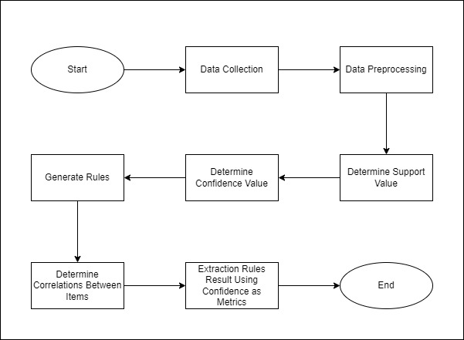
- Research flow

Results

Data Collection
The data used in this study, namely data on sales of grocery products at grocery stores that are available open source which are interrelated with the various types of goods purchased by consumers. The total sales transaction entries on each column can be seen in figure 1.
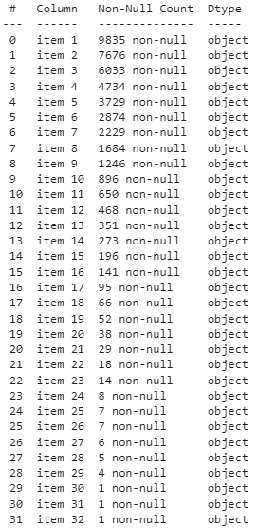
- Total entries on each column

Data Preprocessing
In preprocessing the data determines the tabulator of the sales transaction data. The tabulator format is a calculation of how many occurrences of each sales item in groceries store. Tabulator format can be seen in table 1.
- The tabular format
 | Instant Food Products | UHT-Milk | Abrasive Cleaner | … | Zwieback
0 | False | False | False | … | False
1 | False | False | False | … | False
2 | False | False | False | … | False
3 | False | False | False | … | False
4 | False | False | False | … | False

Determine Support Value
In this section, we will search for a combination of each product item set that meets the specified minimum support value requirements, which is 1% or 0.01. The calculation of the support value of the itemset is done using the following formula:
Support(A→B) = Support(A U B) = P(A ꓥ B)
Where P(A) is the probability of cases containing A.
- Top 20 biggest Support value itemset
No. | Itemset | Support
86 | Whole milk | 0.255516
55 | Other vegetables | 0.193493
66 | Rolls/buns | 0.183935
75 | Soda | 0.174377
87 | Yogurt | 0.139502
6 | Bottled water | 0.110524
67 | Root vegetables | 0.108998
81 | Tropical fruit | 0.104931
73 | Shopping bags | 0.098526
70 | Sausage | 0.093950
58 | Pastry | 0.088968
19 | Citrus fruit | 0.082766
5 | Bottled beer | 0.080529
52 | Newspaper | 0.079817
12 | Canned beer | 0.077682
60 | Pip fruit | 0.075648
239 | Other vegetables, whole milk | 0.074835
37 | Fruit/vegetable juice | 0.072293
83 | Whipped/sour cream | 0.071683
7 | Brown bread | 0.064870
The table above shows top 20 biggest support value itemset. As you can see, whole milk and other vegetables are the top 1 and 2. Also, take a look at number 239. It is the only combination on the top list. It consists of top 1 and top 2 item.

Determine Confidence Values
After determine support value, now we looking for item set’s confidence value that meets the specified minimum confidence value requirements, which is 40% or 0,4. The 40% confidence threshold provides a manageable 62 rules shown in the table below. The calculation of confidence value of the itemset is done by using the following formula:
Confidence(A→B) = P(B┃A) = P(A ꓥ B)
P(A)
Where P(A) is the probability of cases containing A.
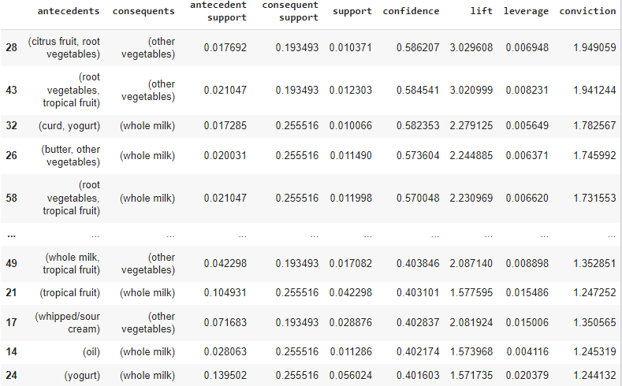
- Top itemset based on confidence value

Generate Rules
After finding all the high frequency values, the next step is to find the association rules (A, B) that meet the minimum confidence value requirements, which is 40% or 0.4. Figure 3 below shows there are 62 rules that meet the minimum requirements
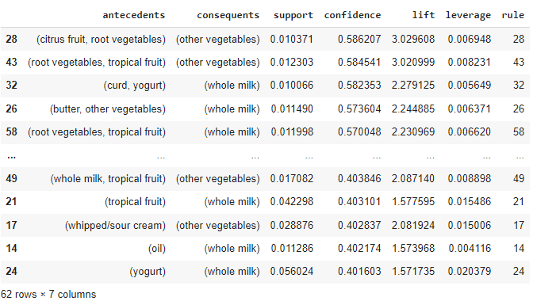
- Top 62 biggest confidence value

Determine Correlations Between Items
In this section, we try to find correlations between items by creating a visual network as shown in figure 4.
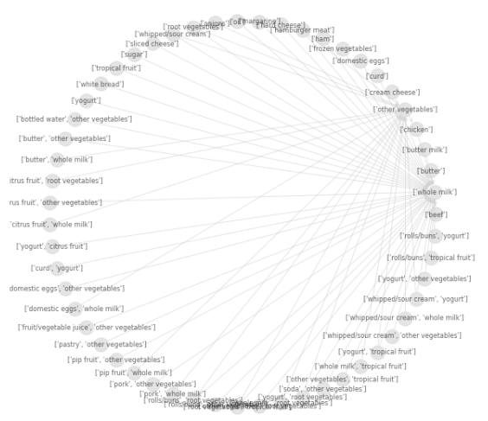
- Correlation between items
The figure above shows that the whole milk and other vegetables items have a lot of relation to other items. The following shows the relation if whole milk and other vegetables are the center as shown in figure 5 below.
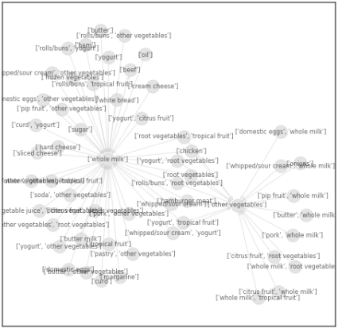
- Correlation between items with whole milk and other vegetables as the center
Figure 5 above show that there is a strong correlation between items whether whole milk as center or other vegetables as center. Also have a look at the cluster of meat and bread products that connected with whole milk. These two categories are very possible to generate more sales on product sales.

Extraction Rules Result Using Confidence as Metrics
After we find out that there is a strong correlation between items. In this section, we will see the best support items for whole milk and other vegetables. The following figure displays the best support items from both products.
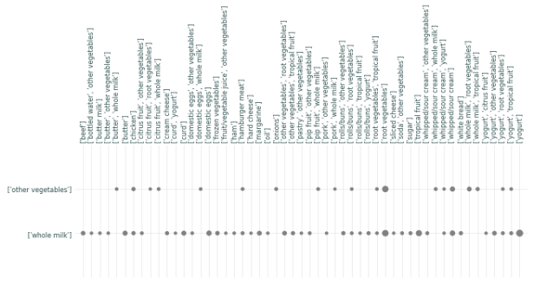
- The best support items for both products
As seen in the figure above, whole milk is the most frequent consequence (y-axis). The size of the marks on the chart is the support, showing that root vegetables have the most support for both whole milk and other vegetables, and that yogurt is the next best for whole milk. That is, when a customer buys whole milk or other vegetables, it is very likely that the customer will also buy the item support, which in theory will increase sales revenue.
based on the description above, dairy products (such as whole milk, yogurt, curd, butter, and cream) are often associated with vegetable and fruit products (such as other vegetables, frozen vegetables, root vegetables, citrus fruit, and tropical fruit). It seems that it makes sense to put the dairy products close to the vegetables and fruits if it is the intent of the store owner only to sell those items. In practice however, these items are usually put at opposite ends of a store to encourage more browsing in between within the isles that could lead to more purchases.
So naturally the items associated with other vegetables (such as fruits and vegetables) will be grouped together, as will the dairy products with each other. Special price offerings can be offered when these items are purchased together. As seen in a figure 5 correlation between items, there is a cluster of meat and bread products that lead to the purchase of both vegetables and dairy. This could be stationed far away from the other products as well to encourage browsing. The owner of the store can offer deals on purchasing dairy and vegetable products together to encourage the browsing through the other isles (it makes them move from one end of the store to another). This would likely lead to more purchases of unrelated products.

Conclusion
The bigger a company is, of course, the greater the data it has. These data include consumer data, sales data, purchase transaction data, payroll data. All transaction data is usually stored by the company in a database center. It would be a pity if the pile of data obtained by the company in transactions and activities is only as an archive or unused files, because these data can be empowered using data mining tools that can be used to forecast business strategies and improve the company in the future. This study produced 62 rules by limiting the minimum support value to 1% or 0.01 and the minimum confidence value to 40% or 0.4. These results can be used to place the most popular items in a group with their support products. In addition, strategically placing the most popular items away from the entrance so that customers are encouraged to browse through the other isles, which results in customers having a great opportunity to buy unrelated products.

References
- J. Suntoro, “22-DATA MINING Algoritma dan Implementasi Menggunakan Bahasa Pemrograman PHP,” DATA Min. Algoritm. dan Implementasi Menggunakan Bhs. Pemrograman PHP, vol. 9, no. 9, pp. 259–278, 2019.
- A. Rifqy Alfiyan, A. Hafidzul Kahfi, M. Rizky Kusumayudha, and M. Rezki, “Analisis Market Basket Dengan Algoritma Apriori Pada Transaksi Penjualan Di Freshfood,” IJCIT (Indonesian J. Comput. Inf. Technol., vol. 4, no. 1, pp. 1–8, 2019.
- S. Qomariyah, “Perbandingan Algoritma Fp-Growth, Apriori, Dan Squeezer Pada Analisis Perilaku Konsumen Di Minimarket K1Mart Its,” Diss. Inst. Teknol. Sepuluh Nop., 2017.
- P. S. Sarjana, D. Statistika, F. Matematika, and D. A. N. S. Data, “TUGAS AKHIR – SS 141501 MARKET BASKET ANALYSIS MENGGUNAKAN ALGORITMA APRIORI , FUZZY c-COVERING , DAN ASSOCIATION RULES NETWORKS DI K1 MART ITS ZUMARSIYAH MAHSYARI,” 2018.
- M. P. Tana, F. Marisa, and I. D. Wijaya, “Penerapan Metode Data Mining Market Basket Analysis Terhadap Data Penjualan Produk Pada Toko Oase Menggunakan Algoritma Apriori,” J I M P - J. Inform. Merdeka Pasuruan, vol. 3, no. 2, pp. 17–22, 2018, doi: 10.37438/jimp.v3i2.167.
- F. Panjaitan, A. Surahman, and T. D. Rosmalasari, “Analisis Market Basket Dengan Algoritma Hash-Based Pada Transaksi Penjualan (Studi Kasus: Tb. Menara),” J. Teknol. dan Sist. Inf., vol. 1, no. 2, pp. 111–119, 2020, [Online]. Available: http://jim.teknokrat.ac.id/index.php/JTSI
- “Erlin Elisa,” Mark. Basket Anal. Pada Mini Mark. Ayu Dengan Algoritm. Apriori, vol. Vol. 2 No., no. ISSN : 2580- 0760 (media online), p. Terbit online pada laman web jurnal : http://jurna, 2018.
- A. Salam, J. Zeniarja, W. Wicaksono, and L. Kharisma, “Pencarian Pola Asosiasi Untuk Penataan Barang Dengan Menggunakan Perbandingan Algoritma Apriori Dan Fp-Growth (Study Kasus Distro Epo Store Pemalang),” Dinamik, vol. 23, no. 2, pp. 57–65, 2019, doi: 10.35315/dinamik.v23i2.7178.
- “Data Mining : Definis, Fungsi, Metode dan Penerapannya.” [Online]. Available: https://www.jagoanhosting.com/blog/apa-itu-data-mining/
- M. Kaur and S. Kang, “Market Basket Analysis: Identify the Changing Trends of Market Data Using Association Rule Mining,” Procedia Comput. Sci., vol. 85, no. Cms, pp. 78–85, 2016, doi: 10.1016/j.procs.2016.05.180.
- Y. Akbar and M. J. Hakim, “Market Basket Analysis Menggunakan Algoritma Apriori Berbasis Bahasa R (Studi Kasus Transretail Indonesia),” CKI SPOT, vol. 11, no. 2, pp. 173–180, 2018.
- A. Muzakir and L. Adha, “Market Basket Analysis (Mba) Pada Situs Web E-Commerce Zakiyah Collection,” Simetris J. Tek. Mesin, Elektro dan Ilmu Komput., vol. 7, no. 2, p. 459, 2016, doi: 10.24176/simet.v7i2.755.
- A. Chandra, “Peningkatan Performa Algoritma Apriori Untuk Aturan Asosiasi Data Mining,” Semnasteknomedia, no. 2, pp. 85–90, 2017.
- S. Sinaga and A. M. Husein, “Penerapan Algoritma Apriori dalam Data Mining untuk Memprediksi Pola Pengunjung pada Objek Wisata Kabupaten Karo,” J. Teknol. dan Ilmu Komput. Prima, vol. 2, no. 1, pp. 49–54, 2019, doi: 10.34012/jutikomp.v2i1.461.
- T. Evendi and R. F. A. Aziza, “300969-Penerapan-Algoritma-Apriori-Untuk-Menemu-D7a1Ce63,” Teknokompak, vol. 13, no. 1, pp. 18–23, 2019.
- Prof. Dr. Sugiyono, “Metode Penelitian Kuantitatif, Kualitatif, dan R&D – MPKK,” 2017. [Online]. Available: https://cvalfabeta.com/product/metode-penelitian-kuantitatif-kualitatif-dan-rd-mpkk/

