Dava Virgio Kertawijaya

00000056848

--------------------------------------------------------------------------------------------------------------------

QUESTIONS:

1. CLO3-Sub-CLO 4 Weight 40 %

* Create a Pentaho Data Integration program as an answer to question number two (the ETL process you are planning) on the UTS IS545 Data Warehouse Theory, complete with input data and output results.
* Your answer is equipped with a word file containing the following pictures:
  + 1. Screenshot of Program contents.
  + Program contents of Product transformation

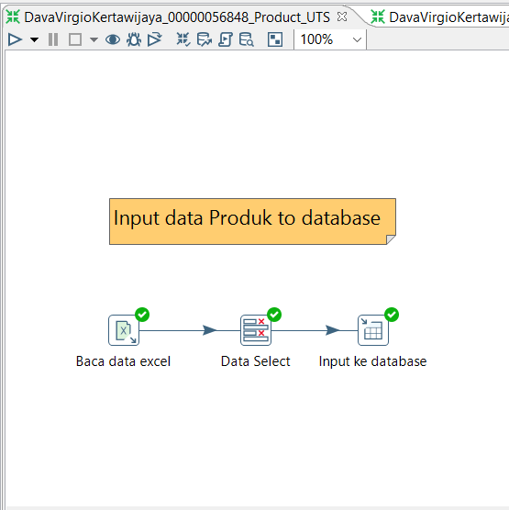

* + Program contents of Sales transformation

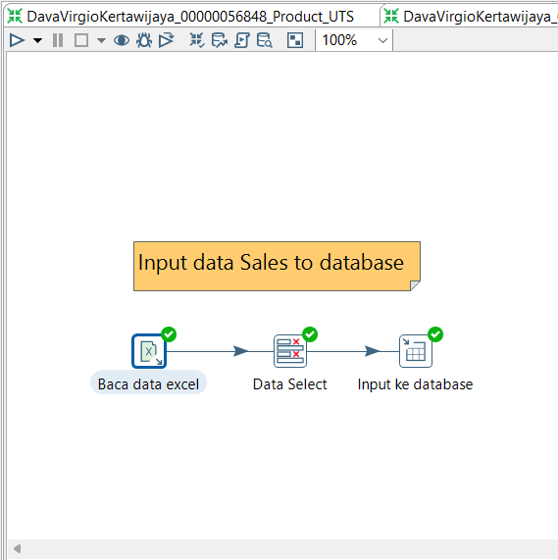

* + Program contents of Customer transformation

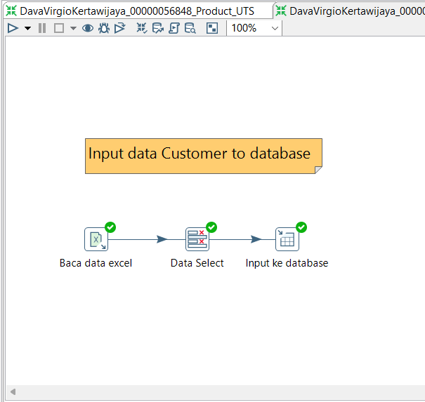

* + Program contents of Invoice transformation

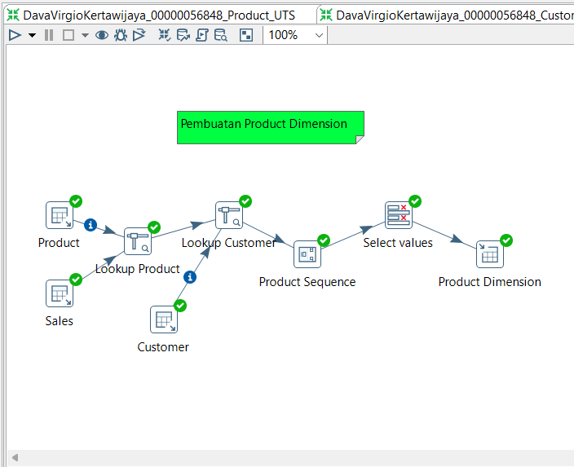

* + 1. Screenshot of the Input Data Repository used

C:\00000056848-DavaVirgioKertawijaya UTS Data Warehouse Lab Odd 2022-2023\DataToyotaCorolla.xlsx

* + Input Data Repository used of Product transformation

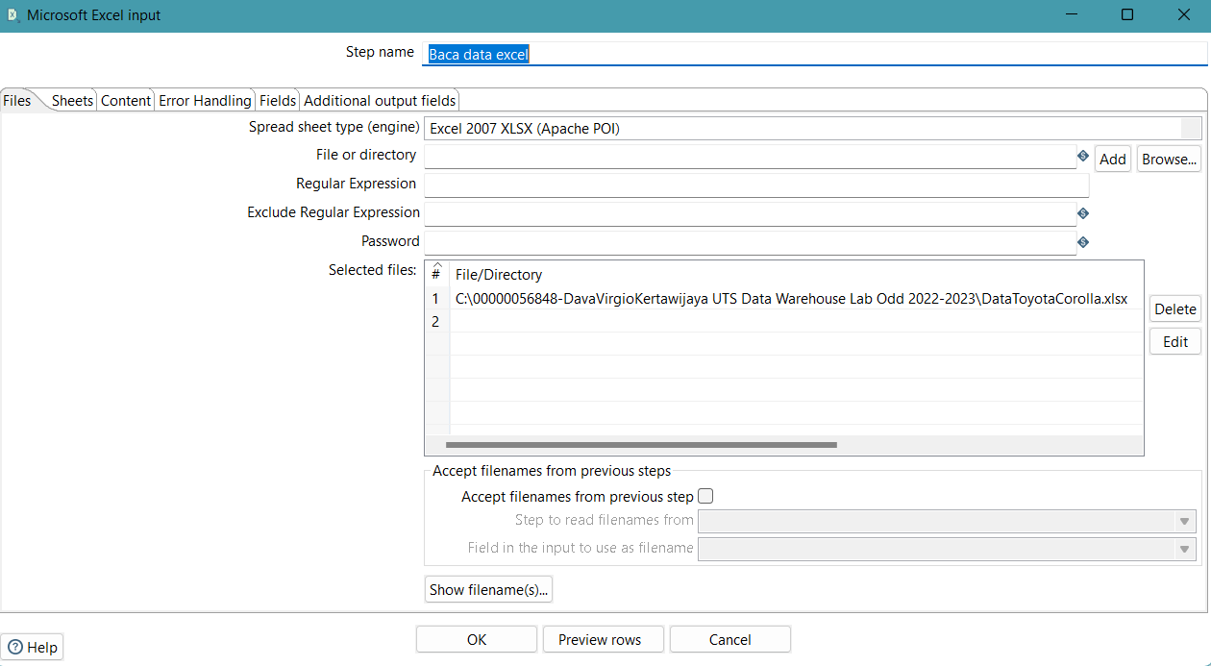

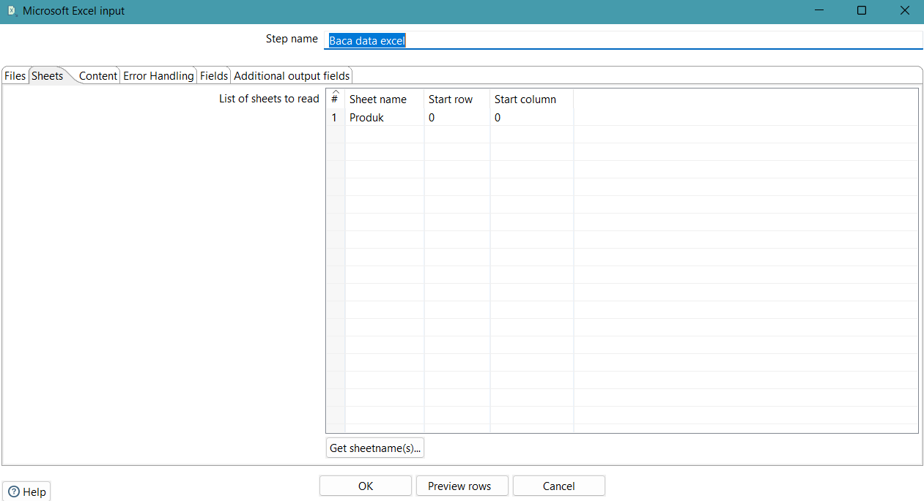

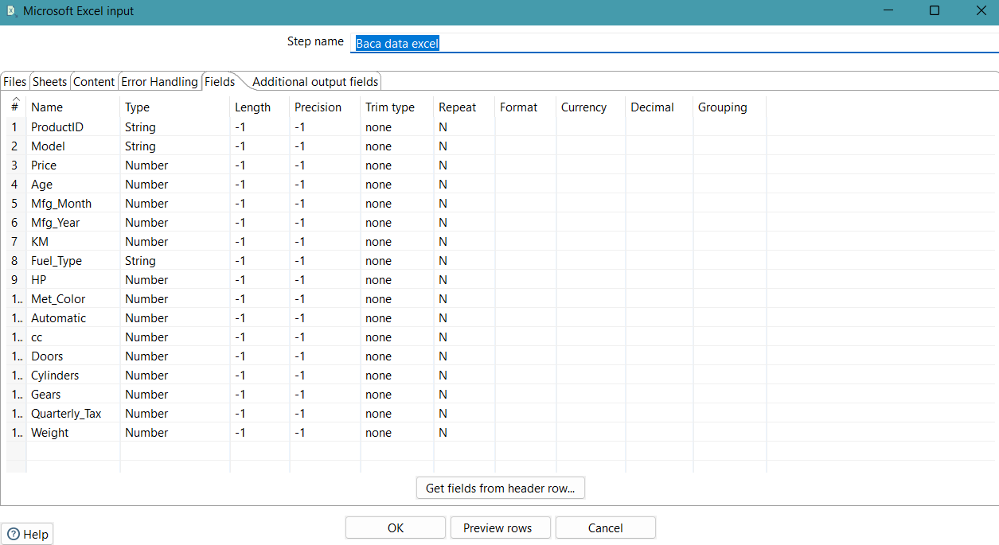

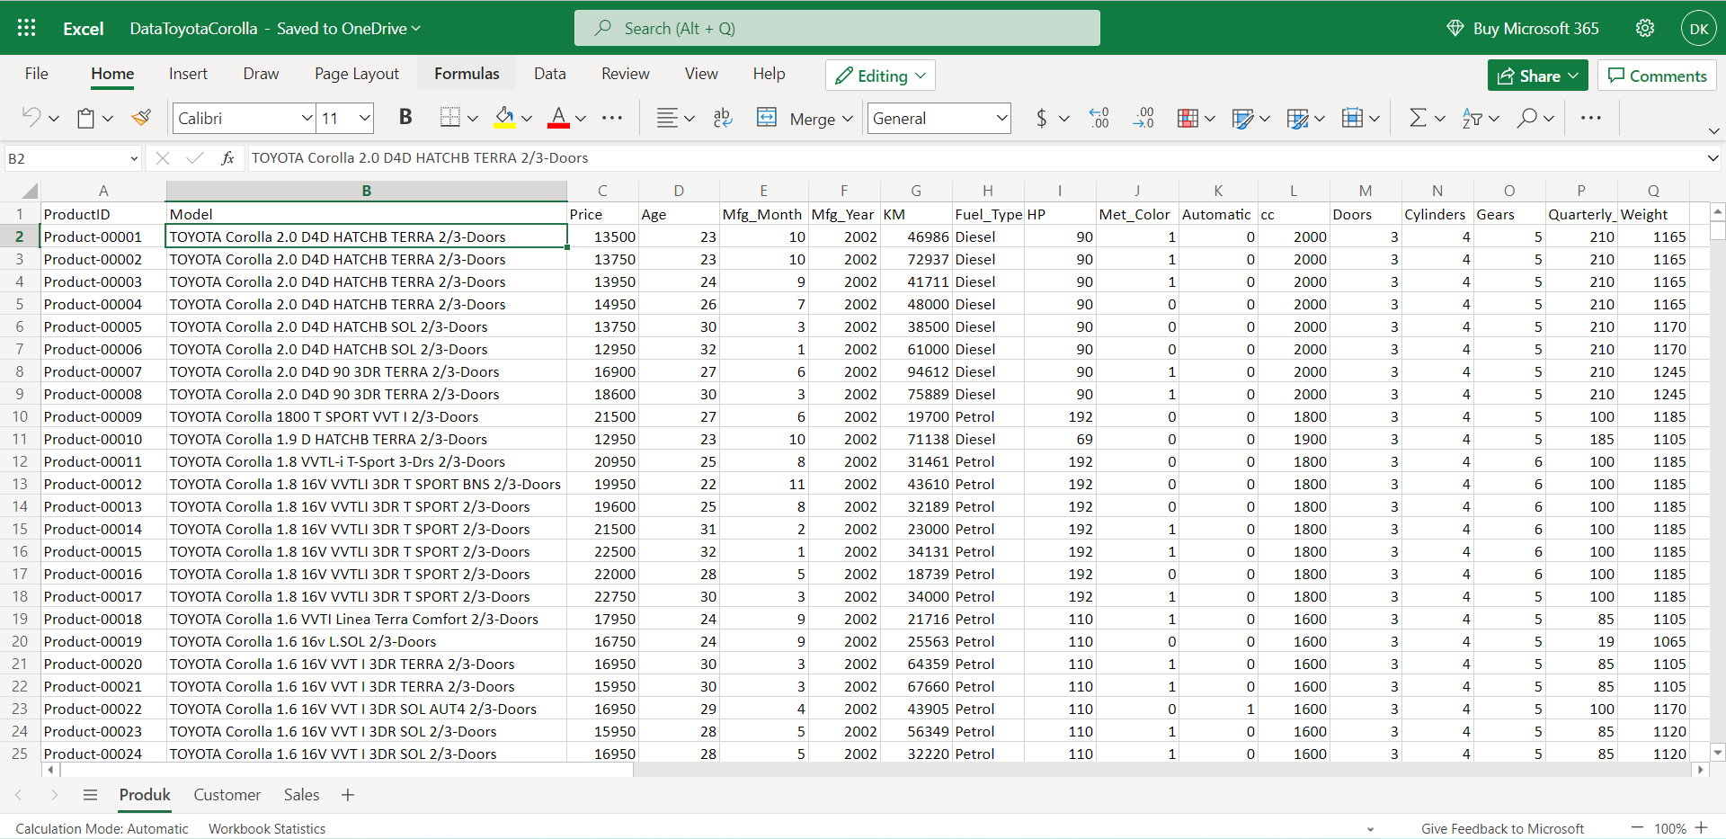

* + Input Data Repository used of Sales transformation

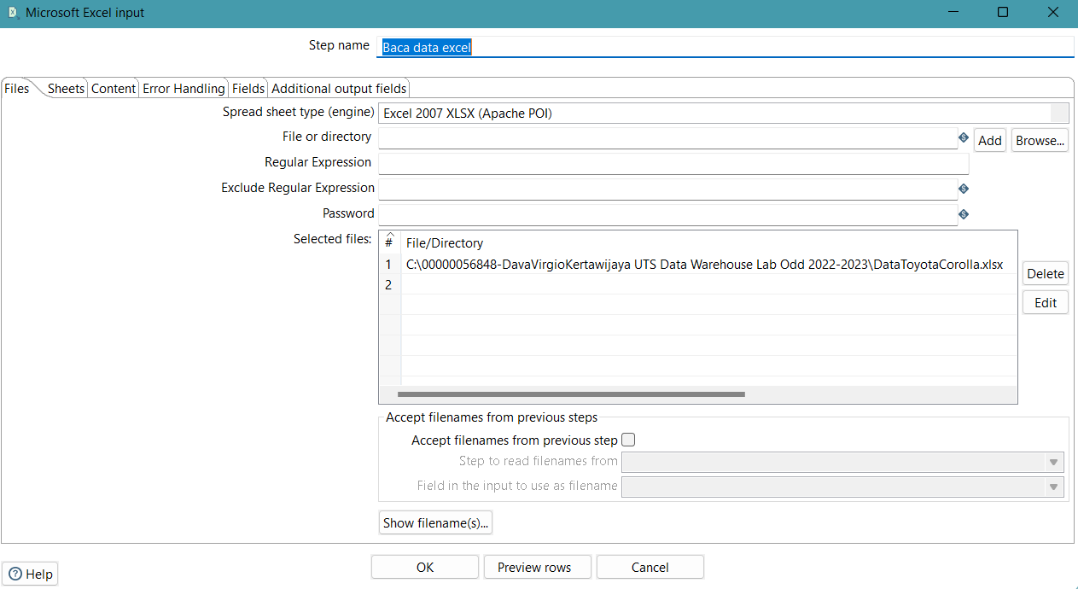

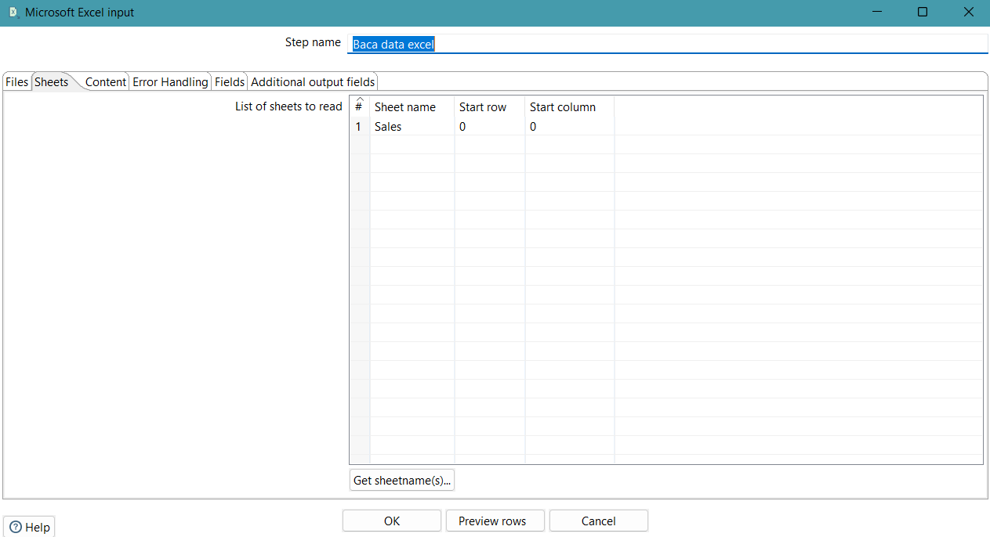

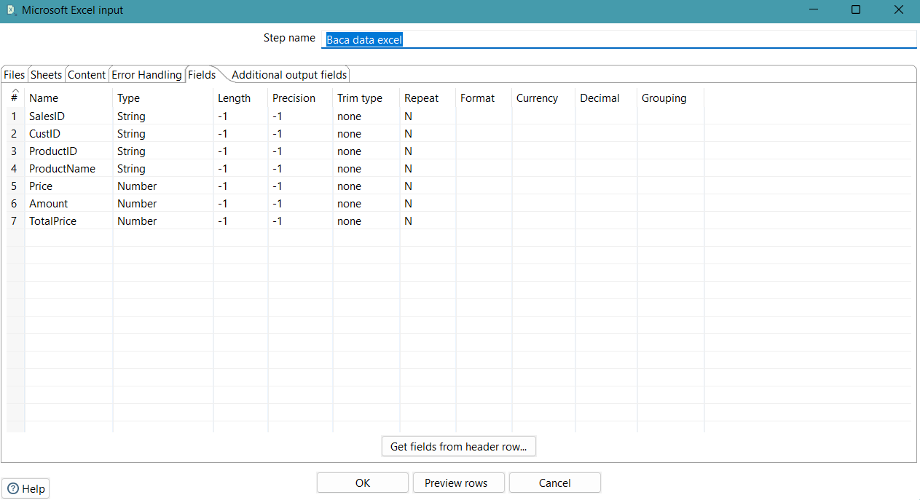

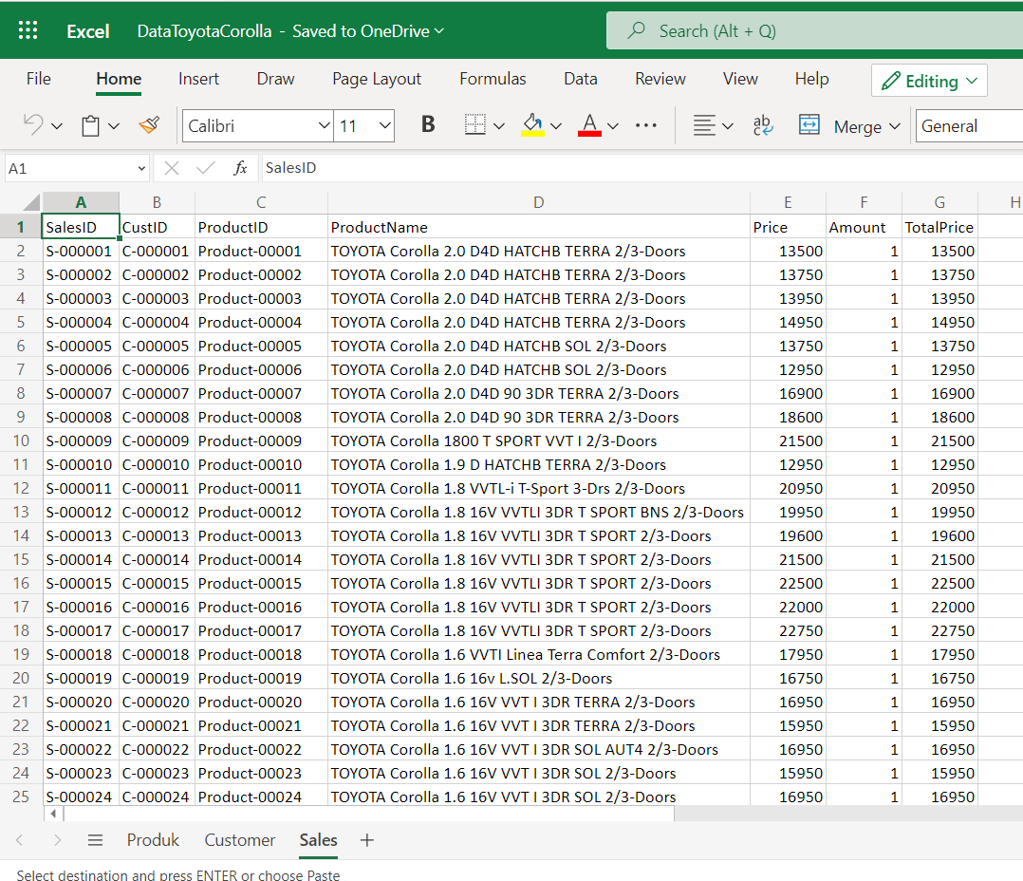

* + Input Data Repository used of Customer transformation

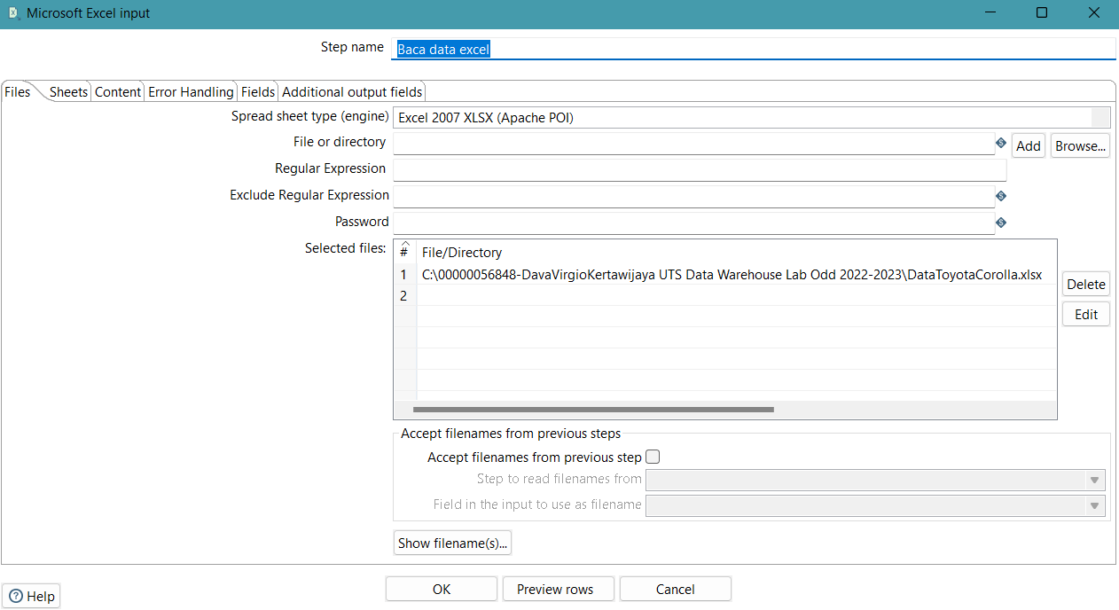

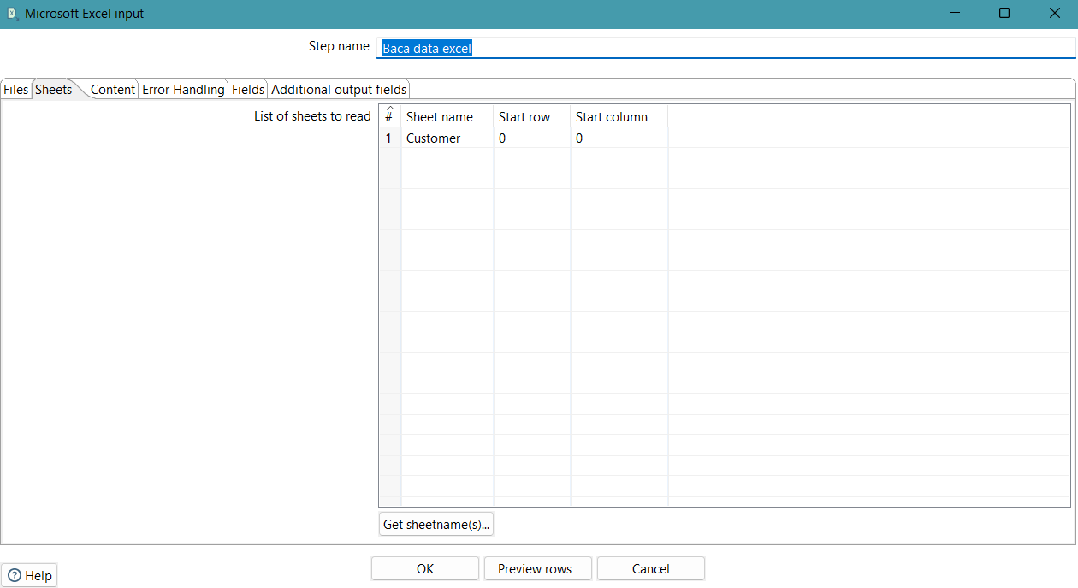

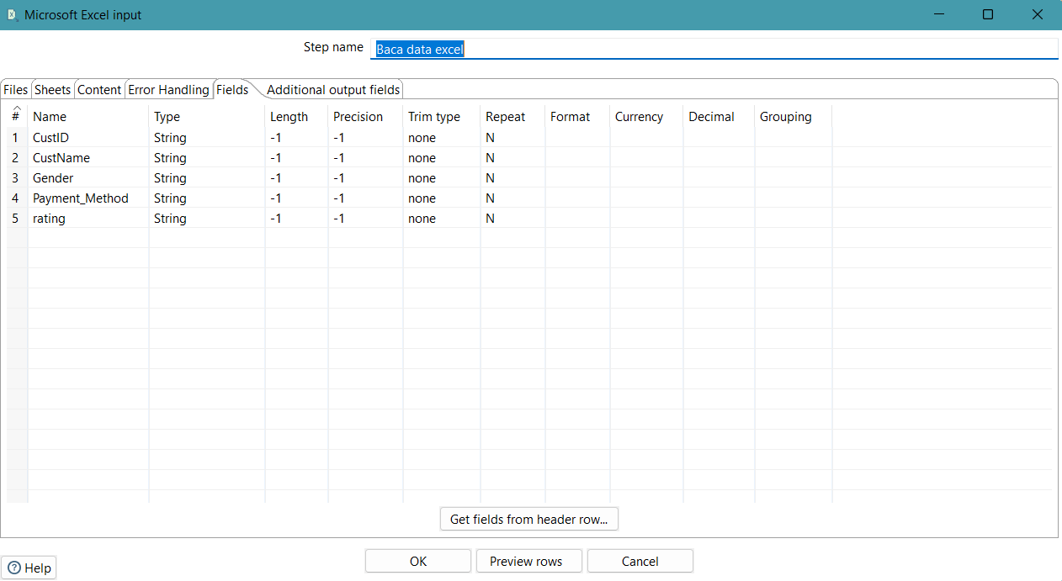

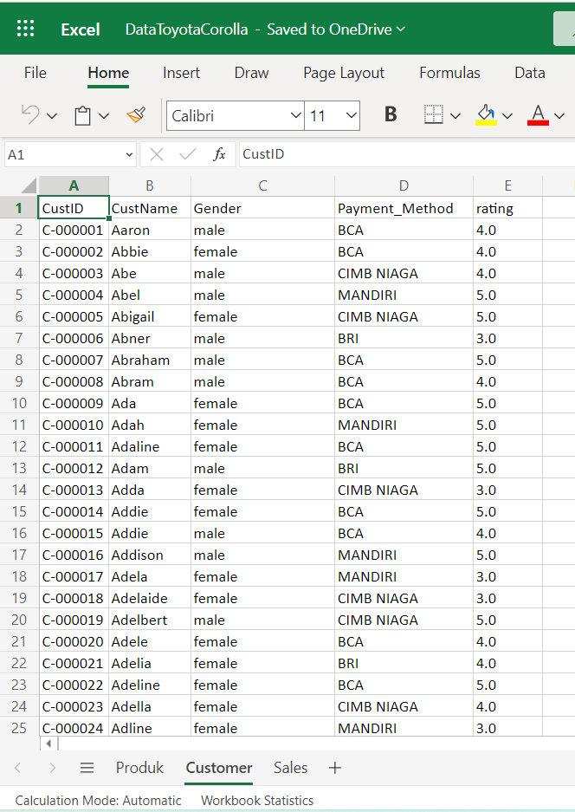

* + Input Data used of Invoice transformation

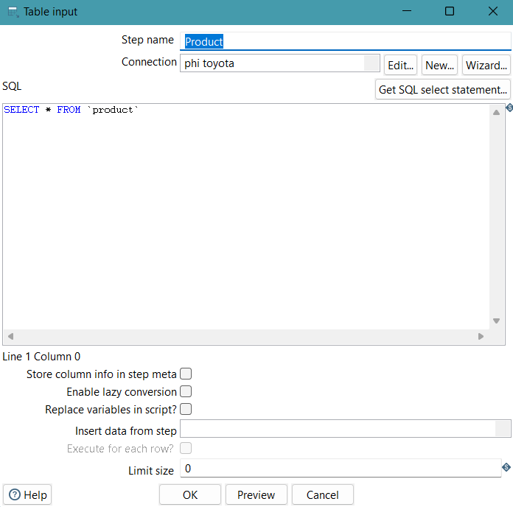

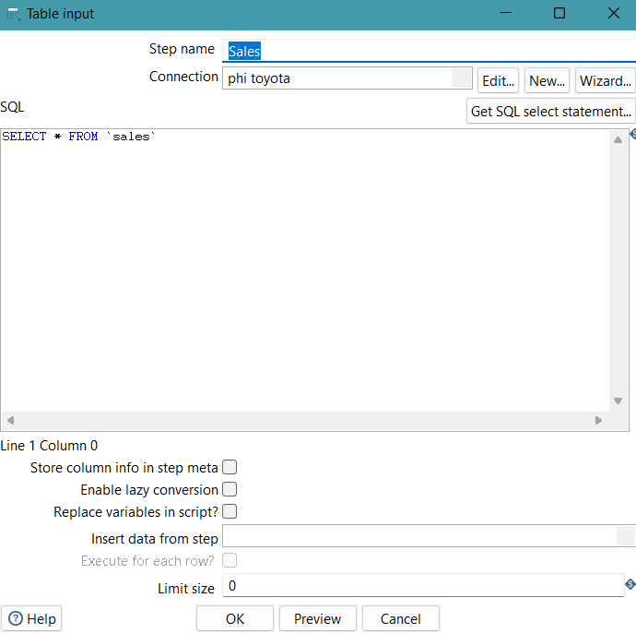

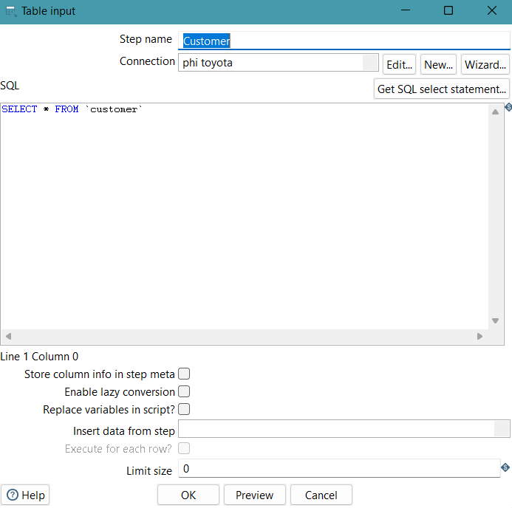

* + 1. Screenshot of the execution log
  + Execution log of Product transformation

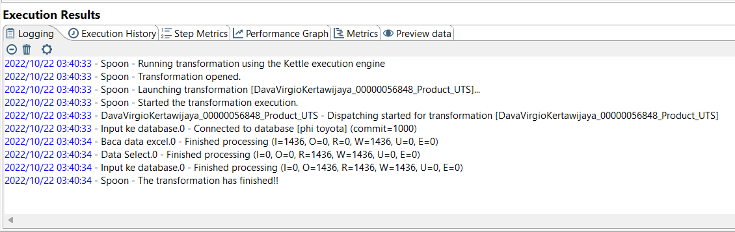

* + Execution log of Sales transformation

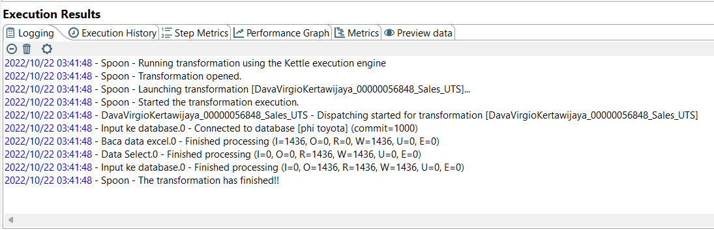

* + Execution log of Customer transformation

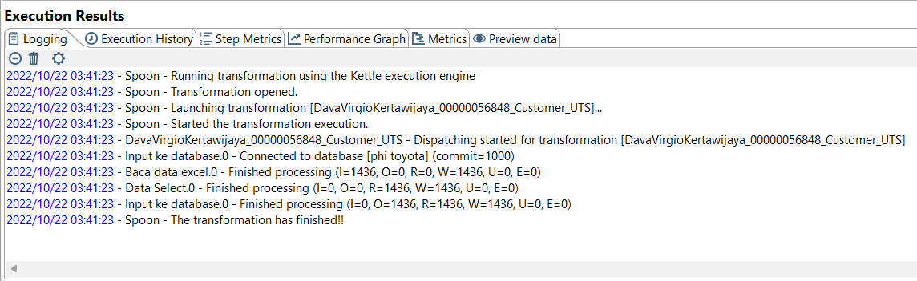

* + Execution log of Invoice transformation

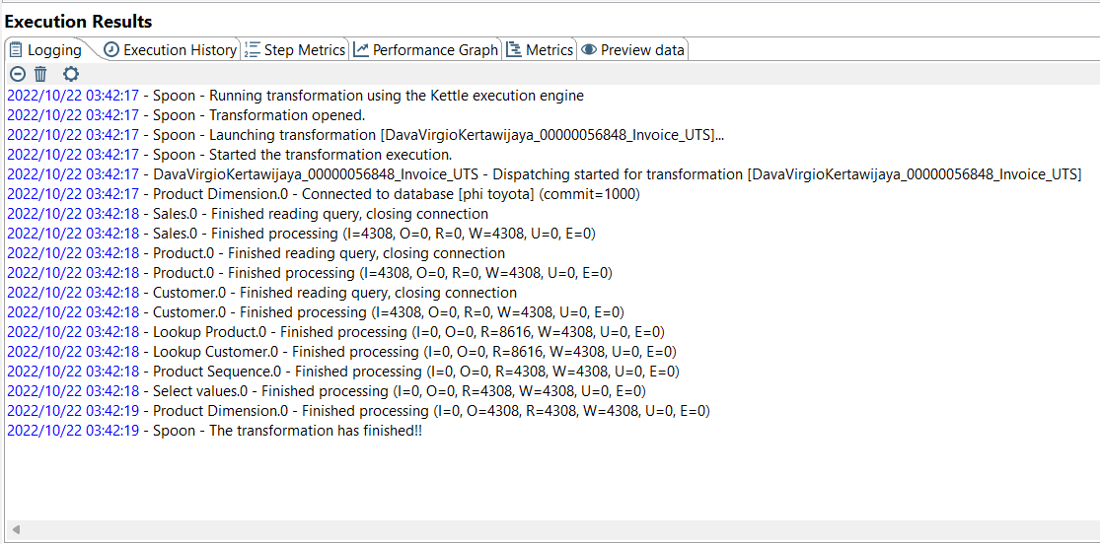

* + 1. Screenshot of the resulting output.
  + Output of Product transformation

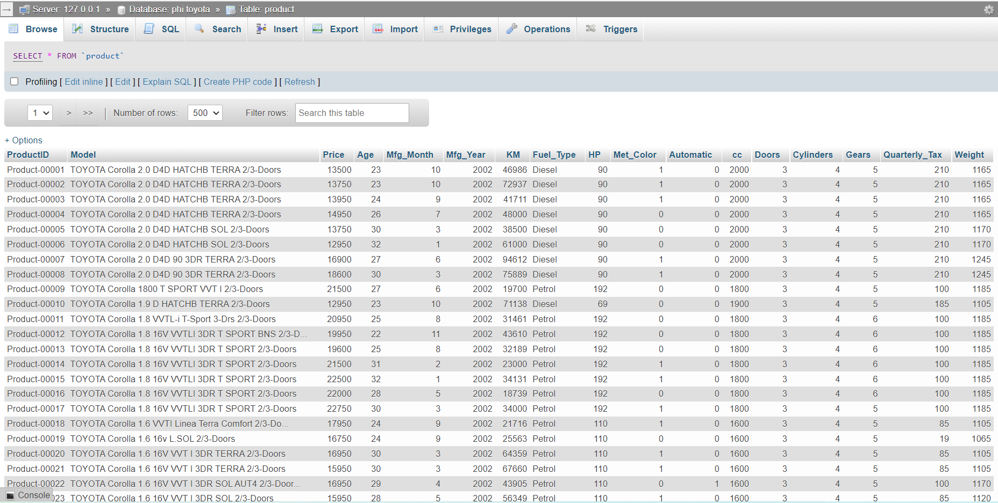

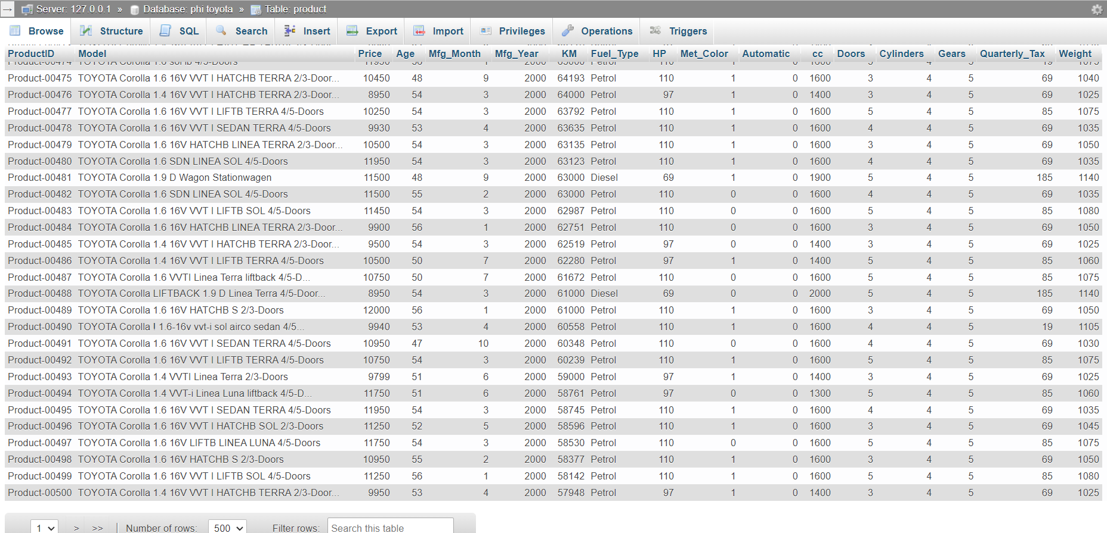

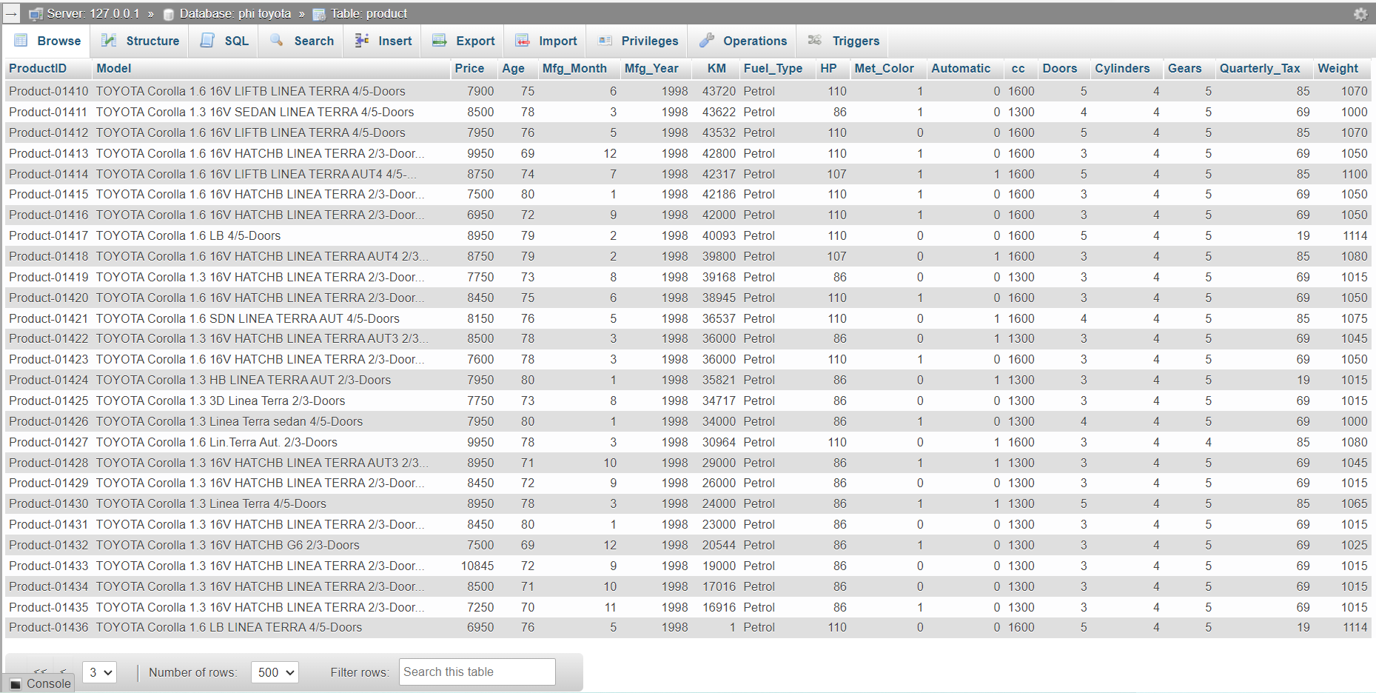

* + Output of Sales transformation

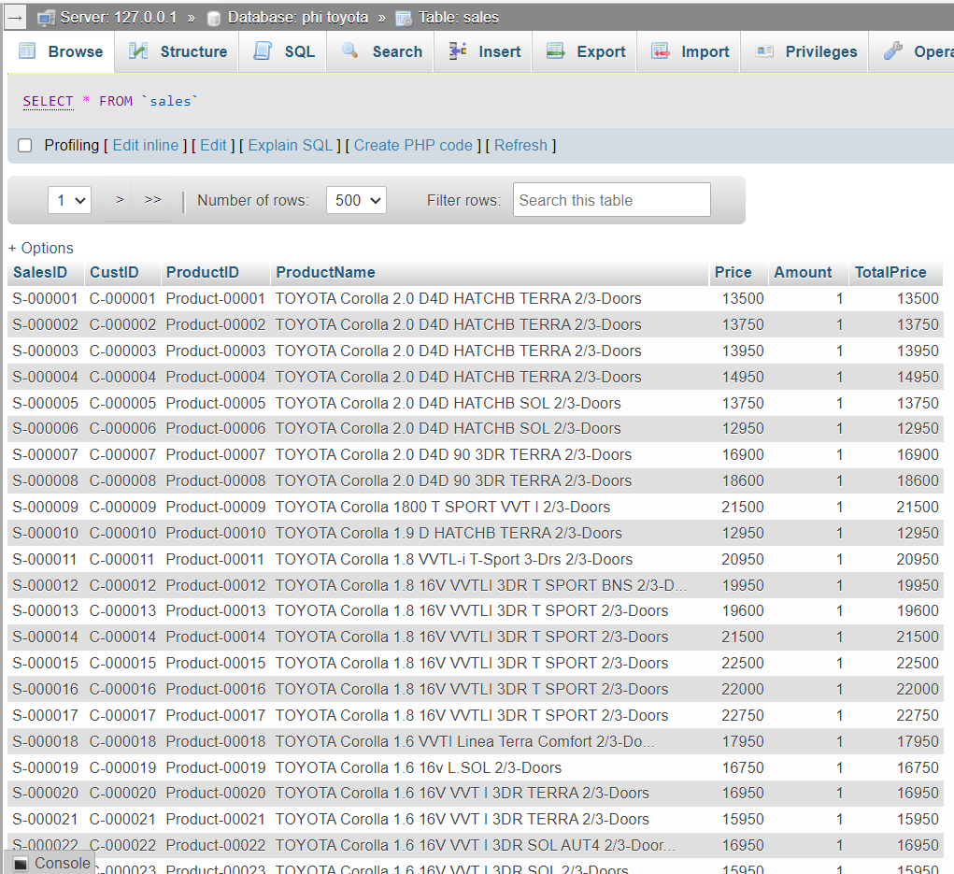

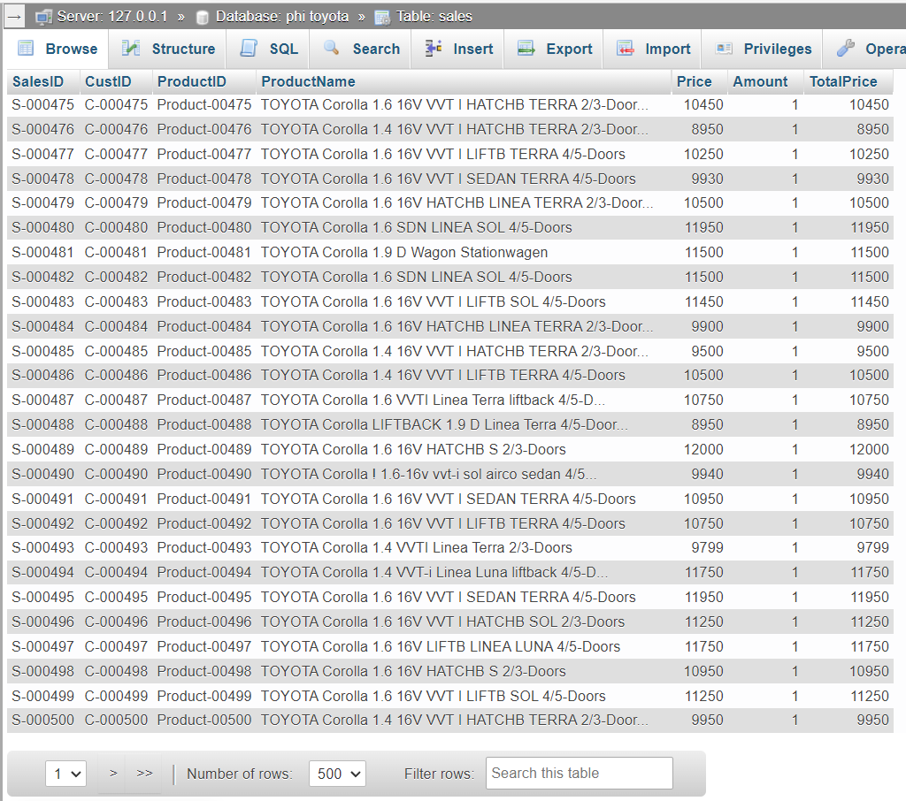

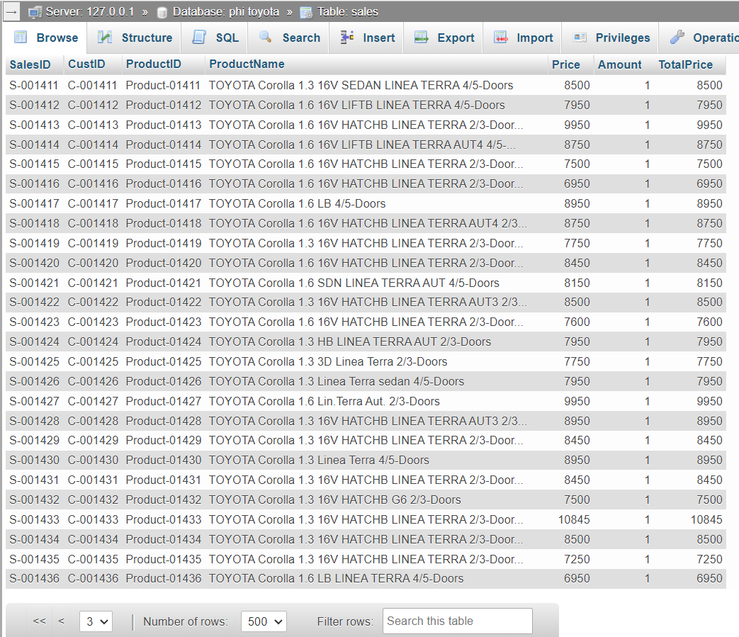

* + Output of Customer transformation

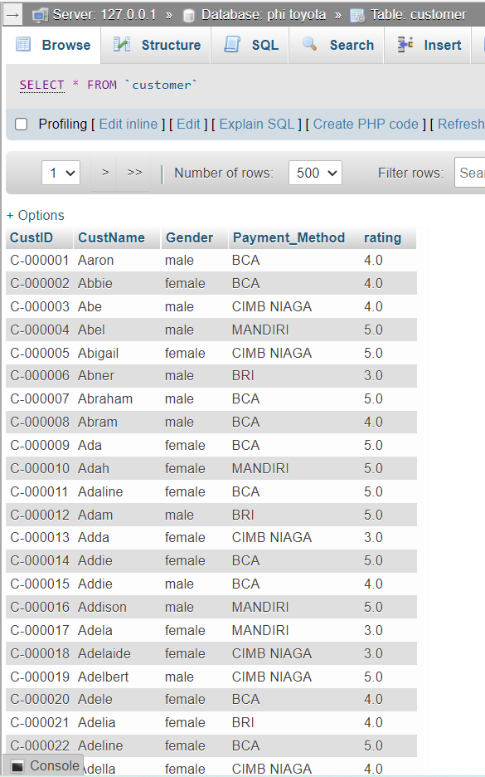

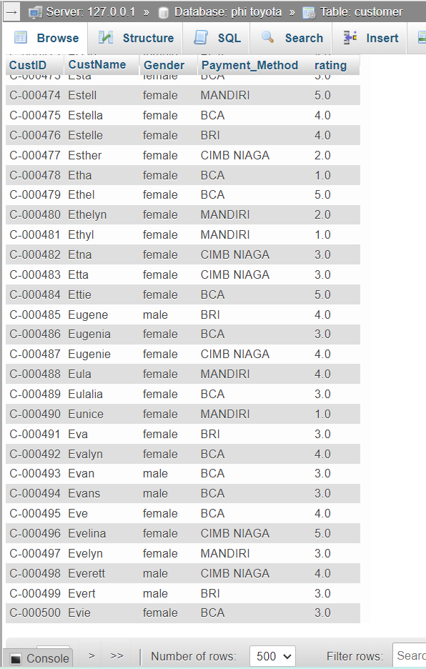

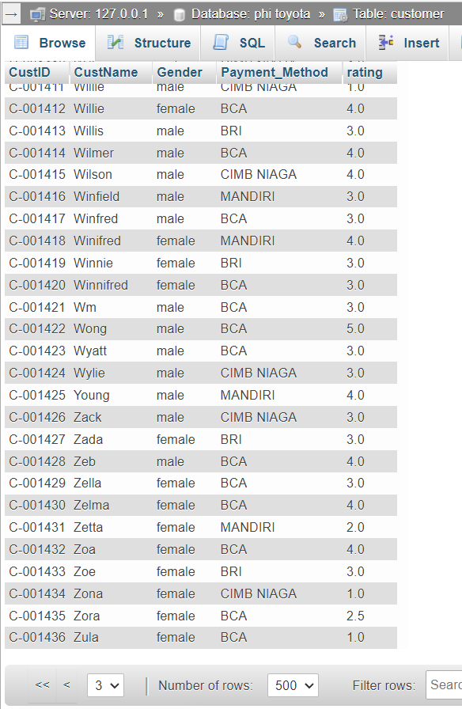

* + Output of Invoice transformation

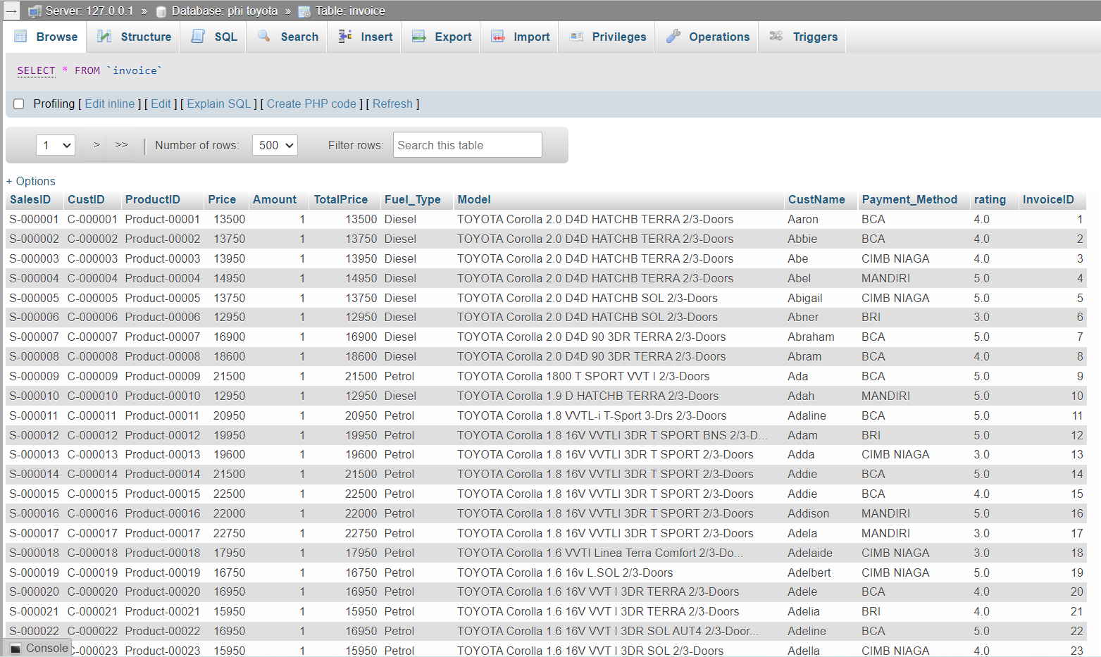

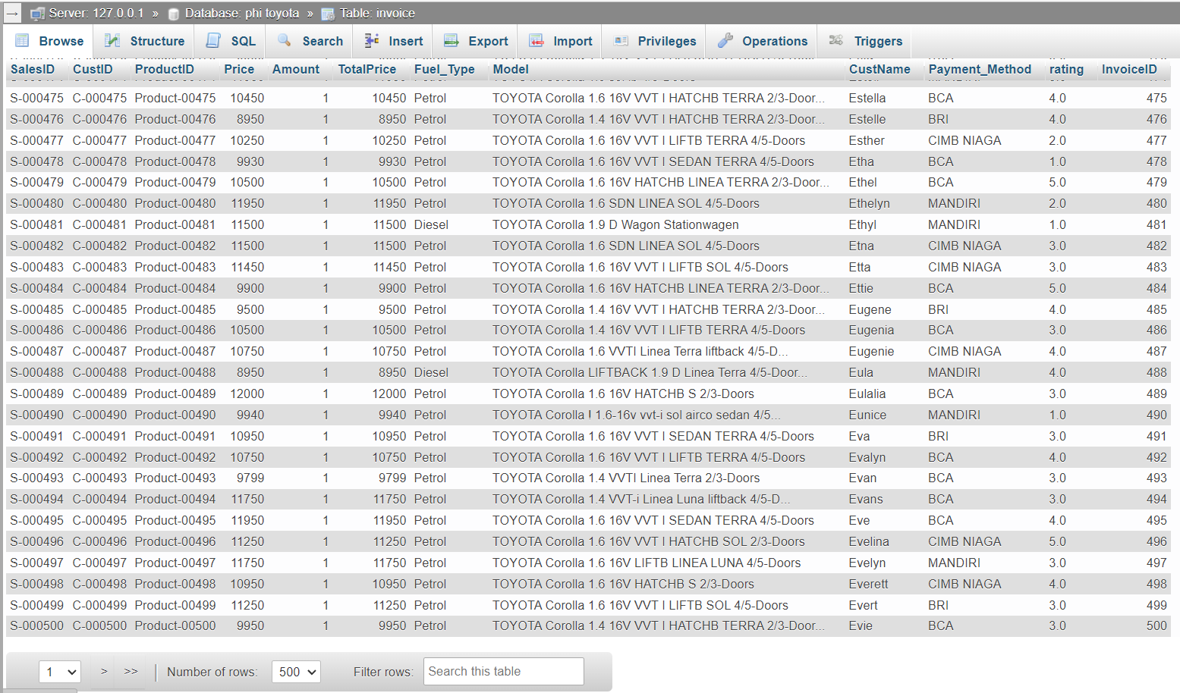

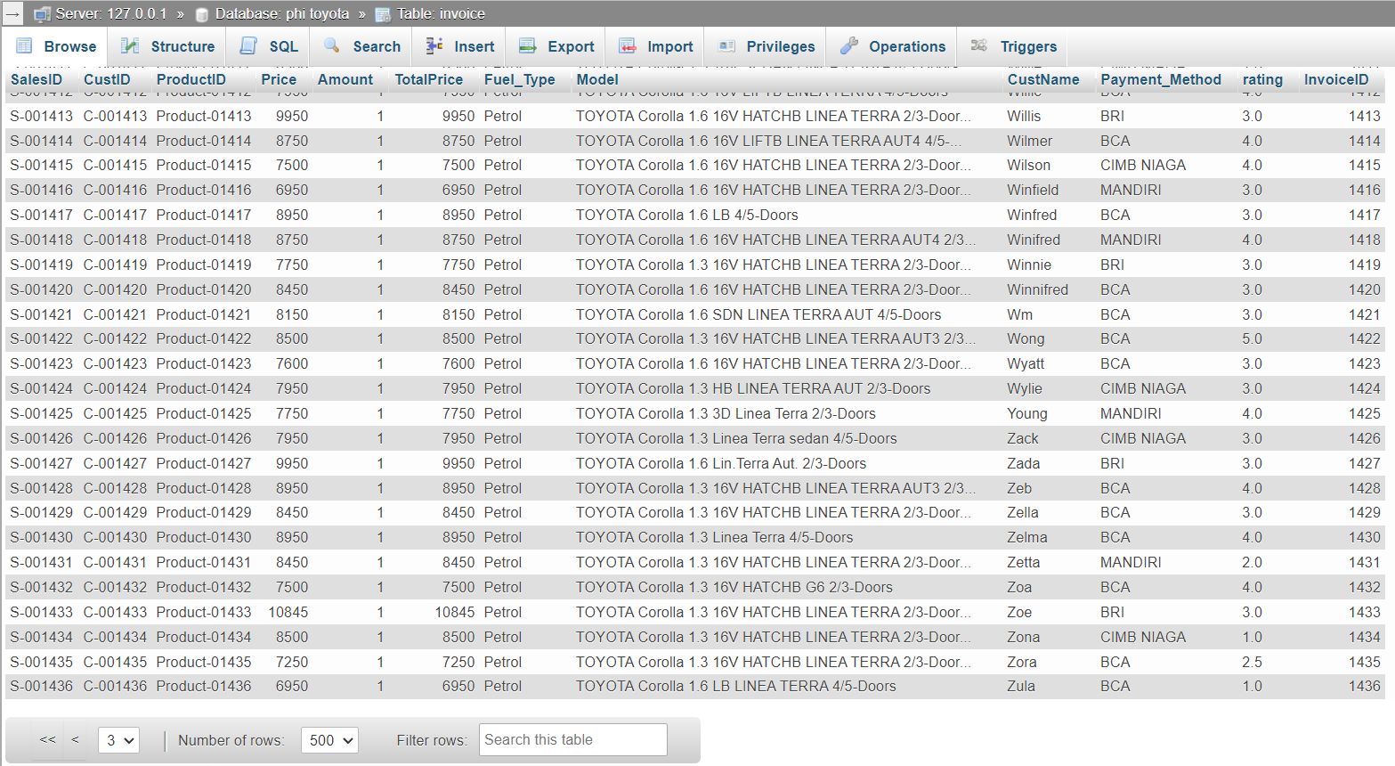

1. CLO1-Sub-CLO 5 & CLO1-Sub-CLO 7 Weight 60%

* Create a Pentaho Data Integration program to generate a star schema as the answer you gave to UTS Theory IS545 Data Warehouse number four.
* Your answer is equipped with a word file containing the following pictures:
  + 1. Screenshot of Program contents.
    2. Screenshot of the Input Data Repository used
    3. Screenshot of the execution log
    4. Screenshot of the resulting output.

Star schema option is not available anymore in Pentaho as shown on image below.

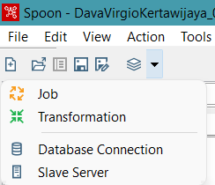

So, I tried make it manually using draw.io.

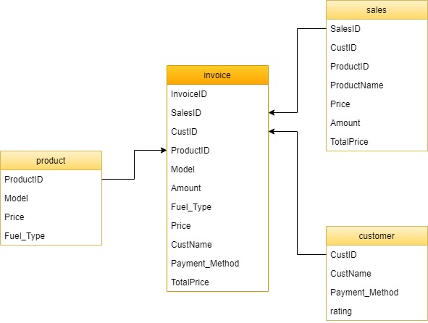

Here is the link of draw.io above:

<https://drive.google.com/file/d/1qx6EXMzWe2Il8aF_Nwd7v6WrEJLE-Z3A/view?usp=sharing>