Note on Chapter 7  
Symmetric Matrices and Quadratic Forms

Book: Linear Algebra and its Applications. Fourth edition.

# Diagonalization

## Symmetrix Matrix

**DEFINITION. (Symmetric Matrix)** A symmetric matrix is a matrix such that   
Such matrix is:

1. Square
2. Elements are **symmetrical about the main diagonal.**

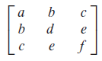

**THEOREM 1.** If is symmetric, then any two eigenvectors from different eigenspaces are orthogonal.

**PROOF:**

Let and be eigenvectors that correspond to distinct eigenvalues and . To show , compute

Also

Thus we yield

As , so

**DEFINITION. (Orthogonal matrix)** An matrix is an orthogonal matrix if its **column vectors are linearly independent and orthonormal vectors**. It can be proved that is an orthogonal matrix if and only if

**DEFINITION. (Orthogonal diagonalization)** An matrix is orthogonally diagonalizable if there is an orthogonal matrix and a diagonal matrix such that

**THEOREM 2.** An matrix is orthogonally diagonalizable if and only if is a symmetric matrix.

## Spectral Decomposition

**DEFINITION. (Spectrum of a matrix, 矩阵的谱)** The set of eigenvalues of a matrix is called the spectrum of.

**THEOREM 3. The Spectral Theorem for Symmetric Matrices**

注：这个定理给我一个直觉认识，那就是对称矩阵可以通过特征分解分成多个“光谱”，每一个谱都对应一个特征值和特征空间。个人认为，3.c是光谱定理的核心。

An symmetric matrix has the following properties:

1. has real eigenvalues, counting multiplicities.
2. dimension of eigenspace = multiplicity of eigenvalue.
3. eigenspaces are mutually orthogonal <=> eigenvectors corresponding to different eigenvalues are orthogonal.
4. A is orthogonally diagonalizable.

基于光谱定理，我们可以对一个对称矩阵进行光谱分解。

**DEFINITION 5. (Spectral Decomposition)**

Suppose , where the columns of are orthonormal eigenvectors of and the corresponding eigenvalues are in the diagonal matrix . Since ,

此外，还是实数向量到向量的投影矩阵。详见练习题7.35。

# Quadratic Forms

## Definition

**DEFINITION. (Quadratic Forms, 二次型)**

A quadratic form on is a function defined on whose value at a vector in can be computed by an expression of the form

where is an symmetric matrix.

**NOTE.** Example 2 of Section 7.2 reveals **the relationship of analytical expression and the coefficient matrix of a quadratic form** （解析式和系数矩阵的关系）:

1. The coefficient of term = The th entry on the main diagonal of .
2. The coefficient of cross-product term = The and entry of .

## Change of Variable

**DEFINITION. (Change of variable)** If represents a variable in , then a change of variable is an equation of the form

or equivalently

If the change of variable is made in a quadratic form , then

**THEOREM 4. (The Principal Axes Theorem)**

Let be an symmetric matrix. Then there is an orthogonal change of variable, , that transforms the quadratic form into a quadratic form **with no cross-product term**.

**DEFINITION.** The columns of are called the **principal axes** of the quadratic form . The vector is the **coordinate vector** of relative to the orthonormal basis of given by these principal axes.

主轴定理的几何意义：坐标旋转

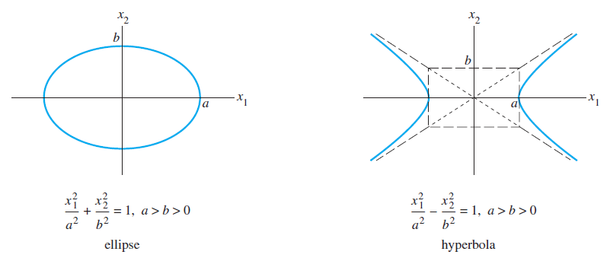

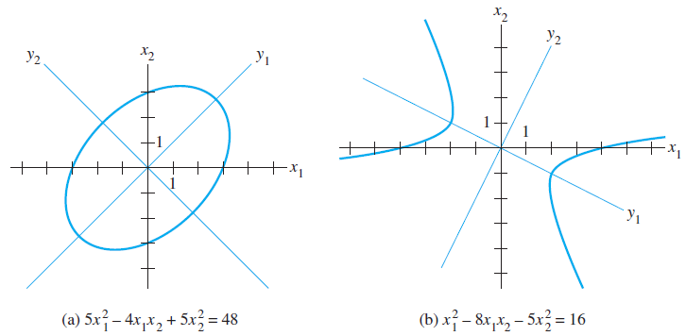

## Classification of Quadratic Forms

# Constrained Optimization