Note on Chapter 7  
Symmetric Matrices and Quadratic Forms

Book: Linear Algebra and its Applications. Fourth edition.

# Diagonalization

## Symmetrix Matrix

**DEFINITION. (Symmetric Matrix)** A symmetric matrix is a matrix such that   
Such matrix is:

1. Square
2. Elements are **symmetrical about the main diagonal.**

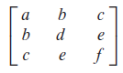

**THEOREM 1.** If is symmetric, then any two eigenvectors from different eigenspaces are orthogonal.

**PROOF:**

Let and be eigenvectors that correspond to distinct eigenvalues and . To show , compute

Also

Thus we yield

As , so

**DEFINITION. (Orthogonal matrix)** An matrix is an orthogonal matrix if its **column vectors are linearly independent and orthonormal vectors**. It can be proved that is an orthogonal matrix if and only if

**DEFINITION. (Orthogonal diagonalization)** An matrix is orthogonally diagonalizable if there is an orthogonal matrix and a diagonal matrix such that

**THEOREM 2.** An matrix is orthogonally diagonalizable if and only if is a symmetric matrix.

## Spectral Decomposition

**DEFINITION. (Spectrum of a matrix, 矩阵的谱)** The set of eigenvalues of a matrix is called the spectrum of.

**THEOREM 3. The Spectral Theorem for Symmetric Matrices**

注：这个定理给我一个直觉认识，那就是对称矩阵可以通过特征分解分成多个“光谱”，每一个谱都对应一个特征值和特征空间。个人认为，3.c是光谱定理的核心。

An symmetric matrix has the following properties:

1. has real eigenvalues, counting multiplicities.
2. dimension of eigenspace = multiplicity of eigenvalue.
3. eigenspaces are mutually orthogonal <=> eigenvectors corresponding to different eigenvalues are orthogonal.
4. A is orthogonally diagonalizable.

基于光谱定理，我们可以对一个对称矩阵进行光谱分解。

**DEFINITION 5. (Spectral Decomposition)**

Suppose , where the columns of are orthonormal eigenvectors of and the corresponding eigenvalues are in the diagonal matrix . Since ,

此外，还是实数向量到向量的投影矩阵。详见练习题7.35。

# Quadratic Forms

## Definition

**DEFINITION. (Quadratic Forms, 二次型)**

A quadratic form on is a function defined on whose value at a vector in can be computed by an expression of the form

where is an symmetric matrix.

**NOTE.** Example 2 of Section 7.2 reveals **the relationship of analytical expression and the coefficient matrix of a quadratic form** （解析式和系数矩阵的关系）:

1. The coefficient of term = The th entry on the main diagonal of .
2. The coefficient of cross-product term = The and entry of .

## Change of Variable

**DEFINITION. (Change of variable)** If represents a variable in , then a change of variable is an equation of the form

or equivalently

If the change of variable is made in a quadratic form , then

**THEOREM 4. (The Principal Axes Theorem)**

Let be an symmetric matrix. Then there is an orthogonal change of variable, , that transforms the quadratic form into a quadratic form **with no cross-product term**.

**DEFINITION.** The columns of are called the **principal axes** of the quadratic form . The vector is the **coordinate vector** of relative to the orthonormal basis of given by these principal axes.

主轴定理的几何意义：坐标旋转

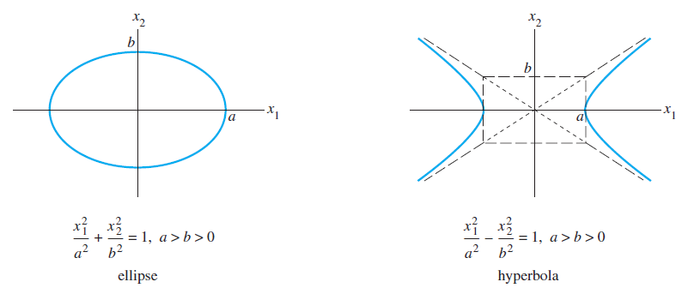

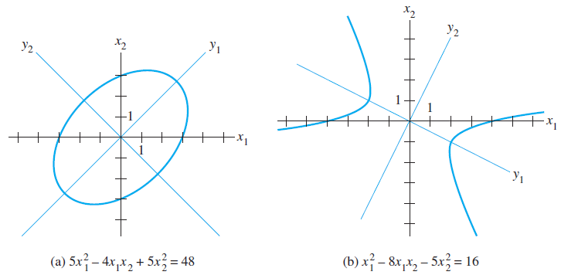

## Classification of Quadratic Forms

**DEFINITION.** A quadratic form is:

1. positive definite（正定）if for all .
2. negative definite（负定）if for all
3. indefinite（未定）if assumes both positive and negative values.

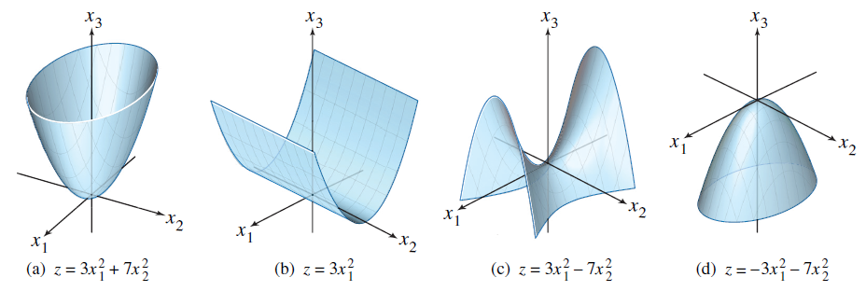

**THEOREM 5. Quadratic forms and eigenvalues**

Let be an symmetric matrix. Then a quadratic form is:

1. positive definite if and only if the eigenvalues of are all positive,
2. negative definite if and only if the eigenvalues of are all negative, or
3. indefinite if and only if has both positive and negative eigenvalues.

用主轴定理来证明。

# Constrained Optimization

问题背景: 有时候需要寻找二次型在一些区间内的最大值或最小值. 通常情况下, 通过对进行仿射变换, 可以使落在单位向量区间里.

Example 2帮我们建立了Constrained Optimization的几何意义: 找到一个空间曲线的极值.

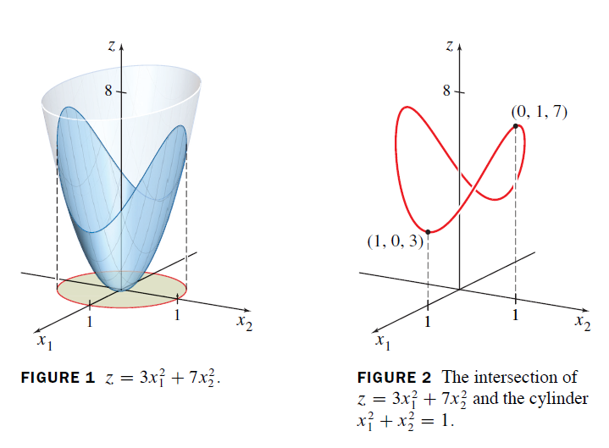

当为单位向量时, 最优化问题满足如下定理

**THEOREM 6.** Optimization of where is any unit vector in .

Let be a symmetric matrix, and let

and .

Then is the greatest eigenvalue of and is the least eigenvalue of . The extreme value is yield when equals to the corresponding eigenvalue.

证明: 精髓在于构造不等式.

首先令. 为了方便表示, 令的特征值降序排列. 令为中的单位向量. 则

类似地,