Assignment-1

Please try to finish it before next class.

QUESTION 1:

Write a Program in Java to input a number and check whether it is a **Pronic Number** or **Heteromecic Number** or not.

**Pronic Number :** A pronic number, oblong number, rectangular number or heteromecic number, is a number which is the product of two consecutive integers, that is, n (n + 1).

The first few pronic numbers are:  
0, 2, 6, 12, 20, 30, 42, 56, 72, 90, 110, 132, 156, 182, 210, 240, 272, 306, 342, 380, 420, 462 … etc.

QUESTION 2:

Write a Program in Java to input 2 numbers and find their **Greatest Common Divisor (GCD)**.

**Note:** If the 2 numbers are 54 and 24, then the **divisors (factors) of 54** are: **1, 2, 3, 6, 9, 18, 27, 54.**

Similarly **the divisors (factors) of 24** are: **1, 2, 3, 4, 6, 8, 12, 24.**

The numbers that these two lists share in common are the **common divisors (factors)** of 54 and 24: **1, 2, 3, 6.**

The greatest (highest) of these is **6**. That is the **greatest common divisor** or the highest common factor of 54 and 24.

(also try using recursion)

QUESTION 3:

Write a program to generate Fibonacci series up to n terms.

The Fibonacci Sequence is the series of numbers: 0, 1, 1, 2, 3, 5, 8, 13, 21, 34, …

The first two numbers in the series is ‘0’ and ‘1’ and every next number is found by adding up the two numbers before it.

The 2 is found by adding the two numbers before it (1+1)  
Similarly, the 3 is found by adding the two numbers before it (1+2),  
And the 5 is (2+3),  
and so on!

QUESTION 4:

Write a Program in Java to input a number and check whether it is an **Automorphic Number** or not.

**Note:** An automorphic number is a number which is present in the last digit(s) of its square.  
**Example:** 25 is an automorphic number as its square is 625 and 25 is present as the last digits

QUESTION 5:

Write a program to input a word from the user and remove the consecutive repeated characters by replacing the sequence of repeated characters by its single occurrence.

**Example:**

INPUT–Jaaavvvvvvvvaaaaaaaaaaa  
OUTPUT – Java

INPUT–Heeeiiiissggoiinggg  
OUTPUT – Heisgoing

QUESTION 6:

Write a program to find the shortest and the longest word in a sentence and print them along with their length.

**Sample Input:** I am learning Java  
**Sample Output:**  
Shortest word = I  
Length = 1  
Longest word = learning  
Length = 8

QUESTION 7:

**Caesar Cipher** is an encryption technique which is implemented as ROT13 (‘rotate by 13 places’). It is a simple letter substitution cipher that replaces a letter with the letter 13 places after it in the alphabets, with the other characters remaining unchanged.

[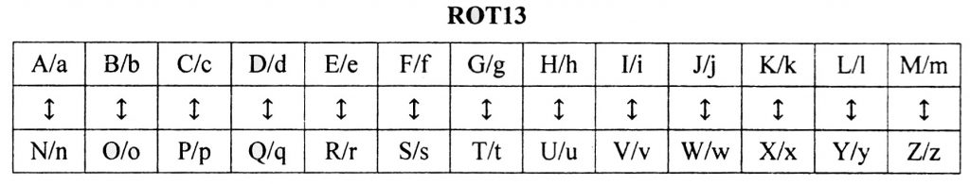](http://www.guideforschool.com/wp-content/uploads/2017/02/caeser-cipher-java-program.jpg)

Write a program to accept a plain text of length L, where L must be greater than 3 and less than 100.

Encrypt the text if valid as per the Caesar Cipher.

Test your program with the sample data and some random data:

**Example 1**

**INPUT :**Hello! How are you?

**OUTPUT :**The cipher text is:  
Uryyb? Ubj ner lbh?

QUESTION 8:

Sort a 1-D array using bubble sort

QUESTION 9:

Search element in an array using linear and binary search.

**Binary Search:** Search a sorted array by repeatedly dividing the search interval in half. Begin with an interval covering the whole array. If the value of the search key is less than the item in the middle of the interval, narrow the interval to the lower half. Otherwise narrow it to the upper half. Repeatedly check until the value is found or the interval is empty.

Example :[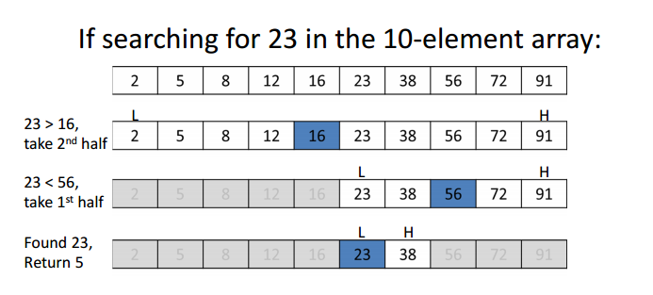](https://www.geeksforgeeks.org/wp-content/uploads/gq/2014/01/binary-search1.png)

Share your doubts on Telegram group. Common doubts will be cleared in next class