**OWASP Top Ten Report FOR XXXXXXXx**

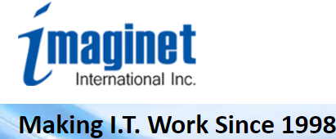

The scan has revealed the following number of Alerts, according to OWASP Top Ten. This has recently been officially changed to:- 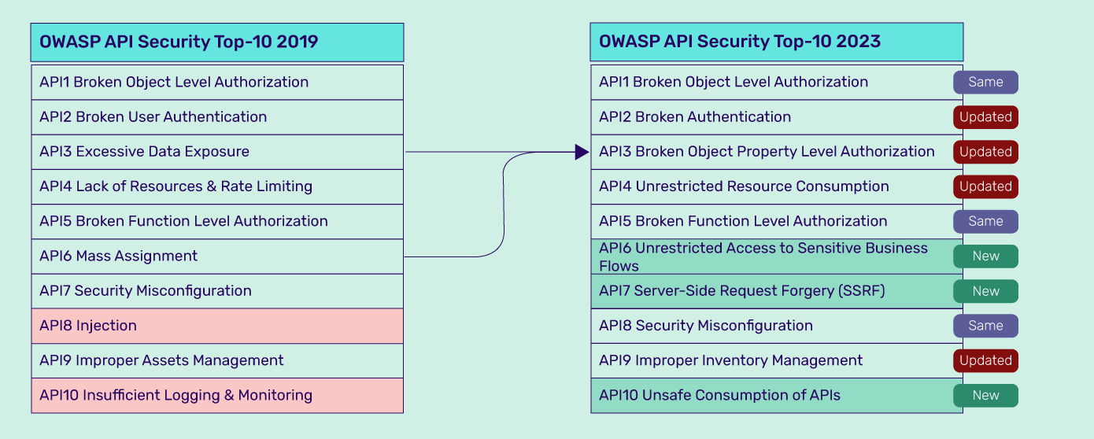

**INSERT THE SUMMARY TABLE FROM THE HTML GENERTED BY OWASP SCRIPT SERVER.**

**It is strongly recommend that a full test according to PTESS standard is undertaken. This will detail, together with remedial actions, the Alerts given above.**