University of Eastern Africa, Baraton
School of Business — Department of Information Systems and Computing
INSY492 — Senior Project
CAMPUS NAVIGATION SYSTEM
System Documentation
Field | Detail
Author | David Chikamai
Student ID | SCHIDA2311
Major | BBIT
Supervisor | Mr. Fred Mobisa
Instructor | Mr. Dickson Omari
Date | July 2026

1. Introduction

1.1 Background
The University of Eastern Africa, Baraton campus consists of multiple buildings spread across a wide area. New students, visitors, and even continuing students frequently encounter difficulty locating lecture halls, administrative offices, laboratories, and other facilities. Navigation currently relies on physical signposts and verbal directions, which can cause confusion and delays.

1.2 Purpose of This Document
This document is the complete technical and user reference for the Campus Navigation System. It describes the system architecture, database design, API endpoints, frontend modules, and provides a visual walkthrough of all major system functions using screenshots taken from the live system.

1.3 System Objectives
The system was designed to meet the following specific objectives:
- Provide an interactive digital campus map displaying all buildings and paths.
- Implement building search functionality allowing users to find facilities by name, code, or description.
- Compute and display the shortest walking route between any two campus locations.
- Provide an administrative module for managing building and path data.

2. System Overview

2.1 Architecture
The system follows a three-tier client-server architecture:
┌────────────────────────────────────────┐
│ USER / BROWSER │
│ HTML · CSS · JavaScript │
└──────────────┬─────────────────────────┘
│ HTTP REST (JSON)
▼
┌────────────────────────────────────────┐
│ SPRING BOOT BACKEND │
│ REST API · Spring Security · Dijkstra │
│ Port 8080 │
└──────────────┬─────────────────────────┘
│ JDBC / JPA
▼
┌────────────────────────────────────────┐
│ MYSQL DATABASE │
│ categories, buildings, paths, users │
└────────────────────────────────────────┘

2.2 Module Summary
Module | Description
Map Module | Interactive HTML5 Canvas map with colour-coded building nodes, path edges, pan, zoom, hover tooltips, and click-to-detail.
Search Module | Real-time building search against name, code, and description fields with live dropdown results.
Routing Module | Dijkstra shortest path computation. Visualises route on canvas with total distance and step-by-step waypoints.
Admin Module | Authenticated dashboard for adding, editing, and deleting buildings and paths. Protected by role-based access control.

3. Technologies Used

3.1 Frontend
Technology | Detail | Purpose
HTML5 | — | Page structure and semantic markup
CSS3 | — | Styling, layout, responsive design
JavaScript ES6+ | — | Application logic, DOM manipulation
HTML5 Canvas API | — | Campus map rendering
Sora / JetBrains Mono | Google Fonts | UI typeface and monospace display

3.2 Backend
Technology | Version | Purpose
Java | 17 | Primary backend language
Spring Boot | 3.2.0 | Application framework
Spring Web | — | REST API layer
Spring Data JPA / Hibernate | — | Database persistence and ORM
Spring Security | — | Authentication and authorisation
JJWT | 0.11.5 | JSON Web Token generation and validation
Lombok | — | Boilerplate code reduction
Maven | — | Build and dependency management

3.3 Database & Tools
Technology | Purpose
MySQL 8.x | Relational database
MySQL Workbench | Database design and administration
IntelliJ IDEA / Kiro IDE | Backend and frontend development
Git / GitHub | Version control
Docker | Backend containerisation (Dockerfile provided)

4. Database Design

4.1 Entity Relationship Overview
The database contains four tables. A category classifies one or many buildings (e.g., Lecture Hall, Laboratory). A building belongs to one category and holds map coordinates used as graph nodes. A path is a directed weighted edge between two buildings used by the routing algorithm. A user holds admin credentials with role ADMIN or VIEWER.

4.2 Table: categories
Column | Type | Description
id | INT PK AUTO | Primary key
name | VARCHAR(100) | Category name (e.g., Lecture Hall)
icon | VARCHAR(50) | Icon identifier for UI rendering

4.3 Table: buildings
Column | Type | Description
id | INT PK AUTO | Primary key
name | VARCHAR(150) | Full building name
code | VARCHAR(20) UNIQUE | Short code (e.g. SB, LIB)
description | TEXT | Building description
category_id | INT FK | References categories.id
map_x / map_y | DECIMAL(8,2) | Canvas coordinates for map rendering
image_url | VARCHAR(255) | Optional building photo URL
created_at / updated_at | TIMESTAMP | Audit timestamps

4.4 Seeded Buildings (12)
Code | Name | Category
SB | School of Business | Lecture Hall
SC | Science Block | Laboratory
LIB | University Library | Library
ADM | Administration Block | Administrative
CAF | Student Centre / Cafeteria | Cafeteria
DORM-A | Male Dormitory A | Dormitory
DORM-B | Female Dormitory B | Dormitory
SPT | Sports Complex | Sports Facility
CHP | University Chapel | Chapel/Worship
HC | Health Centre | Medical
ENG | Engineering Block | Laboratory
PKA | Parking Lot A | Parking

4.5 Table: paths
Column | Type | Description
id | INT PK AUTO | Primary key
from_id | INT FK | Source building
to_id | INT FK | Destination building
distance | DECIMAL(8,2) | Distance in metres — Dijkstra edge weight
path_name | VARCHAR(100) | Named walkway (e.g., Main Boulevard)
is_accessible | BOOLEAN | Wheelchair accessibility flag
Paths are stored bidirectionally — 30 records covering 15 unique walkways.

4.6 Table: users
Column | Type | Description
id | INT PK AUTO | Primary key
username | VARCHAR(80) UNIQUE | Login username
password_hash | VARCHAR(255) | BCrypt hash (strength 12)
role | ENUM(ADMIN, VIEWER) | Access role
active | BOOLEAN | Account active flag

5. Backend API Documentation

5.1 Base URL
http://localhost:8080/api

5.2 Authentication
The API uses JWT (JSON Web Token) based authentication. Public read-only endpoints require no token. Write operations require a valid bearer token in the Authorization header: Authorization: Bearer <token>. Passwords are stored as BCrypt hashes (cost factor 12). Sessions are stateless.

5.3 Buildings Endpoints
Method | Endpoint | Auth | Description
GET | /api/buildings | None | Retrieve all buildings
GET | /api/buildings/{id} | None | Retrieve single building by ID
GET | /api/buildings/search?q= | None | Search by name, code, or description
GET | /api/buildings/category/{id} | None | Filter by category
POST | /api/buildings | ADMIN | Create a new building
PUT | /api/buildings/{id} | ADMIN | Update an existing building
DELETE | /api/buildings/{id} | ADMIN | Delete a building

5.4 Routing Endpoint
Method | Endpoint | Auth | Description
GET | /api/route?from={id}&to={id} | None | Compute shortest path between two buildings
Response includes: found (boolean), totalDistance (metres), path (ordered list of buildings).

5.5 Auth & Paths Endpoints
Method | Endpoint | Auth | Description
POST | /api/auth/login | None | Submit credentials, receive JWT token
GET | /api/paths | None | Retrieve all path edges
POST | /api/paths | ADMIN | Create a new path edge
DELETE | /api/paths/{id} | ADMIN | Delete a path edge

5.6 Dijkstra's Algorithm
Implemented in RoutingService.java. Steps: (1) Load all path edges and build an in-memory adjacency map. (2) Initialise a min-heap priority queue with the source building at distance 0. (3) Relax edges iteratively, updating shortest known distances. (4) Terminate early when the target node is dequeued. (5) Reconstruct path by tracing the predecessor map from target to source.
Time complexity: O((V + E) log V). Space complexity: O(V + E).

6. Frontend Documentation

6.1 File Structure
frontend/
├── index.html (single-page app shell)
├── css/style.css (all styling)
└── js/
├── api.js (REST API client)
├── map.js (Canvas map renderer)
├── admin.js (Admin panel logic)
└── app.js (bootstrap and wiring)

6.2 Map Module (map.js)
The campus map renders on an HTML5 Canvas. Buildings are drawn as filled circles colour-coded by category. Paths are drawn as connecting lines. Route highlighting draws a glowing green line over the computed shortest path. Labels appear on nodes when zoom exceeds 0.7. Users can pan by dragging, zoom via scroll wheel or ±buttons, and click a building to open its detail panel.
Category | Colour
Lecture Hall | #2ea043 — Green
Laboratory | #1f6feb — Blue
Administrative | #d29922 — Yellow
Library | #8957e5 — Purple
Cafeteria | #e36209 — Orange
Dormitory | #388bfd — Light Blue
Sports Facility | #3fb950 — Bright Green
Medical | #da3633 — Red
Parking | #6e7681 — Grey

6.3 Search Module (app.js)
A text input listens for keystrokes. Each keystroke fires GET /api/buildings/search?q=. Up to 8 results display in a dropdown. Selecting a result opens the building detail panel. If the backend is unreachable, search falls back to client-side filtering of embedded sample data.

6.4 Routing UI (app.js)
Two dropdowns are populated with all buildings on page load. The user selects From and To, then clicks Get Shortest Route. The frontend calls GET /api/route?from={id}&to={id}. On success, the route is highlighted on the canvas and a step-by-step waypoint list with total distance (metres) is shown in the sidebar.

6.5 Admin Module (admin.js)
Accessible via the Admin navigation button. After JWT login, the dashboard reveals two tabs — Buildings and Paths. Buildings tab: full CRUD (add/edit/delete) via modal forms. Paths tab: add new path edges by selecting From/To buildings and entering distance. All write operations send the JWT token as a Bearer header.

6.6 Offline / Demo Mode
If the Spring Boot backend is not running, the frontend falls back to embedded SAMPLE_BUILDINGS and SAMPLE_PATHS constants. The map renders fully and search works client-side. Route calculation requires the backend to be running.

7. System Screenshots
All screenshots were captured on 29 July 2026 from the live system running at localhost:63342.

7.1 Campus Map — Main View
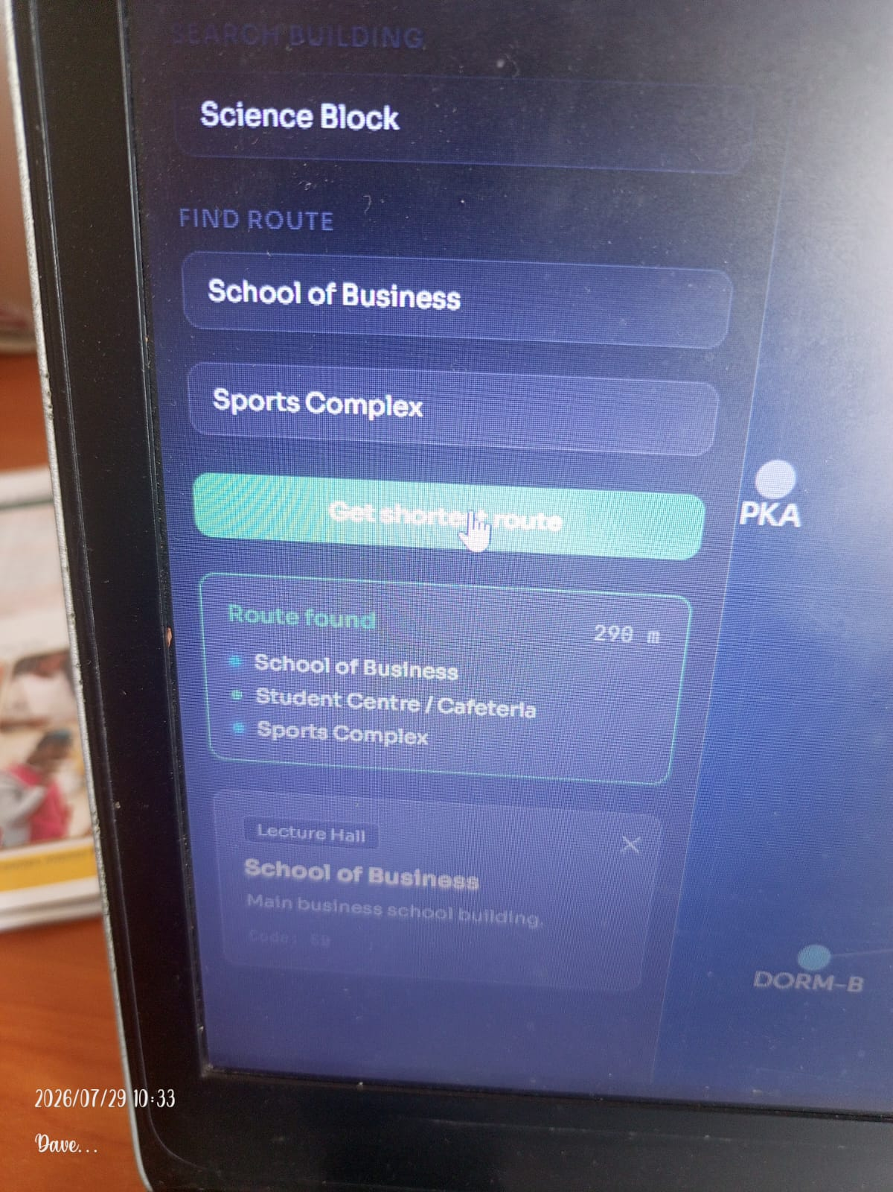
Figure: Main campus map with building detail panel open (School of Business)

7.2 Route Dropdown — All Buildings Listed
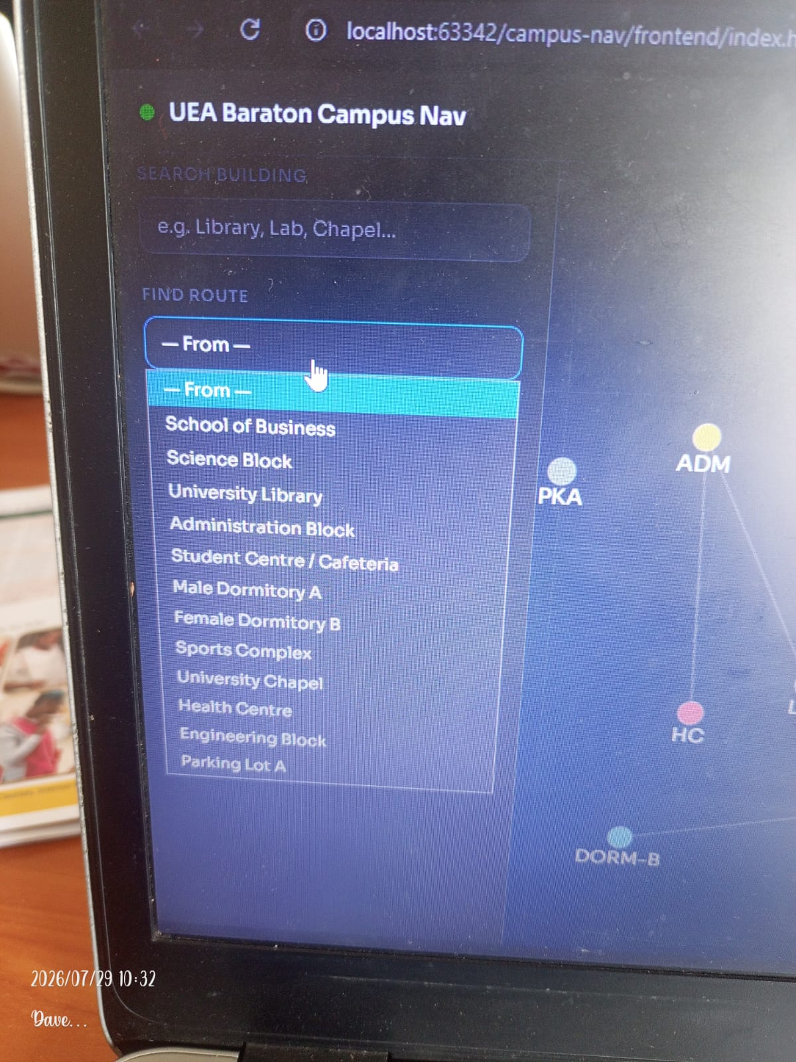
Figure: Find Route 'From' dropdown expanded showing all 12 campus buildings

7.3 Building Search Results
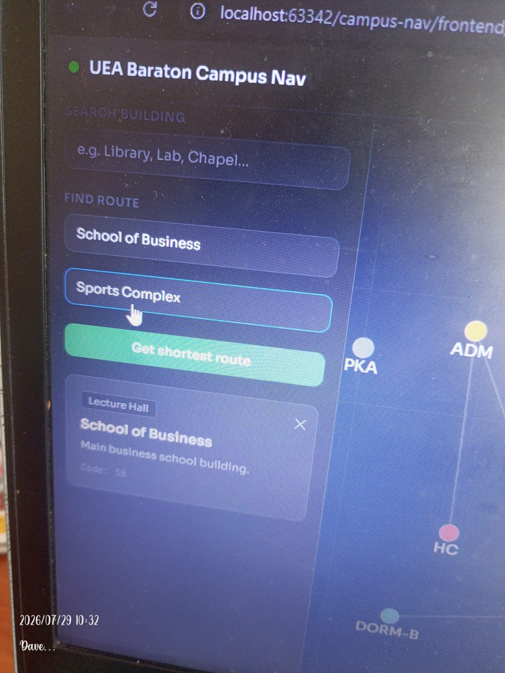
Figure: Search results for 'SC' — matching School of Business, Science Block, Sports Complex

7.4 Route Selection
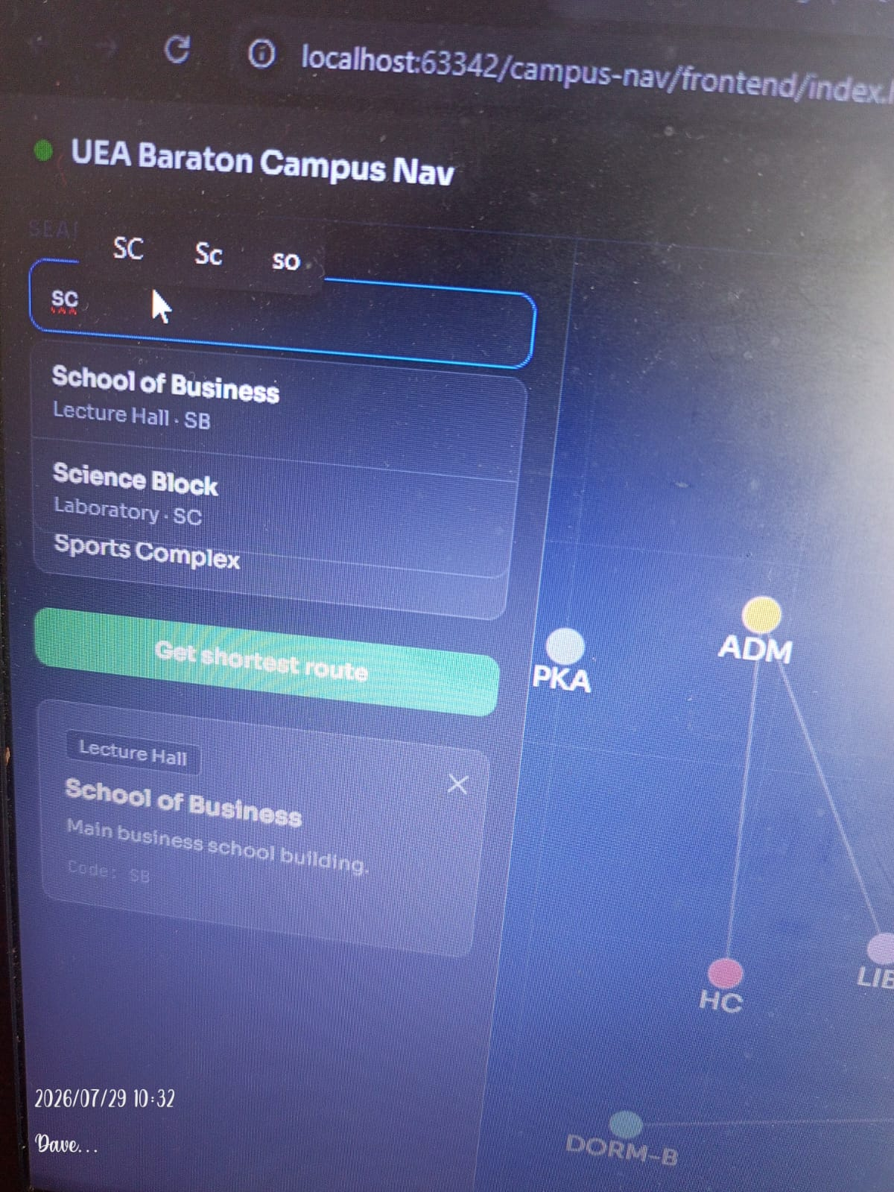
Figure: Both From (School of Business) and To (Sports Complex) dropdowns filled

7.5 Route Result Panel
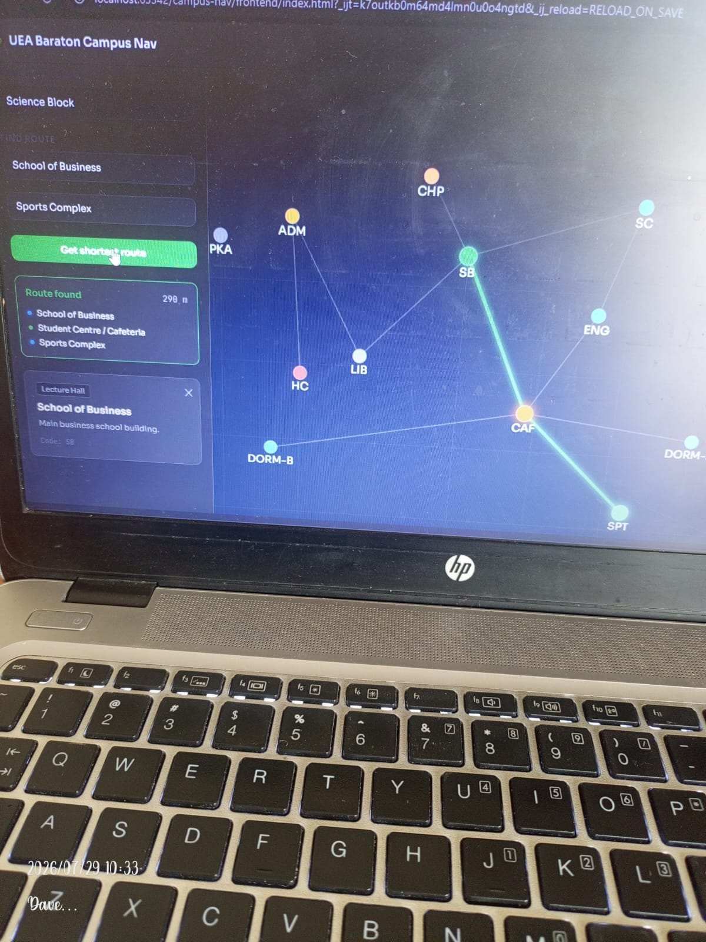
Figure: Route result: 290m via School of Business → Student Centre/Cafeteria → Sports Complex

7.6 Route Highlighted on Map
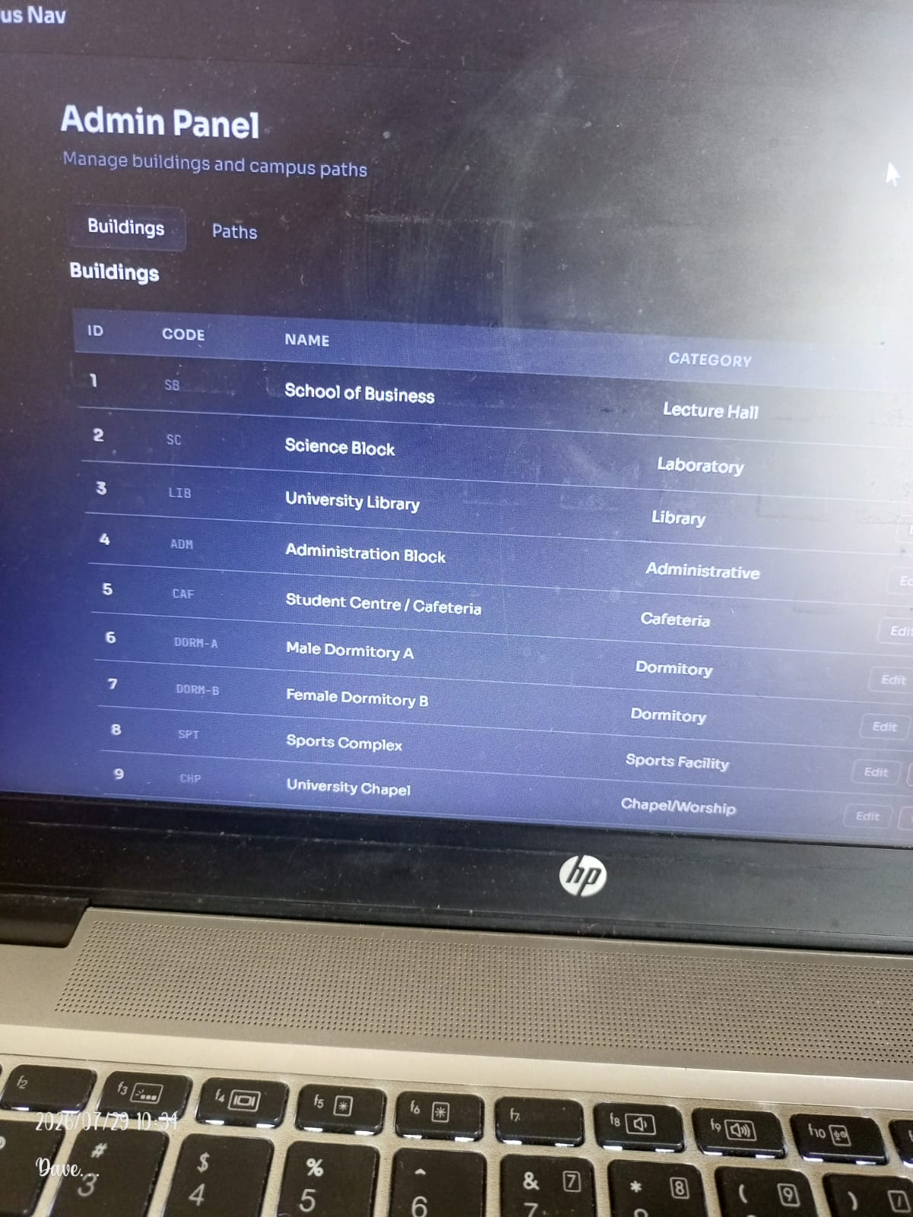
Figure: Green glowing route line drawn on canvas: SB → CAF → SPT

7.7 Admin Buildings Table
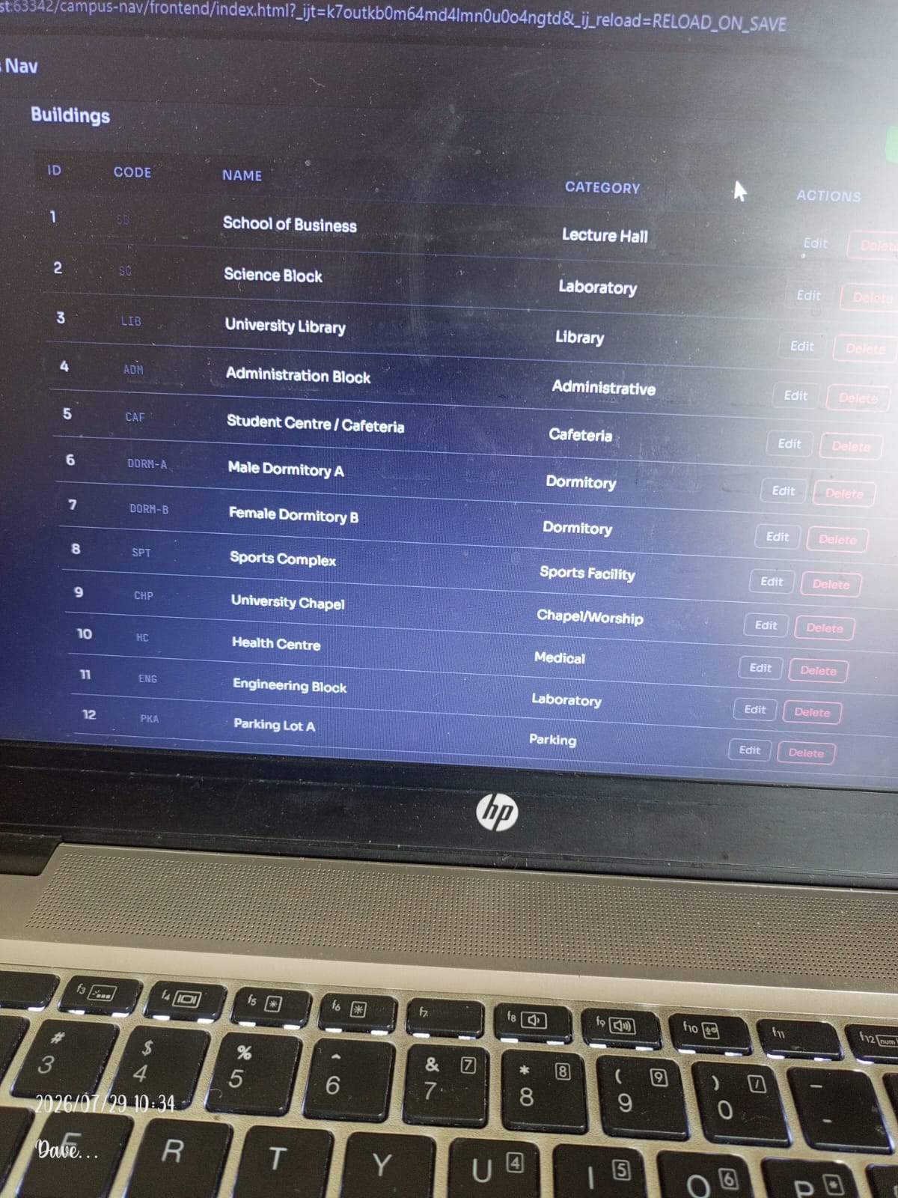
Figure: Admin dashboard Buildings tab — all 12 buildings with Edit/Delete actions

7.8 Admin Login Screen
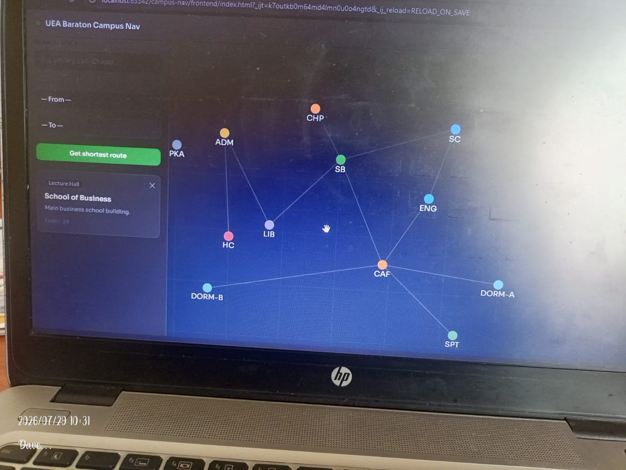
Figure: Admin Panel Sign In form with username and password fields

7.9 Admin Dashboard After Login
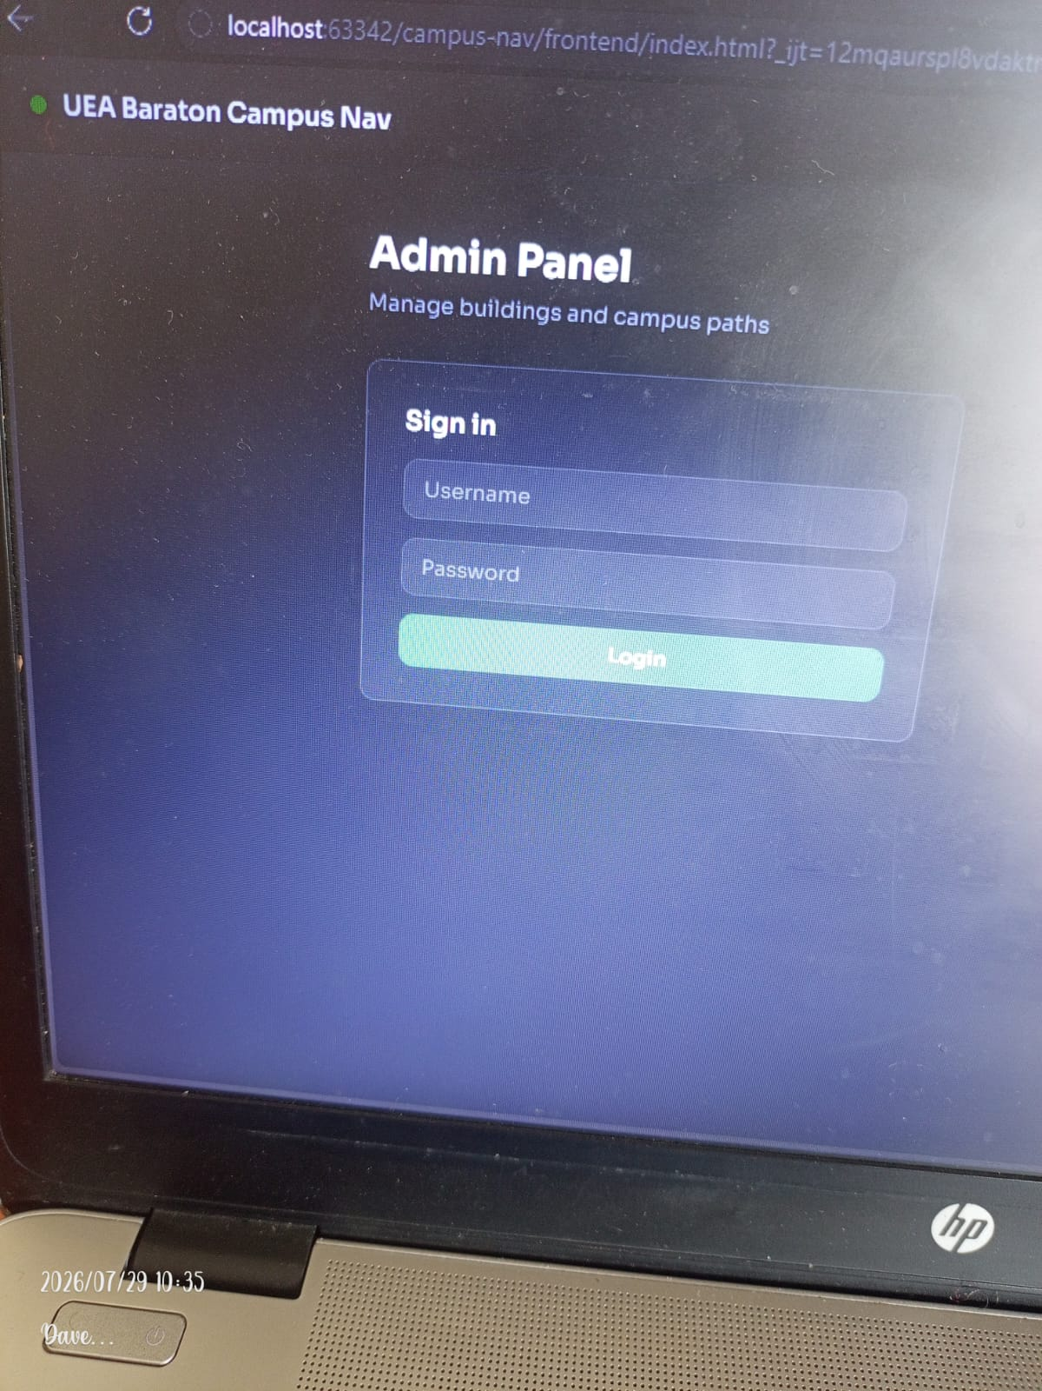
Figure: Admin dashboard Buildings tab after successful authentication

8. User Guide

8.1 For Students and Visitors

Viewing the Campus Map
- Open the system in a web browser. The map loads automatically on the Map tab.
- Buildings appear as coloured circles — each colour represents a building category.
- Use the + and − buttons to zoom. Click and drag to pan around the campus.
- Hover over any building to see its name in a tooltip.
- Click a building to open the detail panel showing name, category, code, and description.

Searching for a Building
- Click the Search Building field on the left sidebar.
- Type any part of the building name, code, or description (e.g., 'lib', 'LIB', 'library').
- A dropdown shows matching results. Click a result to view its details.

Finding the Shortest Route
- Under Find Route, select your starting location from the From dropdown.
- Select your destination from the To dropdown.
- Click Get Shortest Route. The shortest path is highlighted on the map in green.
- The sidebar shows the list of waypoints and total walking distance in metres.

8.2 For Administrators

Logging In
- Click the Admin button in the top navigation bar.
- Enter your username and password, then click Login.
- On success the admin dashboard opens. The JWT token is stored for the session.

Managing Buildings
- Buildings tab: click + Add building to create a new record via the modal form.
- Click Edit on any row to update an existing building's details.
- Click Delete to remove a building (also removes connected paths — confirmation required).

Managing Paths
- Paths tab: click + Add path to connect two buildings with a named walkway and distance.
- Click Delete on a path row to remove that connection.
- New paths are used in route calculations immediately.

9. Known Limitations and Future Work

9.1 Current Limitations
Limitation | Detail
JWT filter incomplete | JwtAuthenticationFilter is referenced but not fully implemented. A local dev fallback exists in the frontend.
No real-time GPS | Building positions are pixel coordinates on a fixed canvas, not real GPS coordinates.
No mobile native app | The system is a web application only — native Android/iOS is out of scope for this phase.
Accessibility filtering unused | The is_accessible column exists in paths but is not yet used to filter routes.

9.2 Recommendations for Future Development
- Complete JWT authentication — implement JwtAuthenticationFilter and JwtService to fully secure the admin API.
- GPS integration — replace canvas coordinates with real lat/long and render on Leaflet.js or Google Maps.
- Mobile application — build a Flutter or React Native client using the existing REST API.
- Accessibility routing — add a wheelchair-accessible toggle constraining Dijkstra to is_accessible = TRUE edges.
- Turn-by-turn directions — generate human-readable walking instructions between waypoints.
- Building images — populate image_url with actual campus building photos.
- User accounts — allow students to save favourite locations and recent routes.

— End of Document —
University of Eastern Africa, Baraton · INSY492 Senior Project · 2026

