PATHWAY AI
Implementation Document

IST 440W Capstone | Penn State University
David Ademoye | June 2026

A student-first career readiness platform

1. Implementation Summary

Pathway AI is a student career readiness web platform built as a Next.js application. The goal is to give college students a single, free tool that brings together ATS resume checking, career path exploration, skill gap analysis, and AI-powered mock interview coaching — capabilities that currently exist only in separate paid products.

The current MVP delivers a polished public landing page, a student dashboard workspace, and a working ATS-style resume checker. The resume checker runs locally in the browser without requiring external API keys, which satisfies the assignment requirement that the code can run on any computer without developer configuration.

The three remaining modules — Career Path Explorer, Skill Gap Roadmap, and Mock Interview Coach — are represented on the dashboard and will be built using the Claude API in subsequent implementation phases through August 2026.

2. Completed Implementation

2.1 Landing Page (app/page.tsx)
The landing page introduces Pathway AI to prospective users. It includes:
- Sticky header navigation with logo and call-to-action
- Hero section communicating the student career readiness problem
- Product preview mock dashboard
- Student journey steps
- Module overview cards for all four planned features
- Responsible AI and privacy messaging
- Branded loading animation based on the Pathway AI logo

2.2 Dashboard (app/dashboard/page.tsx)
The dashboard acts as the logged-in student workspace. It displays:
- Career readiness summary cards
- Module status cards linking to working and planned features
- Visual student journey map showing the progression through Pathway AI
- Sidebar navigation via AppShell component

2.3 Resume Checker (app/resume-checker/resume-checker-client.tsx)
The resume checker is the primary functional feature of the MVP. It accepts resume text and a target job description, then returns:
- ATS match score (0-100)
- Matched keywords found in both resume and job description
- Missing keywords present in the job description but absent from the resume
- Resume section completeness check (Education, Skills, Experience, Projects, Impact)
- Identified strengths
- Personalized improvement recommendations

2.4 Shared Components
- AppShell.tsx — Sidebar layout, navigation, and shared shell for all inner routes
- PathwayLogo.tsx — Reusable branded logo with hollow/solid dot styling
- globals.css — CSS custom properties for brand colors and Apple-inspired typography

3. Functional Decomposition — Level 0

The Level 0 diagram treats Pathway AI as a single system boundary. It shows the primary inputs entering the system, the four internal subsystems, and the outputs produced for the student.

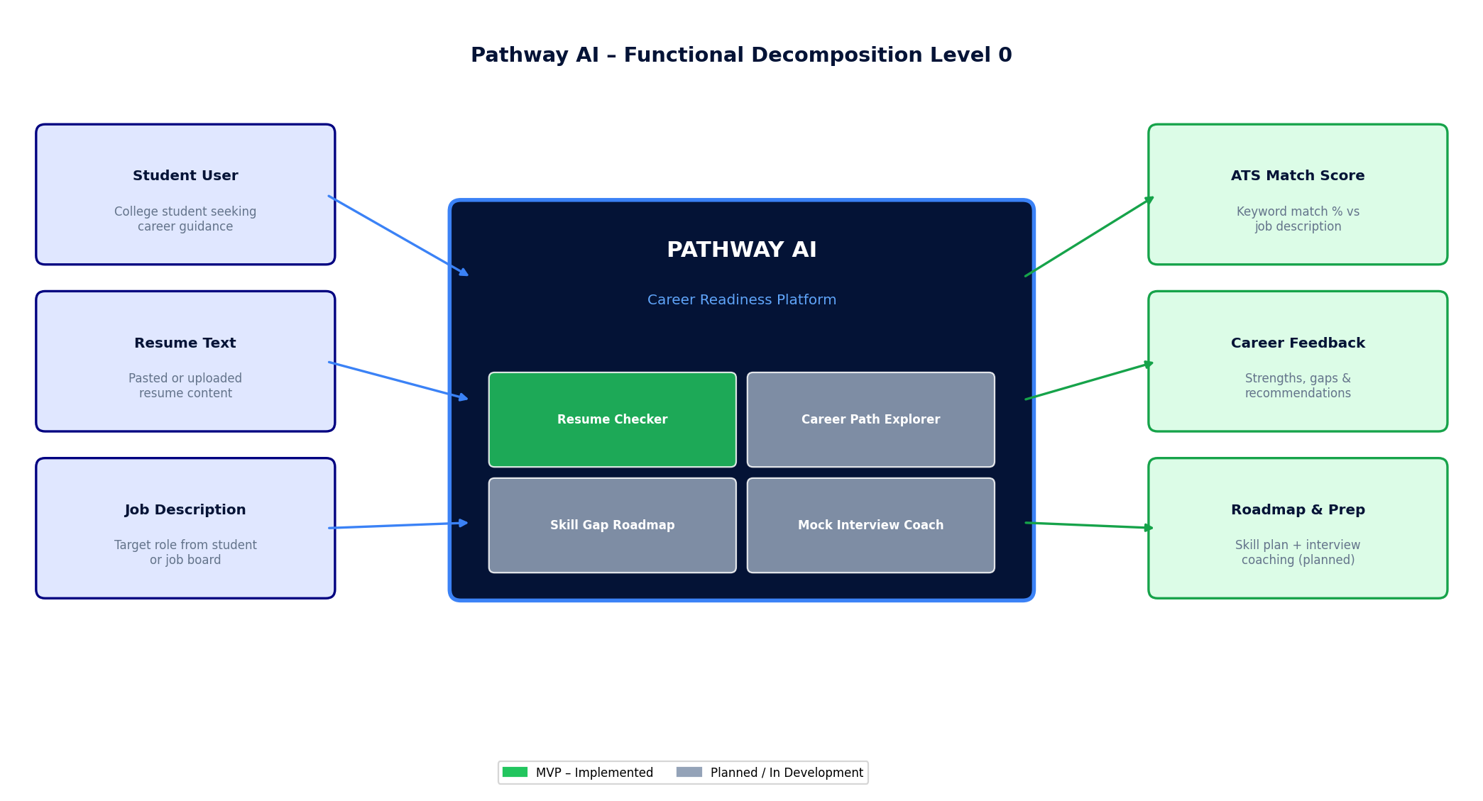
Figure 1. Pathway AI Functional Decomposition — Level 0

At Level 0, three types of input enter the system: the student user, their resume content, and a target job description. The system processes these through its four modules and returns career-specific outputs: a match score, feedback, and a preparation roadmap.

4. Functional Decomposition — Level 1

Level 1 expands each major subsystem into its specific implemented functions and planned sub-features. Completed components are shown in blue and green; planned modules are shown in gray with a dashed boundary.

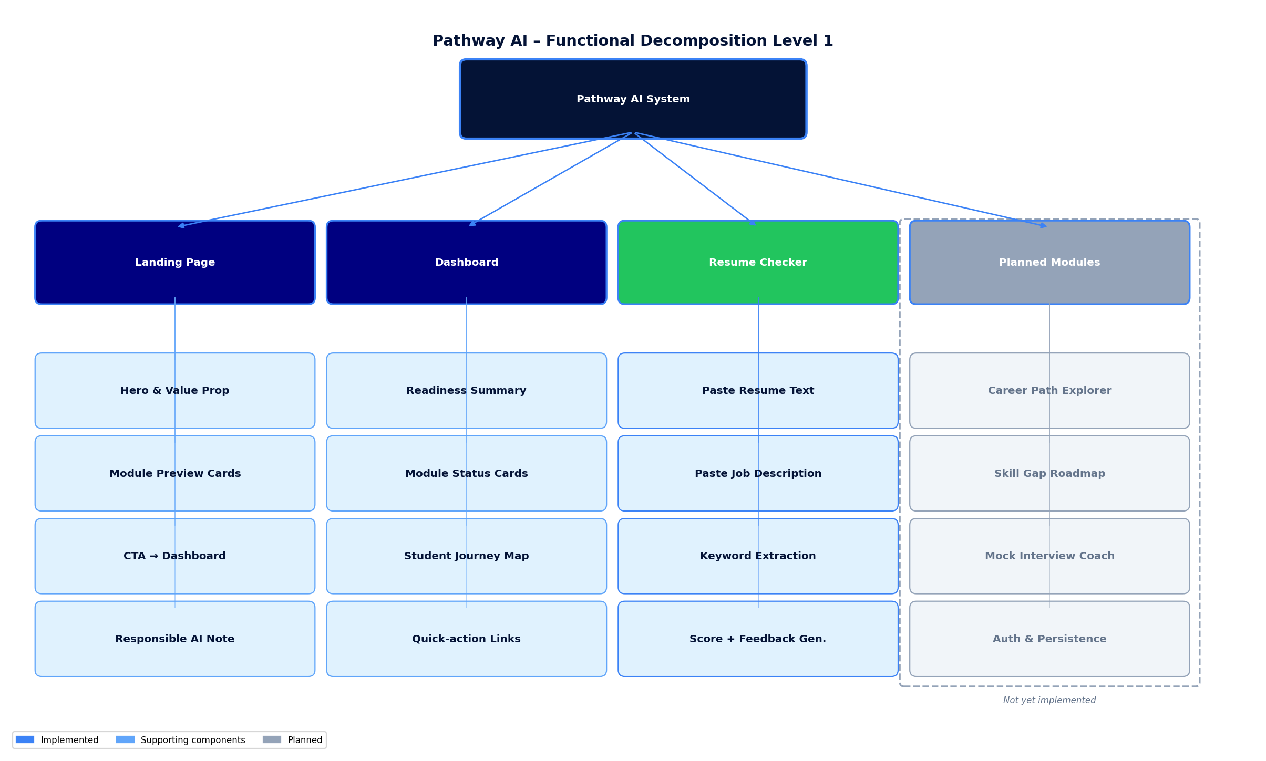
Figure 2. Pathway AI Functional Decomposition — Level 1

The Resume Checker subsystem is fully implemented with four functions: text input, keyword extraction, match scoring, and feedback generation. The three planned modules — Career Path Explorer, Skill Gap Roadmap, and Mock Interview Coach — are scoped for development in subsequent phases using the Claude API.

5. Technical Design Flowchart

The technical design diagram shows how the Next.js App Router connects the three current routes, how shared components are consumed, and how the resume checker analysis pipeline operates client-side. The bottom row shows the planned future integrations: Clerk authentication, NeonDB for persistence, the Claude API for AI analysis, and Vercel for public deployment.

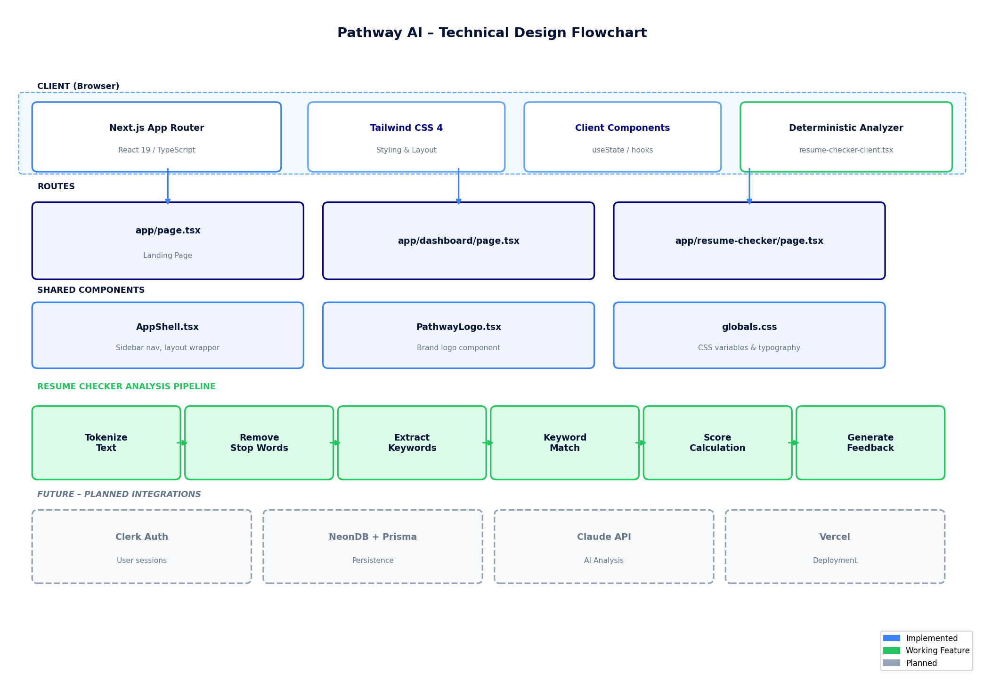
Figure 3. Pathway AI Technical Design Flowchart

The current implementation runs entirely on the client side for the resume analysis pipeline. A future server-side API route will proxy Claude API calls to keep credentials secure, following Next.js App Router conventions for server components and API handlers.

6. Operational Flowchart — User Point of View

The operational flowchart traces the student experience from first arriving on the Pathway AI landing page through completing a resume analysis and acting on the recommendations.

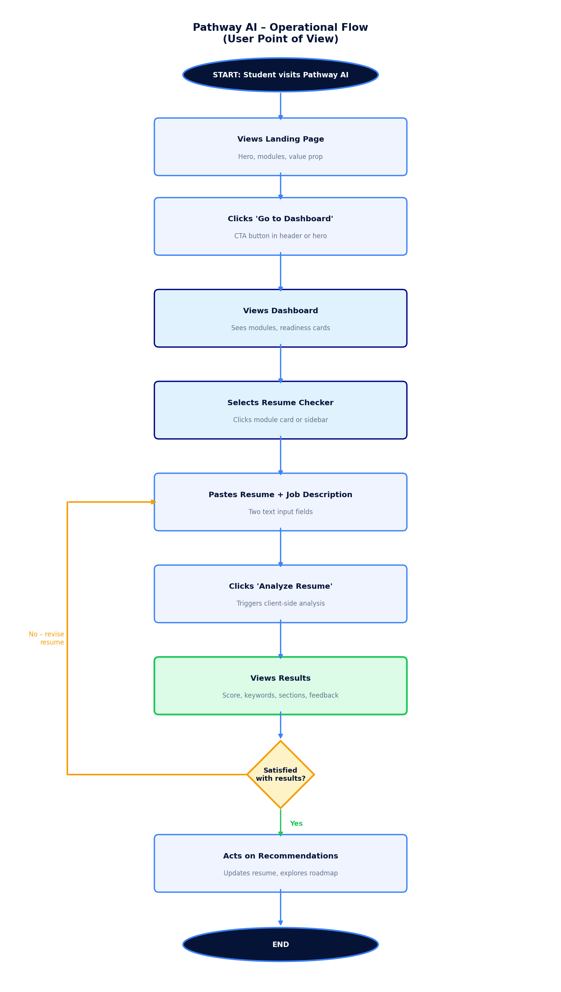
Figure 4. Pathway AI Operational Flowchart — User Point of View

7. Verification Evidence

The MVP implementation was verified using the following local commands on the development machine:

- npm install — all dependencies installed without errors
- npm run lint — zero lint errors or warnings
- npm run build — production build completed successfully

The production build confirmed the following static routes were generated:
- / (Landing Page)
- /dashboard (Student Dashboard)
- /resume-checker (ATS Resume Checker)
- /_not-found (404 handler)

The application is deployed on Vercel. The public production URL is confirmed and accessible in a browser without requiring Vercel account login.

8. Future Development Roadmap

The following enhancements are planned for implementation through August 2026. Note: the original project specification included shadcn/ui as a planned UI component library. It has not yet been installed but is scheduled for Phase 3, prior to building the remaining career readiness modules.

Phase 2 — AI Integration
- Integrate Claude API via secure Next.js server-side route for AI-powered resume analysis
- Replace deterministic keyword matching with semantic understanding and contextual feedback

Phase 3 — UI Component Library
- Install and configure shadcn/ui for consistent, accessible UI components across all modules
- Replace custom card and input components with shadcn/ui equivalents — Button, Card, Input, Badge, Tabs
- shadcn/ui is installed via the CLI (npx shadcn@latest init) and integrates directly with the existing Tailwind CSS 4 setup

Phase 4 — Authentication and Persistence
- Add Clerk authentication for student accounts
- Set up NeonDB with Prisma ORM for storing resume history and student profiles

Phase 5 — Remaining Modules
- Career Path Explorer — AI-guided exploration of career trajectories based on major and interests
- Skill Gap Roadmap — Personalized learning roadmap to close skill gaps identified from resume analysis
- Mock Interview Coach — AI-powered interview question generation and feedback

Phase 6 — Polish and Submission
- Resume PDF/DOCX upload and parsing
- Export and sharing options for resume feedback
- Accessibility improvements
- End-to-end testing suite
- Final documentation and capstone submission

