PATHWAY AI
Project Management Charts

IST 440W Capstone | Penn State University
David Ademoye | May 20 – August 12, 2026

1. Project Management Summary

This document contains the project management artifacts for Pathway AI, organized around the project window of May 20, 2026 through August 12, 2026. The plan covers all phases of development: from initial research and documentation through frontend implementation, AI integration, module development, and final submission.

As of June 30, 2026, the project has completed the documentation phase and the core MVP frontend. The immediate next step is deploying the application to Vercel with a confirmed public URL, followed by integrating the Claude API and building the remaining three career readiness modules.

2. Gantt Chart

The Gantt chart shows all project tasks plotted across the May 20 to August 12 timeline. Green bars are completed work, amber bars are currently in progress, and blue bars are planned. The red dashed line marks today, June 30, 2026.

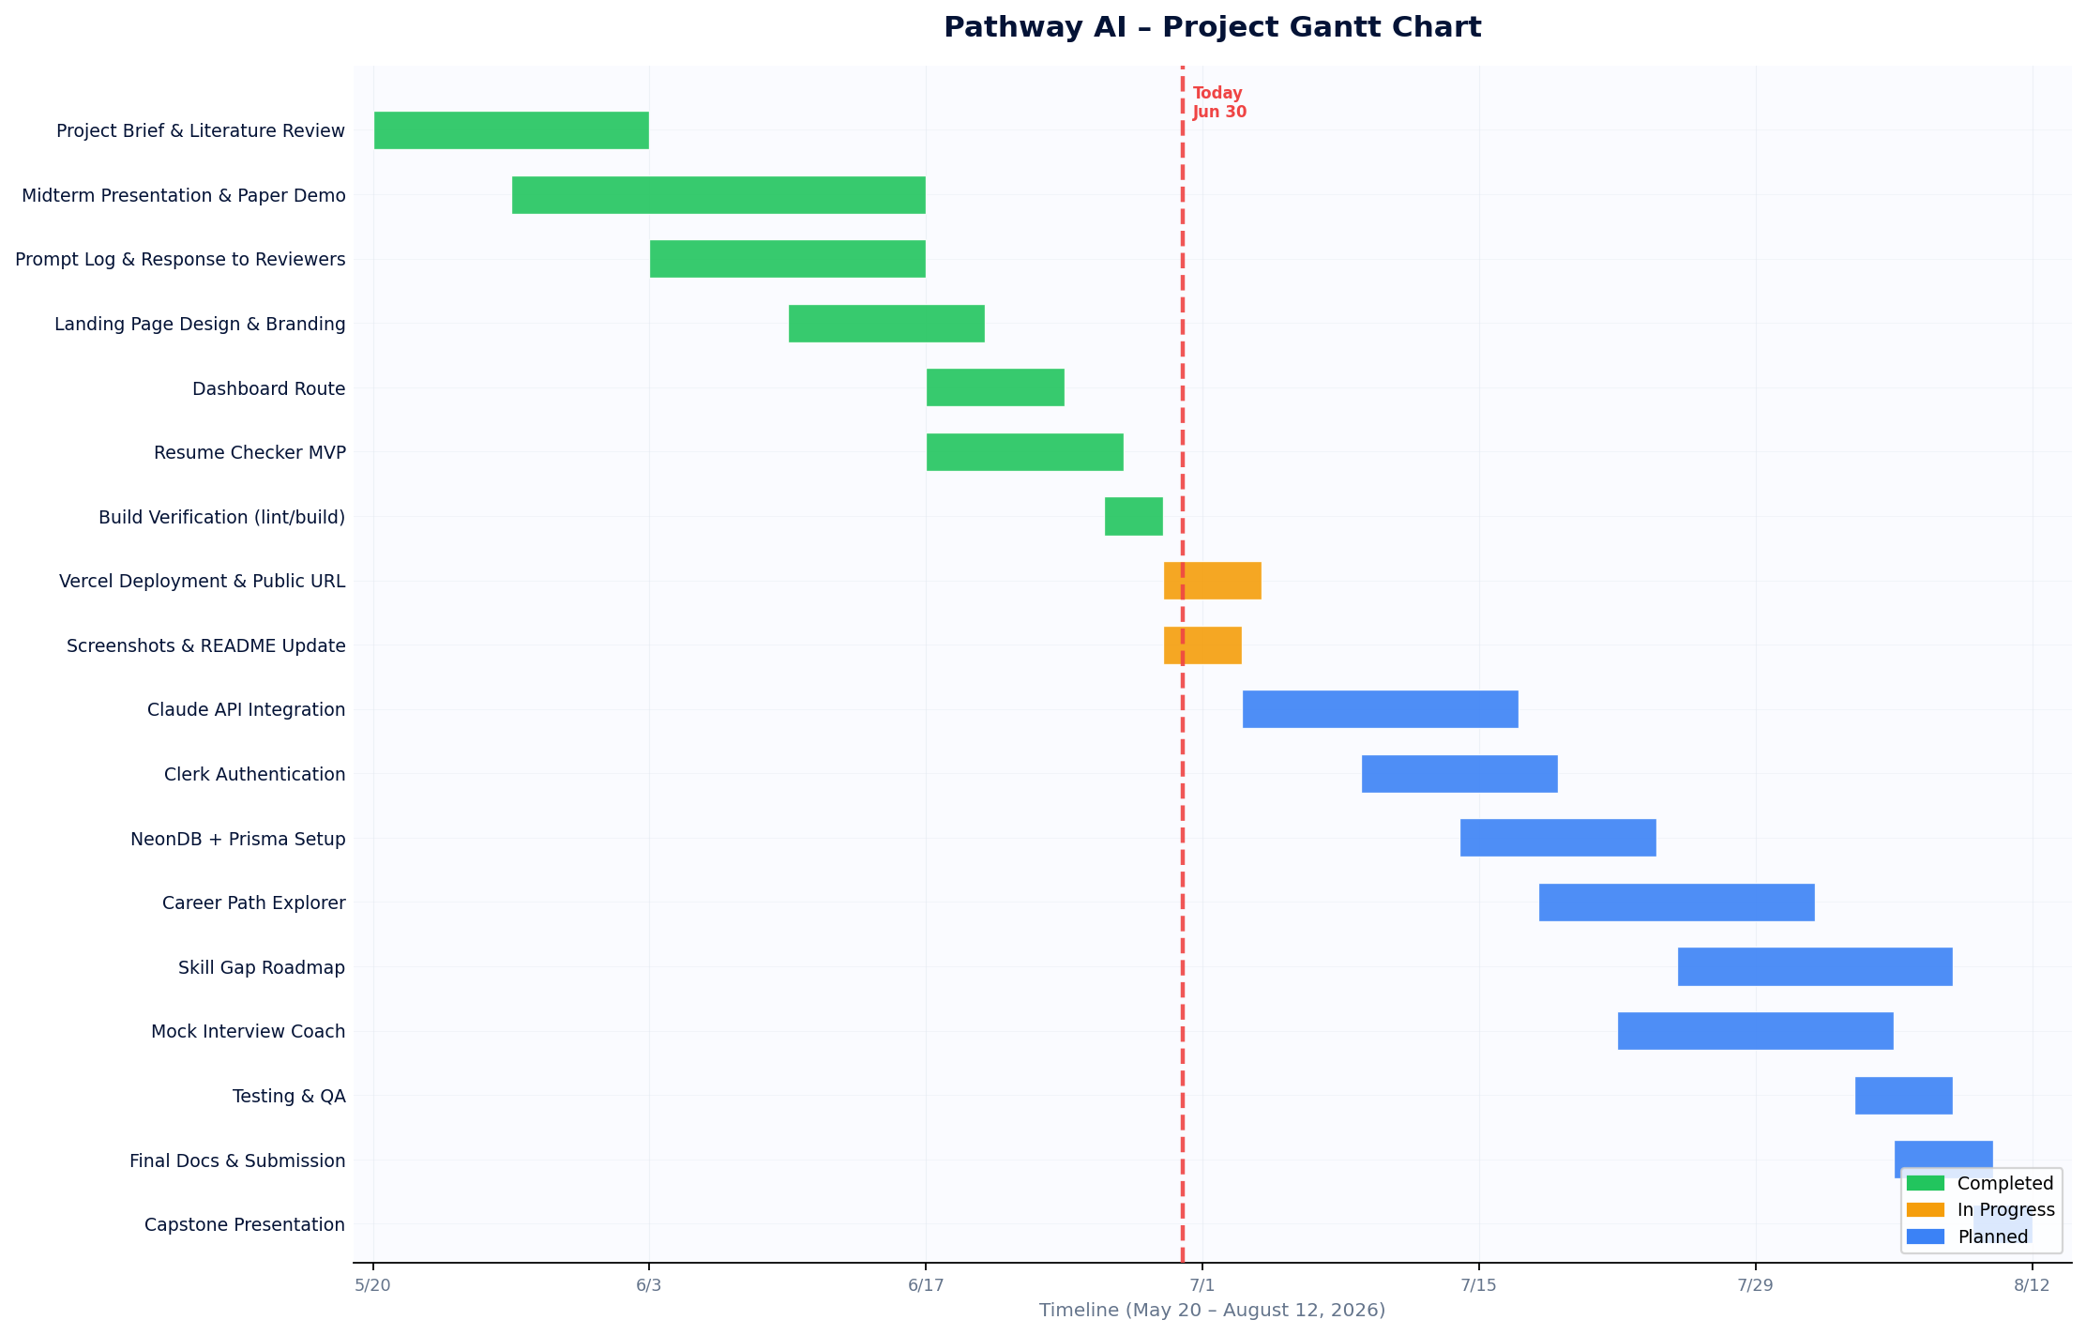
Figure 1. Pathway AI Gantt Chart — May 20 to August 12, 2026

3. Critical Path Analysis

The critical path is the sequence of dependent tasks that controls the final project delivery date. Any delay on the critical path directly delays the August 12 submission. Tasks not on the critical path have available slack.

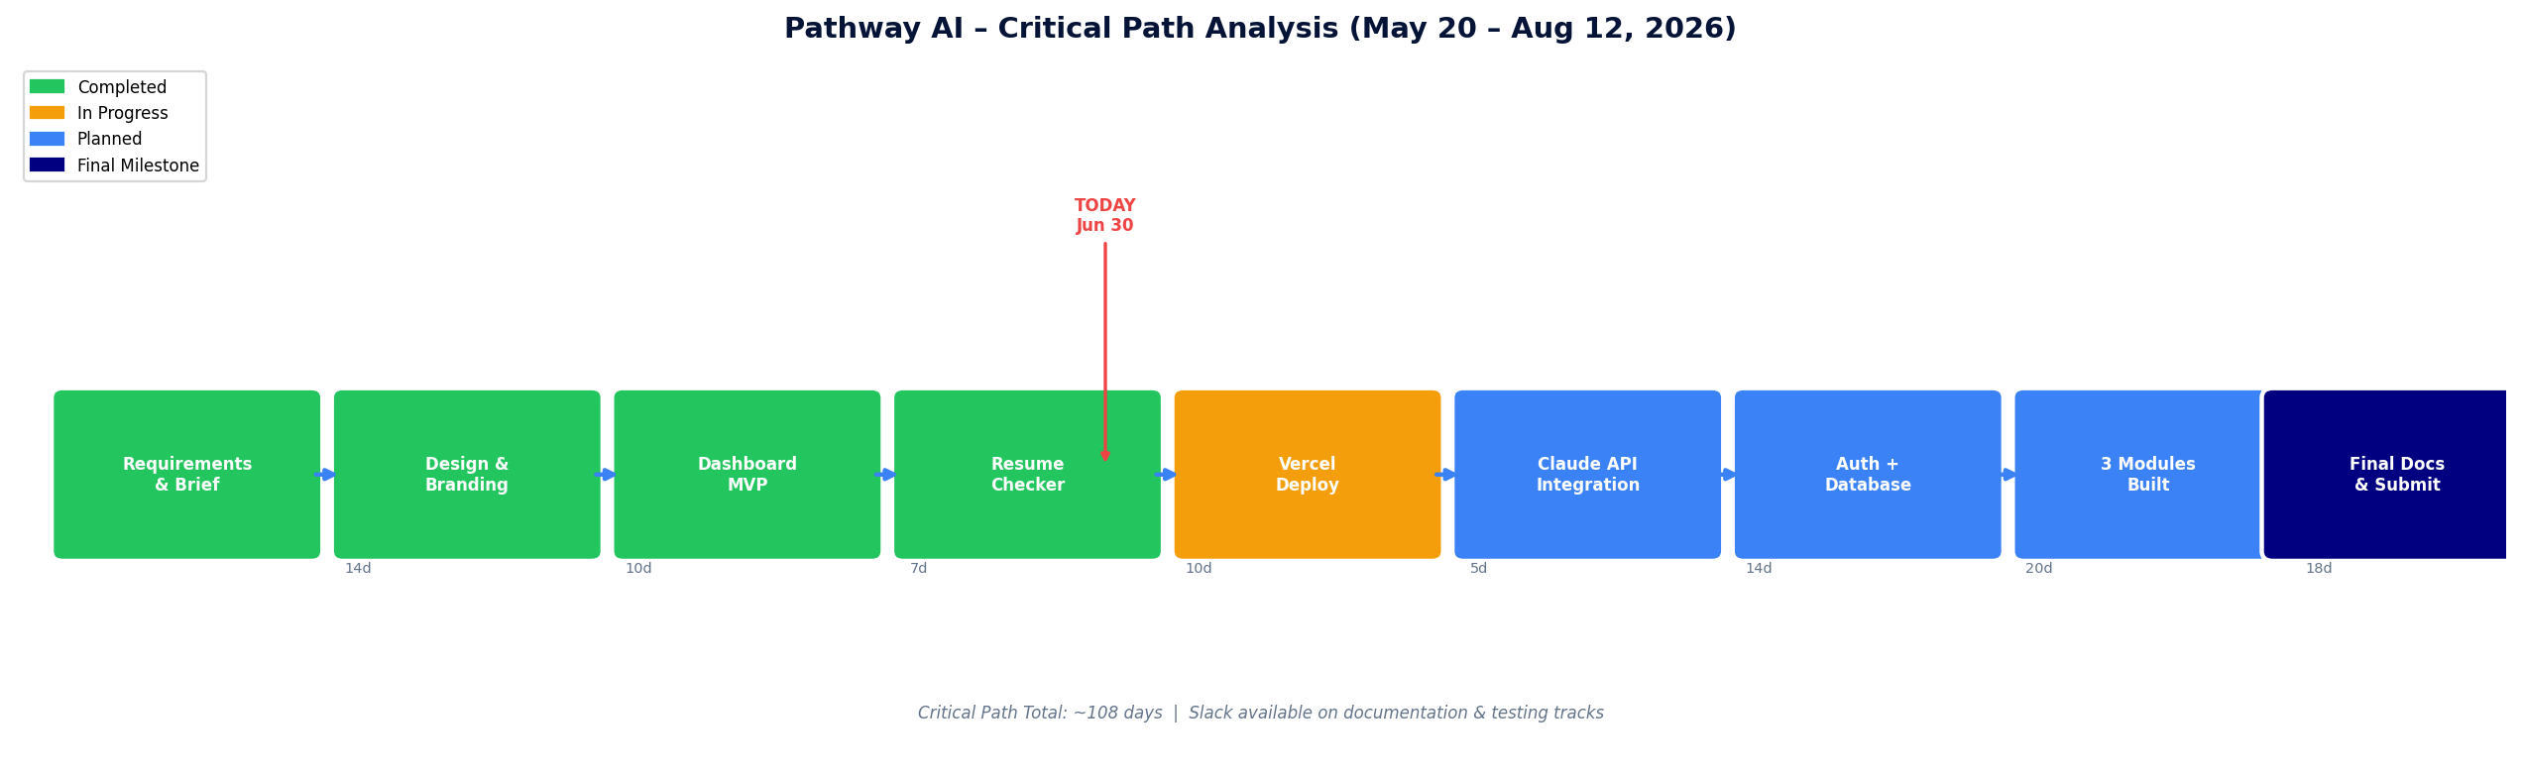
Figure 2. Pathway AI Critical Path — May 20 to August 12, 2026

Critical Path Sequence
- A Requirements & Brief (5d)
- C Design & Branding (8d)
- D Dashboard Route (5d)
- E Resume Checker MVP (8d)
- F Vercel Deployment (4d) ← In Progress
- G Claude API Integration (12d)
- H Authentication & Database (10d)
- K Mock Interview Coach (14d) ← Longest module
- L Final Documentation & Submission (8d)

Total critical path duration: approximately 74 expected days. The project window is 84 days, leaving approximately 10 days of total float available for risk mitigation.

4. PERT Estimate Table

Each task is estimated using three scenarios: Optimistic (O), Most Likely (M), and Pessimistic (P). The PERT expected time (te) is calculated as: te = (O + 4M + P) / 6.

ID | Task | O (days) | M (days) | P (days) | te (days) | Status
A | Requirements & Project Brief | 3 | 5 | 7 | 5.0 | Completed
B | Literature Review & Research | 5 | 7 | 10 | 7.2 | Completed
C | Design & Branding | 5 | 8 | 12 | 8.2 | Completed
D | Dashboard Route | 3 | 5 | 8 | 5.2 | Completed
E | Resume Checker MVP | 5 | 8 | 12 | 8.2 | Completed
F | Vercel Deployment | 2 | 4 | 7 | 4.2 | In Progress
G | Claude API Integration | 7 | 12 | 18 | 12.2 | Planned
H | Clerk Auth + NeonDB | 7 | 10 | 15 | 10.3 | Planned
I | Career Path Explorer | 7 | 12 | 18 | 12.2 | Planned
J | Skill Gap Roadmap | 7 | 12 | 18 | 12.2 | Planned
K | Mock Interview Coach | 10 | 14 | 21 | 14.5 | Planned
L | Final Documentation & Submission | 5 | 8 | 12 | 8.2 | Planned

O = Optimistic days | M = Most Likely days | P = Pessimistic days | te = PERT expected time

5. PERT Chart

The PERT chart maps all tasks as nodes in a dependency network spanning May 20 to August 12. Each node shows the task ID, name, and expected duration (te). Arrows represent dependencies — a task cannot begin until all upstream tasks are complete.

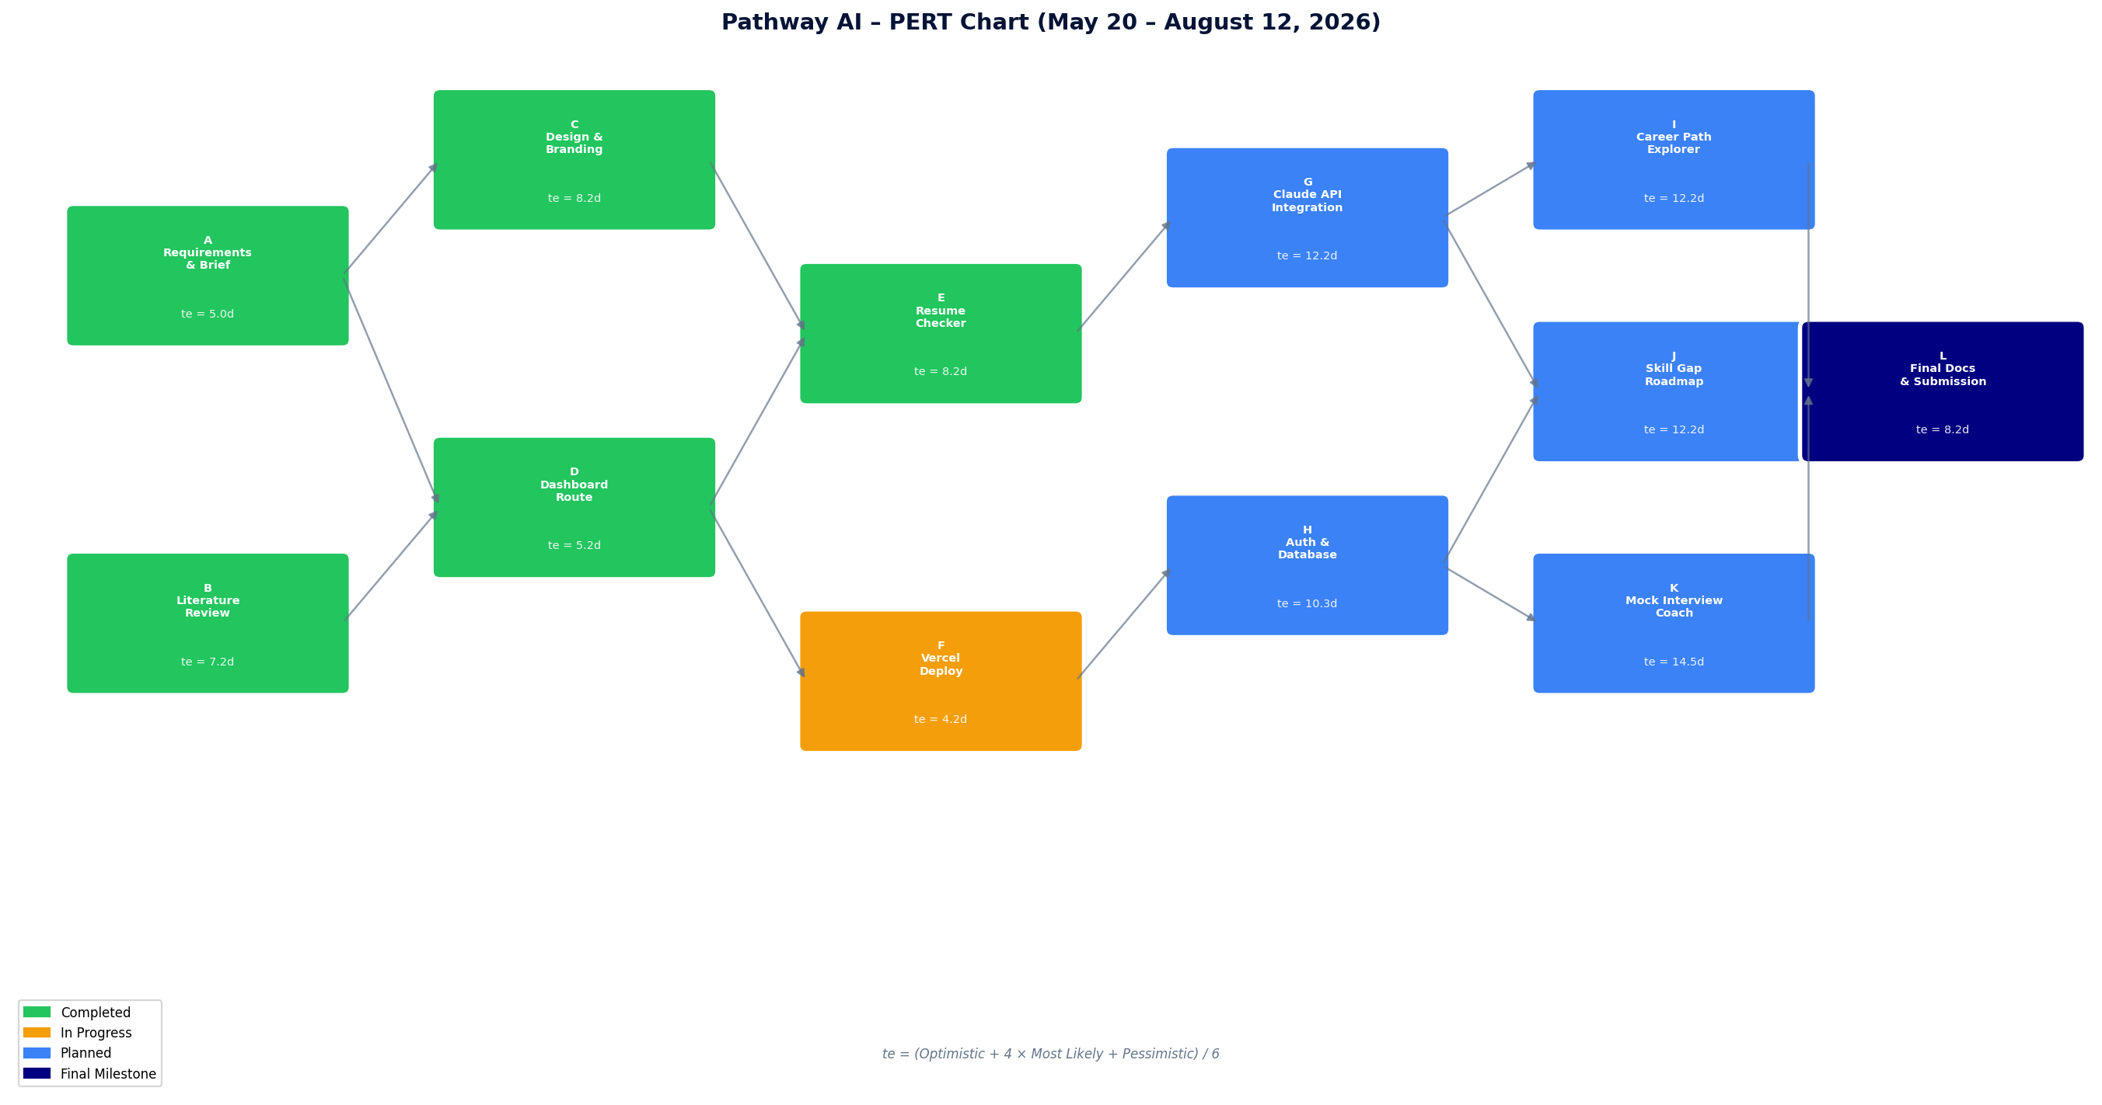
Figure 3. Pathway AI PERT Chart — May 20 to August 12, 2026

The network shows two parallel development tracks converging at the final submission: the frontend and AI integration track (A → C → E → G → I → L) and the infrastructure track (B → D → F → H → K → L). Both tracks must complete before the final documentation and submission milestone.

