PATHWAY AI
IST 440W Capstone Assignment
Enhancement & Implementation Report
Penn State University
Student: David Ademoye
Date: July 6, 2026
Live URL: https://pathway-aiapp.vercel.app
GitHub: https://github.com/Dave-ASC1/pathway-ai

1. Executive Summary
Pathway AI is a free career readiness platform for college students that combines four modules—Resume Checker, Career Path Explorer, Skill Gap Roadmap, and Mock Interview Coach—into a single integrated tool. This assignment documents the enhancement from a simple, locally-powered MVP to a fully AI-integrated platform using the Claude Opus 4.8 API.

Key Enhancement: Claude API Integration
All four modules now leverage Claude Opus 4.8 for intelligent, personalized analysis and guidance. Each module includes rate limiting and graceful local fallbacks to ensure reliability.

2. Comparative Analysis: Simple Phase vs. Enhanced Phase

2.1 Simple Phase (Initial MVP)
What Was Built:
- Landing page with 4-step journey visualization
- Dashboard with module navigation cards
- Resume Checker using local keyword-matching algorithm (no AI)
- Three placeholder modules (Career Path, Skill Gap, Interview Coach) with no functionality
Limitations:
- Deterministic keyword matching could not provide nuanced resume feedback
- Three modules were UI mockups only with no real guidance
- No integration between modules for data handoff
- No file upload support (resume text-only)

2.2 Enhanced Phase (AI-Powered)
What Was Added:
- Claude Opus 4.8 API integration across all 5 backend routes
- Four fully functional modules with intelligent AI analysis
- PDF/DOCX file upload capability for resumes
- Data handoff system (resume → career → roadmap → interview)
- Browser-based persistence (user progress saved automatically)
- Rate limiting and graceful fallback mechanisms
Improvements:
- Resume analysis now provides nuanced, contextual feedback from Claude, not just keyword matching
- Career Path Explorer generates 3 realistic career options tailored to student profile
- Skill Gap Roadmap creates prioritized learning plans with specific resources
- Mock Interview Coach generates role-specific questions and evaluates student responses

3. Architectural Enhancement Flowcharts
The following two diagrams illustrate the transformation from the simple phase to the enhanced phase with color-coded components showing the progression.

3.1 Simple Phase Architecture (Before Enhancement)
Color Legend: Red = Local/Limited • Gray = Placeholder • Blue = Functional
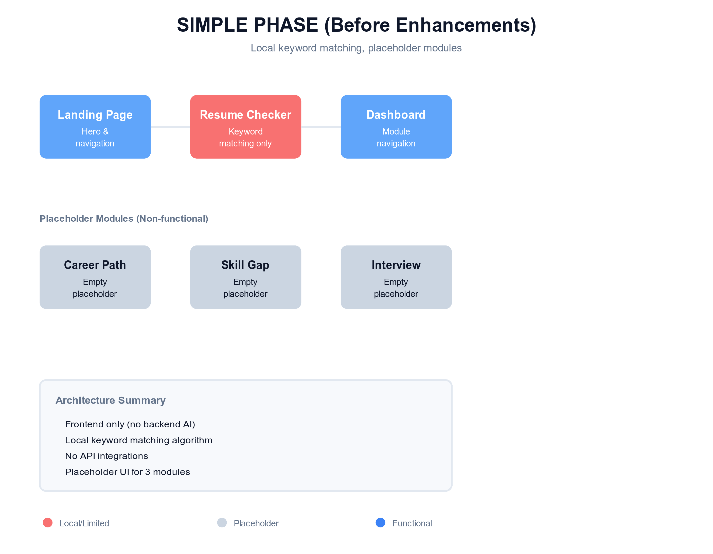

3.2 Enhanced Phase Architecture (After Enhancement)
Color Legend: Cyan = Claude AI Powered • Purple = Backend Integration • Blue = Functional UI
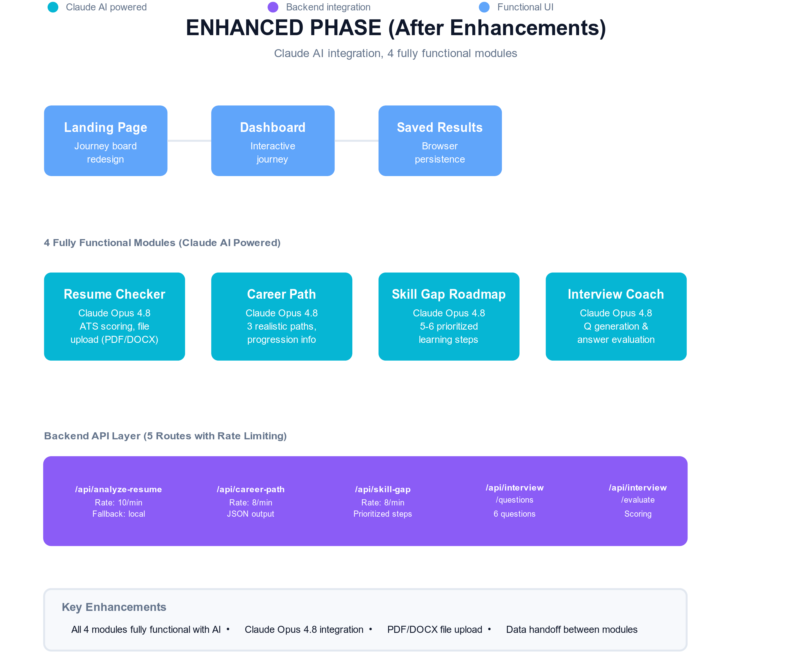

4. AI Prompts Used for Claude Integration

4.1 Resume Analysis Prompt
Purpose: Score a resume against a job description and provide actionable feedback

You are an expert ATS resume reviewer. Analyze the resume against the job description below. Return ONLY valid JSON with matched/missing keywords, section scores (Education, Experience, Projects, Skills, Impact), 3 strengths, and 3 specific improvements. Do not use em dashes; use commas, periods, or parentheses instead.

4.2 Career Path Explorer Prompt
Purpose: Generate 3 realistic career paths based on student profile

You are an experienced career advisor for college students. Based on the student profile (major, year, interests, target industries), suggest THREE realistic career paths. For each path, provide: job title, why it fits this student (2 sentences), 3-role progression trajectory, 5 required skills, and one concrete action the student can take this semester. Return only valid JSON. Keep tone natural, no em dashes.

4.3 Skill Gap Roadmap Prompt
Purpose: Create a prioritized learning roadmap to bridge skill gaps

You are an experienced career and learning coach for college students. Build a focused skill-gap roadmap from the student's current skills to a target role. Return JSON with: summary (honest gap assessment), haveSkills (relevant skills they already have), and steps (5-6 prioritized skills with why, resource type, time estimate, and priority level). Be realistic for a student. No em dashes.

4.4 Interview Questions Generator Prompt
Purpose: Generate role-specific interview questions (behavioral + technical mix)

You are an experienced hiring manager preparing interview questions. Based on the role or job description, write 6 realistic interview questions (mix of behavioral and technical). Behavioral questions explore real situations, teamwork, and problem solving. Technical questions fit the role and are answerable by a student or entry-level candidate. Return only JSON with questions and type. No em dashes.

4.5 Interview Answer Evaluator Prompt
Purpose: Score and provide feedback on interview practice answers

You are an experienced interview coach reviewing a candidate's practice answers for a role. Evaluate each answer honestly and constructively as if coaching a student. Return JSON with for each answer: score (0-100), strengths (1-2 sentences on what went well), missing (1-2 sentences on gaps), and modelAnswer (3-5 sentence strong example). For behavioral questions, reward STAR structure (Situation, Task, Action, Result). Keep tone encouraging. No em dashes.

5. Technical Implementation Details

5.1 Backend API Routes with Claude Integration
Endpoint | Purpose | Rate Limit | Fallback
POST /api/analyze-resume | ATS resume scoring & feedback | 10/min | Local keyword matching
POST /api/career-path | Generate career paths | 8/min | N/A (API required)
POST /api/skill-gap | Skill gap analysis & roadmap | 8/min | N/A (API required)
POST /api/interview/questions | Generate interview questions | 8/min | N/A (API required)
POST /api/interview/evaluate | Evaluate interview answers | 6/min | N/A (API required)

5.2 Technology Stack
Next.js 16 (App Router) / React 19 / TypeScript / Tailwind CSS 4 / Anthropic SDK (@anthropic-ai/sdk v0.107.0)

6. Results & Success Metrics

6.1 What Works Today
- All 4 modules are fully functional with AI-powered guidance
- Resume Checker: Accepts text input or PDF/DOCX uploads; provides ATS scores and contextual feedback
- Career Path Explorer: Generates 3 realistic career paths with 5-10 year progression
- Skill Gap Roadmap: Creates 5-6 prioritized learning steps with specific resources and time estimates
- Mock Interview Coach: Generates 6 role-specific questions and evaluates student responses with scores 0-100
- Data handoff system carries resume skills to roadmap and role info to interview coach
- Browser-based persistence saves all results automatically as users navigate
- Live on Vercel at https://pathway-aiapp.vercel.app with no authentication required

6.2 Build & Deploy Status
- npm run lint: PASS
- npm run build: PASS (19 static routes, 7 dynamic API routes)
- Vercel deployment: LIVE (no authentication required)

7. Enhancement Narrative
The transformation from simple to enhanced was driven by a single insight: local keyword matching cannot provide the personalized, contextual guidance that students actually need. The upgrade involved integrating Claude Opus 4.8 across all four modules.

For the Resume Checker, the system now reads the resume holistically, understands context, and provides nuanced feedback. Instead of simply listing missing keywords, Claude explains why those keywords matter for the role and suggests concrete ways to address them.

For Career Path, Skill Gap, and Interview Coach, the enhancement meant building them from scratch with Claude. Each module now delivers real, personalized guidance instead of placeholder UI.

The system also implements intelligent data handoff: a resume uploaded to the checker automatically carries its skills to the roadmap module, and a career path selected carries the target role to the interview module. This transforms the tool from four separate features into one integrated journey.

8. Conclusion
Pathway AI has evolved from a simple MVP with keyword matching to a fully AI-powered career readiness platform. The integration of Claude Opus 4.8 across all four modules has transformed the tool from a UI mockup into a genuine source of personalized guidance for college students.

The app is live, builds successfully, and demonstrates the full scope of the IST 440W capstone project. Future work would include database persistence, user authentication, and enhanced analytics to track student outcomes.

