Pathway AI Implementation Document
Completed MVP: Landing Page, Dashboard, Resume Checker, and Submission Documentation
Project | Pathway AI
Implementation status | Working MVP completed and pushed to public GitHub repository
Primary routes | /, /dashboard, /resume-checker
GitHub repository | https://github.com/Dave-ASC1/pathway-ai

1. Implementation Summary
Pathway AI is a student career readiness platform built to help students move from career confusion to a clearer preparation plan. The completed MVP includes a polished public landing page, a dashboard workspace, and a local ATS-style resume checker that compares resume text against a target job description.
The resume checker is intentionally dependency-light for the course submission. It runs locally without external API keys, which supports the requirement that the code can run on a separate computer without the developer's help.

2. Completed Implementation Details
- Landing page: Presents Pathway AI branding, value proposition, student journey, core modules, and responsible AI messaging.
- Dashboard: Provides a workspace view with readiness summary cards, module status cards, and the student operational journey.
- Resume checker: Accepts resume text and job description text, then returns match score, matched keywords, missing keywords, section checks, strengths, and recommended improvements.
- Documentation: Includes AI prompt log, implementation details, functional decomposition, design flow, operational flow, Gantt chart, critical path analysis, and PERT chart.
- GitHub packaging: Includes README instructions so another computer can clone, install, build, and run the app.

3. Functional Decomposition - Level 0
Level 0 shows the major Pathway AI system areas that are either implemented in the MVP or documented as planned modules.
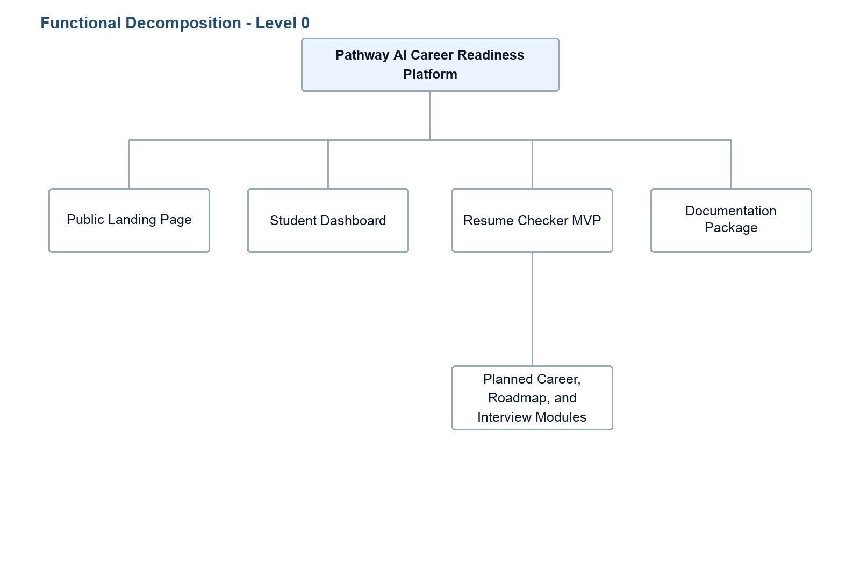
Figure 1. Level 0 functional decomposition for Pathway AI.

4. Functional Decomposition - Level 1
Level 1 expands each major system area into the specific functions completed for the MVP submission.
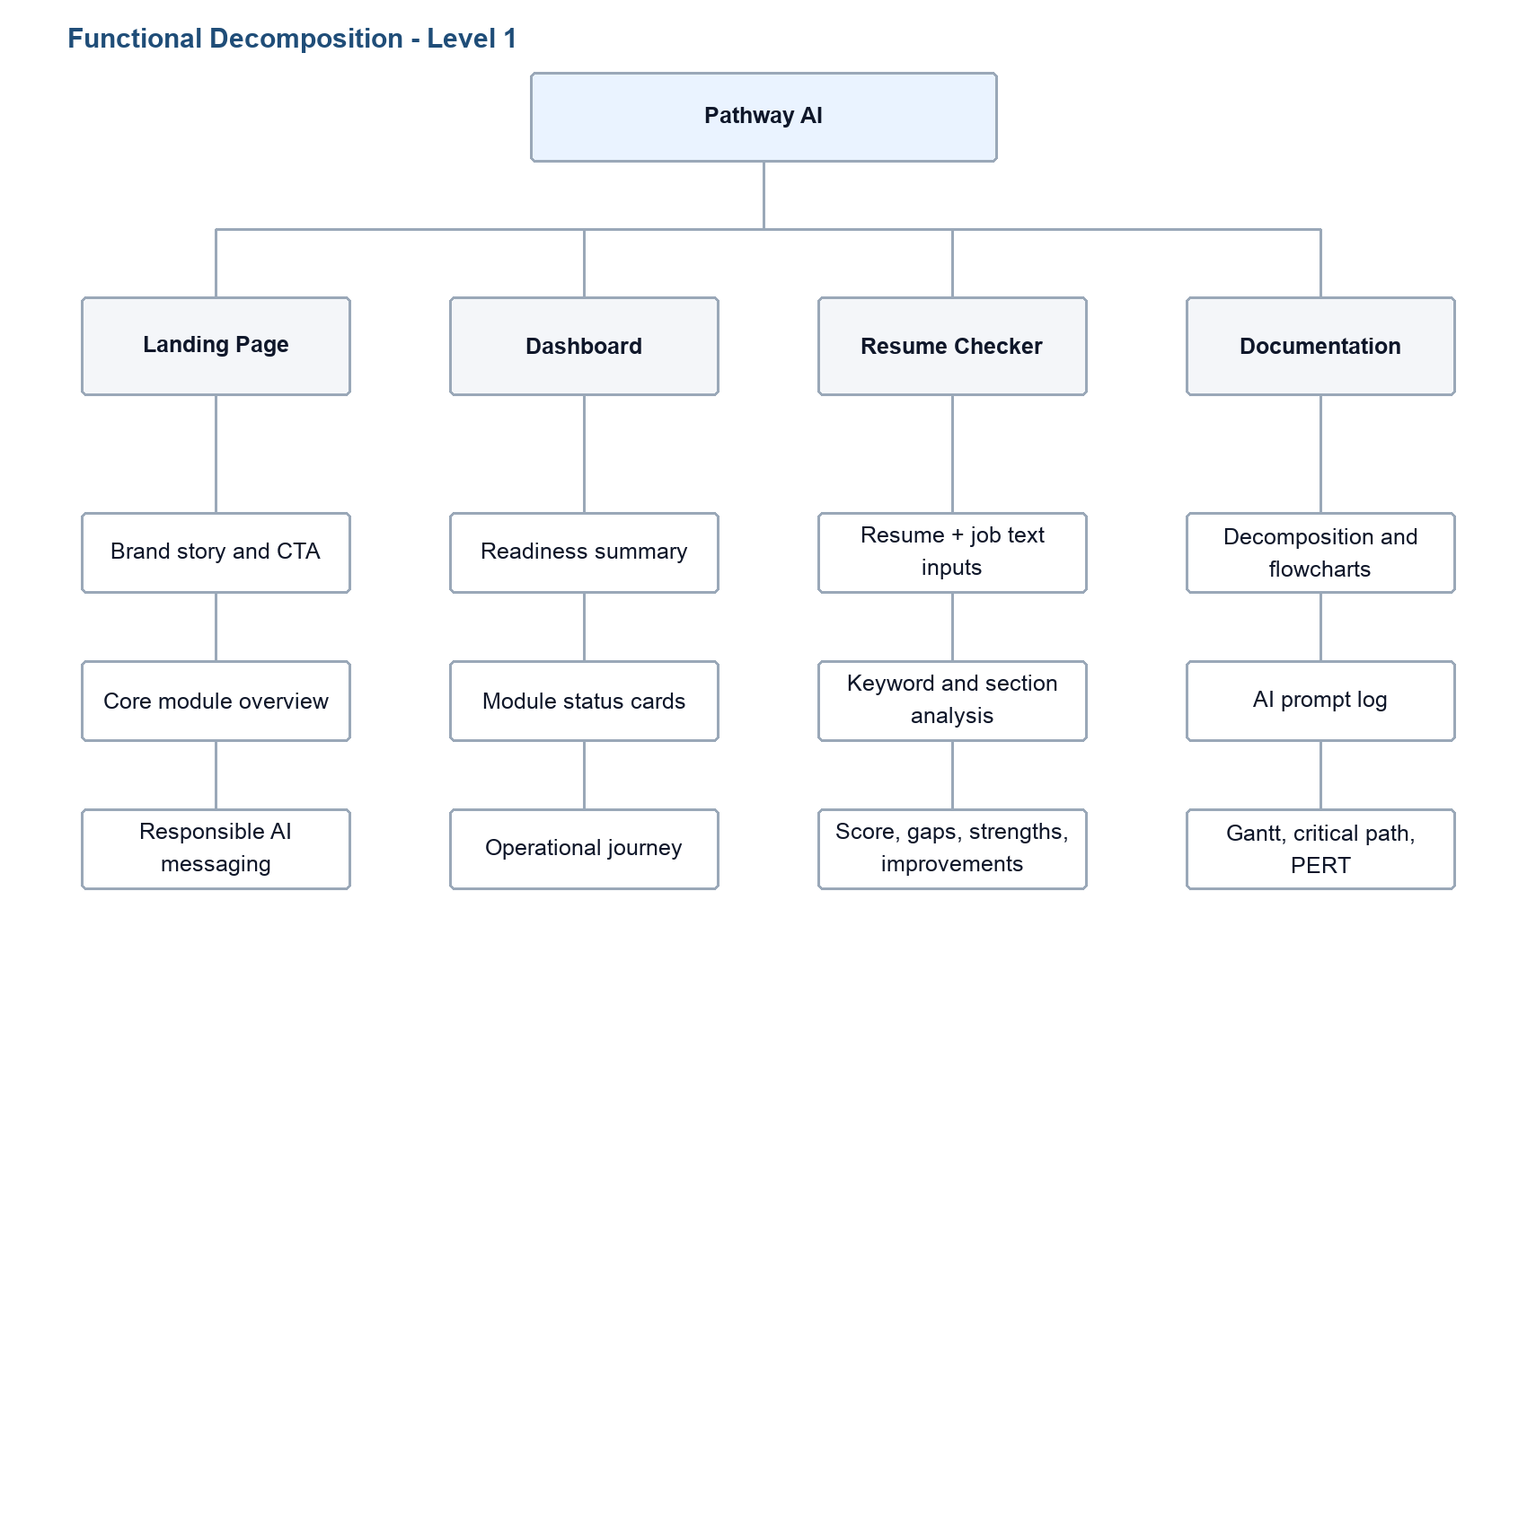
Figure 2. Level 1 functional decomposition showing completed implementation functions.

5. Design Flow Chart - Technical Design
The technical flow shows how the Next.js app routes connect to the dashboard and resume checker logic. The resume checker performs the core MVP analysis locally in the browser.
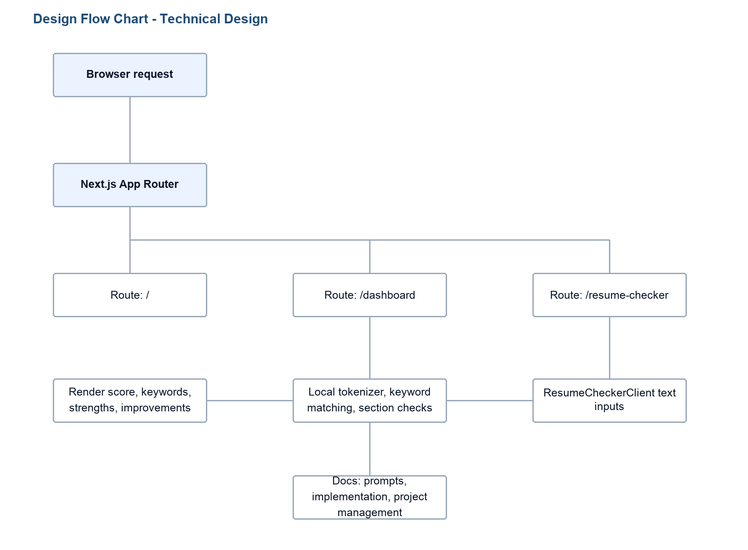
Figure 3. Technical design flow for the Pathway AI MVP.

6. Operational Flow Chart - User Point of View
The operational flow shows how a student experiences the platform from the landing page through resume feedback.
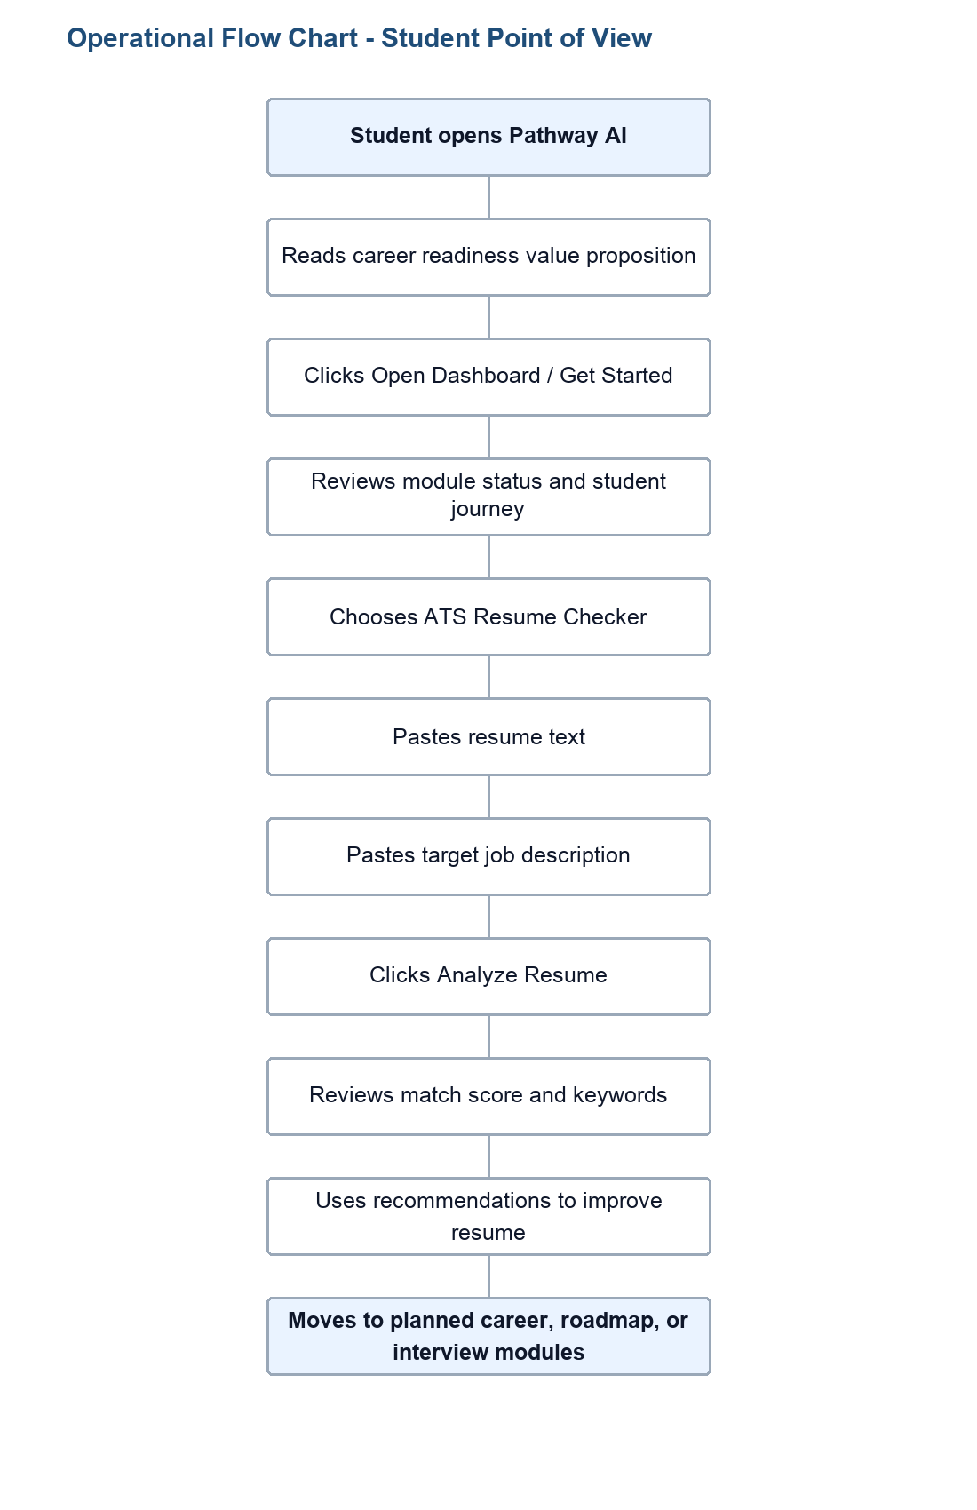
Figure 4. User operational flow for the Pathway AI MVP.

7. Verification Evidence
The implementation was verified with the following local commands:
- npm install completed successfully.
- npm run lint completed without lint errors.
- npm run build completed successfully.
- The production build listed the implemented routes: /, /dashboard, and /resume-checker.

8. Remaining Future Work
- Add authentication for student accounts.
- Add database persistence for saved resumes, feedback, and progress.
- Connect AI-generated analysis through a secure server-side route.
- Build full Career Path Explorer, Skill Gap Roadmap, and Mock Interview Coach modules.
- Add resume PDF/DOCX upload and parsing.

