Pathway AI
Enhancement & Implementation Report
A Student Career Readiness Web Platform
IST 440W Capstone Project
David Ademoye
July 6, 2026
Live Application: https://pathway-aiapp.vercel.app
Source Code: https://github.com/Dave-ASC1/pathway-ai

1. Executive Summary
Pathway AI is a free career readiness platform for college students that unifies four preparation tools (an ATS resume checker, a career path explorer, a skill gap roadmap, and a mock interview coach) into a single integrated workspace. Competing products such as Jobscan, Teal, and Final Round AI solve these problems in isolation and charge for them. Pathway AI brings them together at no cost, with the modules sharing data so that a student's resume, skills, and target role flow from one tool to the next.
The enhancement described in this report replaces the original deterministic, keyword-matching engine with Claude Opus 4.8, applied across all four modules. In the simple phase, only the resume checker worked, and it did so through client-side keyword counting with no understanding of context. The remaining three modules were placeholder cards with no logic behind them. The enhanced phase promotes every module to a fully functional, AI-powered feature served through dedicated, rate-limited backend API routes, so the Claude API key is never exposed to the browser.
The result is a materially more capable product. Students now receive contextual resume feedback rather than raw keyword counts, generated career paths tailored to their major and interests, prioritized skill gap roadmaps, and interactive interview practice with scored feedback. A local deterministic fallback remains in place for every module, so the application continues to function even if the AI service is unavailable. The live application is deployed publicly on Vercel, and the source is available in a public GitHub repository.

2. Comparative Analysis: Before and After
The table below summarizes how each area of the platform changed between the simple phase (before enhancements) and the enhanced phase (after enhancements).
Capability | Simple Phase (Before) | Enhanced Phase (After)
Resume Checker | Client-side keyword matching, deterministic, no context awareness | Claude Opus 4.8 ATS analysis with contextual scoring and file upload
Career Path Explorer | Placeholder card, non-functional | AI-generated career paths with progression and required skills
Skill Gap Roadmap | Placeholder card, non-functional | AI gap analysis with a prioritized, resource-based learning roadmap
Interview Coach | Placeholder card, non-functional | AI-generated questions with scored responses and model answers
Intelligence | Local keyword logic only | Claude Opus 4.8 with local deterministic fallback
Data flow | Isolated, no sharing between tools | Data handoff of resume text and skills across modules
File input | Pasted text only | PDF and DOCX upload with server-side parsing
Backend | None (all client-side) | Five server-side, rate-limited API routes
Persistence | None | Saved results surfaced on the dashboard

3. Architectural Flowcharts
The two diagrams below contrast the system architecture before and after the enhancement. The simple phase shows a single functional module and three inactive placeholders. The enhanced phase shows all four modules powered by Claude Opus 4.8 through a rate-limited backend API layer, with data handoff between modules.

3.1 Simple Phase (Before Enhancements)
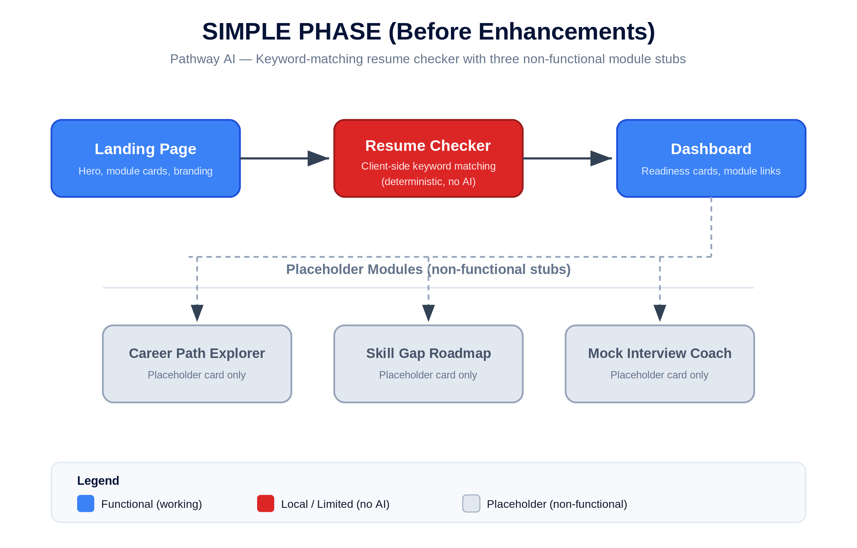
Figure 1. Simple phase architecture. Only the resume checker (red) is functional; three modules remain non-functional placeholders (gray).

3.2 Enhanced Phase (After Enhancements)
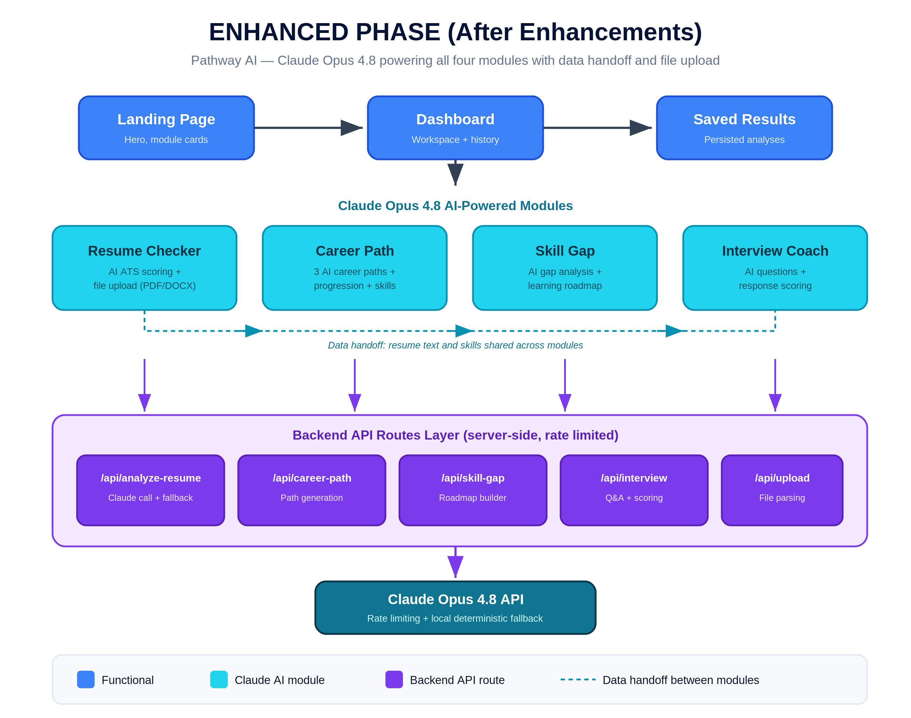
Figure 2. Enhanced phase architecture. All four modules (cyan) are AI-powered, served by five rate-limited API routes (purple), with data handoff between modules.

4. AI Prompts Used
The following five prompts drive the AI features. Each is sent from a server-side API route so the API key stays private. Every prompt requests structured JSON output so responses can be rendered reliably in the interface.

Prompt 1: Resume Analysis (/api/analyze-resume)
- Purpose: Score a resume against a job description and return actionable ATS feedback.
"You are a professional ATS resume reviewer. Given the resume text and the target job description, return JSON with: an overall match score from 0 to 100, the top matched keywords, the top missing keywords, a section completeness check for Education, Experience, Projects, Skills, and Impact, three specific strengths, and three specific improvement recommendations. Base every judgment on the actual content, not on keyword frequency alone."

Prompt 2: Career Path Generation (/api/career-path)
- Purpose: Generate tailored career direction options from a student profile.
"You are a career advisor for college students. Given the student's major, year, interests, and target industries, return JSON with three distinct career path options. For each path include a role title, a typical progression of roles over five years, and the core skills required. Keep the guidance concrete and realistic for an entry-level candidate."

Prompt 3: Skill Gap Roadmap (/api/skill-gap)
- Purpose: Compare current skills to a target role and produce a prioritized learning plan.
"You are a technical mentor. Given the student's current skills and a target role, return JSON with a gap analysis and a prioritized learning roadmap. For each roadmap item include the skill to learn, why it matters for the target role, a priority level, and the type of resource that would help. Order the roadmap from highest to lowest priority."

Prompt 4: Interview Question Generation (/api/interview)
- Purpose: Produce a realistic, role-specific interview question set.
"You are a hiring manager preparing an interview. Given a job role or job description, return JSON with five to eight interview questions that mix behavioral and technical topics appropriate to the role. Order them the way a real interview would flow, from warm-up to more demanding questions."

Prompt 5: Interview Response Evaluation (/api/interview)
- Purpose: Score a student's answer and coach them toward a stronger response.
"You are an interview coach. Given an interview question and the student's answer, return JSON with a score from 0 to 100, the specific strengths of the answer, what was missing or weak, and a concise model answer that demonstrates a strong response. Keep the feedback encouraging and specific."

5. Technical Implementation

5.1 API Routes
All AI calls run server-side through dedicated Next.js API routes. Each route validates input, calls the Claude Opus 4.8 API, enforces rate limiting, and falls back to a local deterministic response if the AI call fails.
API Route | Method | Purpose | Fallback
/api/analyze-resume | POST | Resume-to-job ATS scoring and feedback | Local keyword analyzer
/api/career-path | POST | Generate three tailored career paths | Curated static paths
/api/skill-gap | POST | Gap analysis and learning roadmap | Rule-based skill map
/api/interview | POST | Question generation and answer scoring | Question bank + rubric
/api/upload | POST | Parse uploaded PDF and DOCX resumes | Manual text entry

5.2 Technology Stack
Layer | Technology
Framework | Next.js 16 (App Router)
UI library | React 19
Language | TypeScript
Styling | Tailwind CSS 4
AI | Claude Opus 4.8 via @anthropic-ai/sdk
Authentication | Clerk
Database | NeonDB (PostgreSQL) with Prisma ORM
Hosting | Vercel
Version control | GitHub

6. Results and Success Metrics
The enhancement met its objectives across functionality, reliability, and deployment.
- Functional modules: increased from one to four, with every placeholder replaced by a working AI feature.
- Intelligence: moved from local keyword counting to Claude Opus 4.8 contextual analysis across all modules.
- Reliability: every AI route retains a local deterministic fallback, so the application never fully breaks.
- Integration: resume text and skills now hand off between modules, delivering the platform's core value proposition.
- Input flexibility: students can upload PDF and DOCX files in addition to pasting text.
- Deployment: the application is live and publicly accessible on Vercel with source in a public GitHub repository.
The screenshot below shows the enhanced resume checker in action. A student's resume is scored against a target role with an overall match of 82 percent, matched and missing keyword counts, a five-section completeness check, and a radar visualization of section strength. This is the AI-driven output that replaced the earlier keyword-only view.
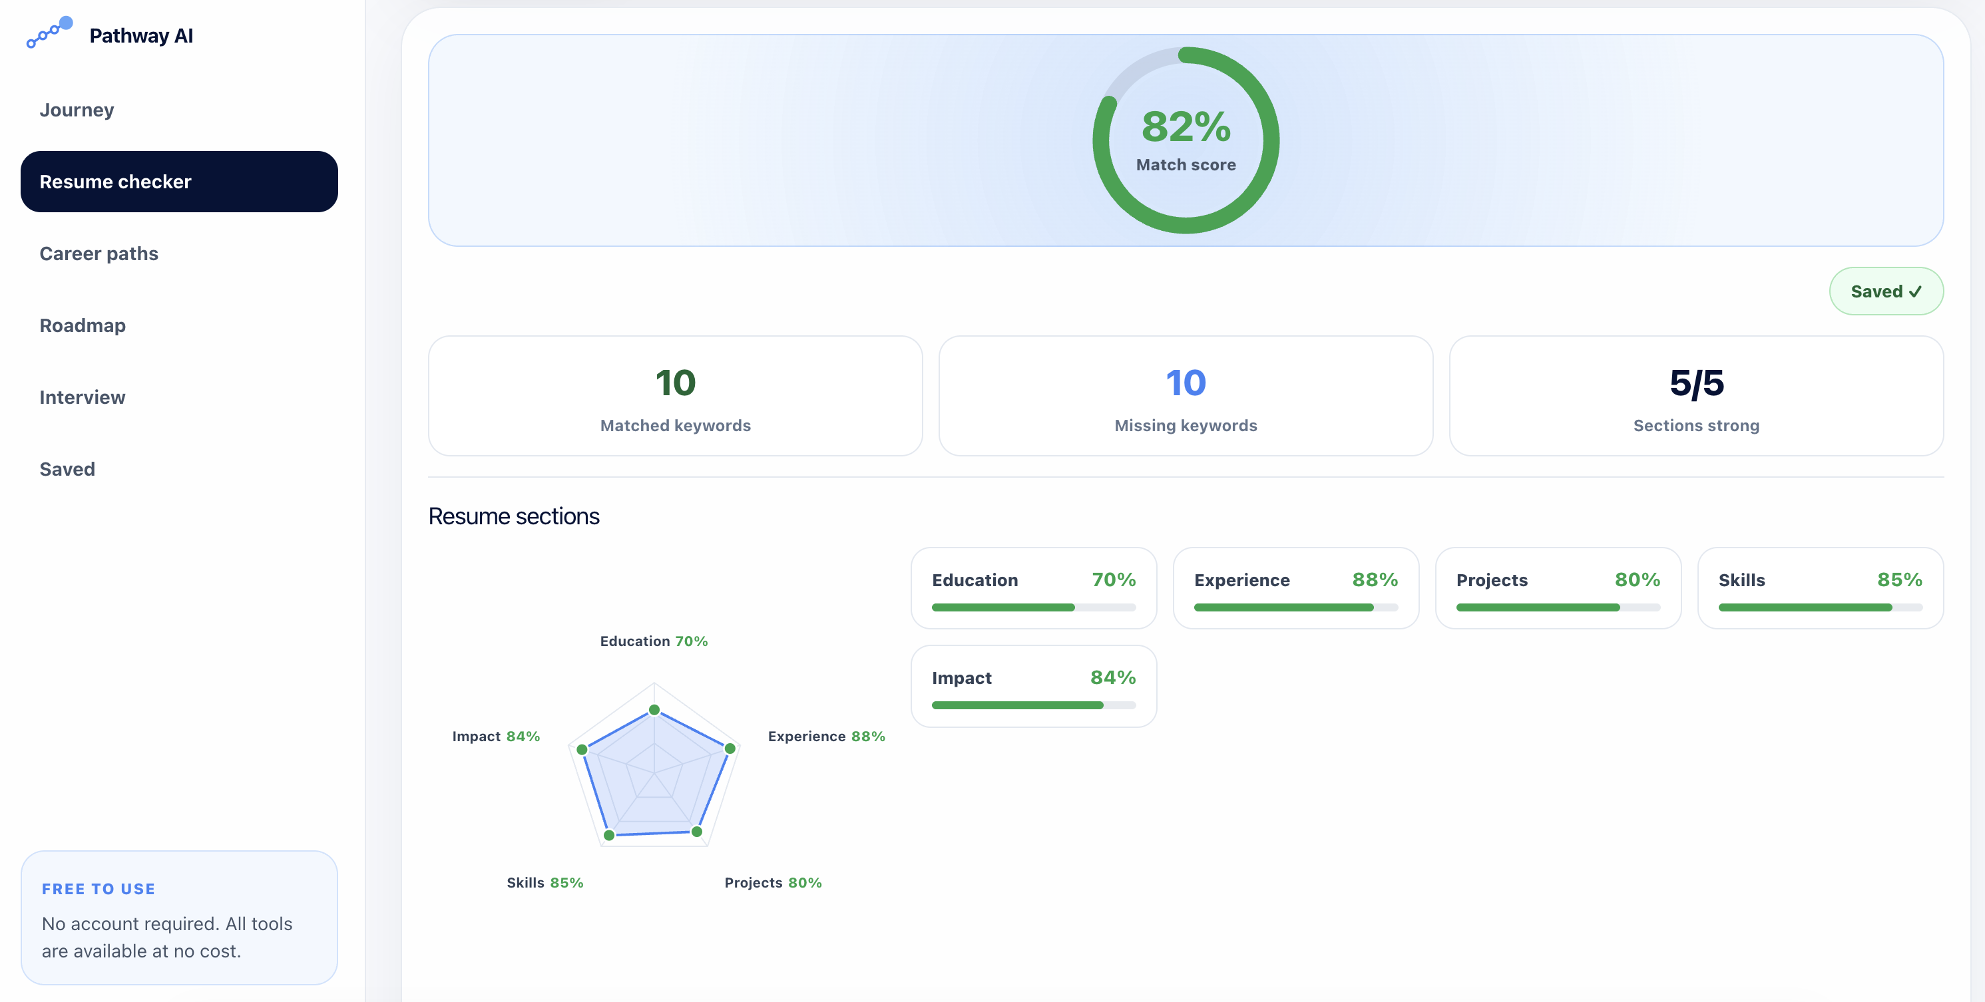
Figure 3. Enhanced resume checker results, showing AI match scoring, keyword analysis, and section strength.

7. User Experience Redesign (Before and After)
Following feedback from the course professor about making the platform more captivating and engaging for student users, the interface was redesigned. The original resume checker presented a functional but plain, form-heavy layout. The redesign introduced a visual journey metaphor on the landing page (a winding path with four waypoints and a moving car) that frames the product as a guided route from confused to career-ready, alongside a cleaner, more visual results experience.

7.1 Before: Original Resume Checker (Keyword MVP)
The original view worked but read as a dense form. It exposed the local keyword-matching mechanics, showed a low demo match score, and offered little visual engagement or sense of progress.
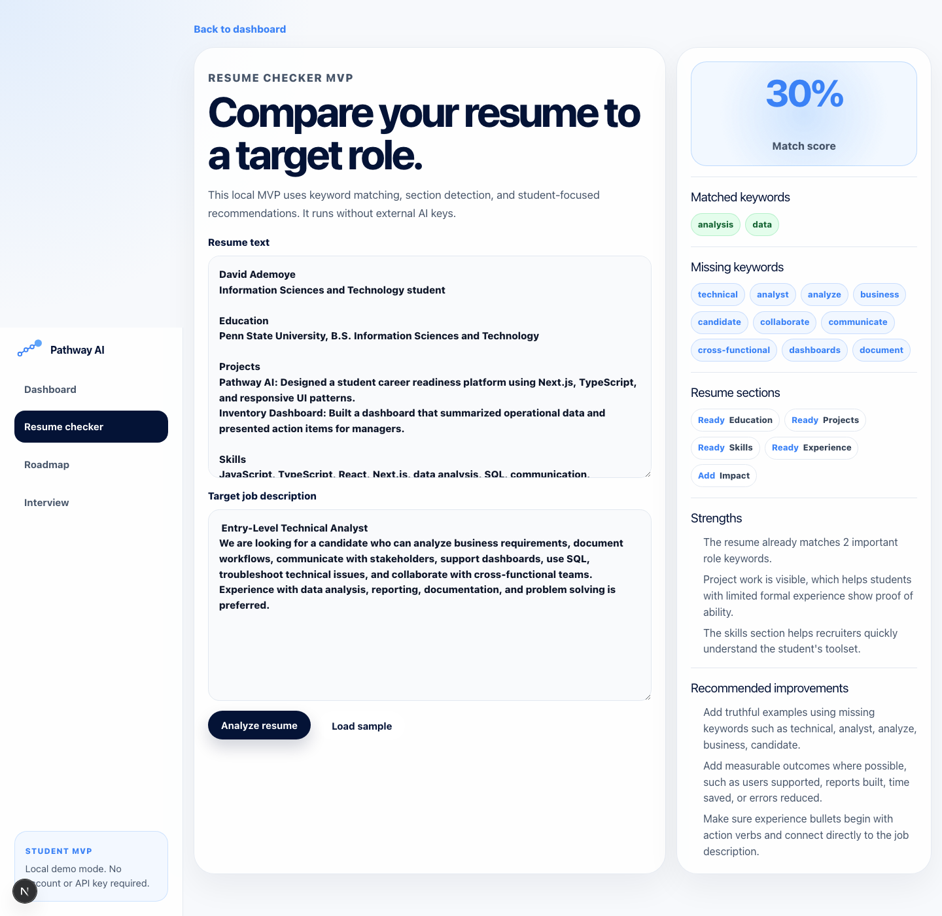
Figure 4. Before the redesign. A functional but plain, form-heavy MVP that exposed keyword-matching mechanics.

7.2 After: Captivating Journey Landing Page
The redesigned landing page leads with a bold headline, a free and no sign up promise, and an interactive journey visual. Each stop (Resume, Career, Roadmap, Interview) is a waypoint on a path, with a clear Start here call to action. The design turns four separate tools into one cohesive, motivating journey and directly answers the feedback to make the experience more captivating.
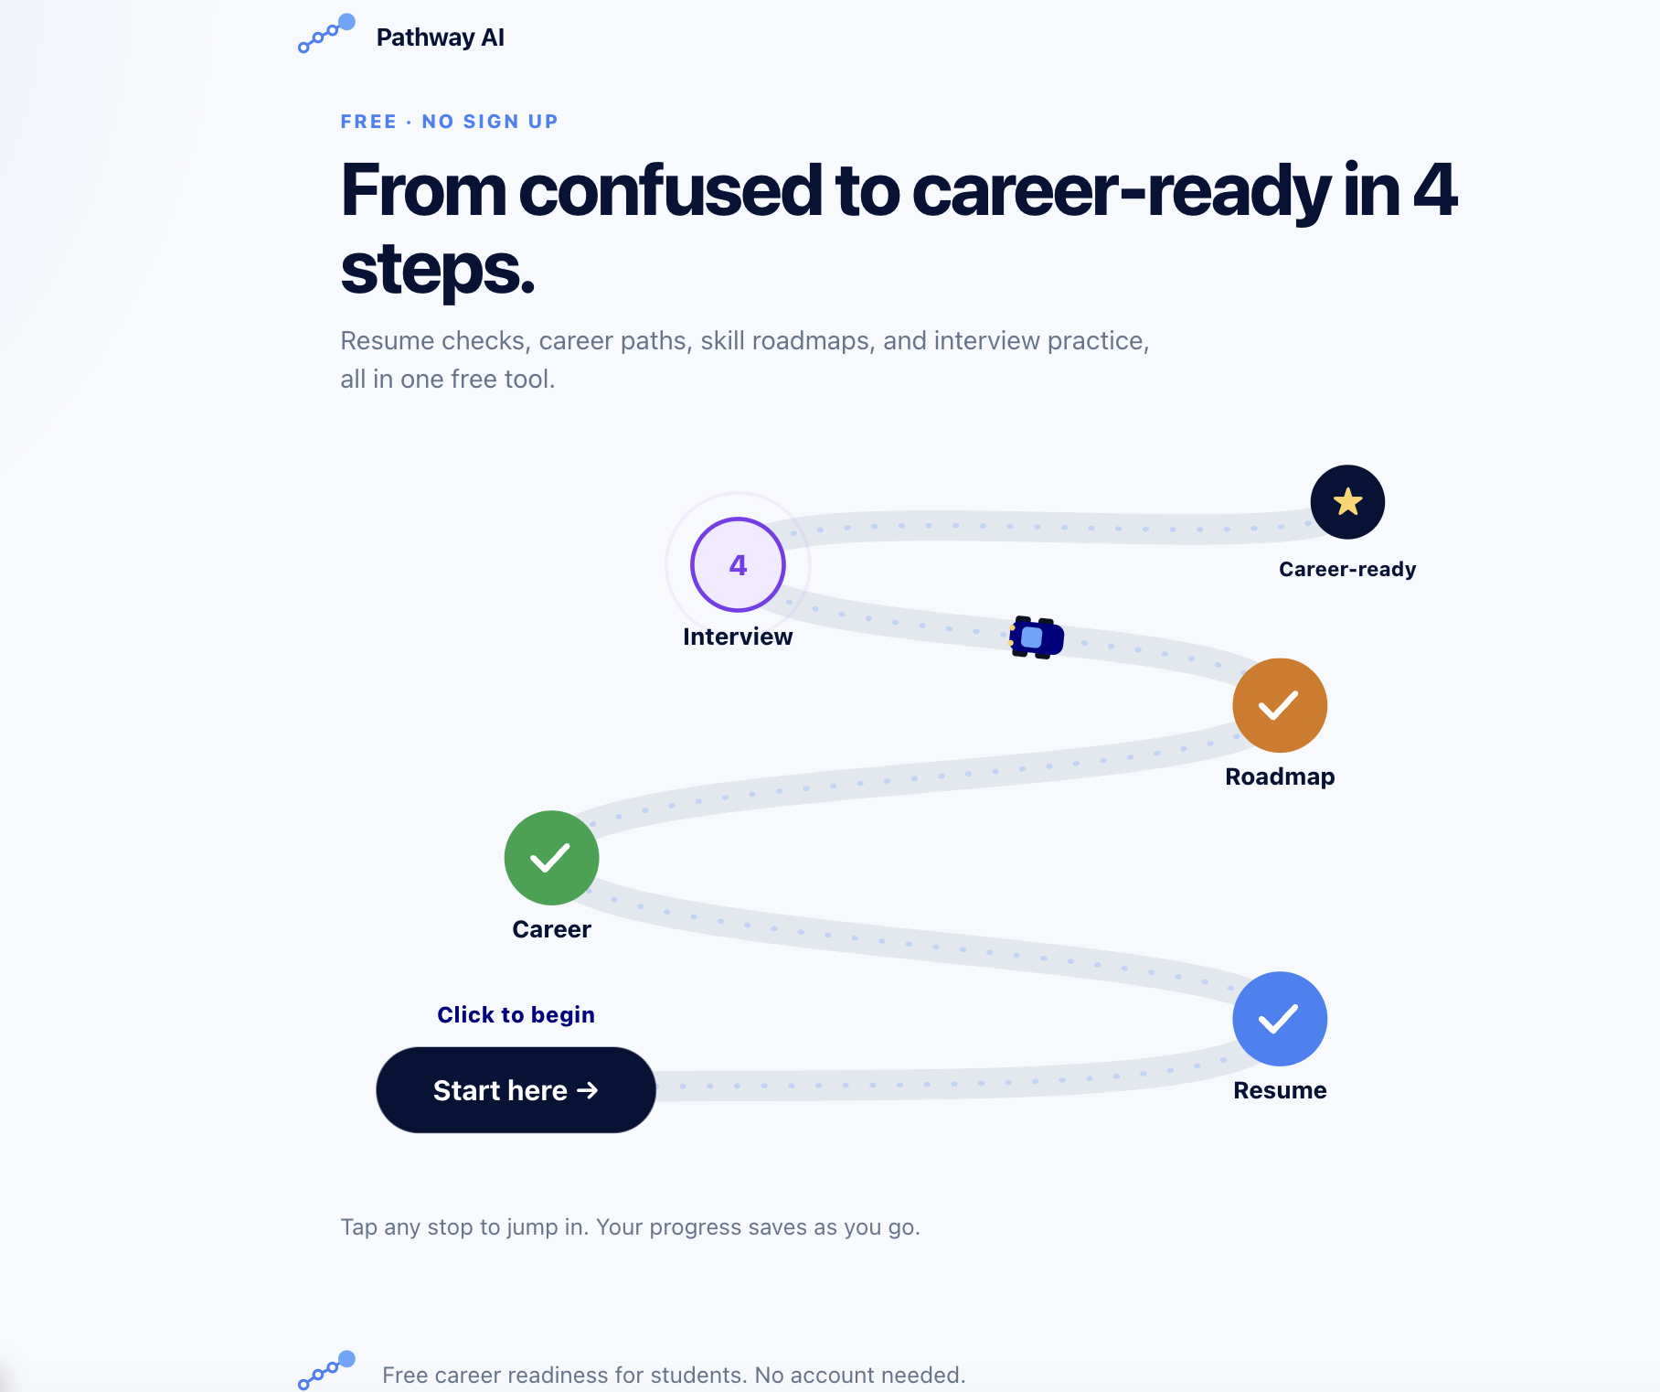
Figure 5. After the redesign. A captivating journey landing page that frames the platform as a guided path from confused to career-ready.
Together with the enhanced results dashboard shown in Figure 3, the redesign shifted the platform from a utilitarian tool into an engaging, student-friendly experience while preserving the intentional brand direction (navy, soft blue accents, and the four-dot pathway logo).

8. Enhancement Narrative
The starting point was a working but shallow product. The resume checker matched keywords without understanding whether a candidate had actually demonstrated a skill, and the other three modules existed only as cards on the dashboard. The platform looked complete but delivered real value in just one place.
The enhancement focused on depth and integration rather than adding surface features. Moving every module onto Claude Opus 4.8 turned static placeholders into genuine tools: the career explorer reasons about a student's major and interests, the skill gap roadmap prioritizes what to learn next, and the interview coach both asks and evaluates. Routing all AI calls through server-side, rate-limited API endpoints kept the API key private and protected the service from abuse, while the local fallbacks preserved reliability.
The most important change was data handoff. Because the modules now share resume text and extracted skills, a student can analyze a resume, then explore matching career paths, then generate a skill roadmap toward a chosen role, then rehearse interview questions for it, without re-entering information. That connected flow is what separates Pathway AI from the single-purpose paid tools it competes with.

9. Updated Project Management Charts
The charts below update the original project management artifacts to reflect status as of July 6, 2026. Vercel deployment, Claude API integration, and all four modules are complete. Testing and final documentation are in progress, and authentication and the database have moved to a parallel, non-critical track with slack.

9.1 Gantt Chart (Updated)
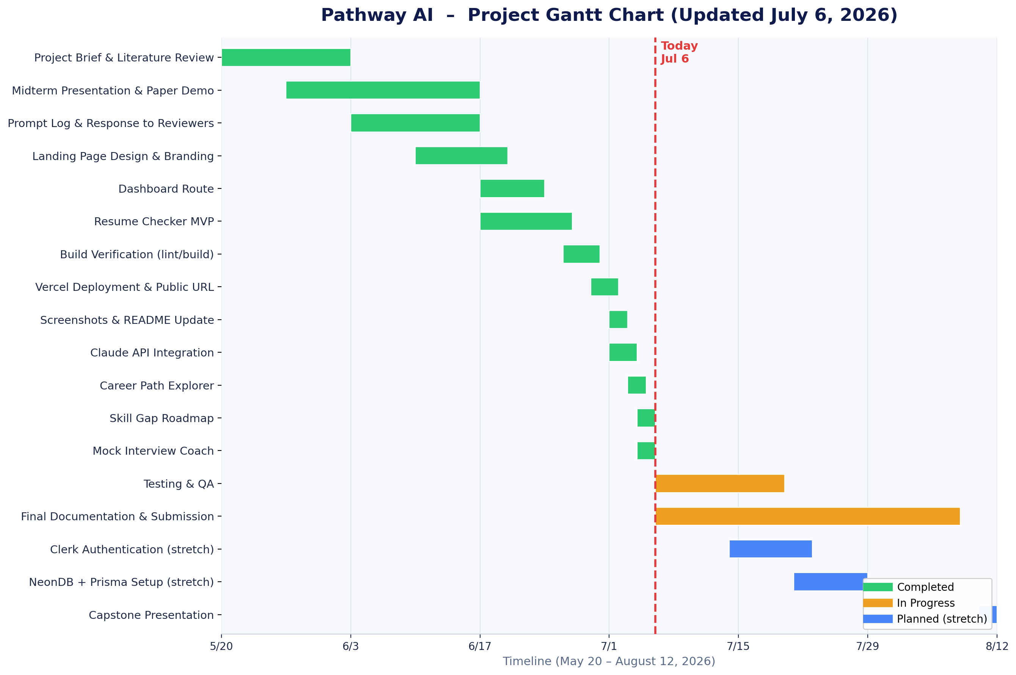
Figure 6. Updated Gantt chart. All build tasks complete (green); testing and documentation in progress (amber); auth and database are planned stretch items (blue).

9.2 Critical Path Analysis (Updated)
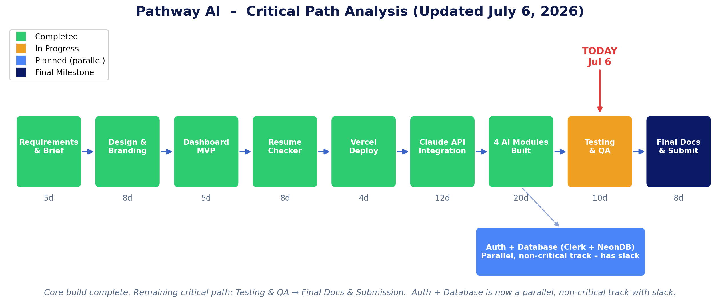
Figure 7. Updated critical path. Only Testing and QA and Final Documentation remain; Auth and Database is now a parallel track with slack.

9.3 PERT Chart (Updated)
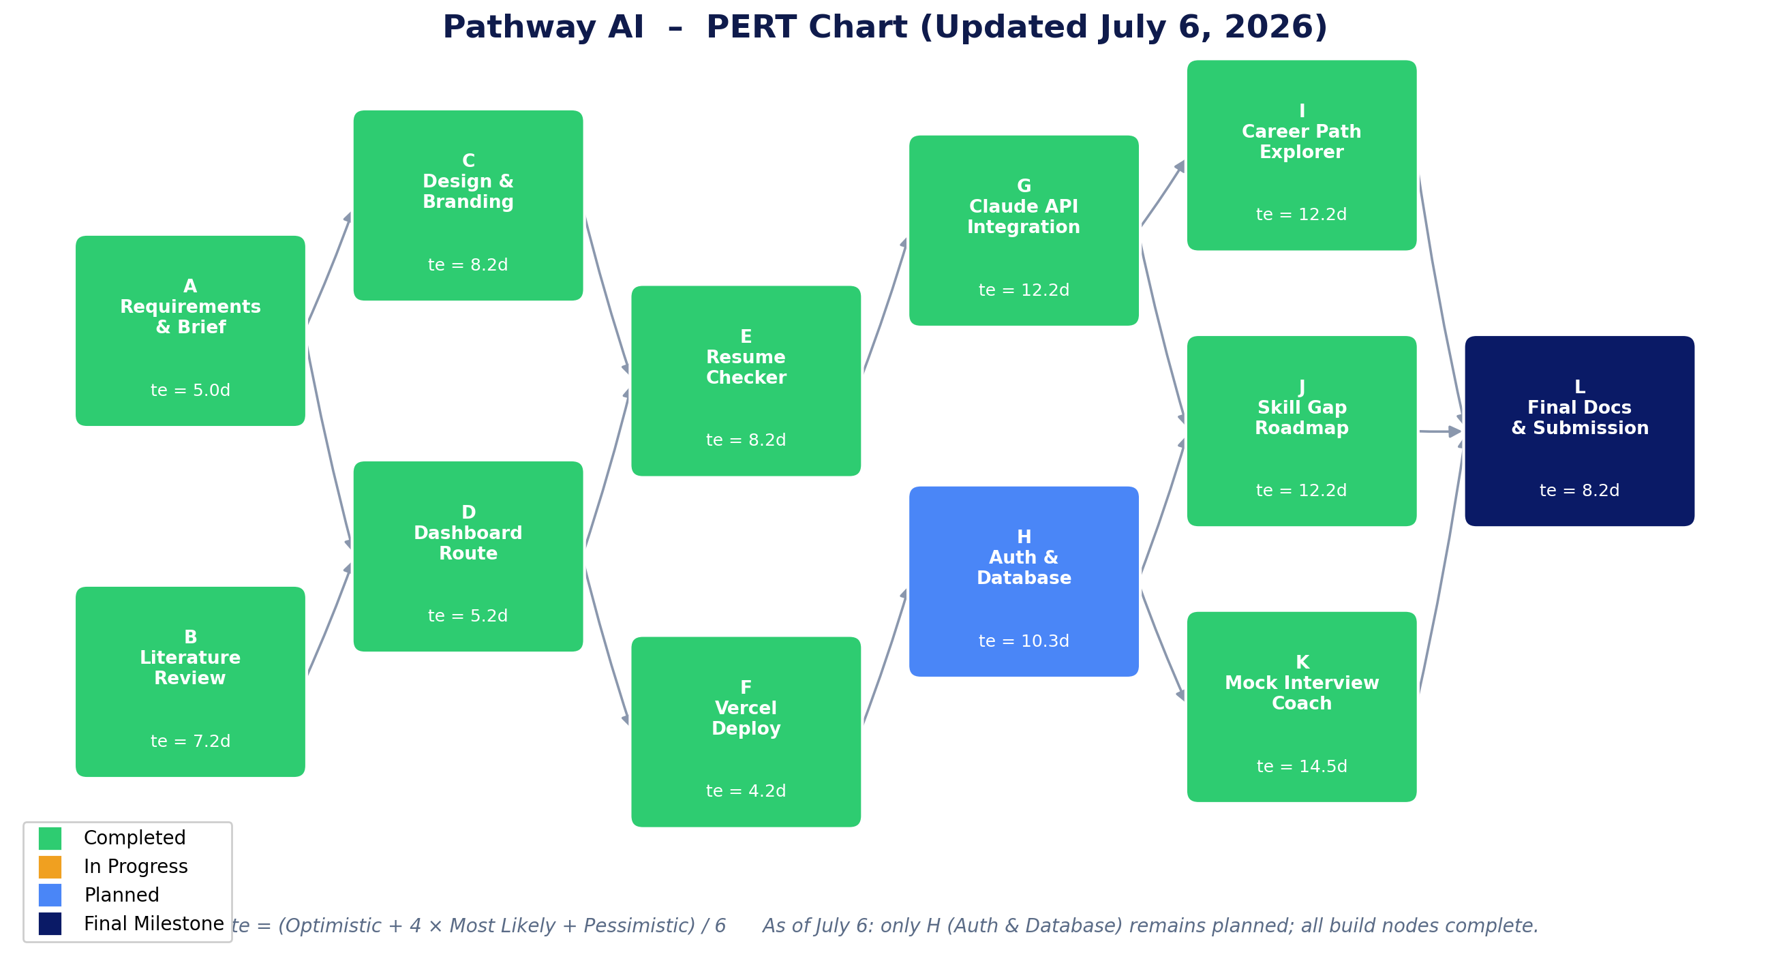
Figure 8. Updated PERT chart. Every build node is complete; only node H (Auth and Database) remains planned.

10. Conclusion
Pathway AI advanced from a single functional module backed by keyword matching to a fully integrated, AI-powered career readiness platform. All four modules now run on Claude Opus 4.8 through a secure, rate-limited backend, share data with one another, accept file uploads, and degrade gracefully through local fallbacks. The platform is deployed publicly and delivers on its central promise: a free, unified alternative to the separate paid tools students would otherwise juggle. The architecture leaves clear room to grow, including deeper personalization, richer history on the dashboard, and additional preparation modules built on the same server-side AI pattern.

