PATHWAY AI
Project Management Charts (Updated)
IST 440W Capstone | Penn State University
David Ademoye | May 20 – August 12, 2026 | Status as of July 6, 2026
1. Project Management Summary
This document contains the updated project management artifacts for Pathway AI, reflecting project status as of July 6, 2026. Since the June 30 baseline, the project has advanced well ahead of the original plan. Vercel deployment is complete with a confirmed public URL, the Claude Opus 4.8 API is integrated, and all four career readiness modules (Resume Checker, Career Path Explorer, Skill Gap Roadmap, and Mock Interview Coach) are built and AI-powered.
The remaining critical path is short: Testing and QA, followed by final documentation and submission, closing with the capstone presentation on August 12. Clerk authentication and the NeonDB database were intentionally moved to a parallel, non-critical track. Because the application uses browser-based storage, these items carry available slack and can be completed as stretch goals without affecting the submission date.
2. Gantt Chart
The Gantt chart plots every task across the May 20 to August 12 timeline. Green bars are completed work, amber bars are currently in progress, and blue bars are planned stretch items. The red dashed line marks today, July 6, 2026.
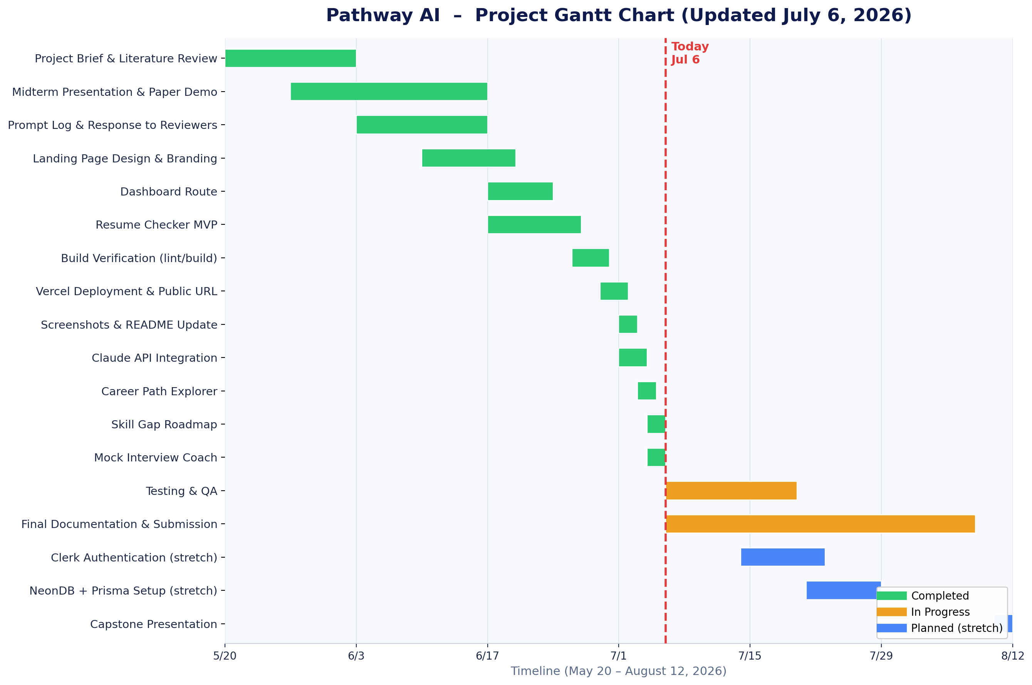
Figure 1. Pathway AI Gantt Chart (Updated) — May 20 to August 12, 2026
3. Critical Path Analysis
The critical path is the sequence of dependent tasks that controls the final delivery date. With the core build complete, the critical path now runs only through Testing and QA and Final Documentation and Submission. Authentication and the database have moved off the critical path into a parallel track with slack.
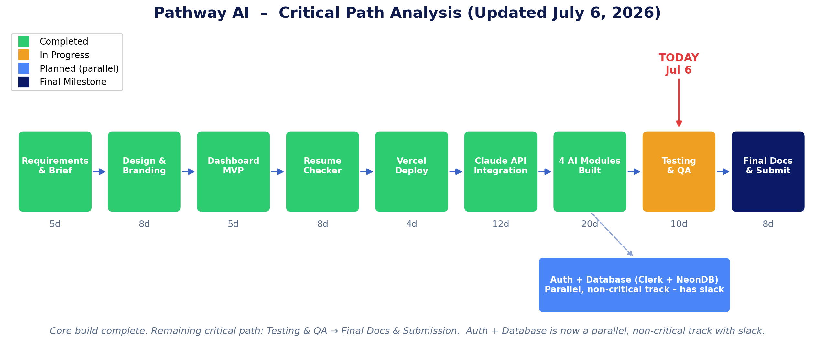
Figure 2. Pathway AI Critical Path (Updated) — core build complete
Updated Critical Path Sequence
- A Requirements & Brief (5d) — Completed
- C Design & Branding (8d) — Completed
- D Dashboard Route (5d) — Completed
- E Resume Checker MVP (8d) — Completed
- F Vercel Deployment (4d) — Completed
- G Claude API Integration (12d) — Completed
- I / J / K Four AI Modules Built (approx. 20d) — Completed
- Testing & QA (10d) — In Progress
- L Final Documentation & Submission (8d) — In Progress
The completed and in-progress critical path totals roughly 80 expected days within the 84-day window. The core development is finished ahead of schedule, leaving comfortable float for testing, documentation, and the optional authentication and database work.
4. PERT Estimate Table
Each task is estimated with three scenarios: Optimistic (O), Most Likely (M), and Pessimistic (P). PERT expected time is te = (O + 4M + P) / 6. Status is updated to July 6, 2026.
ID | Task | O | M | P | te | Status
A | Requirements & Project Brief | 3 | 5 | 7 | 5.0 | Completed
B | Literature Review & Research | 5 | 7 | 10 | 7.2 | Completed
C | Design & Branding | 5 | 8 | 12 | 8.2 | Completed
D | Dashboard Route | 3 | 5 | 8 | 5.2 | Completed
E | Resume Checker MVP | 5 | 8 | 12 | 8.2 | Completed
F | Vercel Deployment | 2 | 4 | 7 | 4.2 | Completed
G | Claude API Integration | 7 | 12 | 18 | 12.2 | Completed
H | Clerk Auth + NeonDB | 7 | 10 | 15 | 10.3 | Planned
I | Career Path Explorer | 7 | 12 | 18 | 12.2 | Completed
J | Skill Gap Roadmap | 7 | 12 | 18 | 12.2 | Completed
K | Mock Interview Coach | 10 | 14 | 21 | 14.5 | Completed
L | Final Documentation & Submission | 5 | 8 | 12 | 8.2 | In Progress
O = Optimistic days | M = Most Likely days | P = Pessimistic days | te = PERT expected time
5. PERT Chart
The PERT chart maps all tasks as nodes in a dependency network. Each node shows the task ID, name, and expected duration (te). Arrows represent dependencies: a task cannot begin until all upstream tasks are complete. As of July 6, every build node is complete; only node H (Auth and Database) remains planned, and it sits on a parallel track.
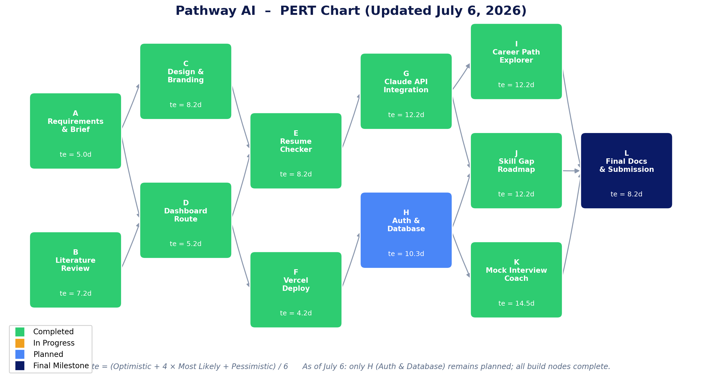
Figure 3. Pathway AI PERT Chart (Updated) — May 20 to August 12, 2026
The two development tracks (frontend and AI integration, A → C → E → G → I → L; and infrastructure, B → D → F → H → K → L) both converge at final submission. With the AI track fully complete, delivery risk now rests almost entirely on documentation and testing, both of which are underway with slack to spare.

